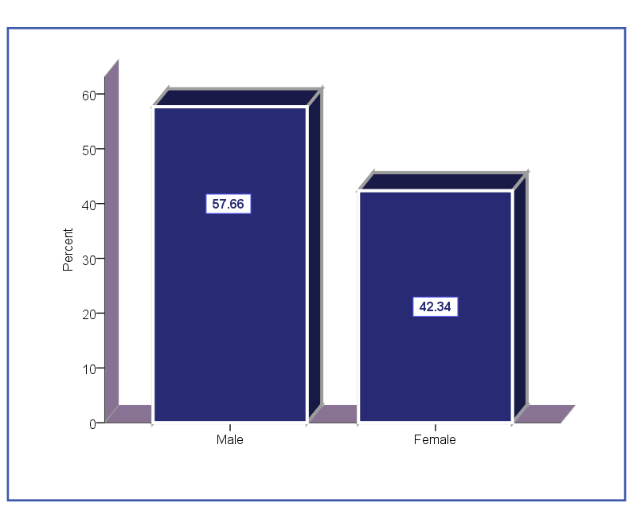

**Figure1: percentage of gender (sex group) according to Referral System.**

* In this study show percentage of gender (sex) group according to Referral system from total no. of all patients were refer , and show the males 57.7% higher than females 42.3% in general ,& p _value was considered significant (0.0001) .

Table 1: The age groups No. and percentage according to referral system.

|  | | |
| --- | --- | --- |
| Age group | No. | (%) |
| <11 | 99 | 9.4 |
| 11-20 | 161 | 15.2 |
| 21-30 | 191 | 18.1 |
| 31-40 | 205 | 19.4 |
| 41-50 | 207 | 19.6 |
| 51-60 | 121 | 11.4 |
| >60 | 74 | 7.0 |
| Total | 1058 | 100.0 |

P= 0.0001 *

* This study show the percent and number of the age groups were classify into 7 groups, which start below 11 years to above 60 years. And the result of the age group (41 -50 years) 19.6% was the highest among the groups, while the age group (> 60 years) was the lowest among all groups.

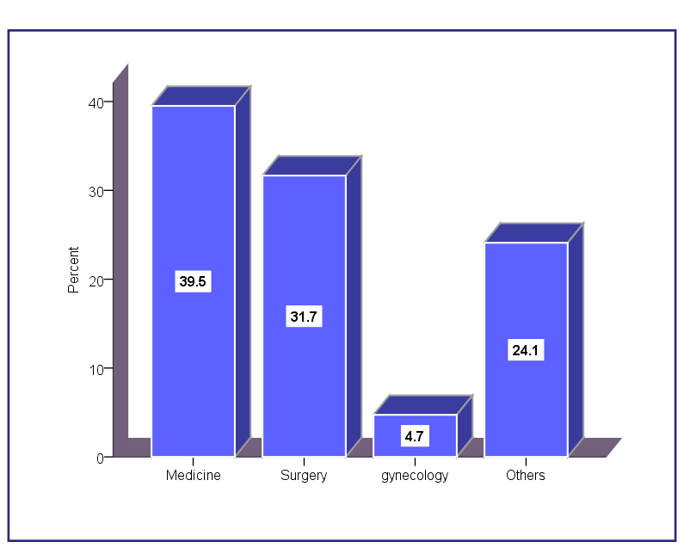

**Figure 2: Departments of health for referral the patients from primary to secondary level*.***

This study shows the health departments in the secondary level (Hospitals), which refer the patients from the primary level (Health Center), so the medical department had the highest percentage of referring (39.5%)***,***followed by surgical department (31.7%) , obstetrics & gyne. (4.7%) but other medical division (24.1%) .

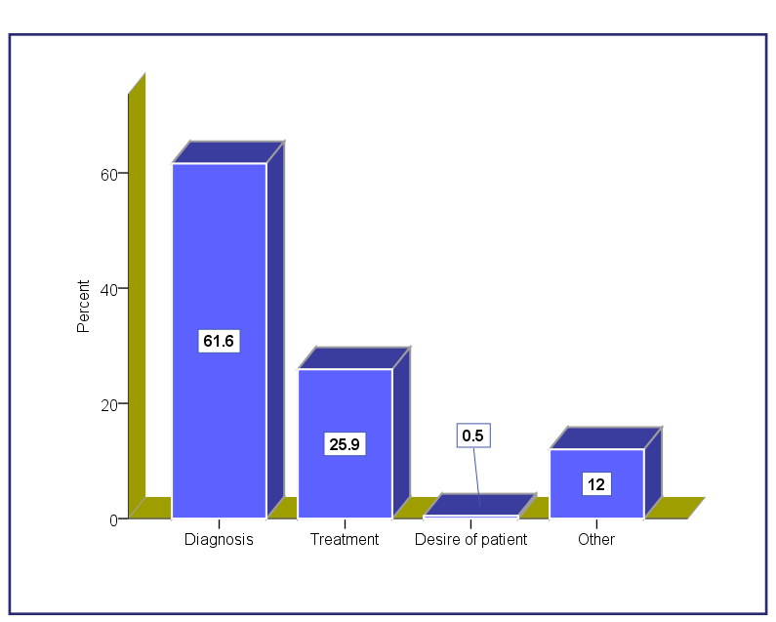

Figure 3: The Reasons for referral depending on the decision of the doctors & desire of the patient.

* This study shows the reasons for referral of the patient from primary care depending on the opinion of the Family Doctors for further diagnosis (61.6%) in the secondary level because of more facility & medical equipment. In addition to the reason of treatment (25.9%), but Desire of patient (0.5%) one of the reasons for referring the patients, so other reasons was formed in (12%).

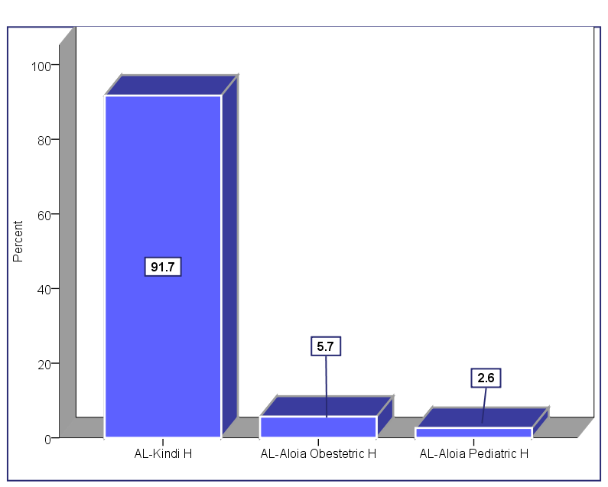

**Figure 4: Referral according to hospitals**

* In this study shows the main Hospital for Referral which coordinate with Family Health center depending on geographical area to refer from primary to secondary level was AL-kindi teaching hospital (91.7%) . Al-aloia obstetrics’ hospital (5.7%) and Al-aloia pediatrics hospital (2.6%) .

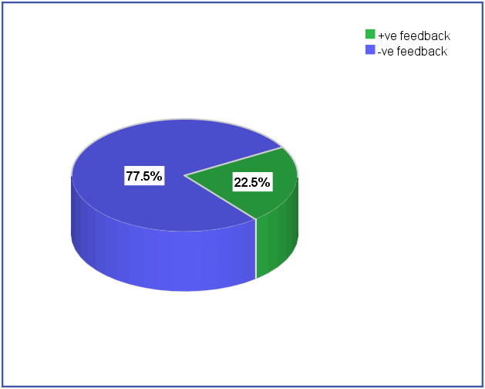

**Figure5: Referral feedback between hospitals and family medicine health center.**

* In this study show the percentage of referral feedback mechanism between the hospitals of referral and health center, so the +ve feedback (22.5%) while the –ve feedback (77.5%) from the total patients under study.

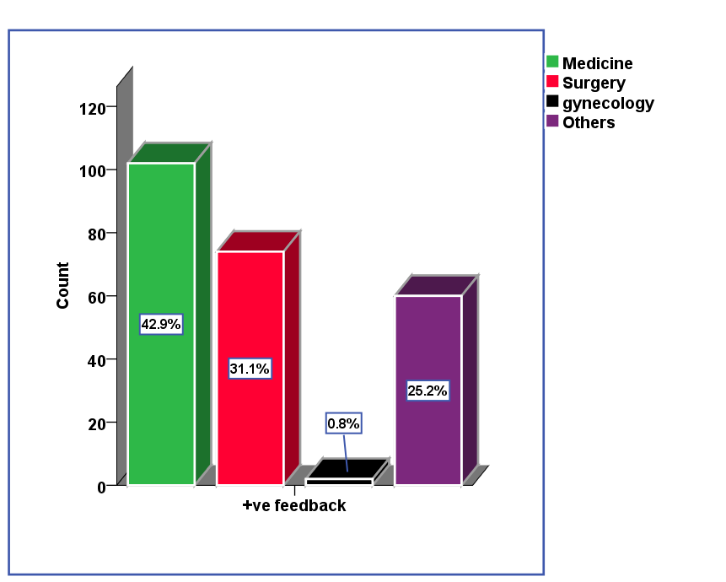

**Figure6: +Ve feedback mechanism and health departments for referral.**

In this study shows the +ve feedback for referral system with health department in the hospitals depending on the medical state refer from primary level, the department of medicine (42.9%) Is higher than other branch like surgery (31.1%) , obstetrics & gyne. (0. 8%) while the other medical division consists of (25.2%) were finding in the secondary level facility.

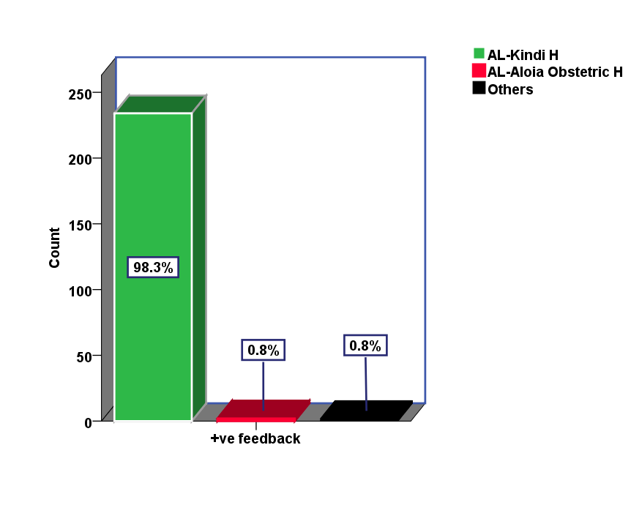

**Figure7: +Ve feedback mechanism and hospitals of referral.**

* In this study shows the +ve feedback mechanism of referral system with Hospitals of referral, firstly AL-Kindi teaching hospital (98.3%) according to medical departments, AL-aloia obstetric hospital (0.8%) ,lastly others (0.8%) .

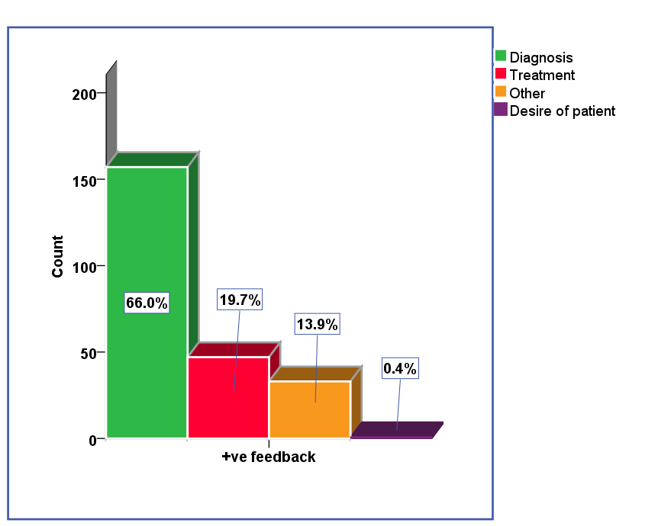

**Figure8: +Ve feedback mechanism and the reasons for referral.**

* This study shows the percentage of +ve feedback mechanism with the reasons for referral , for diagnosis (66.0%) ,or for treatment (19.7%) while desire of patient (0.4%) , other reasons (13.9%) .

| **Table2:Association of feedback with department** | | | | | | |
| --- | --- | --- | --- | --- | --- | --- |
|  | | | | | | |
| Association of feedback  with department | | department | | | | Total |
| M. | S. | O.&G | Others |
| feedback | +ve feedback | 9.6% | 7.0% | .2% | 5.7% | 22.5% |
| -ve feedback | 29.9% | 24.7% | 4.5% | 18.4% | 77.5% |
| Total | | 39.5% | 31.7% | 4.7% | 24.1% | 100.0% |

P=0.01 *

* This study shows the association between the feedback mechanism of referral system with Health department depending on the family doctors decision was significant (p=0.01).

| **Table3: Association of feedback with hospital of referral.** | | | | | | |
| --- | --- | --- | --- | --- | --- | --- |
|  | | | | | | |
| Association of feedback with hospital of referral | | Hospital of referral | | | | Total |
| Al-kindi H. | Al-aloia obstetric H. | Al-aloia pediatric H. | Others |
|  | +ve feedback | 22.1% | .2% | 0% | .2% | 22.5% |
| -ve feedback | 63.5% | 5.1% | 2.5% | 6.4% | 77.5% |
| Total | | 85.6% | 5.3% | 2.5% | 6.6% | 100.0% |

P=0.0001 *

* In this study shows the association of feedback mechanism with hospital of referral depending on health status, was significance(p=0.0001) occurred between +ve & -ve feedback mechanism .

| **Table4:Association of feedback with reason** | | | | | | |
| --- | --- | --- | --- | --- | --- | --- |
|  | | | | | | |
| Association of feedback with reason | | reason | | | | Total |
| diagnosis | treatment | other | desire of patient |
| feedback | +ve feedback | 14.8% | 4.4% | 3.1% | .1% | 22.5% |
| -ve feedback | 46.8% | 21.5% | 8.9% | .4% | 77.5% |
| Total | | 61.6% | 25.9% | 12.0% | .5% | 100.0% |

P=0.09 *

* In this study shows the association between the feedback mechanism of referral system with the reason of referral , diagnosis ,treatment ,

desire of patient and other, also the feedback was significant between

+ve & -ve mechanism in a total no. of patients of referral.