QuickLoan
High-Level Design (HLD) Document
AI Loan Pre-Qualification Assistant for FastFinance India (NBFC)

Agentic AI Engineering — Batch 1 · Launchpad Project
Document version 1.0 — 2026-09-14
Covers repository state through git tag s15

Document Control
Version | Date | Author | Summary of changes
1.0 | 2026-09-14 | QuickLoan engineering (AI-assisted) | Initial HLD covering the multi-agent LangGraph architecture, Azure (ACR/ACI/Front Door) deployment, and data layer as of tag s15.

Reference Documents
Document | Location
Product Requirements Document | quickloan-prd.md (repo root)
AI/Agentic terminology glossary | ai-glossary.md (repo root)
Engineering/agent guidance | CLAUDE.md (repo root)
Low-Level Design | docs/LLD.md → docs/LLD.docx (companion document)
Golden evaluation dataset | data/golden_dataset.json

1. Introduction

1.1 Purpose
This document describes the high-level architecture of QuickLoan, an AI-powered loan pre-qualification assistant built for FastFinance India, a Non-Banking Financial Company (NBFC). It is intended for engineers, reviewers, and course instructors who need to understand how the system is structured, how its components interact, and how it is deployed -- without needing to read the implementation source code first.

1.2 Project Overview
QuickLoan is a Launchpad project built across a 17-session Agentic AI Engineering course. It progressively evolved from a single-turn terminal chatbot into a multi-agent, RAG-and-tool-augmented, guarded, compliance-checked, human-reviewed conversational assistant with a Streamlit web UI, and is now containerised and deployed to Azure (Container Registry + Container Instances, fronted by Azure Front Door for managed HTTPS).

1.3 Key Constraint
QuickLoan pre-qualifies only — it never approves or rejects a loan application.
Final approval always requires document verification, a credit bureau check, and sometimes a field inspection by FastFinance staff. This distinction is enforced at the prompt level (SYSTEM_PROMPT explicitly states it) and mechanically, via the Compliance Agent's banned-phrase check (e.g. “loan is approved”, “guaranteed approval”, “pre-approved” are all rejected and rewritten before a customer ever sees them).

2. Scope

2.1 In Scope
- Conversational pre-qualification for four loan products: Personal, Home, Business, and Gold Loan.
- Live interest rate, eligibility, and loan-term lookups via MCP-exposed database tools.
- Policy/process/document guidance via retrieval-augmented generation (RAG) over FastFinance's policy documents.
- Two-layer input guard (regex + semantic) against PII exposure and prompt injection / jailbreak attempts.
- Automated RBI-compliance checking of every generated response, with human-in-the-loop review for revised responses.
- Multi-turn, multi-conversation memory via a Streamlit chat UI with per-thread persistence.
- Containerised deployment to Azure Container Instances behind Azure Front Door for managed HTTPS.

2.2 Out of Scope
- Final loan approval, underwriting, or disbursal decisions of any kind.
- Document upload / KYC verification workflows.
- Direct integration with a live credit bureau (CIBIL) API — CIBIL scores are customer-stated inputs only.
- EMI calculation as a callable tool — planned in the original PRD (US-04) but not implemented; see Section 11, Known Gaps.
- Multi-replica horizontal scaling of the deployed container — current persistence design (see Section 6) assumes a single running instance.

3. System Architecture Overview
QuickLoan is built as a LangGraph state machine: a directed graph of plain Python node functions that each receive the shared QuickLoanState and return a partial update, which LangGraph merges back into state automatically. The graph implements a Supervisor / Specialist-Agent pattern with a security guard in front and a compliance check (plus human review) behind.
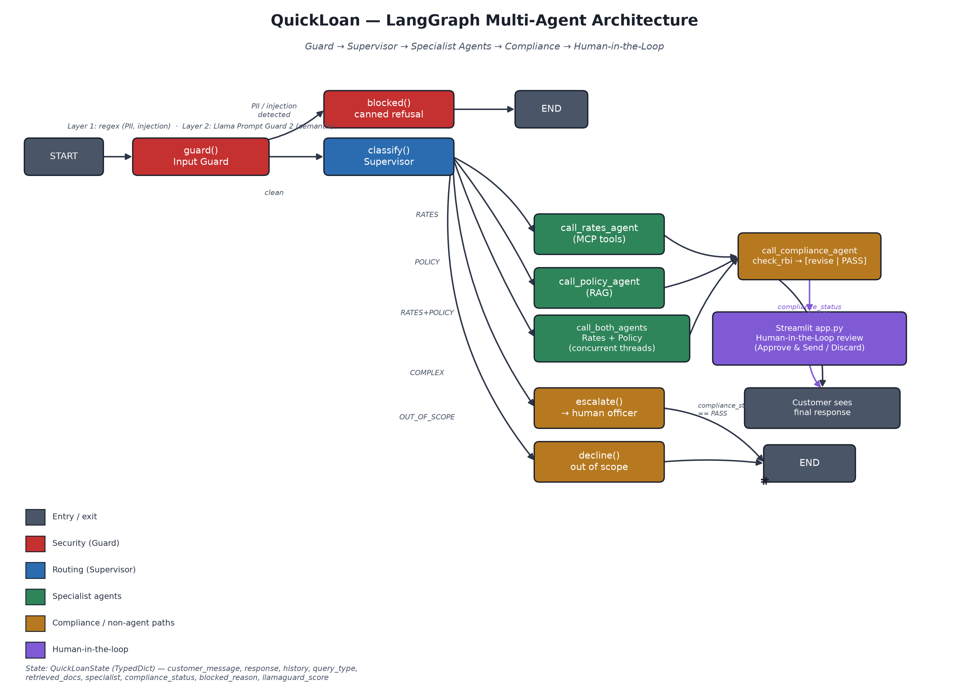
Figure 1 — QuickLoan LangGraph multi-agent architecture

3.1 Request Flow, Narrative
- guard() (Input Guard) inspects every incoming message before any LLM sees it. Layer 1 is deterministic regex (PII — Aadhaar/PAN patterns — and known injection/jailbreak phrasings). Layer 2 is a semantic classifier (Llama Prompt Guard 2, 86M parameters, via Groq) that catches rephrased jailbreak attempts regex would miss.
- classify() (Supervisor) runs only on messages that pass the guard. A dedicated, smaller/faster LLM (groq/compound-mini) classifies the message into one of five labels: RATES, POLICY, RATES+POLICY, COMPLEX, or OUT_OF_SCOPE.
- route_supervisor() dispatches by label to the Rates Agent (live MCP tool calls against SQLite), the Policy Agent (RAG over ChromaDB), call_both_agents() (both, concurrently, for compound questions), escalate() (hands off to a human loan officer, no LLM call), or decline() (out-of-scope refusal, no LLM call).
- call_compliance_agent() runs after every specialist response and checks it against RBI-safety rules: banned phrases and hallucinated interest rates (any quoted rate not found in the SQLite rate_slabs table for that specific product is treated as a hallucination, regardless of whether the number happens to look plausible).
- A response that fails compliance is rewritten once by an LLM, then held for human-in-the-loop approval in the Streamlit UI before it can reach the customer — the operator may approve as-is, edit and approve, or discard entirely.

4. Component Overview
Component | Responsibility | Key file(s)
Input Guard | Two-layer PII/injection/jailbreak screening before any LLM call. | nodes.py: guard(), blocked()
Supervisor | Classifies clean queries into 5 routing labels via a dedicated classifier LLM. | nodes.py: classify(), route_supervisor()
Rates Agent | Answers rate/eligibility questions via live MCP tool calls (never from memory). | nodes.py: call_rates_agent(), _rates_respond()
Policy Agent | Answers documents/process/tenure questions via RAG over policy documents. | nodes.py: call_policy_agent(), _policy_respond()
Compound handler | Runs Rates + Policy concurrently (thread pool) and merges results for two-part questions. | nodes.py: call_both_agents()
Compliance Agent | Checks every draft for banned phrases / hallucinated rates; rewrites on failure. | nodes.py: check_rbi(), revise_response()
MCP Server | Standalone process exposing SQLite queries as MCP tools over stdio. | quickloan/mcp_server.py
MCP Client / Tool binding | Spawns the MCP server subprocess, fetches tool list, binds to the agent LLM. | quickloan/tools.py
Graph assembly | Builds and compiles the LangGraph StateGraph; terminal REPL entry point. | quickloan/agent.py
Web UI | Streamlit chat interface: multi-conversation sidebar, streaming, HITL review form. | app.py

5. Data Architecture
QuickLoan deliberately separates two data modalities to avoid a single field having two sources of truth that can drift apart:
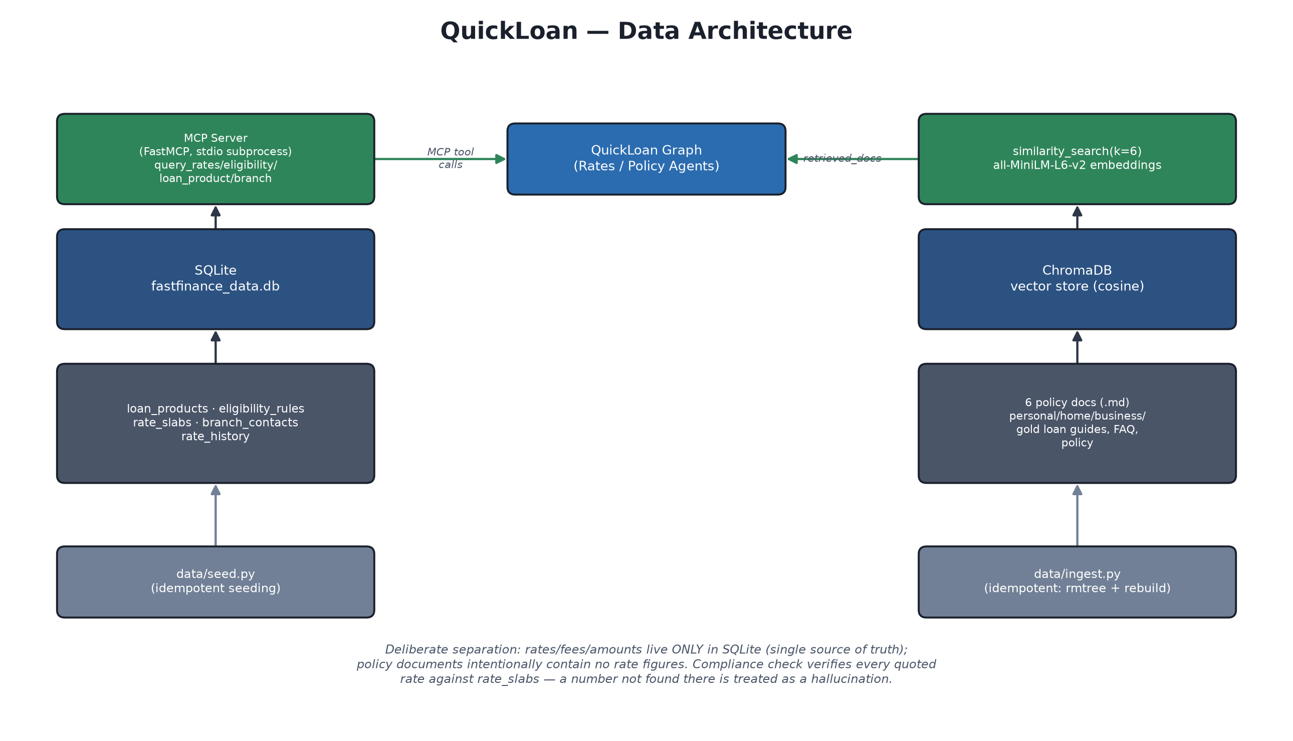
Figure 2 — QuickLoan data architecture

5.1 SQLite — Structured, Numeric Facts
fastfinance_data.db holds every number that can change independently of narrative policy text: interest rate slabs (banded by CIBIL score), eligibility thresholds, loan terms (tenure/amount/fees), branch contacts, and rate change history. It is queried live, per request, through MCP tools — never cached into a prompt as static text — so a rate change only requires re-running data/seed.py, never a prompt edit.

5.2 ChromaDB — Unstructured Policy Knowledge
Six Markdown policy documents (product guides for each loan type, an FAQ, and a general policy document) are chunked (500 chars, 50 overlap), embedded with HuggingFace's all-MiniLM-L6-v2 model, and stored in a cosine-distance ChromaDB collection. These documents intentionally contain no rate, fee, or EMI figures — that data lives only in SQLite (Section 5.1).

5.3 Why Two Data Stores
The Compliance Agent's hallucination check (Section 9.2) is only possible because rates have exactly one authoritative source: any interest rate the LLM states that doesn't match rate_slabs for the product it's attached to is treated as a hallucination and triggers a rewrite — a check that would be unreliable if rates could also appear, possibly inconsistently, inside the RAG documents.

6. Deployment Architecture
QuickLoan is packaged as a single multi-stage Docker image and deployed to Azure using three managed services: Azure Container Registry (image storage), Azure Container Instances (compute), and Azure Front Door (HTTPS edge / ingress).
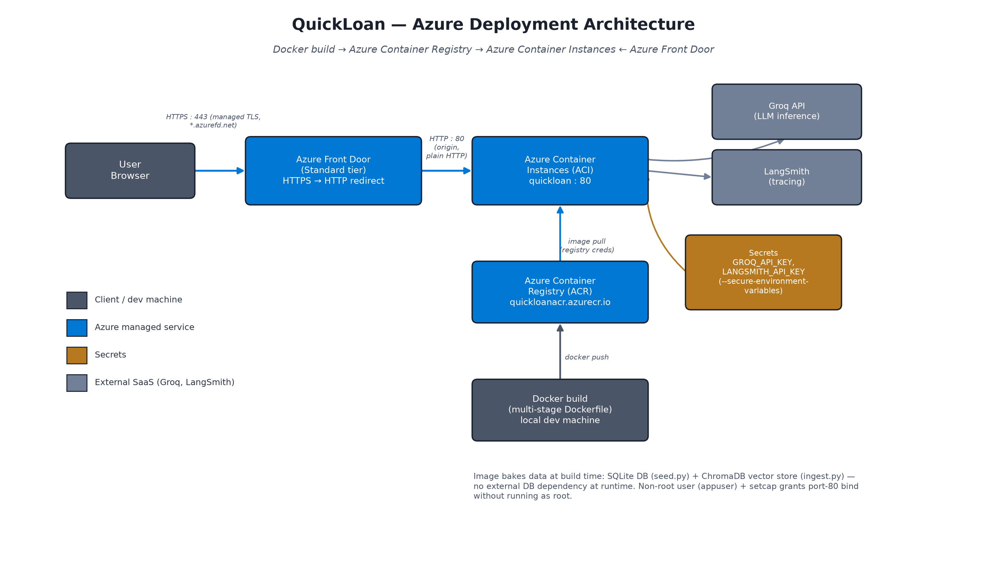
Figure 3 — QuickLoan Azure deployment topology (ACR / ACI / Front Door)

6.1 Container Image
- Two-stage Dockerfile: a builder stage (with build-essential, for compiling chromadb/tokenizers/sentence-transformers wheels) and a lean runtime stage that only receives the compiled artefacts — the compiler toolchain never ships in the final image.
- Data is baked in at build time: data/seed.py populates SQLite and data/ingest.py builds the ChromaDB vector store inside the image, so the running container has no external database dependency and starts ready to answer queries immediately.
- Runs as a non-root user (appuser). To still serve on the plain HTTP port 80 (rather than an unusual high port) without running as root, the Python interpreter binary is granted the CAP_NET_BIND_SERVICE Linux capability via setcap at build time — a file capability, not a process privilege, so appuser remains non-root for everything else.

6.2 Azure Container Registry (ACR)
The built image is pushed to a private registry (quickloanacr.azurecr.io). Azure Container Instances authenticates to it using registry admin credentials supplied at container-group creation time.

6.3 Azure Container Instances (ACI)
The container group (“quickloan”) runs the image, listening on port 80, with GROQ_API_KEY and LANGSMITH_API_KEY passed as secure environment variables (masked in the Azure Portal and CLI output, never baked into the image). A single replica is intentionally used — see Section 10.1 for why.

6.4 Azure Front Door (Standard tier)
ACI alone only serves plain HTTP; Front Door sits in front of it as a managed HTTPS edge, providing a free, auto-provisioned TLS certificate on its own *.azurefd.net domain, redirecting any HTTP request to HTTPS, and proxying (HttpOnly) to the ACI origin on port 80. This is what allows the application to be reached at a plain https:// URL with no port number and no certificate management.

6.5 External Dependencies
Service | Purpose | Called from
Groq API | LLM inference — agent model, classifier model, guard model. | quickloan/tools.py (ChatGroq clients)
LangSmith | Distributed tracing / observability for every graph run. | @traceable decorators in nodes.py

7. Technology Stack
Layer | Technology
Orchestration | LangGraph (StateGraph, conditional edges, checkpointers)
LLM provider | Groq (langchain-groq)
Tool protocol | Model Context Protocol (MCP) — mcp, langchain-mcp-adapters
Vector store | ChromaDB (langchain-chroma), cosine distance
Embeddings | HuggingFace all-MiniLM-L6-v2 (langchain-huggingface, sentence-transformers)
Relational store | SQLite (stdlib sqlite3)
Persistence / checkpointing | langgraph-checkpoint-sqlite (SqliteSaver) / MemorySaver
Web UI | Streamlit
Observability | LangSmith (langsmith)
Evaluation | Custom golden-dataset harness + LLM-as-judge (evaluate.py)
Containerisation | Docker (multi-stage build)
Cloud hosting | Azure Container Registry + Azure Container Instances + Azure Front Door
Language / runtime | Python 3.11 (container) / Python 3.14 (local dev, observed)

8. LLM and Model Usage
QuickLoan deliberately uses multiple, differently-sized models for different jobs rather than one model for everything — latency, cost, and output-format reliability all differ significantly across these roles.
Role | Model | Provider | Notes
Agent / response synthesis | openai/gpt-oss-120b | Groq | MAX_TOKENS=1500, TEMPERATURE=0.3; confirmed Groq-compatible tool-call output
Supervisor classifier | groq/compound-mini | Groq | Low-latency, 5-way label classification; MAX_TOKENS=10
Input Guard, Layer 2 | meta-llama/llama-prompt-guard-2-86m | Groq | Semantic jailbreak probability classifier; threshold 0.5; fails open on error
Evaluation judge | llama-3.3-70b-versatile | Groq | evaluate.py; scores SIMPLE-category responses 1–5. (CLAUDE.md's plan to move this to OpenAI GPT-4o-mini has not yet landed in this file — see Section 11.)
Compliance rewrite | openai/gpt-oss-120b (same as agent) | Groq | revise_response(); capped to a 150-word compliant rewrite

9. Security, Compliance and Guardrails

9.1 Input Guard (Session 14)
- Layer 1a — PII: regex detects Aadhaar (12-digit) and PAN (5-letter/4-digit/1-letter) patterns. Matching messages are blocked before reaching any LLM (DPDP Act 2023).
- Layer 1b — Injection: regex catches known jailbreak phrasings (“ignore previous instructions”, persona-hijack attempts, etc.), tuned to avoid false positives on legitimate banking language (e.g. a customer mentioning their own new job role).
- Layer 2 — Semantic: Llama Prompt Guard 2 catches rephrasings that bypass regex (e.g. “set aside your earlier guidelines”). Fails open (treated as safe) if the guard model itself is unreachable, so an outage never blocks legitimate traffic — a deliberate trade-off distinct from the Supervisor's fail-safe behaviour below.
- Unicode normalisation (NFKD) and invisible-character stripping run before every regex check, closing a known smuggling vector (zero-width characters, Unicode tag blocks) that could otherwise hide a payload from the regex layer.

9.2 RBI Compliance Check
- Banned-phrase check: any response containing phrases like “guaranteed approval”, “loan is approved”, or “pre-approved” fails compliance immediately — QuickLoan must never imply a lending decision has been made.
- Hallucinated-rate check: every percentage figure in a response is matched against the live rate_slabs table for the specific product it's attached to (not just “does this number exist anywhere”) — a rate correct for one product but quoted against another still fails.
- A failed check triggers one LLM rewrite pass (revise_response()), capped at 150 words, which must still end with the mandatory sign-off line.

9.3 Human-in-the-Loop (HITL)
Every compliance-revised response is held — never sent automatically — until a human operator reviews it in the Streamlit UI. The operator may approve as-is, edit the text and approve, or discard the turn entirely. Whatever the operator decides is reconciled back into the LangGraph checkpoint (_sync_hitl_decision()), so the model's own conversational memory never diverges from what the customer actually saw.

9.4 Fail-Safe Classification
If the Supervisor's classifier call itself fails (rate limit, network error, service outage), the query defaults to COMPLEX — not a lucky-guess category. This was a deliberate correction after a golden-dataset run showed that defaulting to RATES under sustained rate-limiting silently dropped every COMPLEX case's mandatory human-escalation safety net.

9.5 Secrets Management
GROQ_API_KEY and LANGSMITH_API_KEY are never baked into the Docker image (only supplied at container-run time via environment variables) and are passed to the deployed ACI instance as secure environment variables, masked in both the Azure Portal and CLI output.

10. Non-Functional Considerations

10.1 Scalability
Conversation state (both Streamlit's in-memory thread list and the LangGraph checkpointer) is local to a single running container. Running more than one ACI replica would give each replica its own independent, inconsistent view of conversation history — the current deployment intentionally pins to a single replica (min-replicas = max-replicas = 1) rather than silently producing that inconsistency. Horizontal scaling would require externalising the checkpointer (e.g. to a shared Postgres/Redis-backed LangGraph checkpointer) first.

10.2 Reliability
- LLM calls that hit Groq's occasional spurious-tool-call 400 error are retried exactly once (_invoke_with_retry()) at every call site in the tool-calling loop, not just the final synthesis step.
- MAX_TOKENS is deliberately capped (1500 for the agent) as an unbounded-consumption safeguard (OWASP LLM06:2026).
- The Input Guard's semantic layer fails open (Section 9.1); the Supervisor's classifier fails closed to COMPLEX (Section 9.4) — two different, individually justified fail-safe directions for two different risk profiles.

10.3 Observability
LangSmith tracing is wired via @traceable decorators on the Input Guard and RBI compliance check specifically, alongside standard LangGraph tracing of the full run. Every terminal-REPL and MCP tool call is also printed to stdout/stderr (PYTHONUNBUFFERED=1 in the container so these appear promptly under `docker logs -f` / `az container logs`).

10.4 Performance
The Streamlit UI streams the agent's response token-by-token (with a configurable per-character delay, default 15ms) for single-specialist answers. Compound RATES+POLICY answers run both specialist agents concurrently on separate threads (rather than sequentially) to keep response latency comparable to a single-agent query, then replay the merged text through the same typewriter effect once both halves are ready.

11. Known Gaps and Technical Debt
Area | Gap | Impact
EMI calculation | PRD (US-04) planned a calculate_emi MCP tool; not implemented. query_loan_product() (terms/tenure/fees) exists instead, which the PRD's session mapping does not mention. | COMPLEX classification correctly routes EMI questions to a human officer instead of calculating one, so this is a scope gap, not a correctness bug.
Retrieval relevance threshold | RETRIEVAL_SCORE_THRESHOLD is defined in config.py but unused — _policy_retrieve() calls a plain similarity_search(k=6), not similarity_search_with_relevance_scores(). | Low-relevance chunks are never filtered out of the Policy Agent's context; only chunk count (k) is bounded.
Evaluation judge model | CLAUDE.md documents a planned move of the LLM-judge to OpenAI GPT-4o-mini (kept off the agent's own model/provider to avoid self-grading bias); evaluate.py currently still uses Groq's llama-3.3-70b-versatile. | Evaluation runs correctly today, but the documented target architecture and the actual evaluate.py have drifted apart.
Golden dataset routing labels | data/golden_dataset.json's expected_route values are still SIMPLE / COMPLEX / OUT_OF_SCOPE — the three-bucket scheme from an earlier session — while the live graph now classifies into five labels (RATES / POLICY / RATES+POLICY / COMPLEX / OUT_OF_SCOPE). | The dataset has not been re-labelled to the current routing scheme; any automated pass/fail check keyed on expected_route needs updating first.
No automated test suite | No tests/ folder or pytest config exists yet, despite the PRD (US-05) specifying one with a mockable LLM-judge fixture. | Regression risk is currently caught only via the golden-dataset run and manual/agent-driven UI testing.
Single-replica deployment | See Section 10.1. | No automatic failover if the single ACI instance crashes; Azure will restart it per its restart policy, with a brief outage.

12. Roadmap
Per the PRD's session-to-story mapping, work remaining beyond the current state (tag s15):
Session | Planned capability
S16 | Advanced evaluation + prompt versioning, including an EMI-calculation regression gate.
S17 | Demo Day — QuickLoan presented as the Batch 1 Launchpad project.

Candidate improvements identified during this review (not currently scheduled to a specific session): externalising the LangGraph checkpointer for multi-replica scaling, adding the pytest suite specified in the PRD, re-labelling the golden dataset to the current five-way routing scheme, and completing the evaluation judge's move to OpenAI GPT-4o-mini.

