QuickLoan
Low-Level Design (LLD) Document
Module, Function, Schema and Sequence-Level Reference

Agentic AI Engineering — Batch 1 · Launchpad Project
Document version 1.0 — 2026-09-14
Companion to HLD.docx · Covers repository state through git tag s15

1. Introduction
This document is the detailed companion to HLD.docx. Where the HLD describes what QuickLoan's components are and why they are structured the way they are, this LLD describes exactly how each module, function, data schema, and request flow works — at a level of detail sufficient to modify or extend the system without re-reading the full source tree first.

1.1 Repository Layout Referenced Here
quickloan/ (repo root)
Dockerfile, docker-commands.txt, .dockerignore
requirements.txt, CLAUDE.md, quickloan-prd.md, ai-glossary.md
data/
seed.py, ingest.py, golden_dataset.json
documents/*.md (6 policy documents)
fastfinance_data.db (generated)
vectorstore/ (generated)
s01/starter/
app.py, evaluate.py, langgraph.json
quickloan/
__init__.py, config.py, state.py, db_queries.py,
tools.py, mcp_server.py, nodes.py, agent.py

2. State Schema — QuickLoanState
Defined in quickloan/state.py as a TypedDict. Every node function receives this shape and returns a partial dict of only the keys it changed; LangGraph merges the partial update back into the running state automatically.
Field | Type | Purpose
customer_message | str | The current turn's incoming message.
response | str | The answer being built / returned for this turn.
history | list[dict] | Full conversation so far, as {role, content} dicts — the app-level chat memory, checkpointed per thread_id.
query_type | str | Supervisor's classification label: RATES / POLICY / RATES+POLICY / COMPLEX / OUT_OF_SCOPE.
retrieved_docs | list[str] | RAG chunks retrieved by the Policy Agent, each prefixed with its source document name.
compliance_status | str | "" (not yet checked) / PASS / REVISED / FAIL: <reason>.
specialist | str | Which node produced the response: rates_agent / policy_agent / rates_agent+policy_agent / escalated / declined / guard.
blocked_reason | str | "" (clean) / pii / injection / llamaguard — set by guard().
llamaguard_score | float | Layer 2 injection probability (0.0–1.0); -1.0 if Layer 2 was never reached.

state.py has an import-time guard that raises NotImplementedError if a required field is missing from the TypedDict definition, catching an incomplete schema edit immediately at import rather than as a runtime KeyError deep in a node.

3. Module-by-Module Reference

3.1 quickloan/__init__.py
First file imported when the quickloan package loads. Sets HF_HUB_VERBOSITY=error (quiets HuggingFace download noise) and calls load_dotenv() so GROQ_API_KEY is available before any other module in the package reads it.

3.2 quickloan/config.py
Pure configuration — no API calls. Key constants:
Constant | Value | Notes
MODEL_NAME | openai/gpt-oss-120b | Agent LLM; TEMPERATURE=0.3, MAX_TOKENS=1500
CLASSIFIER_MODEL | groq/compound-mini | Supervisor; MAX_TOKENS=10
LLAMAGUARD_MODEL | meta-llama/llama-prompt-guard-2-86m | Guard Layer 2; MAX_TOKENS=30
LLAMAGUARD_THRESHOLD | 0.5 | Score above this = treated as injection
INJECTION_PATTERNS | list[str] (regex) | Guard Layer 1b — jailbreak/persona-hijack phrasings
PII_PATTERNS | list[str] (regex) | Aadhaar (12-digit) and PAN (5L/4D/1L) patterns
QUICKLOAN_BANNED_PHRASES | list[str] | Compliance check — “guaranteed approval”, “pre-approved”, etc.
RETRIEVAL_K | 6 | Chunks returned per RAG query
RETRIEVAL_SCORE_THRESHOLD | 0.3 | Defined but currently unused — see LLD §6 / HLD §11
DATA_DIR | Path(__file__).parent×4 / "data" | Resolves to repo-root data/; breaks silently if package nesting depth changes
EMBED_MODEL | all-MiniLM-L6-v2 | HuggingFace sentence-transformers model

Also defines the four prompt templates (SYSTEM_PROMPT, POLICY_SYSTEM_PROMPT, CLASSIFY_SYSTEM_PROMPT) and canned response strings (ESCALATE_RESPONSE, DECLINE_RESPONSE, GUARD_*_RESPONSE, SAFE_COMPLIANCE_RESPONSE).

3.3 quickloan/db_queries.py
Framework-agnostic SQL functions, deliberately undecorated (no @tool / @mcp.tool()) so tools.py (LangChain, in-graph) and mcp_server.py (FastMCP, standalone) both wrap the same logic instead of each keeping its own copy.
query_rates(product_id: str = "all") -> str
query_rates(product_id: str = "all") -> str
Joins rate_slabs to loan_products, ordered by CIBIL band descending. Returns one line per slab: "{product}: {rate:.2f}% p.a. (CIBIL {min}-{max})".
query_eligibility(product_id: str = "all") -> str
query_eligibility(product_id: str = "all") -> str
Joins eligibility_rules to loan_products. Returns CIBIL/income/age/employment criteria per product.
query_loan_product(product_id: str = "all") -> str
query_loan_product(product_id: str = "all") -> str
Reads loan_products directly. Returns tenure range, max loan amount, and processing fee — the terms neither of the two functions above return.
query_branch(city: str = "all") -> str
query_branch(city: str = "all") -> str
Reads branch_contacts, filtered with SQL LIKE '%city%' when a city is given.

3.4 quickloan/mcp_server.py
A FastMCP("quickloan-tools") server that wraps each db_queries.py function with @mcp.tool(), adding the docstring metadata (parameter descriptions, options) that the MCP protocol exposes to a calling LLM. Run standalone via python -m quickloan.mcp_server (STDIO transport, must run as a package module so its "from . import db_queries" relative import resolves), or launched as a subprocess by tools.py.

3.5 quickloan/tools.py
LLM client construction and MCP tool loading, all at import time:
- llm — ChatGroq(MODEL_NAME), max_retries=6 (a near-full token-budget window needs more than the default 2 retries to clear during a burst of calls).
- classifier_llm — ChatGroq(CLASSIFIER_MODEL), a genuinely separate, smaller model.
- llamaguard_llm — ChatGroq(LLAMAGUARD_MODEL), isolated so its settings never bleed into the main LLM's.
- _mcp_client = MultiServerMCPClient({...}) — spawns "python -m quickloan.mcp_server" as a subprocess over stdio, with env explicitly set to dict(os.environ) (a fix for the MCP SDK's default OS-dependent partial environment inheritance, which reproducibly crashed the subprocess with "GROQ_API_KEY not found" inside a Linux container despite working under native Windows testing).
- mcp_tools = asyncio.run(_mcp_client.get_tools()) — runs at import time, so simply importing quickloan.nodes (and therefore quickloan.agent, and therefore app.py) launches the MCP server subprocess before any user input.
- llm_with_tools = llm.bind_tools(mcp_tools) — the tool-calling-capable agent LLM.
- _run_tool(name, args) — dispatches a call by name through _tool_registry, flattening the MCP content-block result list to plain text via _extract_text().

3.6 quickloan/nodes.py (787 lines — the core of the graph)
Organised into four sections, in source order:

3.6.1 Input Guard
guard(state) -> dict
guard(state: QuickLoanState) -> dict
Entry point node. Strips invisible Unicode, NFKD-normalises, then runs Layer 1a (PII regex), Layer 1b (injection regex), and only if both pass, Layer 2 (_llamaguard_safe()). Returns blocked_reason (""/pii/injection/llamaguard) and llamaguard_score always.
- _llamaguard_safe(message) -> (bool, float): calls llamaguard_llm, parses the returned probability string, compares to LLAMAGUARD_THRESHOLD. Catches any exception and fails open: returns (True, -1.0).
blocked(state) -> dict / route_guard(state) -> str
blocked(state) -> dict
route_guard(state) -> str
blocked() returns the canned response matching blocked_reason. route_guard() is the conditional-edge function: "blocked" if blocked_reason is truthy, else "classify".

3.6.2 Specialist Agents
_generate_response_text(messages: list) -> str
_generate_response_text(messages: list) -> str
If _stream_callback is set (Streamlit UI), streams via llm.stream() and calls the callback per chunk, returning the accumulated text. Otherwise blocks on llm.invoke(). Must never be called with tools bound — tool-call detection needs the full structured response, not a token stream.
_invoke_with_retry(fn, *args, label="LLM", **kwargs)
_invoke_with_retry(fn, *args, label: str = "LLM", **kwargs)
Calls fn once; on any exception, retries exactly once before propagating. Guards against gpt-oss occasionally hallucinating a tool call that isn't bound, which Groq rejects with a 400 — this can happen on any round of the tool-calling loop, not just the first.
_policy_retrieve(state) / _policy_respond(state)
_policy_retrieve(state) -> dict
_policy_respond(state) -> dict
_policy_retrieve() lazily initialises the module-level vectorstore singleton (_init_vectorstore()), then runs similarity_search(k=RETRIEVAL_K) — not similarity_search_with_relevance_scores(), so RETRIEVAL_SCORE_THRESHOLD is currently unused. _policy_respond() builds POLICY_SYSTEM_PROMPT + retrieved chunks + history + the new message, then calls _generate_response_text().
_rates_respond(state) -> dict
_rates_respond(state) -> dict
Runs an explicit tool-calling loop (max 5 rounds): calls llm_with_tools, and while the result has tool_calls, executes each via _run_tool() and appends a ToolMessage, then calls llm_with_tools again. If the loop never called a tool, the first result's content is used directly (not streamed — reconstructing tool_calls from a partial token stream isn't supported). If at least one tool was called, a final tool-less _generate_response_text() call synthesises the streamable reply.

3.6.3 Compound Handler
call_both_agents(state) -> dict
call_both_agents(state: QuickLoanState) -> dict
Runs _rates_agent and _policy_agent concurrently via a 2-worker ThreadPoolExecutor, each with a short scope note appended to customer_message so it only answers its half of the question. _stream_callback is saved, set to None for the duration of both calls (both threads share the same ChatGroq client instance; concurrent llm.stream() reads on it corrupt each other), and restored in a finally block. Results are merged into one Markdown-formatted response with "**Rates & Eligibility**" / "**Documents & Process**" sections.

3.6.4 Compliance Agent
_check_compliance_logic(draft: str) -> tuple
_check_compliance_logic(draft: str) -> (bool, str)
Checks QUICKLOAN_BANNED_PHRASES first (substring match, case-insensitive). Then extracts rate mentions via _RATE_PATTERN (matches "8.75% p.a." and common paraphrases: "per annum", "annually"), pairs each with the nearest preceding product name if present (_extract_rate_mentions()), and checks each against _load_valid_rates_by_product() — a live re-query of rate_slabs, grouped by product_id. A mention with no identifiable product is checked against the set of all valid rates system-wide.
check_rbi(state) / revise_response(state) / route_compliance(state)
check_rbi(state) -> dict
revise_response(state) -> dict
route_compliance(state) -> str
check_rbi() sets compliance_status to PASS or FAIL: <reason>. revise_response() prompts the agent LLM to rewrite the draft (rules: never guarantee approval, never add a new rate, stay under 150 words, keep the sign-off line), falling back to SAFE_COMPLIANCE_RESPONSE on any error. route_compliance() sends FAIL: to "revise", everything else to END.
call_compliance_agent(state) -> dict
call_compliance_agent(state) -> dict
Invokes the compiled compliance sub-graph, sanitises the result (strips stray <br> tags the LLM sometimes emits inside Markdown tables — the app never renders unsafe_allow_html, so a literal <br> would otherwise show up as text), and — critically — overwrites the checkpointed history's last assistant turn with the possibly-revised text, so a revised-away violation is never replayed into the model's own context on the next turn.

3.6.5 Supervisor
classify(state) -> dict
classify(state: QuickLoanState) -> dict
Sends CLASSIFY_SYSTEM_PROMPT plus the last 2 history turns plus the new message to classifier_llm. An unrecognised-but-successful response defaults to RATES (narrow case: the model responded, just not with a known label). Any exception defaults to COMPLEX — fail-safe, not fail-open (see LLD §5.7 / HLD §9.4).
route_supervisor(state) -> str
route_supervisor(state: QuickLoanState) -> str
Maps query_type to a node name: RATES+POLICY → call_both_agents, POLICY → call_policy_agent, COMPLEX → escalate, OUT_OF_SCOPE → decline, anything else (RATES, or an unrecognised default) → call_rates_agent.

3.7 quickloan/agent.py
build_graph(checkpointer=None) assembles the StateGraph: adds all nine nodes, sets guard as the entry point, wires route_guard's conditional edges, route_supervisor's five-way conditional edges, and the fixed edges from each specialist to call_compliance_agent (and from escalate/decline straight to END). Compiling with checkpointer=None (the default) keeps the module-level graph LangGraph-Studio-safe.
run() is the terminal REPL: opens a SqliteSaver against CHECKPOINT_DB, generates one thread_id per session, and prints route/specialist/RAG-source/compliance-status metadata alongside every response.

3.8 app.py (Streamlit UI)
Function | Responsibility
_StreamingState | Renders tokens into a placeholder character-by-character with a blinking-cursor span, at a configurable per-character delay.
build_input_state() | Resets all per-turn state fields (including S14 guard fields) for a fresh graph.invoke() call.
_new_thread() / _clear_current_thread() / _delete_thread() | Sidebar conversation lifecycle. Clearing resets checkpointed history explicitly via update_state(), since a partial-state merge would otherwise leave stale history in place.
_search_thread_ids() / _thread_match_is_title_only() / _inject_live_search_filter() | Two-layer conversation search: server-side CSS filtering (on commit) plus a live per-keystroke JS filter injected via components.html().
_scroll_to_bottom() | Force-scrolls to the latest message via injected JS — needed because Streamlit's own auto-follow only engages while the user is already at the bottom.
_handle_hitl() / _sync_hitl_decision() | Renders the compliance-revision approval form; reconciles the operator's decision (approve/edit/discard) back into the LangGraph checkpoint.
main() | Orchestrates a turn: renders history, checks for a pending HITL review, reads chat_input, wires the streaming callback, invokes the graph, and branches on blocked / needs_human_review / escalated / normal to render the result.

4. Graph Definition
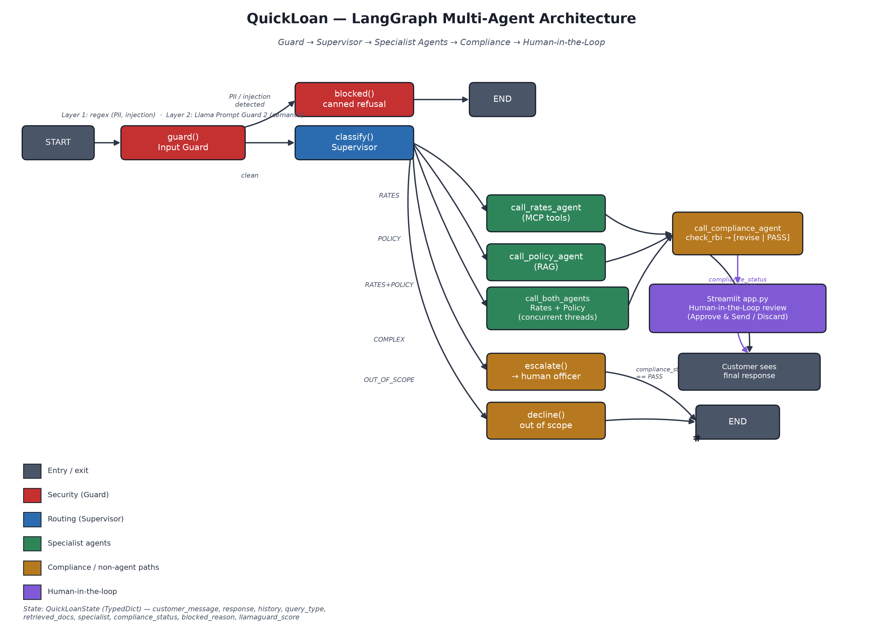
Figure 1 (repeated from HLD) — full graph topology

4.1 Nodes
Node name | Function
guard | guard()
blocked | blocked()
classify | classify()
call_policy_agent | call_policy_agent()
call_rates_agent | call_rates_agent()
call_both_agents | call_both_agents()
call_compliance_agent | call_compliance_agent()
escalate | escalate()
decline | decline()

4.2 Edges
From | To | Condition
START | guard | always
guard | blocked | route_guard() == "blocked" (blocked_reason truthy)
guard | classify | route_guard() == "classify" (clean)
blocked | END | always
classify | call_rates_agent | route_supervisor() == "call_rates_agent" (RATES / default)
classify | call_policy_agent | route_supervisor() == "call_policy_agent" (POLICY)
classify | call_both_agents | route_supervisor() == "call_both_agents" (RATES+POLICY)
classify | escalate | route_supervisor() == "escalate" (COMPLEX)
classify | decline | route_supervisor() == "decline" (OUT_OF_SCOPE)
call_rates_agent | call_compliance_agent | always
call_policy_agent | call_compliance_agent | always
call_both_agents | call_compliance_agent | always
call_compliance_agent | END | always (internal sub-graph already resolved revise|PASS)
escalate | END | always
decline | END | always

Note: the Compliance Agent is itself a compiled sub-graph (check_rbi → [revise | END]), invoked synchronously inside call_compliance_agent() rather than expressed as top-level conditional edges — so the outer graph always sees a single "call_compliance_agent → END" edge regardless of whether a revision happened internally.

5. Sequence Flows

5.1 Simple RATES Query
Example: "What is the home loan interest rate?"
- guard() — passes (no PII/injection detected).
- classify() — classifier_llm returns RATES.
- route_supervisor() → call_rates_agent.
- _rates_respond(): llm_with_tools.invoke() requests query_rates(product_id="home_loan").
- _run_tool() dispatches to the MCP server subprocess; result is a formatted rate string.
- ToolMessage appended; llm_with_tools.invoke() called again — no further tool_calls.
- _generate_response_text() synthesises the final, streamable reply.
- call_compliance_agent(): check_rbi() confirms the quoted rate matches rate_slabs — PASS.
- Response returned to app.py; rendered live via the typewriter placeholder.

5.2 Simple POLICY Query
Example: "What documents do I need for a personal loan?"
- guard() passes; classify() returns POLICY; routes to call_policy_agent.
- _policy_retrieve(): similarity_search(k=6) against ChromaDB returns the top matching chunks.
- _policy_respond(): POLICY_SYSTEM_PROMPT + retrieved chunks + history + message → _generate_response_text().
- call_compliance_agent(): no rate mentions present — PASS (policy answers should never state a rate at all, per POLICY_SYSTEM_PROMPT rule 3).

5.3 Compound RATES+POLICY Query
Example: "What are business loan rates and what documents are needed?"
- guard() passes; classify() returns RATES+POLICY; routes to call_both_agents.
- _stream_callback is saved and set to None for the duration of this node.
- Both _rates_agent.invoke() and _policy_agent.invoke() run concurrently on a 2-worker thread pool, each receiving the original message plus its own scope note.
- Both results are awaited (.result()), _stream_callback is restored.
- Responses are merged into one Markdown block with “Rates & Eligibility” / “Documents & Process” headers.
- call_compliance_agent() checks the merged text as a whole.
- app.py detects specialist == "rates_agent+policy_agent" and replays the already-complete merged text through the typewriter mechanism as a single post-hoc pass (no live streaming was possible during generation — see §3.6.3).

5.4 COMPLEX — Escalation to Human Officer
Example: "Which loan is best for me?"
- guard() passes; classify() returns COMPLEX; routes to escalate.
- escalate() returns ESCALATE_RESPONSE directly — no LLM call.
- Routes straight to END (bypasses call_compliance_agent entirely — canned text needs no compliance check).
- app.py renders this via st.warning() rather than a normal chat bubble.

5.5 OUT_OF_SCOPE — Decline
Same shape as §5.4, using decline() / DECLINE_RESPONSE instead.

5.6 Guard-Blocked Message
Example: a message containing an Aadhaar-shaped number, or "ignore previous instructions".
- guard() detects PII or injection at Layer 1 (or a semantic jailbreak at Layer 2) and returns a non-empty blocked_reason.
- route_guard() sends the graph to blocked() instead of classify() — no LLM (other than the guard model itself) is ever called.
- blocked() returns the matching canned response (GUARD_PII_RESPONSE / GUARD_UNSAFE_RESPONSE).
- Graph ends immediately — never reaches the Supervisor or any specialist.

5.7 Compliance Failure → Human-in-the-Loop
- A specialist agent's draft mentions a banned phrase, or a rate not valid for the product it's attached to.
- check_rbi() sets compliance_status = "FAIL: <reason>"; route_compliance() sends the sub-graph to revise().
- revise_response() prompts the agent LLM for a compliant rewrite (≤150 words, no new rates, mandatory sign-off), setting compliance_status = "REVISED".
- call_compliance_agent() overwrites the checkpointed history's last assistant turn with the revised text — unconditionally, before any human has reviewed it.
- app.py's needs_human_review() detects REVISED, clears the streamed (pre-revision) draft from the UI, and stores the pending review in st.session_state.pending_hitl.
- The operator sees the HITL form (_handle_hitl()): edit the text if desired, then Approve & Send or Discard.
- On approval: the (possibly-edited) text is appended to the visible chat and _sync_hitl_decision() re-syncs the checkpoint to match exactly what was approved.
- On discard: both the customer's question and the unsent answer are removed from the checkpoint — neither reached the visible conversation, so neither should persist in the model's future context.

6. Database Schema — fastfinance_data.db

6.1 loan_products
Column | Type | Notes
product_id | TEXT PK | personal_loan / home_loan / business_loan / gold_loan
product_name | TEXT | Display name, e.g. "Personal Loan"
min_tenure_months / max_tenure_months | INTEGER | e.g. Personal Loan 12–60; Home Loan 60–360
max_loan_amount | INTEGER | Rupees; e.g. Gold Loan capped at 1,500,000
processing_fee_pct | REAL | e.g. 2.0 for Personal Loan

6.2 eligibility_rules
Column | Type | Notes
product_id | TEXT PK | FK to loan_products
min_cibil | INTEGER | 0 for Gold Loan (no CIBIL requirement)
min_monthly_income | INTEGER | Rupees/month
min_age / max_age | INTEGER
employment_types | TEXT | e.g. "salaried/self-employed"

6.3 rate_slabs
Column | Type | Notes
id | INTEGER PK AUTOINCREMENT
product_id | TEXT | FK to loan_products — every row needs a non-NULL max_cibil or a max_cibil >= ? comparison silently fails
min_cibil / max_cibil | INTEGER | Band boundaries; Gold Loan uses a flat 0–900 band (no CIBIL dependency)
annual_rate_pct | REAL | e.g. 11.5 for Personal Loan, CIBIL 750–900

6.4 branch_contacts / rate_history
branch_contacts: branch_id (PK), city, address, phone, email — 3 seeded branches (Pune, Mumbai, Bengaluru). rate_history: id (PK), product_id, old_rate, new_rate, effective_date, changed_by — an audit trail, not currently queried by any tool.
Seeded via data/seed.py, which drops and recreates every table on each run (idempotent — safe to re-run after a rate change).

7. MCP Tool Specifications
All four tools are exposed identically whether accessed via the in-graph MultiServerMCPClient (tools.py) or directly via MCP Inspector against mcp_server.py — both wrap the same db_queries.py functions.
Tool | Parameter | Options | Returns
query_rates | product_id (default "all") | personal_loan / home_loan / business_loan / gold_loan / all | One line per CIBIL band: rate + range
query_eligibility | product_id (default "all") | same as above | CIBIL / income / age / employment per product
query_loan_product | product_id (default "all") | same as above | Tenure range, max amount, processing fee
query_branch | city (default "all") | any city substring, e.g. "Pune" | Address, phone, email per matching branch

SYSTEM_PROMPT explicitly instructs the agent to always call a tool for rates, tenure, amounts, and fees rather than answer from memory — the Compliance Agent's hallucination check (§5.7 step 1) is the mechanical backstop for this rule.

8. Error Handling and Retry Logic
Failure point | Behaviour
Supervisor classification call fails | Fails to COMPLEX (fail-safe, not fail-open) — see §3.6.5.
Guard Layer 2 (LlamaGuard) call fails | Fails open — message treated as safe, llamaguard_score = -1.0.
llm_with_tools.invoke() raises (e.g. a spurious/unbound tool call, Groq 400) | _invoke_with_retry() retries exactly once at every call site in the tool-calling loop.
Policy Agent / Rates Agent LLM call fails after retry | Returns “I am temporarily unavailable. Please try again in a moment.” instead of raising.
Vectorstore fails to load | _init_vectorstore() logs the error; retrieved_docs comes back empty rather than crashing the turn.
Compliance rewrite (revise_response()) fails | Falls back to SAFE_COMPLIANCE_RESPONSE.
Checkpoint read/write fails (get_state/update_state) | Logged and skipped — the turn still completes, just without that particular history reconciliation.

9. Deployment Detail
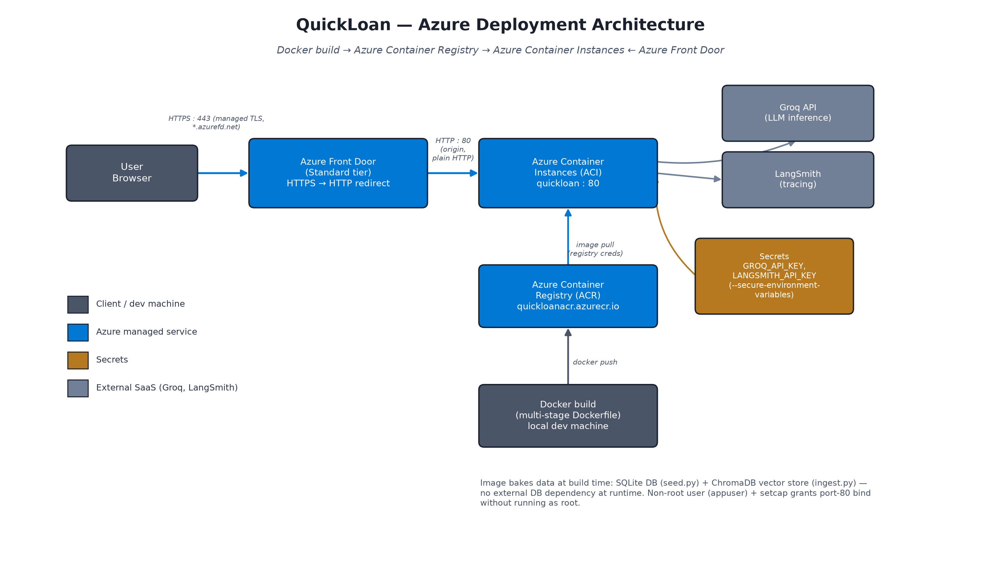
Figure 3 (repeated from HLD) — Azure deployment topology

9.1 Dockerfile — Stage by Stage
Stage | Base image | Key steps
builder | python:3.11-slim | apt: build-essential; pip install torch (CPU-only wheel) then requirements.txt, --user; pre-download the embedding model into the pip/HF cache
runtime | python:3.11-slim | apt: curl + libcap2-bin; create non-root appuser; setcap CAP_NET_BIND_SERVICE on the python3 binary; copy /root/.local and /root/.cache from builder; copy data/, run seed.py + ingest.py as appuser; copy app.py/langgraph.json/quickloan package; EXPOSE 80; HEALTHCHECK against /_stcore/health; CMD streamlit run on port 80, with --server.enableCORS=false --server.enableXsrfProtection=false (see §9.4)

9.2 Azure Resource Reference
Resource | Name used | Key settings
Resource group | quickloan-rg | Location: Central India (metadata only — does not restrict child resource regions)
Container Registry | quickloanacr (quickloanacr.azurecr.io) | SKU: Basic; admin user enabled for ACI pull credentials
Container Instance | quickloan | Image: quickloanacr.azurecr.io/quickloan:latest; 1 vCPU / 2 GiB; port 80; DNS label quickloan-app; region East US 2 (Central India's ACA quota was 0 on this subscription — ACI's own quota was checked and sufficient in East US 2)
Secrets | GROQ_API_KEY, LANGSMITH_API_KEY | Passed via --secure-environment-variables — masked in Portal/CLI, set once at container-group creation (ACI container groups are immutable — changing a secret means delete + recreate, not an in-place edit)
Front Door profile | quickloan-afd (Standard tier) | Endpoint quickloan; origin = ACI's FQDN on port 80; route forces HTTPS redirect, forwards HttpOnly to the origin

9.3 Why Azure Container Apps Was Not Used
Azure Container Apps (ACA) was the first choice — it provides automatic managed HTTPS ingress out of the box, avoiding the need for a separate Front Door resource. However, this subscription (an MSDN/Visual Studio Platforms subscription) reported a hard quota of 0 Container App Environments (MaxNumberOfGlobalEnvironmentsInSubExceeded), a known restriction on this subscription offer type for production-oriented resource types. ACI, not subject to the same restriction, was used instead, with Azure Front Door added separately to restore the managed-HTTPS capability ACA would otherwise have provided for free.

9.4 Front Door WebSocket Origin Mismatch (Post-Deployment Fix)
Symptom: the app loaded a blank page / infinite spinner through the Front Door URL in every browser tested (including fresh incognito windows in two different browsers), while the direct ACI URL worked correctly.

Diagnosis
- curl against both URLs (plain GET, both /_stcore/health and /) returned identical 200 responses with identical page sizes — ruled out a backend outage or DNS/TLS-level client network block.
- A native WebSocket test (Node's built-in WebSocket) against wss://<front-door-domain>/_stcore/stream succeeded from an isolated test environment — ruled out a Front Door route/CORS/caching misconfiguration as such.
- A full Playwright browser session against the Front Door URL reproduced the failure directly: the WebSocket handshake returned 403, followed by 502s on subsequent requests (/_stcore/host-config, /_stcore/health) once the page's own retry logic gave up.
- az container logs on the ACI instance showed the actual rejection reason: "Rejecting WebSocket connection with disallowed Origin or Host header: origin=https://<front-door-domain>, host=<aci-domain>" — Streamlit’s built-in anti cross-site-WebSocket-hijacking check, comparing the browser's Origin against the Host header the request arrived with.

Root Cause
The Front Door origin was configured with --origin-host-header pointing at the ACI hostname (quickloan-app.eastus2.azurecontainer.io), so that's the Host header Front Door forwards to the origin on every request — regardless of what public hostname the browser actually connected to. The browser's Origin header is always the page's real origin (the Front Door domain, *.azurefd.net), so the two values can never match through this proxy configuration. Plain HTTP GETs are unaffected (no origin check applies to them), which is why the initial page load always succeeded even while every WebSocket was rejected.

Fix Attempted First (Not Used)
az afd origin update --origin-host-header <front-door-domain> — makes the forwarded Host match the browser's Origin exactly. Correct in principle, but the change sat in Front Door's edge-propagation pipeline for 10+ minutes with no reliable signal to confirm when (or if) it had actually taken effect (the same deploymentStatus: NotStarted ambiguity encountered earlier when first creating the Front Door route — see the ACR/ACI/Front Door setup history). Also fragile: would need updating again if the Front Door hostname ever changed (e.g. moving to a custom domain).

Fix Shipped
Dockerfile CMD updated to launch Streamlit with --server.enableCORS=false --server.enableXsrfProtection=false, relaxing the origin check unconditionally at the application level rather than depending on what Host header any specific proxy forwards. Verified end-to-end with a Playwright script that navigates to the Front Door URL, inspects console/network/WebSocket events, and asserts the app's title renders — after rebuild, ACR push, and ACI delete+recreate, the WebSocket connected and exchanged frames successfully with zero console errors. See HLD.docx §6.4 and §9.6 for the architecture-level summary and the accepted security trade-off.

