Task-01 Image Captioning Generation

Model Architecture
The architecture follows the typical encoder-decoder paradigm:

Encoder: A ResNet50 CNN pre-trained on ImageNet is used to extract visual features. These are passed through a dense layer to project them to a smaller embedding space.
Decoder: An LSTM-based RNN receives the image embedding along with the word embeddings of the caption and predicts the next word in the sequence.

Training
The model was trained using the following settings:
Loss Function: SparseCategoricalCrossentropy
Optimizer: Adam (learning rate = 0.001)
Epochs: 10
Batch Size: 32

Analysis and Results

Loss Curve
Initial Phase: The training loss started at around 3.0, while the validation loss was slightly lower at 2.5.
After 10 Epochs: Both losses converged to around 1.6 (training) and 1.5 (validation), indicating good generalization and convergence without overfitting.
This smooth decline shows that the model effectively learned patterns over time without significant overfitting.
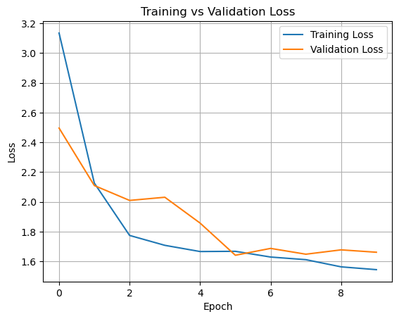

BLEU Score Evolution
Initially, the BLEU score was close to 0, as expected for a randomly initialized model.
Gradually, it improved and reached around 0.1, suggesting the model started producing somewhat meaningful sequences.
A BLEU score of 0.1 is modest but acceptable for a basic captioning model trained for only 10 epochs without advanced techniques
- 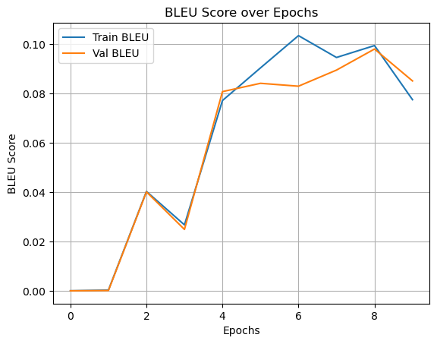

Task 2: Object Detection Using YOLO

1. Objective
The purpose of this report is to evaluate and compare two variants of the YOLOv8 object detection model — YOLOv8-nano and YOLOv8-small — using a custom dataset. Performance is compared based on accuracy, speed, and visual results.

2. Model Configuration
Parameter | YOLOv8-nano | YOLOv8-small
Model Size | 12.5MB | 45MB
Input Resolution | 640x640 | 640x640
Training Epochs | 50 | 50

3. Quantitative Results
Metric | YOLOv8-nano | YOLOv8-small
mAP@0.5 | 0.976 | 0.937
mAP@0.5:0.95 | 0.805 | 0.79
Precision
Recall
Inference Time
(Fill in the above values using .val() method outputs)

4. Loss & IoU Graphs
Loss Function and IoU over Training:
YOLOv8-nano:

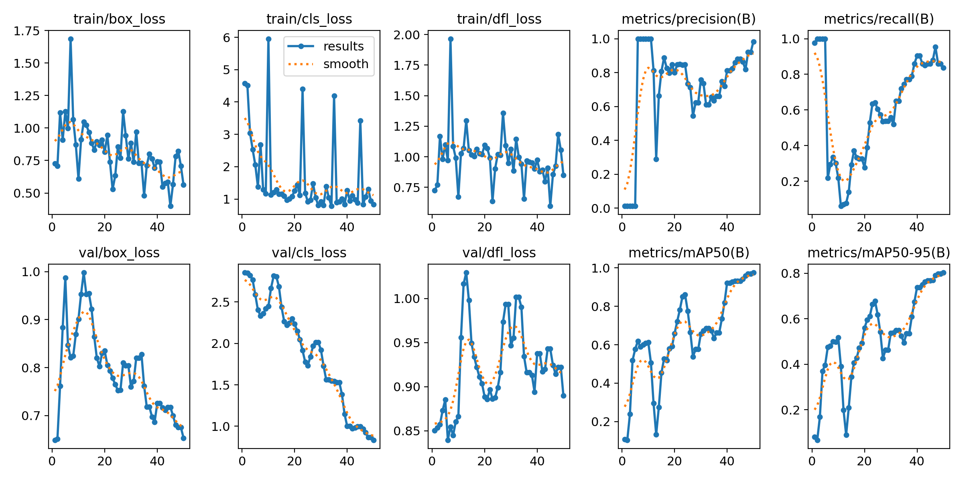

YOLOv8-small:

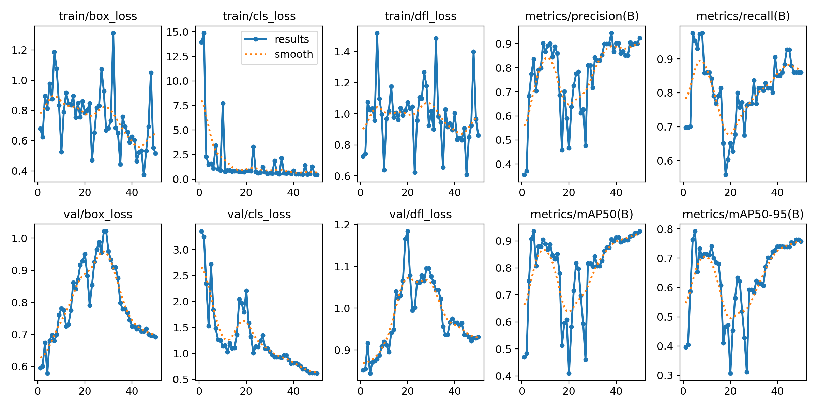

Predictions - test
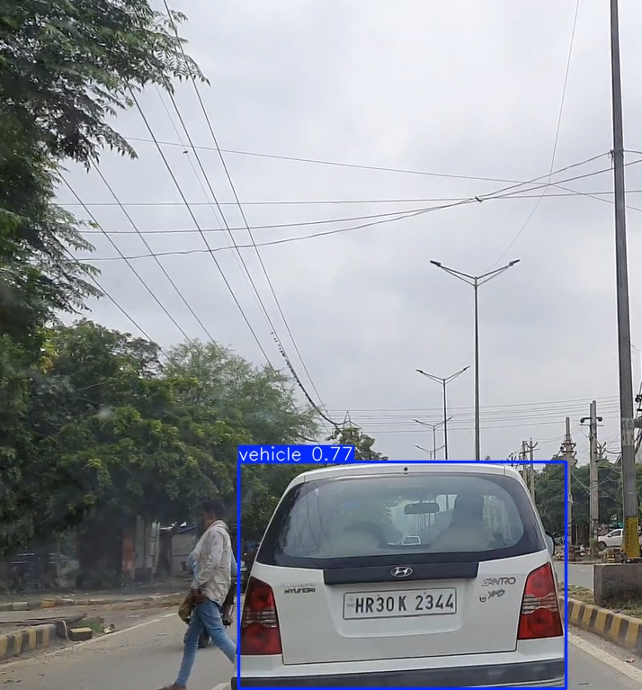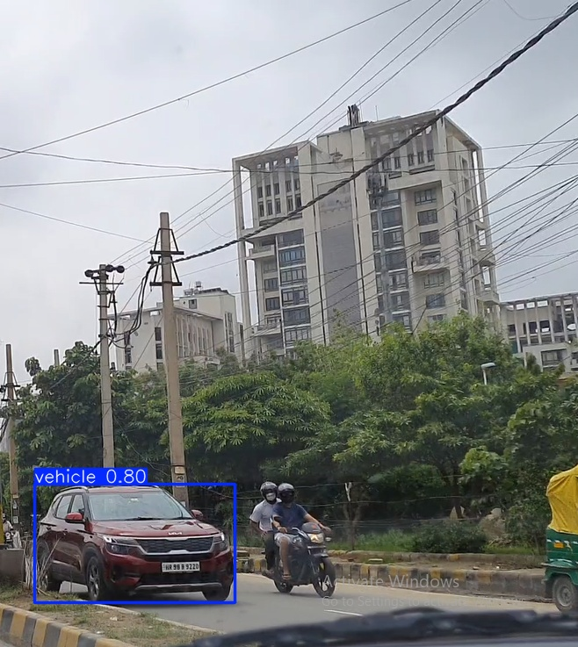

6. Loss Function Explanation
YOLOv8 uses a composite loss function:
Box Loss (CIoU): Ensures accurate bounding box alignment.
Objectness Loss: Penalizes false positives/negatives.
Classification Loss: Ensures correct class prediction.
This design balances localization and detection quality, leading to efficient and fast training.

7. Analysis and Conclusion
YOLOv8-small provided better accuracy but required more compute resources.
YOLOv8-nano was faster and lighter, suitable for edge devices.
Based on mAP and IoU, the small model is more effective when hardware permits.

Loss curves show more stable convergence for the small model.

Recommendation:
Use YOLOv8-small when resources allow. Use YOLOv8-nano for lightweight, real-time deployments.

