Muhammad Murtaza Nadeem
MSDS24040
Deep Learning
Assignment 5

Image Generation Using Diffusion models

• Trained a Diffusion model on Animal dataset for 100 epochs; loss steadily decreased during training.
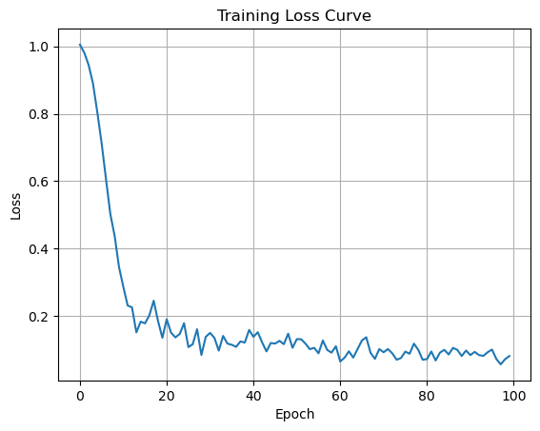
• • Faced CUDA out-of-memory issues – solved by reducing batch size and using torch.no_grad().
• • Encountered device-side assert error – fixed by restarting kernel and ensuring valid label indices.

• • Visualized noise at steps t=200, 500, 800, 999 to show gradual degradation.
• • Successfully denoised from xₜ (t=999) back to x₀ using the trained model.
• • Final outputs is still noisy, so modelarchitecture and training still have room for improvements.
•

Results:

Random noise

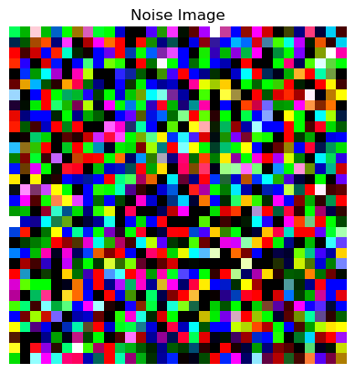

After noise removal
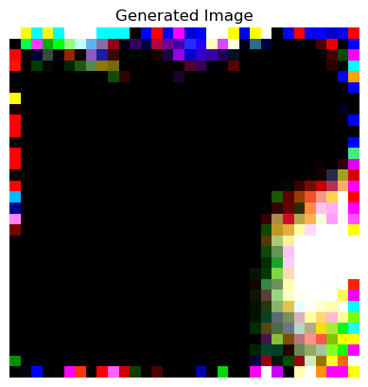

Added noise on image from dataset,

