Data Splitting was done using DF approach.
80% train size, 10% validation and 10% test

Data loader efficiently makes balanced class data

Used ADAM Optimizer for weight update

Initially I trained model for 10 epochs, and 0.01 constant lr,and saved that model, then used validation set to tune the threshold (to predict labels from eucledian distance) based on following table,

Threshold | Accuracy | Precision | Recall | F1 Score | TP | TN | FP | FN
0.50 | 68.4% | 71.2% | 66.9% | 69.0% | 321 | 305 | 130 | 159
0.51 | 69.3 | 71.3 | 69.4 | 70.3 | 333 | 301 | 134 | 147
0.52 | 69.1 | 70.4 | 70.8 | 70.6 | 340 | 292 | 143 | 140
0.55 | 69.9% | 69.1% | 77.3% | 73.0% | 371 | 269 | 166 | 109
0.60 | 69.0% | 65.8% | 85.0% | 74.2% | 408 | 223 | 212 | 72
0.62 | 69.5% | 65.6% | 88.1% | 75.2% | 423 | 213 | 222 | 57

After setting the threshold to 0.52, trained the model again for 15 epochs, dynamic LR, and calculated the desired metrics for training and testing, whose plots are available in graphs folder.

Graphs clearly shows that how on every epoch our model have learnt more features
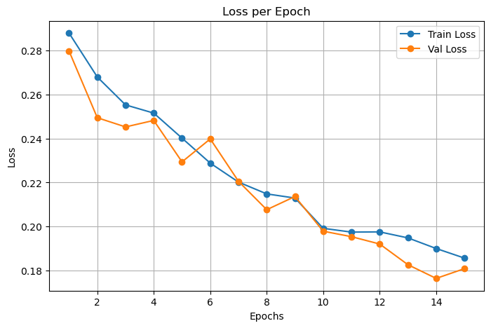
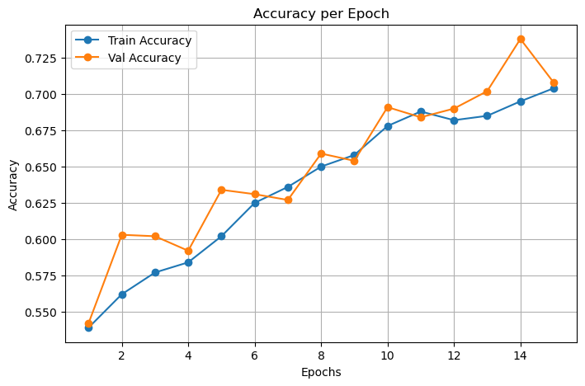
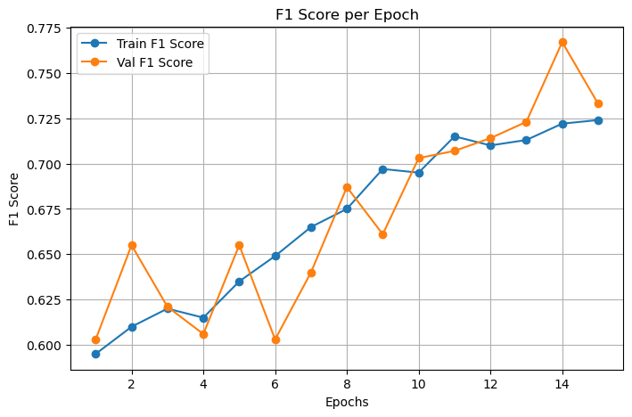
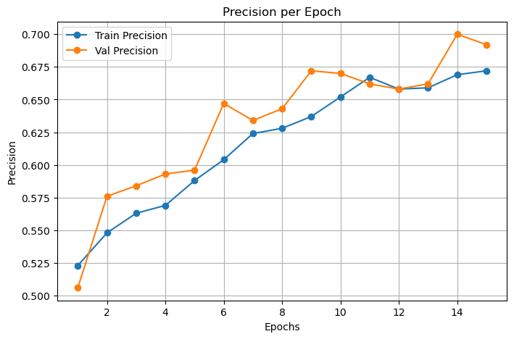
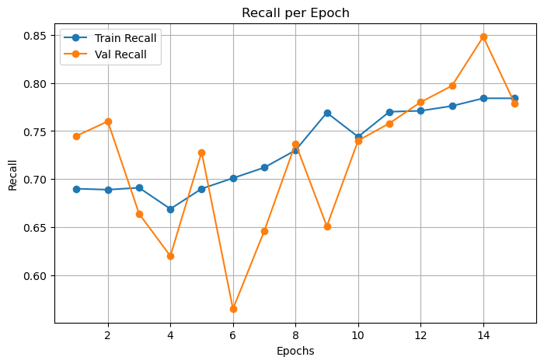
training logs shows that how our model was stuck in local minima (no reduction in loss) and then when we changed the LR, our loss starts to decrease
Test Evaluation Results:
Test Loss: 0.1934
Test Metrics: {'Accuracy': 0.686, 'Precision': 0.655, 'Recall': 0.806, 'F1 Score': 0.723, 'Confusion Matrix': {'TP': 374, 'TN': 253, 'FP': 197, 'FN': 90}}

Training LOGS:
Epoch 1/15
Train Loss: 0.2879, Val Loss: 0.2797
Training Metrics: {'Accuracy': 0.539, 'Precision': 0.523, 'Recall': 0.69, 'F1 Score': 0.595, 'Confusion Matrix': {'TP': 2479, 'TN': 1463, 'FP': 2258, 'FN': 1116}}
Validation Metrics: {'Accuracy': 0.542, 'Precision': 0.506, 'Recall': 0.745, 'F1 Score': 0.603, 'Confusion Matrix': {'TP': 318, 'TN': 178, 'FP': 310, 'FN': 109}}
Model saved!

Epoch 2/15
Train Loss: 0.2679, Val Loss: 0.2494
Training Metrics: {'Accuracy': 0.562, 'Precision': 0.548, 'Recall': 0.689, 'F1 Score': 0.61, 'Confusion Matrix': {'TP': 2509, 'TN': 1603, 'FP': 2070, 'FN': 1134}}
Validation Metrics: {'Accuracy': 0.603, 'Precision': 0.576, 'Recall': 0.76, 'F1 Score': 0.655, 'Confusion Matrix': {'TP': 345, 'TN': 207, 'FP': 254, 'FN': 109}}
Model saved!

Epoch 3/15
Train Loss: 0.2553, Val Loss: 0.2453
Training Metrics: {'Accuracy': 0.577, 'Precision': 0.563, 'Recall': 0.691, 'F1 Score': 0.62, 'Confusion Matrix': {'TP': 2528, 'TN': 1691, 'FP': 1965, 'FN': 1132}}
Validation Metrics: {'Accuracy': 0.602, 'Precision': 0.584, 'Recall': 0.664, 'F1 Score': 0.621, 'Confusion Matrix': {'TP': 299, 'TN': 252, 'FP': 213, 'FN': 151}}
Model saved!

Epoch 4/15
Train Loss: 0.2515, Val Loss: 0.2482
Training Metrics: {'Accuracy': 0.584, 'Precision': 0.569, 'Recall': 0.669, 'F1 Score': 0.615, 'Confusion Matrix': {'TP': 2426, 'TN': 1847, 'FP': 1841, 'FN': 1202}}
Validation Metrics: {'Accuracy': 0.592, 'Precision': 0.593, 'Recall': 0.62, 'F1 Score': 0.606, 'Confusion Matrix': {'TP': 287, 'TN': 255, 'FP': 197, 'FN': 176}}
Reducing LR to 0.005

Epoch 5/15
Train Loss: 0.2402, Val Loss: 0.2294
Training Metrics: {'Accuracy': 0.602, 'Precision': 0.588, 'Recall': 0.69, 'F1 Score': 0.635, 'Confusion Matrix': {'TP': 2536, 'TN': 1868, 'FP': 1774, 'FN': 1138}}
Validation Metrics: {'Accuracy': 0.634, 'Precision': 0.596, 'Recall': 0.728, 'F1 Score': 0.655, 'Confusion Matrix': {'TP': 318, 'TN': 262, 'FP': 216, 'FN': 119}}
Model saved!

Epoch 6/15
Train Loss: 0.2288, Val Loss: 0.2398
Training Metrics: {'Accuracy': 0.625, 'Precision': 0.604, 'Recall': 0.701, 'F1 Score': 0.649, 'Confusion Matrix': {'TP': 2538, 'TN': 2032, 'FP': 1665, 'FN': 1081}}
Validation Metrics: {'Accuracy': 0.631, 'Precision': 0.647, 'Recall': 0.565, 'F1 Score': 0.603, 'Confusion Matrix': {'TP': 257, 'TN': 320, 'FP': 140, 'FN': 198}}
Reducing LR to 0.0025

Epoch 7/15
Train Loss: 0.2202, Val Loss: 0.2206
Training Metrics: {'Accuracy': 0.636, 'Precision': 0.624, 'Recall': 0.712, 'F1 Score': 0.665, 'Confusion Matrix': {'TP': 2644, 'TN': 2012, 'FP': 1593, 'FN': 1067}}
Validation Metrics: {'Accuracy': 0.627, 'Precision': 0.634, 'Recall': 0.646, 'F1 Score': 0.64, 'Confusion Matrix': {'TP': 303, 'TN': 271, 'FP': 175, 'FN': 166}}
Model saved!

Epoch 8/15
Train Loss: 0.2149, Val Loss: 0.2077
Training Metrics: {'Accuracy': 0.65, 'Precision': 0.628, 'Recall': 0.73, 'F1 Score': 0.675, 'Confusion Matrix': {'TP': 2667, 'TN': 2085, 'FP': 1578, 'FN': 986}}
Validation Metrics: {'Accuracy': 0.659, 'Precision': 0.643, 'Recall': 0.737, 'F1 Score': 0.687, 'Confusion Matrix': {'TP': 342, 'TN': 261, 'FP': 190, 'FN': 122}}
Model saved!

Epoch 9/15
Train Loss: 0.2130, Val Loss: 0.2137
Training Metrics: {'Accuracy': 0.658, 'Precision': 0.637, 'Recall': 0.769, 'F1 Score': 0.697, 'Confusion Matrix': {'TP': 2870, 'TN': 1945, 'FP': 1638, 'FN': 863}}
Validation Metrics: {'Accuracy': 0.654, 'Precision': 0.672, 'Recall': 0.651, 'F1 Score': 0.661, 'Confusion Matrix': {'TP': 309, 'TN': 289, 'FP': 151, 'FN': 166}}
Reducing LR to 0.00125

Epoch 10/15
Train Loss: 0.1992, Val Loss: 0.1979
Training Metrics: {'Accuracy': 0.678, 'Precision': 0.652, 'Recall': 0.744, 'F1 Score': 0.695, 'Confusion Matrix': {'TP': 2684, 'TN': 2277, 'FP': 1432, 'FN': 923}}
Validation Metrics: {'Accuracy': 0.691, 'Precision': 0.67, 'Recall': 0.74, 'F1 Score': 0.703, 'Confusion Matrix': {'TP': 335, 'TN': 297, 'FP': 165, 'FN': 118}}
Model saved!

Epoch 11/15
Train Loss: 0.1975, Val Loss: 0.1954
Training Metrics: {'Accuracy': 0.688, 'Precision': 0.667, 'Recall': 0.77, 'F1 Score': 0.715, 'Confusion Matrix': {'TP': 2853, 'TN': 2184, 'FP': 1427, 'FN': 852}}
Validation Metrics: {'Accuracy': 0.684, 'Precision': 0.662, 'Recall': 0.758, 'F1 Score': 0.707, 'Confusion Matrix': {'TP': 348, 'TN': 278, 'FP': 178, 'FN': 111}}
Model saved!

Epoch 12/15
Train Loss: 0.1976, Val Loss: 0.1921
Training Metrics: {'Accuracy': 0.682, 'Precision': 0.658, 'Recall': 0.771, 'F1 Score': 0.71, 'Confusion Matrix': {'TP': 2851, 'TN': 2135, 'FP': 1484, 'FN': 846}}
Validation Metrics: {'Accuracy': 0.69, 'Precision': 0.658, 'Recall': 0.78, 'F1 Score': 0.714, 'Confusion Matrix': {'TP': 354, 'TN': 277, 'FP': 184, 'FN': 100}}
Model saved!

Epoch 13/15
Train Loss: 0.1949, Val Loss: 0.1827
Training Metrics: {'Accuracy': 0.685, 'Precision': 0.659, 'Recall': 0.776, 'F1 Score': 0.713, 'Confusion Matrix': {'TP': 2860, 'TN': 2150, 'FP': 1479, 'FN': 827}}
Validation Metrics: {'Accuracy': 0.702, 'Precision': 0.662, 'Recall': 0.797, 'F1 Score': 0.723, 'Confusion Matrix': {'TP': 357, 'TN': 285, 'FP': 182, 'FN': 91}}
Model saved!

Epoch 14/15
Train Loss: 0.1901, Val Loss: 0.1765
Training Metrics: {'Accuracy': 0.695, 'Precision': 0.669, 'Recall': 0.784, 'F1 Score': 0.722, 'Confusion Matrix': {'TP': 2895, 'TN': 2190, 'FP': 1434, 'FN': 797}}
Validation Metrics: {'Accuracy': 0.738, 'Precision': 0.7, 'Recall': 0.848, 'F1 Score': 0.767, 'Confusion Matrix': {'TP': 395, 'TN': 280, 'FP': 169, 'FN': 71}}
Model saved!

Epoch 15/15
Train Loss: 0.1857, Val Loss: 0.1809
Training Metrics: {'Accuracy': 0.704, 'Precision': 0.672, 'Recall': 0.784, 'F1 Score': 0.724, 'Confusion Matrix': {'TP': 2836, 'TN': 2312, 'FP': 1387, 'FN': 781}}
Validation Metrics: {'Accuracy': 0.708, 'Precision': 0.692, 'Recall': 0.779, 'F1 Score': 0.733, 'Confusion Matrix': {'TP': 367, 'TN': 281, 'FP': 163, 'FN': 104}}
Reducing LR to 0.000625

