Murtaza
MSDS24040
Assignment04

Final Report – Question Answering with Transformer

Objective
Build a Transformer-based generative model to answer questions given a title and description.
Train on a QA dataset and evaluate using loss, perplexity, and BLEU score.
Deploy the model for interactive inference.

Dataset & Preprocessing
Data includes question title, description, and answer.
Combined title + description used as input; answer as target.
Used OpenAI GPT tokenizer (AutoTokenizer).
Masked padding tokens (-100) for loss calculation.
Data split into train, validation, and test sets.
Wrapped tokenized inputs in a custom PyTorch Dataset.

Model Overview
Custom Transformer model with
2 layers, d_model = 256, 8 heads.
Learned token embeddings + positional encodings
Decoder outputs passed through a linear layer.

Training Details
Used CrossEntropyLoss (ignoring pad tokens), Adam optimizer.
CosineAnnealingLR for learning rate scheduling.
Early stopping after no improvement in val loss for 3 epochs.
Tracked metrics: train/val loss, perplexity, and BLEU.
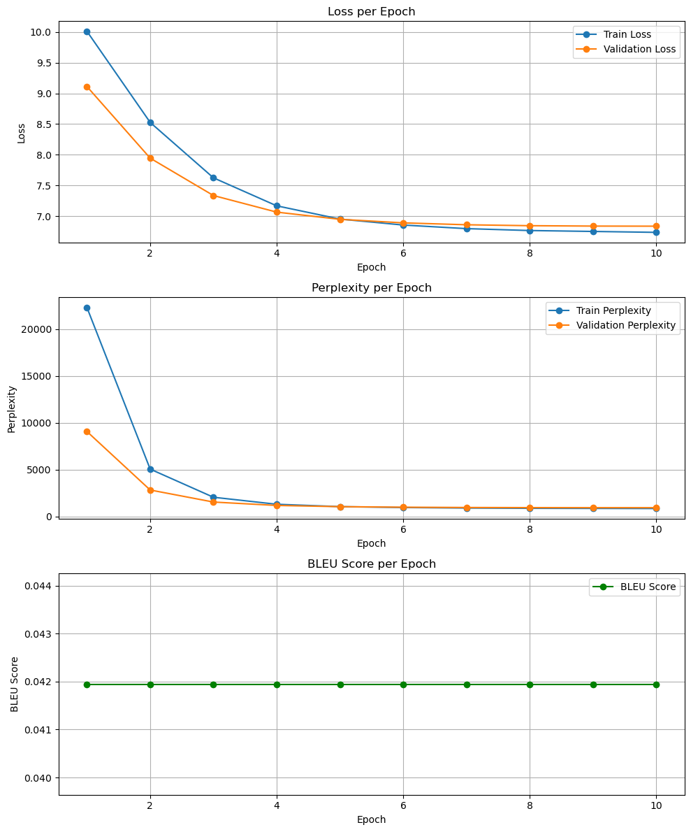

Observations
Model trained steadily; val loss decreased consistently.
Out-of-memory errors fixed by lowering batch size
Padding handling was critical.
Results could be improved as we increase the training data size

