

LEPL - Kutaisi International University

School of Computer Science

Learning Stable Hybrid ODEs for Patient-Specific Seizure Dynamics

Student name: Murtaz Babunashvili
Course: Deep Learning with Ordinary Differential Equations
Professor: Ramaz Botchorishvili

Kutaisi, Georgia
Submission Date: 9/24/2026

Abstract

This report investigates whether seizure-related EEG activity can be represented as a patient-specific continuous-time dynamical system. The proposed approach combines a reduced five-dimensional Epileptor model, which provides a mechanistic description of seizure dynamics, with a neural network that learns a residual correction to account for dynamics not captured by the mechanistic model. EEG signals are mapped between the observed multichannel space and a low-dimensional state and the state is estimated from an observed EEG prefix before the system is evolved forward in time. The resulting hybrid ordinary differential equation is used to forecast future EEG trajectories from previously observed activity.
The project uses the CHB-MIT scalp EEG dataset and evaluates the approach through long-horizon forecasting and comparisons with simpler dynamical and statistical baselines. In addition to forecasting performance, the project investigates the stability of the learned dynamical system using Lyapunov analysis and examines the hypothesis that changes in a Lyapunov-based stability measure may be associated with the approach of seizure onset. The overall goal is to connect mechanistic differential-equation modeling, neural residual learning and stability analysis in a unified framework for studying patient-specific seizure dynamics.

The project builds upon theoretical foundations from the slides used during the lectures of Deep Learning with Ordinary Differential Equations by Ramaz Botchorishvili, including ordinary differential equations, numerical integration, dynamical systems, neural ODEs and Lyapunov stability analysis.
The system was implemented in Python using libraries including PyTorch, NumPy and related scientific computing tools. This project demonstrates how differential equation based modeling and neural learning can be combined to study complex physiological dynamics.

Contents

Abstract 1
- Introduction X
- Problem Statements X
  - Existence and uniqueness of the hybrid ODE X
  - State Identification from EEG X
  - Patient specific continuous time dynamics X
  - Autonomous EEG forecasting X
  - Stability and seizure onset analysis X
- Methodology X
  - Existence and uniqueness of the hybrid ODE X
  - State identification from multichannel EEG X
  - Mechanistic and hybrid continuous time dynamics X
  - Numerical solution and autonomous EEG forecasting X
  - Lyapunov stability and seizure onset analysis X
- Implementation X
  - EEG preprocessing module X
  - Manifest and window construction X
  - Reduced Epileptor implementation X
  - Neural residual and hybrid model X
  - Observation model and state estimation X
  - Numerical rollout and training X
  - Stability analysis and evaluation scripts X
- Results X
  - Dataset and data diversity results X
  - Forecasting results X
  - Baseline and ablation results X
  - Lyapunov stability and seizure onset analysis X

- Analysis & Comparison X
  - Model architecture impact X
  - Baseline comparison X
  - Factors influencing forecasting quality X
  - Stability and seizure onset analysis X
- Conclusion X
- References X

1 Introduction

This project explores differential equation-based modeling applied to the problem of patient-specific seizure dynamics in EEG. The system processes multichannel scalp EEG recordings from the CHB-MIT dataset, where brain activity evolves continuously over time and seizure episodes exhibit complex dynamical behavior. The proposed pipeline represents EEG activity through a low-dimensional continuous time state, models its evolution using a mechanistic Epileptor system with a learned neural correction, estimates the current state from observed EEG and generates future trajectories through ODE integration.
The project connects theory to practice across several topics covered in the Deep Learning with Ordinary Differential Equations course:
- Ordinary Differential Equations – representing EEG dynamics as a continuous-time state-space system
- Numerical Integration – evolving the dynamical state forward in time to generate future trajectories
- Hybrid Neural ODEs – combining mechanistic Epileptor dynamics with a learned residual neural network
- Dynamical Systems and Stability – analyzing the behavior and stability of the learned continuous-time system
- Lyapunov Analysis – investigating whether changes in a stability measure are associated with the approach of seizure onset.

2 Problem Statements

Input Data

The dataset consists of clinical scalp EEG recordings from the CHB-MIT Scalp EEG Database. Each recording provides
- Multichannel EEG signals represented using a canonical set of 22 bipolar EEG channels
- Continuous annotated seizure onset and termination times
- Patient and recording identifiers used to construct patient-disjoint experimental splits

The recordings are divided into temporally ordered windows and labeled as interictal, preictal, ictal, or postictal according to their relation to annotated seizure events. Sampling is made denser around seizure onsets to provide more examples of seizure-related dynamics. The implementation uses separate patient groups for training, validation and testing, preventing patient overlap between the training and held-out cohorts.

2.1 Problem 1: Existence and Uniqueness of the Hybrid ODE

Motivation:
Before using a continuous-time dynamical system for state estimation and forecasting, it is necessary to establish that the corresponding initial-value problem admits a well-defined solution. In particular, the model should produce a unique trajectory for a given initial state and fixed parameters.

Data:
The hybrid system is defined by
$$\frac{dx}{dt}=f_{Epileptor}\left(x;θ_{i}\right)+g_{ϕ}\left(x\right), x\left(t_{0}\right)=x_{0},$$
Where $x∈R^{5}$ is the state, $θ_{i}$ contains patient-specific parameters and $g_{ϕ}$ is the learned neural correction. The project uses the reduced five-dimensional state
$$x=[x_{1},y_{1},z,x_{2},y_{2}]^{T}∈R^{5}$$

Goal:
Determine conditions under which the right-hand side
$$f\left(x\right)=f_{Epileptor}\left(x;θ_{i}\right)+g_{ϕ}\left(x\right)$$
is locally Lipschitz with respect to x, so that the initial-value problem has a unique local solution. The analysis connects the theoretical existence-and-uniqueness results from the differential-equations course with the hybrid dynamical system used for EEG state evolution and forecasting.

2.2 Problem 2: State Identification from EEG

Motivation:
The EEG contains 22 observed signals, while the proposed dynamical model operates in a five-dimensional state. The state at the beginning of forecasting therefore can not be observed directly and must be inferred from the available EEG prefix.

Data:
Observed EEG prefix

$$y\left(t_{k}\right)∈R^{22}, k=0,…,T_{p}$$
And a learned linear observation model

$$y\left(t\right)=μ+Hx\left(t\right),H∈R^{22×5}.$$

Goal:
Estimate the state at the forecast boundary using only the observed prefix. The implementation first obtains a ridge-regression initialization and then performs a small number of gradient-based shooting steps on the state while keeping the model parameters fixed. Future EEG samples are excluded from this estimation procedure.

2.3 Problem 3: Patient-Specific Continuous-Time Dynamics

Motivation:
Seizure activity evolves continuously and may not be fully described by a single fixed mechanistic model. A structured dynamical prior is therefore combined with a learned correction.

Data:
State
$$x=[x_{1},y_{1},z,x_{2},y_{2}]^{T}∈R^{5}$$
And patient-specific parameters
$$θ_{i}=\left(x_{0,i},I_{1,i},I_{2,i}\right).$$

Goal:
Model the evolution using the hybrid ODE
$$\frac{dx}{dt}=f_{Epileptor}\left(x;θ_{i}\right)+g_{ϕ}\left(x\right),$$
Where the reduced Epileptor provides the structured mechanistic component and $g_{ϕ}$ is shared neural residual that represents dynamics not captured by the mechanistic model.

2.4 Problem 4: Autonomous EEG Forecasting

Motivation:
Once the current state has been estimated, the future EEG is unavailable and must be generated solely from the learned dynamical system.

Data:
Boundary state $\overset{ˆ}{x}\left(t_{0}\right)$, parameter parameters $θ_{i}$ and learned hybrid vector field.

Goal:
Numerically integrate the hybrid ODE forward in time,
$${\overset{ˆ}{x}}_{k+1}={\overset{ˆ}{x}}_{k}+Δt\left[f_{Epileptor}\left({\overset{ˆ}{x}}_{k};θ_{i}\right)+g_{ϕ}\left({\overset{ˆ}{x}}_{k}\right)\right],$$

The implementation evaluates this through multi-second rollouts, with forecast error measured against the future EEG trajectory. The project identifies trajectory fidelity and long-horizon rollout as central evaluation objectives.

2.5 Problem 5: Stability and Seizure-Onset Analysis

Motivation:
Accurate trajectory prediction alone does not establish whether the learned system reproduces meaningful dynamical behavior. The project therefore investigates whether the transition toward seizure activity can be characterized through loss of local stability.

Data:
Learned trajectory $x\left(t\right)$, reference state $x^{*}$ and a positive-definite matrix $P$.

Goal:
Construct the quadratic Lyapunov candidate
$$V\left(x\right)={\left(x-x^{*}\right)}^{T}P\left(x-x^{*}\right)$$
and evaluate
$$\dot{V}\left(x\right)=2{\left(x-x^{*}\right)}^{T}P\left[f_{Epileptor}\left(x;θ_{i}\right)+g_{ϕ}\left(x\right)\right].$$
The resulting stability measure
$$S\left(t\right)=\frac{\dot{V}\left(x\left(t\right)\right)}{V\left(x\left(t\right)\right)+ϵ}$$
Is used to investigate whether a transition from negative stability margin toward $S\left(t\right)→0$ is associated with the approach of clinically annotated seizure onset. This is posed as a hypothesis to be tested rather than assumed to be true.

3 Methodology

3.1 Existence and Uniqueness of the Hybrid ODE

Following the definitions and theorems from the lectures, the dynamics are formulated as an initial value problem (IVP):
$$\dot{x}\left(t\right)=F\left(t,x\left(t\right)\right), x\left(t_{0}\right)=x_{0},$$
where $x\left(t\right)∈R^{5}$ is the state. A solution is a continuously differentiable function satisfying both the differential equation and the initial condition over the considered interval.

Existence:
Peano’s theorem states that if $F$ to be continuous in an neighborhood of the initial point, then the IVP has at least one local solution. Continuity alone, however, does not guarantee that the solution is unique. For example, $x'=x^{1/3}$, for $x\left(0\right)=0$ admits multiple solutions through the same initial point.

Uniqueness:
Picard-Lindelöf strengthens the result by requiring F to be continuous in t and Lipschitz continuous is x:
$$\left\|F\left(t,x_{1}\right)-F\left(t,x_{2}\right)\right\|≤L\left\|x_{1}-x_{2}\right\|.$$
Under this condition, the IVP has a unique local solution. A practical sufficient condition is that the Jacobian $\frac{∂F}{∂x}$ exists and is bounded locally.
For proposed model, $F\left(x\right)=f_{Epileptor}\left(x;θ_{i}\right)+g_{ϕ}\left(x\right)$, the mechanistic dynamics consist of polynomial and sigmoid nonlinearities, while the implemented residual network uses smooth Tanh activations. Thus the vector field is locally differentiable and satisfies the regularity conditions used to establish local existence and uniqueness. The analysis is local. It does not claim global existence solely from these conditions. The lecture similarly distinguishes the local guarantee from the separate question of global continuation.

3.2 State Identification from Multichannel EEG

The recorded EEG is modeled as an observation of a lower-dimensional state. For each time $t_{k}, y\left(t_{k}\right)=μ+Hx\left(t_{k}\right)$, where $y\left(t_{k}\right)∈R^{22}$ and $x\left(t_{k}\right)∈R^{5}$. $μ$ is the fixed training-set mean and $H∈R^{22×5}$ is a trainable linear observation matrix initialized from PCA.
The initial state is not obtained using a neural encoder. Instead, a ridge-regularized inverse of the observation model provides an initial estimate:
$${\overset{˜}{x}}_{0}=argmin_{x}\left\{{\left\|Hx-\left(y_{last}-μ\right)\right\|}_{2}^{2}+α{\left\|x\right\|}_{2}^{2}\right\}.$$
Let $Φ_{t}\left(x_{0}\right)$ denote the ODE trajectory generated from the candidate initial state. The state is optimized according to
$${\overset{ˆ}{x}}_{0}=argmin_{x_{0}}\frac{1}{N_{p}}\sum_{k}{{\left\|θ+HΦ_{t_{k}}\left(x_{0}\right)-y\left(t_{k}\right)\right\|}_{2}^{2}},$$
Using only the observed prefix. Model parameters are frozen during this inner optimization and the state at the end of the prefix is used as the boundary condition for forecasting. This separates state identification from future prediction and prevents future EEG observations from entering the state-estimation procedure.

3.3 Mechanistic and Hybrid Continuous-Time Dynamics

Following the neural-mass formulation used in the project presentation, seizure dynamics are represented using a reduced five-dimensional Epileptor model. The state is
$$x={\left[x_{1},y_{1},z,x_{2},y_{2}\right]}^{T}∈R^{5.}$$
The mechanistic component is $\dot{x}=f_{mech}\left(x;θ_{i}\right)$, with patient-specific parameter $θ_{i}=\left(x_{0,i}, { I}_{1,i}, I_{2,i}\right)$. The implemented equations are
$${\dot{x}}_{1}=y_{1}-f_{1}\left(x_{1}\right)-z+I_{1}, {\dot{y}}_{1}=1-5x_{1}^{2}-y_{1},$$
$$\dot{z}=\frac{4\left(x_{1}-x_{0}\right)-z}{2857}, {\dot{x}}_{2}=-y_{2}+x_{2}-x_{2}^{3}+I_{2}+0.002g\left(x_{1}\right)-0.3\left(z-3.5\right),$$
$${\dot{y}}_{2}=\frac{-y_{2}+f_{2}\left(x_{2}\right)}{10},$$
Where the nonlinear functions are
$$f\left(x_{1}\right)=3x_{1}^{3}-2x_{1}^{2},{ f}_{2}\left(x_{2}\right)=6\left(x_{2}+0.25\right)σ\left(20\left(x_{2}+0.25\right)\right),$$
$$g\left(x_{1}\right)=σ\left(10\left(x_{1}+0.5\right)\right).$$
The state components represent different dynamical timescales: $\left(x_{1},y_{1}\right)$ describe fast activity, $\left(x_{2},y_{2}\right)$ describe a slower oscillatory subsystem and z acts as a slow transition variable.
To account for dynamics not represented by the mechanistic prior, the project uses a hybrid formulation:
$$\dot{x}=f_{mech}\left(x;θ_{i}\right)+g_{ϕ}\left(x\right)$$
Where $g_{ϕ} : R^{5}→R^{5}$ is a shared neural residual. The current implementation uses a $5→128→128→5$ Tanh MLP. The mechanistic component therefore provides the structured dynamical prior, while the neural component learns a correction to model mismatch.
To prevent residual from replacing the mechanistic model, the training objective includes a residual-energy penalty:
$$L=L_{data}+λ_{R}\int{{\left\|g_{ϕ}\left(x\left(t\right)\right)\right\|}_{2}^{2}dt}.$$
The implementation evaluates this integral numerically along the predicted trajectory.

3.4 Numerical Solution and Autonomous EEG Forecasting

After estimating the state at the end of the observed prefix, the hybrid ODE is solved forward without access to future EEG measurements. The project currently uses the explicit Euler method:
$$x_{k+1}=x_{k}+Δt\left[f_{mech}\left(x_{k};θ_{i}\right)+g_{ϕ}\left(x_{k}\right)\right].$$
Starting from the estimated boundary state $\overset{ˆ}{x}\left(t_{0}\right)$, the system is repeatedly integrated to obtain the future trajectory $\overset{ˆ}{x}\left(t_{0}\right), \overset{ˆ}{x}\left(t_{1}\right), …, \overset{ˆ}{x}\left(t_{T}\right)$. Trajectory is mapped back to the EEG space using $\overset{ˆ}{y}\left(t_{k}\right)=μ+H\overset{ˆ}{x}\left(t_{k}\right)$. Forecast accuracy is measured by the mean squared error over channels and forecast time:
$$L_{forecast}=\frac{1}{22T}\sum_{c=1}^{22}{\sum_{k=1}^{T}{{\left({\overset{ˆ}{y}}_{c,k}-y_{c,k}\right)}^{2.}}}$$

3.5 Lyapunov Stability and Seizure-Onset Analysis

Following the Lyapunov stability formulation from the lectures and project presentation, the stability of the learned hybrid dynamics is analyzed around a reference state $x^{*}$. A quadratic Lyapunov candidate and derivative along a trajectory are defined as
$$V\left(x\right)={\left(x-x^{*}\right)}^{T}P\left(x-x^{*}\right), P>0.$$
$$\dot{V}\left(x\right)=2{\left(x-x^{*}\right)}^{T}P\left[f_{mech}\left(x;θ_{i}\right)+g_{ϕ}\left(x\right)\right].$$
If $\dot{V}<0$, the candidate Lyapunov energy decreases locally, indicating decay of perturbations. Loss of this negative condition provides a candidate indication of loss of local stability.

For the learned system, the stability measure proposed in the project is $S\left(t\right)=\frac{\dot{V}\left(x\left(t\right)\right)}{V\left(x\left(t\right)\right)+ϵ}$ where $ϵ>0$ prevents numerical division by zero. The intended interpretation is S(t) < 0 for a locally decreasing Lyapunov quantity, followed by $S\left(t\right)→0$ as the stability margin shrinks. The stability extension also parameterizes P as $P=LL^{T}+ϵI$, which guarantees positive definiteness. The current implementation uses trace normalization to remove the trivial scale degree of freedom and applies a penalty to positive $\dot{V}$ values on interictal trajectories:
$$L_{Lyap}=λ_{L}mean\left[max\left(0,\dot{V}+γ\right)\right].$$

4 Implementation

The proposed system was implemented in Python as a modular pipeline separating data processing, experimental models, numerical integration, evaluation and training. The implementation uses PyTorch for differentiable dynamical modeling and optimization, together with NumPy and scientific Python utilities for EEG preprocessing and dataset construction. Only the key implementation components are presented below.

4.1 EEG Preprocessing Module (preprocessing.py)

The preprocessing module converts the original clinical EEG recordings into the normalized signals used by the dynamical model. The main operations include bandpass filtering, resampling, per-channel standardization and amplitude clipping.

The processing pipeline is implemented through functions such as:

data = bandpass_filter(data, sfreq, low, high)
data = notch_filter(data, sfreq, 60.0)
data, sfreq = resample(data, sfreq, target_fs)
data = zscore_per_channel(data)
data = clip_outliers(data, thresh=8.0)

The preprocessing is performed before the signals are divided into forecasting windows.

4.2 Manifest and Window Construction (manifest.py, windowing.py)

The manifest module builds a structured description of the available CHB-MIT recordings and their clinically annotated seizure intervals. The windowing module then converts continuous recordings into fixed-duration temporal samples.
Each generated window stores information including:

{
"patient_id": ...,
"recording_id": ...,
"start_sec": ...,
"end_sec": ...,
"kind": ...,
"seizures": ...
}

Windows are labeled according to their temporal relation to annotated seizure events. Seizure-related regions are sampled more densely, while interictal regions use larger temporal spacing. As a result, the following windows are divided into patient-disjoint training, validation and test sets.

4.3 Reduced Epileptor Implementation (mechanistic.py)

The mechanistic dynamics are implemented in the ReducedEpileptor class. The module directly evaluates the five-dimensional vector field

x1, y1, z, x2, y2 = x.unbind(dim=-1)

dx1 = y1 - f1(x1) - z + I1
dy1 = y0 - 5.0 * x1**2 - y1
dz = (4.0 * (x1 - x0) - z) / tau0
dx2 = -y2 + x2 - x2**3 + I2 \
+ 0.002 * g(x1) - 0.3 * (z - 3.5)
dy2 = (-y2 + f2(x2)) / tau2

The patient specific parameters $x_{0}, I_{1}, I_{2}$ are supplied by the PatientParameters module.

4.4 Neural Residual and Hybrid Model (common.py, hybrid.py)

The only neural component of the main model is the residual vector field $g_{ϕ} : R^{5}→R^{5}$. It is implemented as a multilayer perceptron.

ResidualMLP(
hidden=128,
n_layers=2,
activation="tanh"
)

The hybrid model combines this learned correction with the mechanistic field:

return self.mech(x, theta) + self.residual(x)

Thus the implemented dynamics are $\dot{x}=$ $f_{Epileptor}\left(x;θ_{i}\right)+g_{ϕ}\left(x\right)$. The project also provides separate MechanisticODE and NeuralODE implementations.

4.5 Observation Model and State Estimation (common.py)

The observed EEG is reconstructed from the five-dimensional state using the trainable linear observation operator

return self.mu + x @ self.matrix().T

corresponding to $\overset{ˆ}{y}=μ+Hx$, $H∈R^{22×5}$.
The initial state is estimated without a neural encoder. A ridge-regression solution provides an initial guess:

x = torch.linalg.solve(A, b).T

followed by a small number of gradient-based state optimization steps using only the observed prefix. The implementation explicitly freezes model parameters during this inner optimization and returns the state at the end of the prefix as the starting point for forecasting.

4.6 Numerical Rollout and Training (common.py, main.py)

The continuous-time system is numerically evolved using explicit Euler integration:

x = x + dt * dx

The rollout function returns the trajectory for the required number of integration steps. Training combines the future trajectory reconstruction loss with the residual energy regularization:

$$L=L_{forecast}+λ_{R}Δt\sum_{k}{{\left\|g_{ϕ}\left(x_{k}\right)\right\|}_{2}^{2}}.$$

4.7 Stability Analysis and Evaluation Scripts

The Lyapunov extension is isolated in hybrid_lyapunov.py, leaving the main hybrid model unchanged. The matrix P is parametrized as $P=LL^{T}+ϵI$ to guarantee positive definiteness. The lyapunov_onset.py script evaluates
$$V\left(x\right), \dot{V}\left(x\right), S\left(t\right)=\frac{\dot{V}\left(x\left(t\right)\right)}{V\left(x\left(t\right)\right)+ϵ}$$
And performs the seizure-onset statistical analysis.

The eval_test.py script provides a common held-out evaluation protocol for the mechanistic, pure-neural and hybrid models, reporting MSE, RMSE, per-patient results, per-kind results, per-channel error, correlation and persistence performance.

Overall, the implementation is organized so that the scientific model components are separated from the shared numerical and data-processing infrastructure, allowing different dynamical hypotheses to be evaluated using the same forecasting and evaluation pipeline.

5 Results

5.1 Dataset and Data Diversity Results

The final training set used for the forecasting experiments contains 49,642 windows extracted from 510 EEG recordings belonging to 18 training patients and covering 135 annotated seizure episodes. The selected training windows consist of 40,764 interictal, 3,294 preictal, 2,388 ictal and 3,196 postictal samples. The validation set contains 120 windows, equally distributed across the major phases with 48 interictal, 48 preictal, 12 ictal and 12 postictal windows. The held-out test set contains 300 windows from three completely unseen patients, chb05, chb22 and chb24.

The temporal sampling procedure was also designed to reduce excessive duplication between neighboring windows. The diversity probe identified 135 distinct seizure episodes and 510 recordings. Among the examined neighboring samples, 399 pairs had temporal separation below 30s and all such closely spaced pairs were ictal-ictal. Preictal samples were distributed across different distances from seizure onset, with distance to onset quartiles of 105s, 120s and 180s.
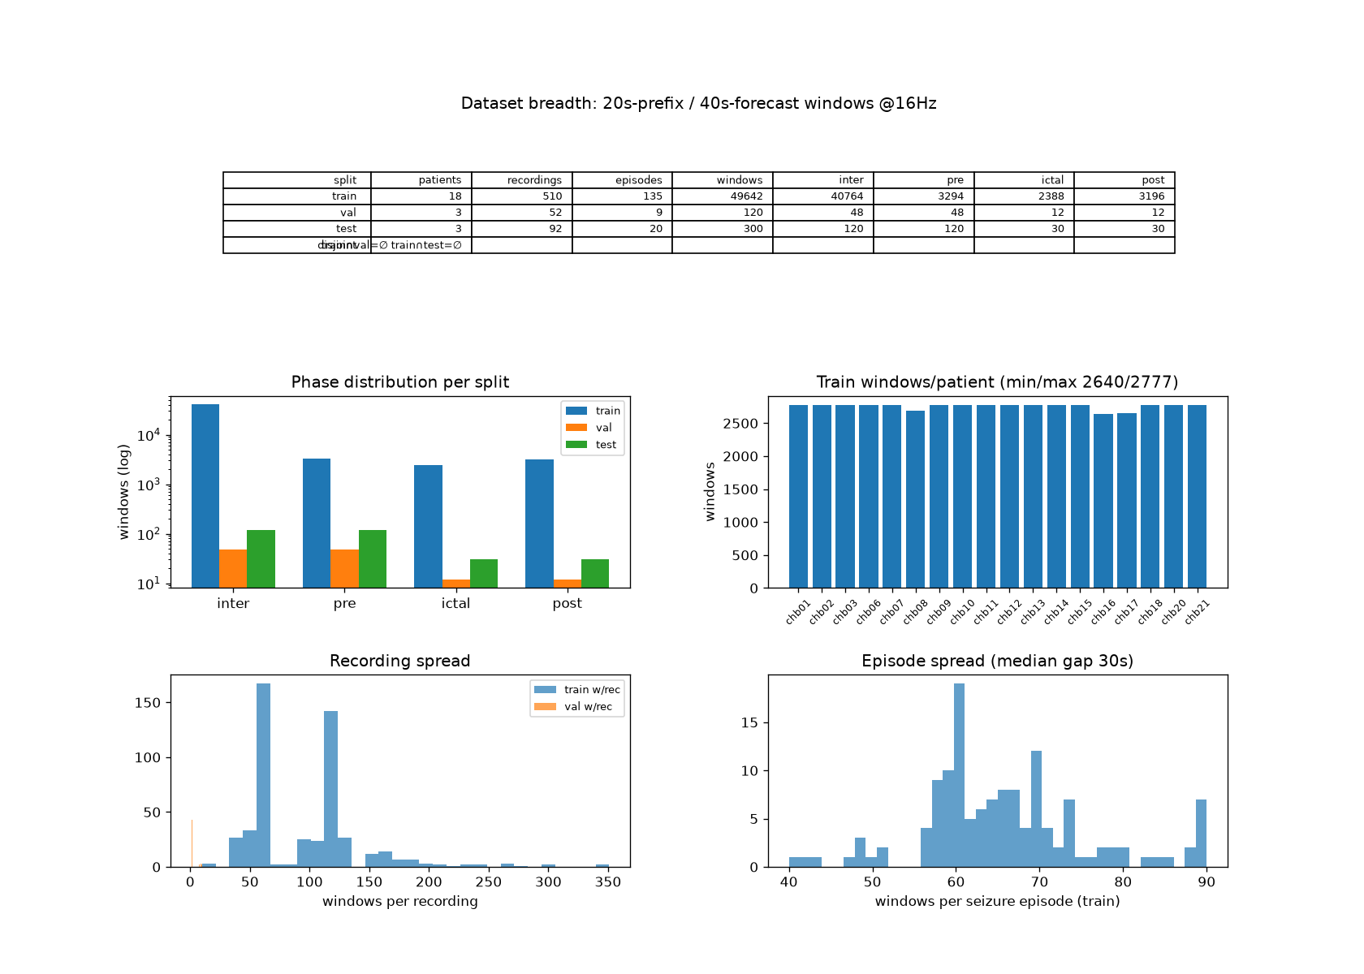
Figure 1: Dataset breadth and distribution for the 20s prefix / 40s forecast setting at 16 Hz. The figure summarizes the patient-, recording- and seizure episode coverage of the training, validation and test sets, together with the distribution of windows across EEG phases, the number of training windows per patient, the number of windows per recording and the number of windows sampled per seizure episode.

Overall, the resulting dataset provides broad coverage across patients, recordings and seizure episodes while preserving additional sampling around seizure related activity.

5.2 Forecasting Results

The proposed hybrid model was trained as a continuous-time dynamical system consisting of the five-dimensional reduced Epileptor model and a learned residual neural field. The main long horizon configuration used a 20s observed prefix followed by a 40s forecast.

Training Behavior
Figure 2 shows the evolution of the training and validation losses during optimization. The validation MSE decreases continuously from approximately 1.06 at the beginning of the reported run to approximately 0.68 after continued training. The decrease was accompanied by a corresponding reduction in the training forecast loss, without a divergence in which training error continued to decrease while validation error deteriorated.

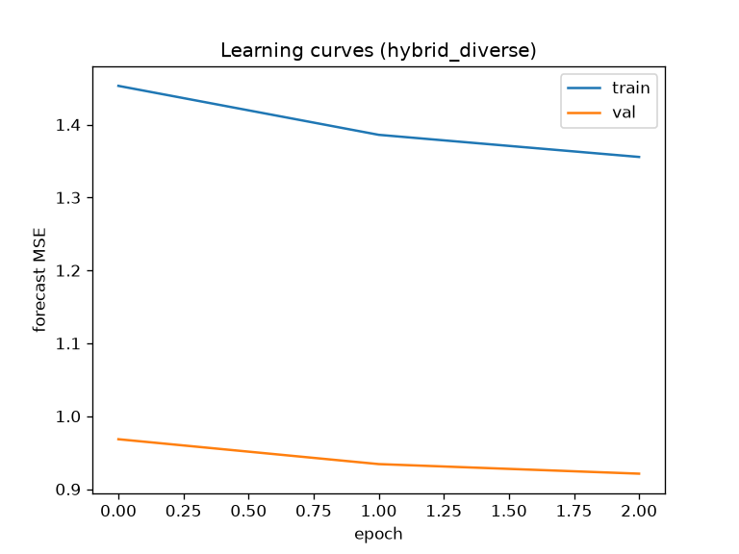 | 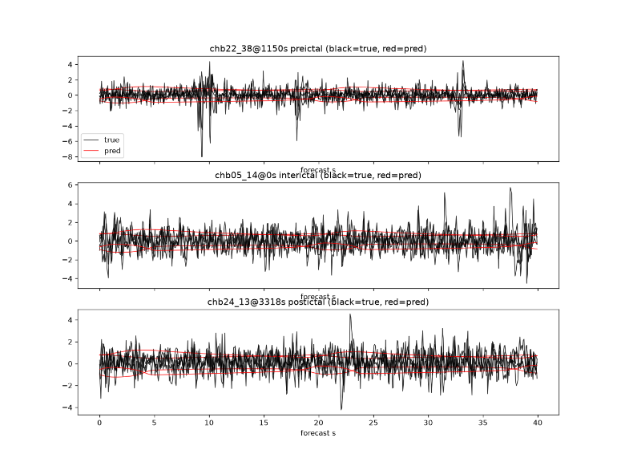
Figure 2-3: Training and validation forecasting MSE of the hybrid model over the first three training epochs for the 20s prefix / 40s forecasting setting. Both losses decrease during optimization, indicating progressive improvement in trajectory fitting. Second figure shows representative 40 second EEG forecasts on held-out patients. True EEG trajectories are shown in black and model predictions in red for preictal (chb22), interictal (chb05) and postictal (chb24) examples.

The learned residual remained relatively small compared with the mechanistic vector field throughout training. In the later stages of the reported run, the ratio $\frac{\left\|g_{ϕ}\right\|}{\left\|f_{mech}\right\|}$ remained close to 0.04, indicating that the neural component acted primarily as a correction to the mechanistic dynamics rather than replacing the mechanistic vector field.

Training Behavior
Figure 3 compares the predicted and reference EEG trajectories over the 40s forecasting interval. The predictions reproduce parts of the broad temporal structure and amplitude behavior of the signals, but are substantially smoother than the reference EEG. High-frequency fluctuations and individual waveform variations are not reproduced consistently.

Therefore, the forecasting result should be interpreted primarily as long-horizon dynamical trajectory modeling, rather than point by point reconstruction of the full high-frequency EEG waveform.

5.3 Baseline and Ablation Results

To evaluate the contribution of the learned dynamics, the mechanistic, pure-neural, hybrid and persistence models were evaluated using the same 300 held-out test windows, the same 20s $→$ 40s forecasting task and same unseen patients, chb05, chb22 and chb24.

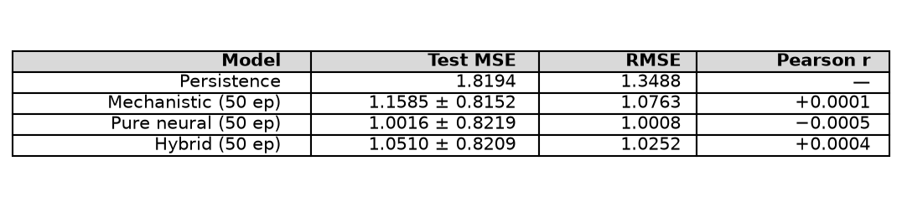
Table 1: Held-out test performance of the mechanistic, pure neural and hybrid models on 300 windows from the unseen patients using the 20s prefix / 40s forecast protocol. The table reports test MSE, RMSE and Pearson correlation with MSE variability shown for the learned models. Persistence is included as the reference baseline.

The mechanistic model improves over persistence, reducing the test MSE from 1.8194 to 1.1585. The pure neural model further reduces the MSE to 1.0016. The hybrid model achieves a test MSE of 1.0510, which is also substantially below persistence but is slightly higher than pure-neural baseline on this particular held-out test set.

Per-patient performance
For the mechanistic model, the test MSEs were:
$$chb05=1.027, chb22=1.203, chb24=1.237.$$
For the pure neural model:
$$chb05=0.860, chb22=1.044, chb24=1.088.$$
For the hybrid model:
$$chb05=0.912, chb22=1.096, chb24=1.134.$$

The per-patient variation demonstrates that generalization performance differs across unseen subjects.

Per-phase performance
The mechanistic model obtained:
$$\text{interictal}=1.092, \text{preictal}=0.874, \text{postictal}=1.220, \text{ictal}=2.501.$$
The pure neural model obtained:
$$\text{interictal}=0.926, \text{preictal}=0.719, \text{postictal}=1.073, \text{ictal}=2.362.$$

The hybrid model obtained:
$$\text{interictal}=0.979, \text{preictal}=0.764, \text{postictal}=1.129, \text{ictal}=2.410.$$

The highest forecasting error occurred during the ictal phase for all models. This indicates that the most dynamically complex seizure period signals remain substantially more difficult to reproduce than interictal or preictal activity.

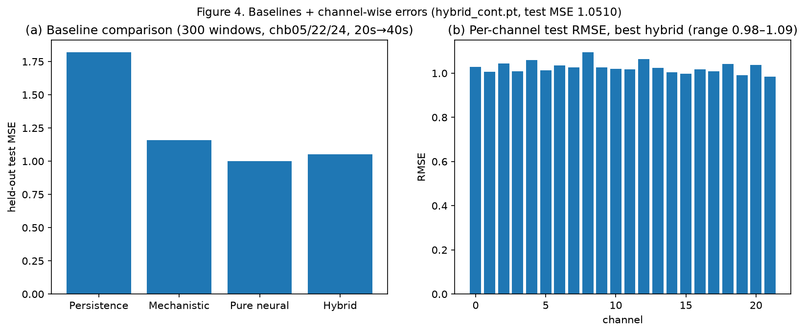
Figure 4 summarizes the baseline comparison along with the per-channel test errors. The channel-wise RMSE remained approximately within the range 0.98-1.09, with no channel exhibiting a clear systematic failure or a dominant predictive advantage.

5.4 Lyapunov Stability and Seizure onset Analysis

The stability experiment evaluates the hybrid latent dynamics using the quadratic Lyapunov candidate
$$V\left(x\right)={\left(x-x^{*}\right)}^{T}P\left(x-x^{*}\right),$$
With the corresponding derivative
$$\dot{V}\left(x\right)=2{\left(x-x^{*}\right)}^{T}P\left[f_{mech}\left(x;θ\right)+g_{ϕ}\left(x\right)\right].$$
The normalized stability measure is $S\left(t\right)=\frac{\dot{V}\left(x\left(t\right)\right)}{V\left(x\left(t\right)\right)+ϵ}$. Approximate numerical equilibria were obtained for the evaluated patients, with equilibrium residuals $\left\|F\left(x^{*}\right)\right\|$ between 0.040 and 0.081.
For the seizure onset analysis, S(t) was compared between 217,728 preictal and 368,640 interictal samples. The median values were $median\left(S_{preictal}\right)=-0.048, median\left(S_{interictal}\right)=-0.026$. The fractions with S < 0 were 0.727 and 0.720, respectively. The preictal distribution was therefore slightly more negative rather than approaching zero. Thus $S\left(t\right)→0$ precedes seizure onset is not supported by the current model.

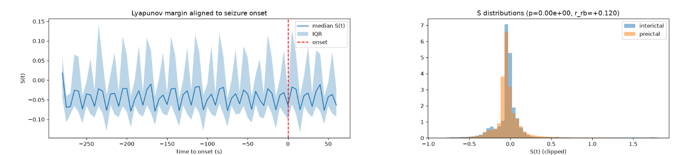
Figure 5: Lyapunov stability measure S(t) aligned to clinically annotated seizure onset. The left panel shows the median S(t) with interquartile range (IQR) before and after onset, while the right panel compares the S(t) distributions for interictal and preictal samples. No systematic transition of S(t) toward zero is observed before seizure onset.

6 Analysis & Comparison

6.1 Model Architecture Impact

The three learned formulations showed different behavior on the held-out test set. The mechanistic model achieved a test MSE of 1.1585, while the pure neural model reduced it to 1.0016. The hybrid model achieved 1.0510. Thus, although the hybrid formulation combines the structured Epileptor dynamics with a learned residual, its benefit depends strongly on sufficient training and does not automatically translate into better hend-out performance.

6.2 Baseline Comparison

Persistence produced the highest error, with MSE = 1.8194. Thehybrid model reduced the error to $1.0510±0.8209$, corresponding to about a 42% reduction relative to persistence. The pure neural model achieved $1.0016±0.8219$. Therefore, the hybrid model provides a substantial improvement over both persistence and the purely mechanistic system, while remaining close to the pure neural benchmark.

6.3 Factors Influencing Forecasting Quality

Forecasting quality was affected by context length, forecast horizon, sampling rate and patient diversity. Longer observed prefixes provide more information for estimating the state, while longer rollouts place greater demands on the learned dynamics. Increasing the sampling rate substantially increases the number of ODE integration steps. The difference between validation and unseen-patient test performance also demonstrates the importance of cross-patient generalization.

6.4 Stability and Seizure Onset Analysis

The Lyapunov experiment did not support an hypothesis that $S\left(t\right)→0$ systematically precedes seizure onset. The preictal and interictal distributions were similar, with median values of -0.048 and -0.026. Thus, under the tested Lyapunov construction, no clear stability-transition pattern was observed.

7 Conclusion

This project investigated patient-specific seizure dynamics by combining continuous-time differential-equation modeling with neural residual learning. The main goal was to represent multichannel EEG activity as a low-dimensional dynamical system and evaluate whether the learned system can generate future trajectories. A reduced five-dimensional Epileptor model was combined with a neural residual correction, with patient specific parameters and a learned observation model connecting the state to the EEG signals.

The experiment showed that the learned dynamical models provided substantial improvement over the persistence baseline. On the held-out test set, the hybrid model achieved an MSE of $1.0510±0.8209$, compared with 1.8194 for persistence and $1.1585±0.8152$ for the mechanistic model. The hybrid model therefore improved the mechanistic dynamics while retaining the structured Epileptor prior.

The long horizon experiments demonstrated that the model can generate forecasts for tens of seconds, while the horizon and context experiments showed that forecasting behavior depends strongly on the amount of observed history, sampling rate and rollout duration. The held-out patient experiments also showed that generalization to unseen patients remain more difficult than validation on the training cohort.

Lessons Learned

The first important lesson is that ODE theory provides the foundation for the learned dynamical system. Existence and uniqueness conditions clarify when an initial state determines a well-defined trajectory, while numerical integration makes this continuous-time formulation computationally usable.

The second lesson is that a mechanistic prior and a neural network can complement each other. The Epileptor provides structured dynamics, while the residual network learns corrections to model mismatch.

The third lesson is that forecasting accuracy alone is not sufficient to evaluate a dynamical model. Long horizon rollouts, cross patient testing, per-channel behavior and stability analysis reveal properties that cannot be captured by a single MSE value.

The final lesson is that model performance depends strongly on the experimental pipeline. Context length, sampling rate, data diversity, state estimation, training strategy and evaluation protocol all influence the observed behavior.

Overall Assessment

Overall, the project demonstrates how differential equations, numerical integration, neural networks and dynamical systems analysis can be combined in a single EEG modeling pipeline. It also shows that a successful continuous time model requires not only an appropriate mathematical formulation, but careful design of the data, state representation, training procedure and evaluation methodology.

8 References

- R. Botchorishvili, Deep Learning with Ordinary Differential Equations: Course Materials, Kutaisi International University, 2026.
- J. Guttag, “CHB-MIT Scalp EEG Database (version 1.0.0),” PhysioNet, 2010, RRID:SCR_007345, doi: 10.13026/C2K01R.
- A. Shoeb, Application of Machine Learning to Epileptic Seizure Onset Detection and Treatment, PhD Thesis, Massachusetts Institute of Technology, 2009.
- V. K. Jirsa, W. C. Stacey, P. S. Quilichini, A. I. Ivanov, and C. Bernard, “On the nature of seizure dynamics,” Brain, vol. 137, no. 8, pp. 2210–2230, 2014, doi: 10.1093/brain/awu133.
- T. Proix, V. K. Jirsa, F. Bartolomei, M. Guye, and W. Truccolo, “Predicting the spatiotemporal diversity of seizure propagation and termination in human focal epilepsy,” Nature Communications, vol. 9, article 1088, 2018, doi: 10.1038/s41467-018-02973-y.

