PA4
Syed Muhammad Murtaza Hassan
2027-10-0214

Task 1:
Forked GitHub Repo:
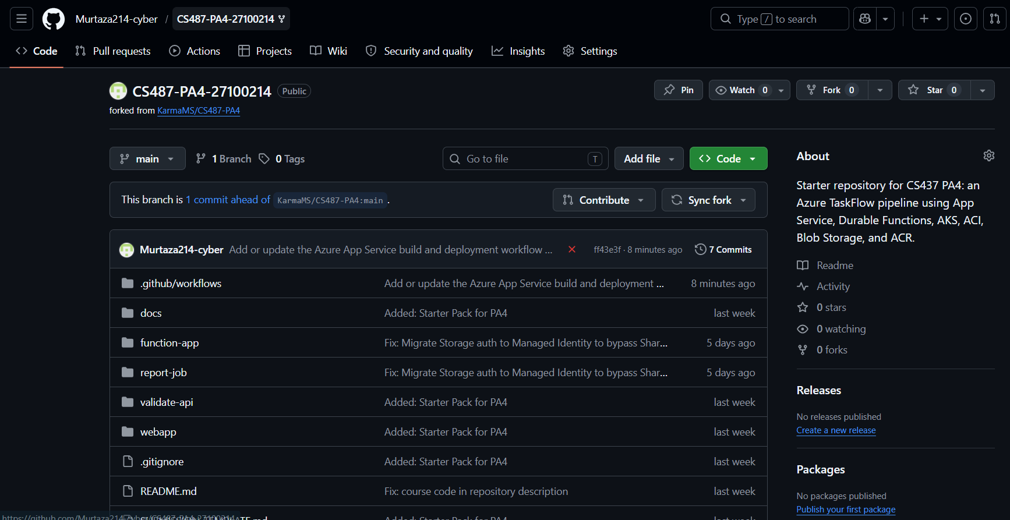
Screenshot of Web App overview showing Running status:
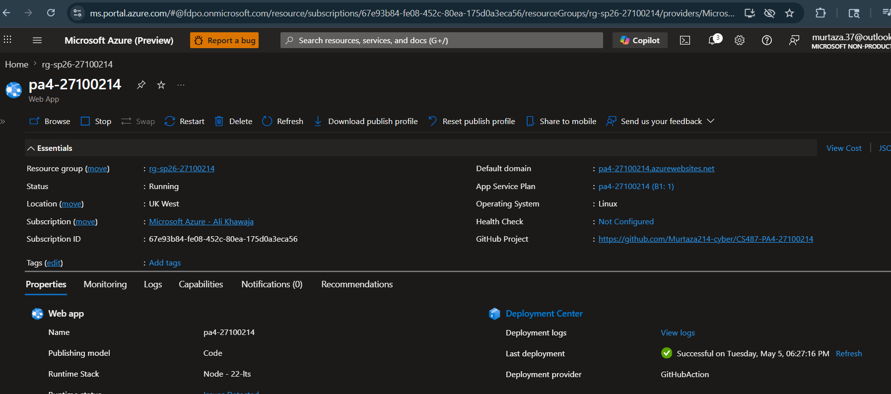
Screenshot of Deployment Center showing GitHub configuration:
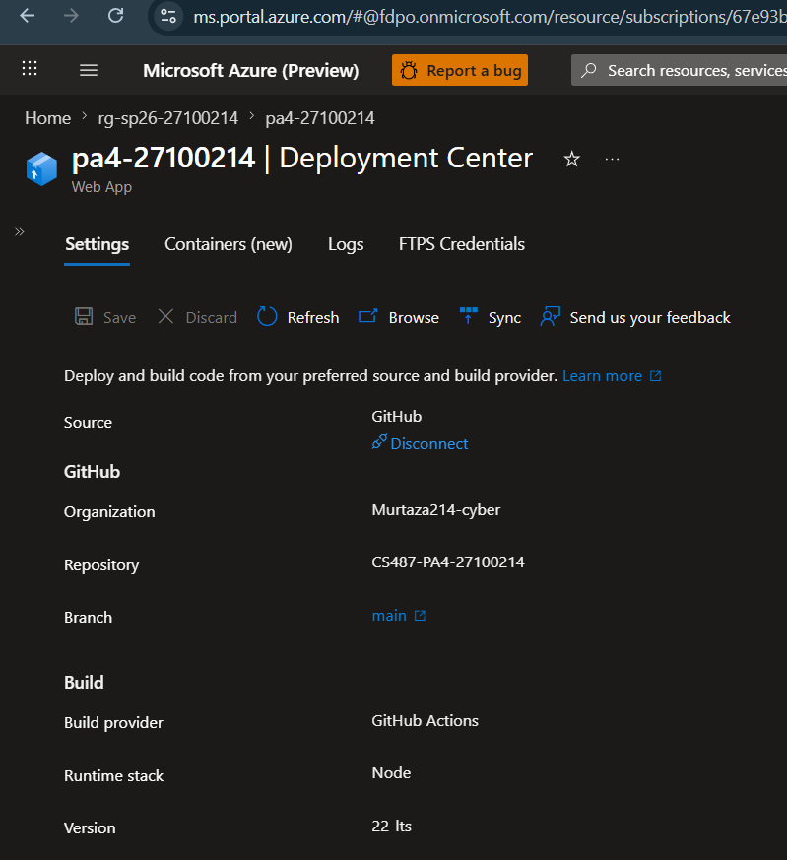
Screenshot of the dashboard loading in a browser:
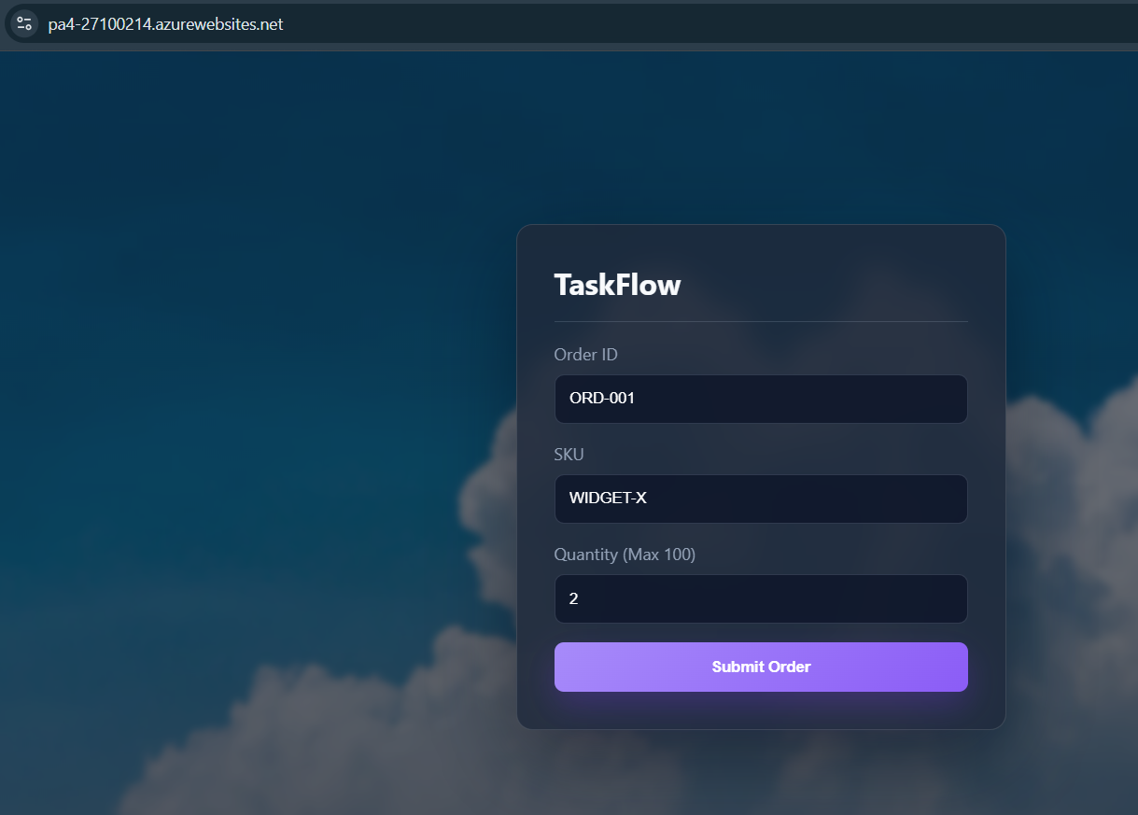
Screenshot of Application Settings configured:
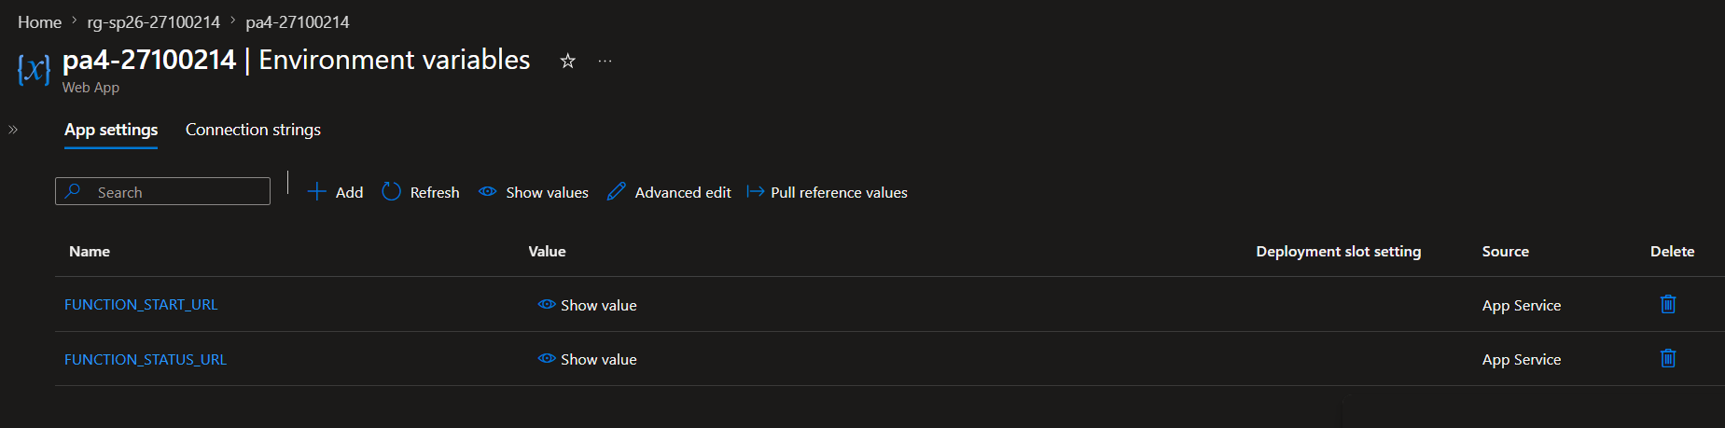
Task 2:
Screenshot of ACR overview in the portal showing Succeeded:
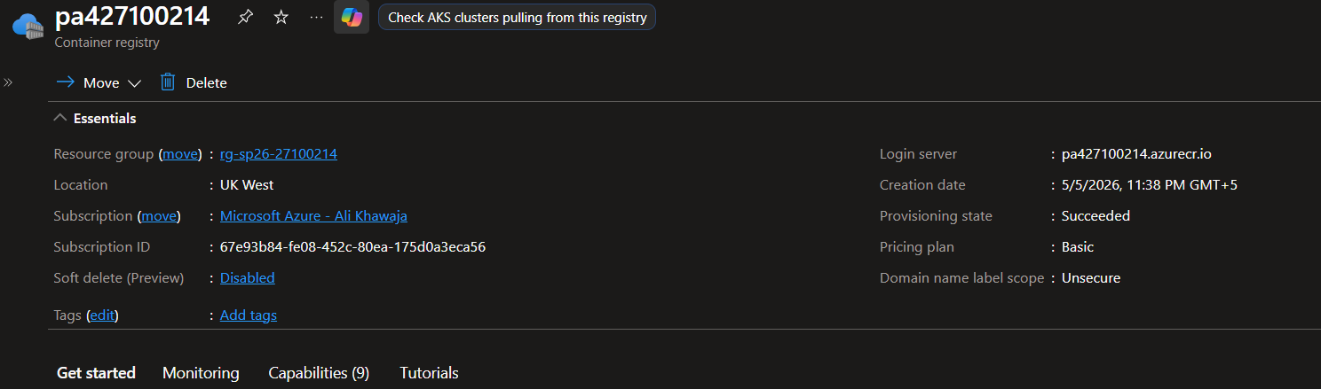
Screenshot of successful Docker builds for all three images:
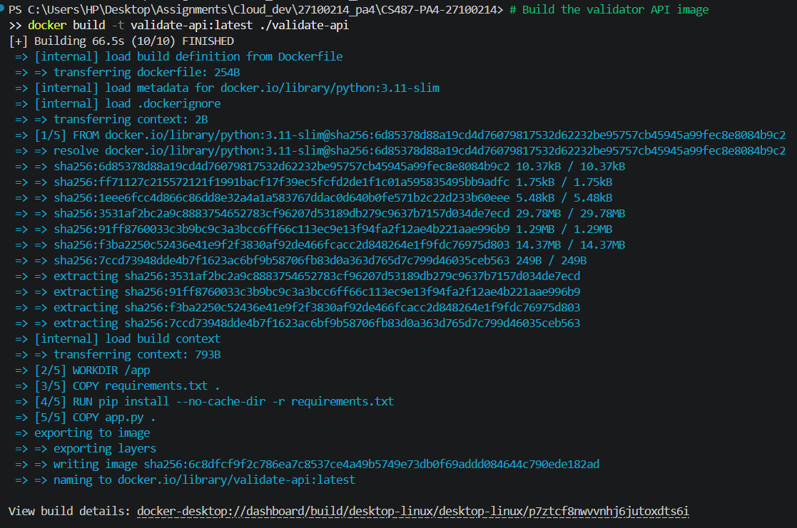
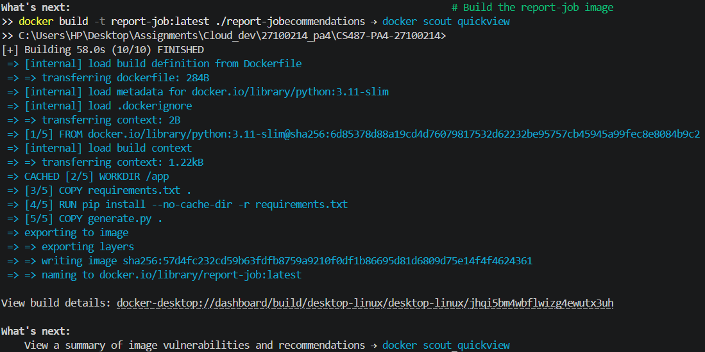
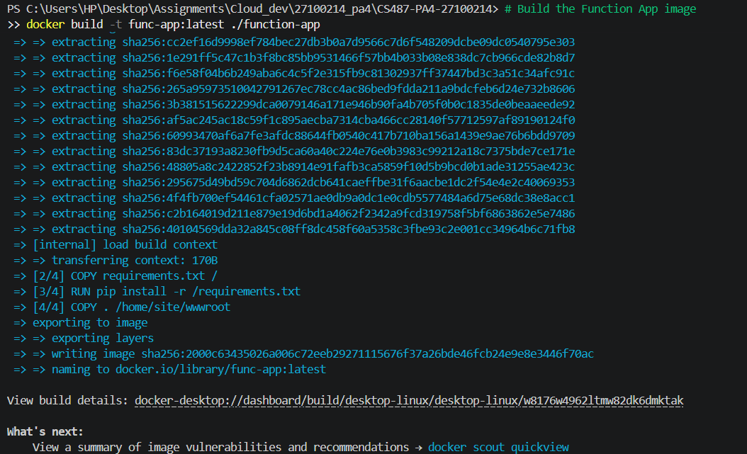
Screenshot of local test of the validator (POST /validate returning JSON)Screenshot of local test of the validator (POST /validate returning JSON):
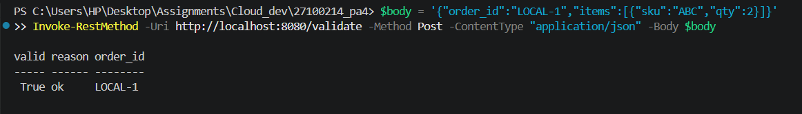
Screenshot of successful pushes to ACR for all three images:
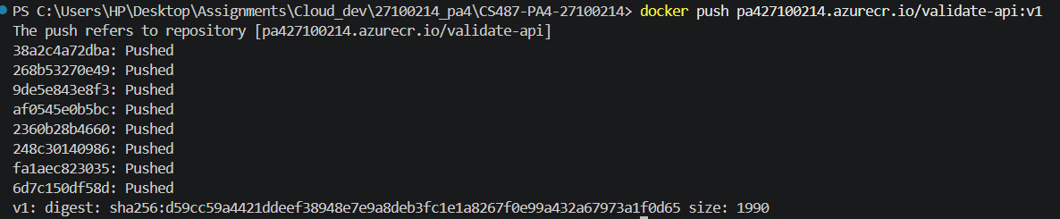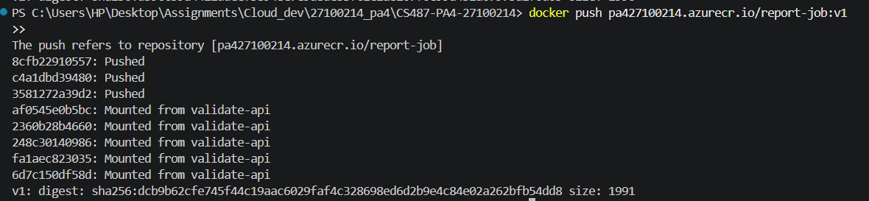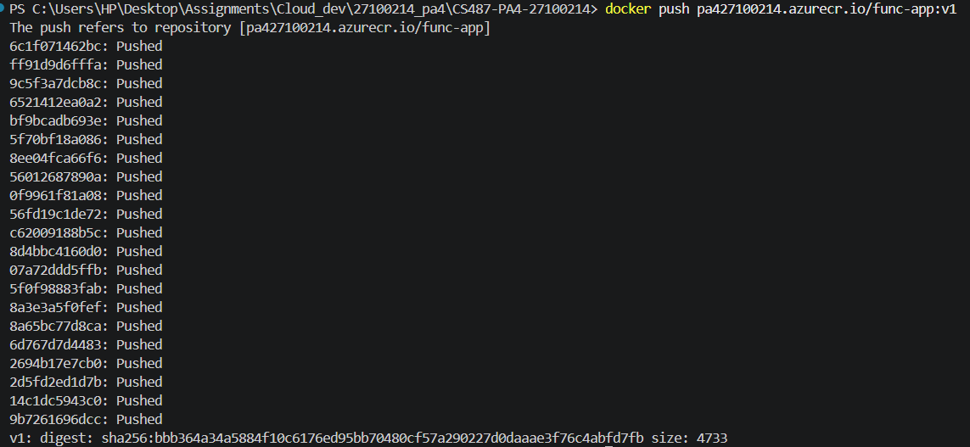
Screenshot of ACR repository list showing validate-api, report-job, and func-app:
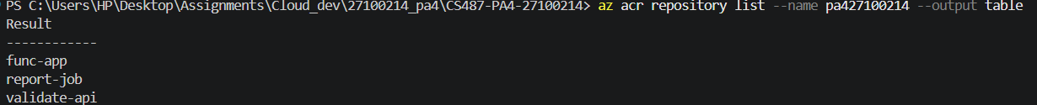

Task 3:
Task 4:
Screenshot of Function App in Azure Portal showing the container image configuration:
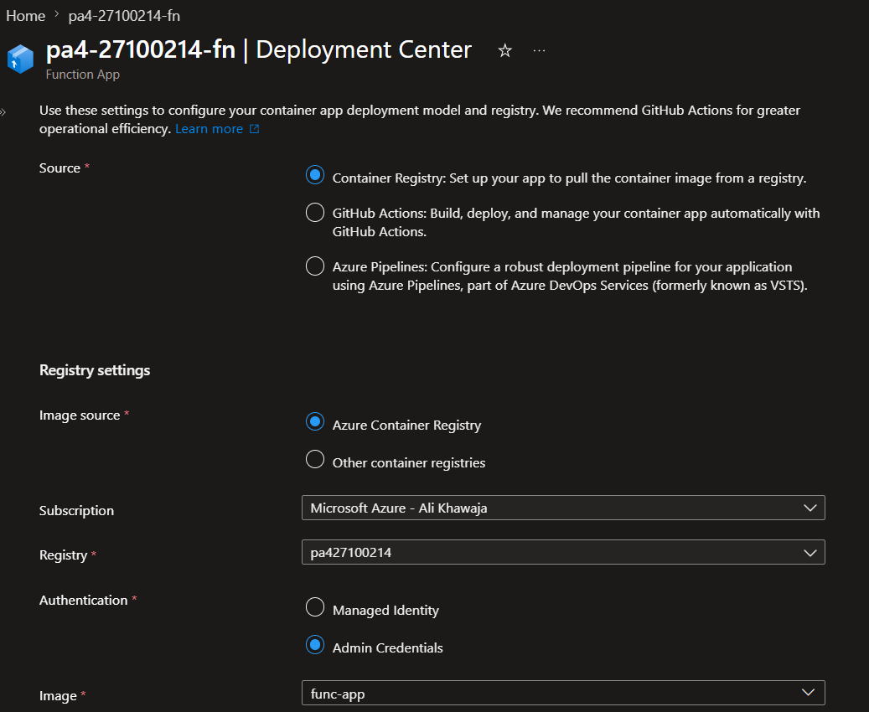
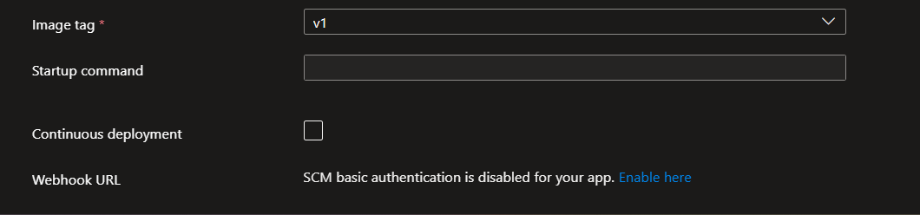

Screenshot of the Functions list in the Portal showing http_starter, my_orchestrator, validate_activity, report_activity:
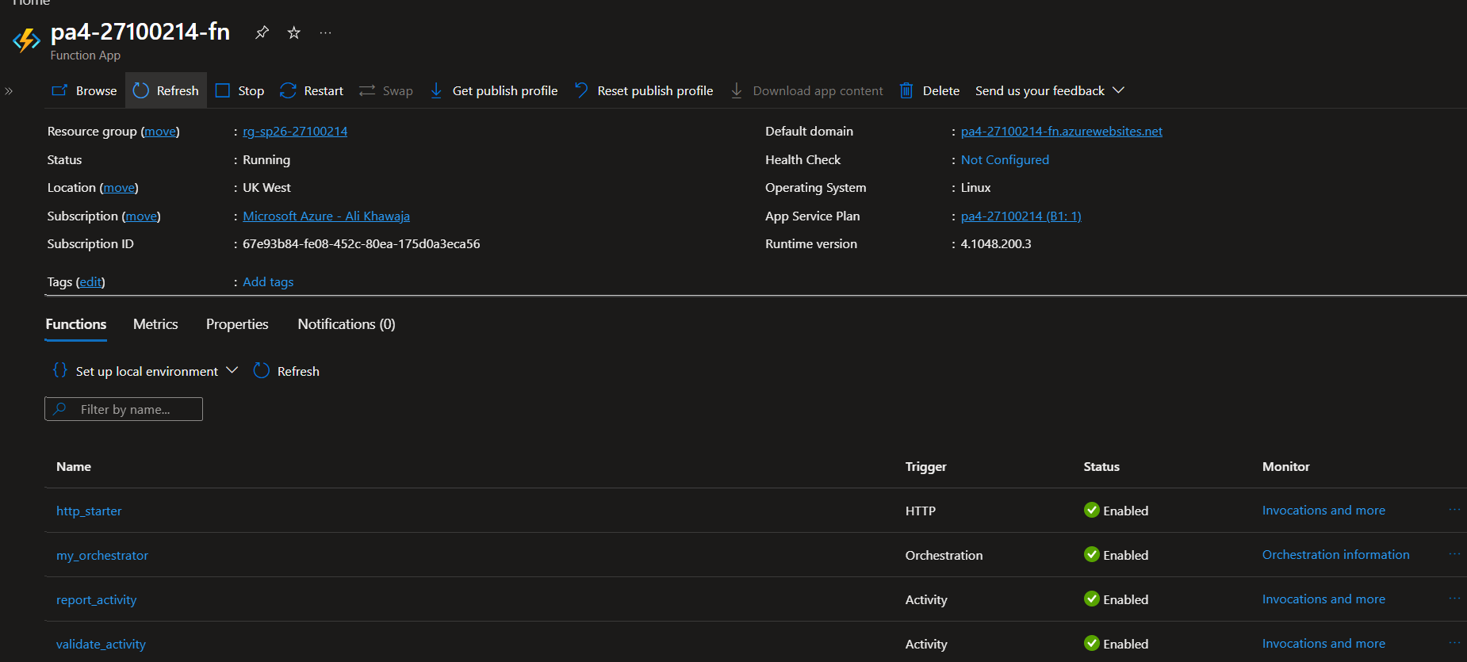
Screenshot of the curl output showing the orchestration started (instance id and statusQueryGetUri visible) :
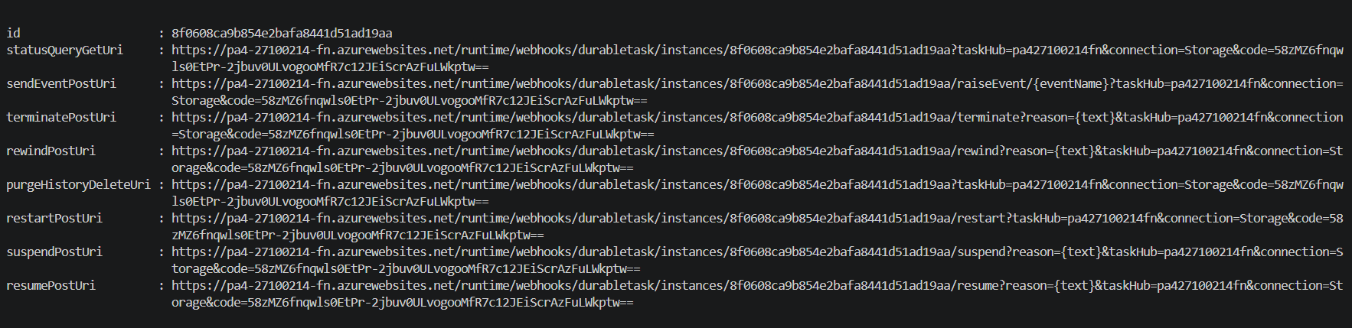
Screenshot of the status query URL JSON showing Failed status at this stage:
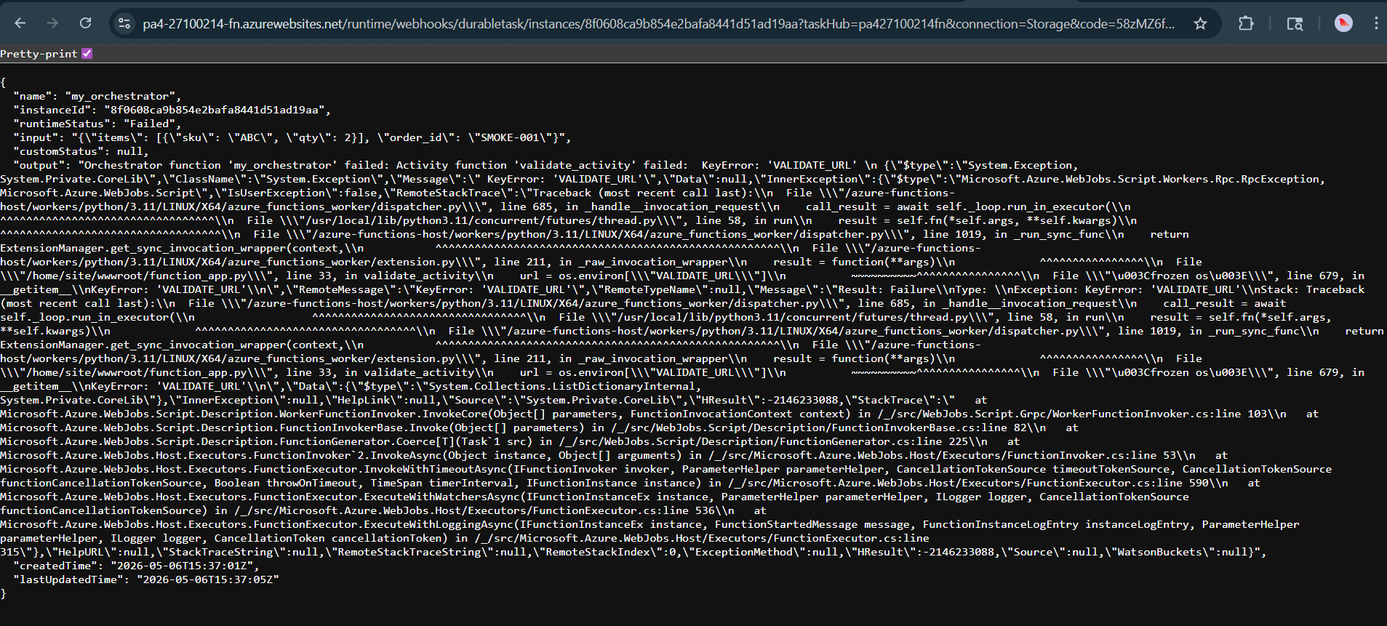

Task 5:
Screenshot of kubectl get nodes showing your cluster is running:
Screenshot of kubectl get pods showing the validator pod is Running:
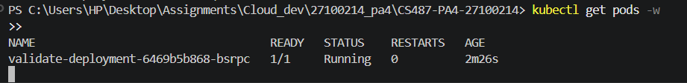
Screenshot of kubectl get service showing the assigned EXTERNAL-IP :
Screenshot of curl /health and both curl /validate runs:
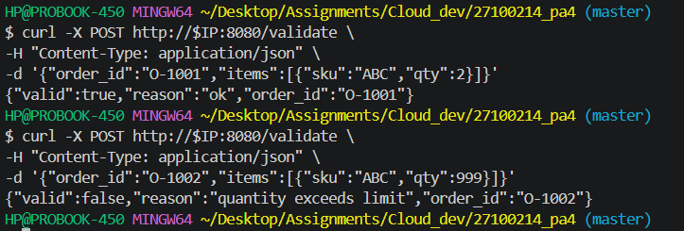
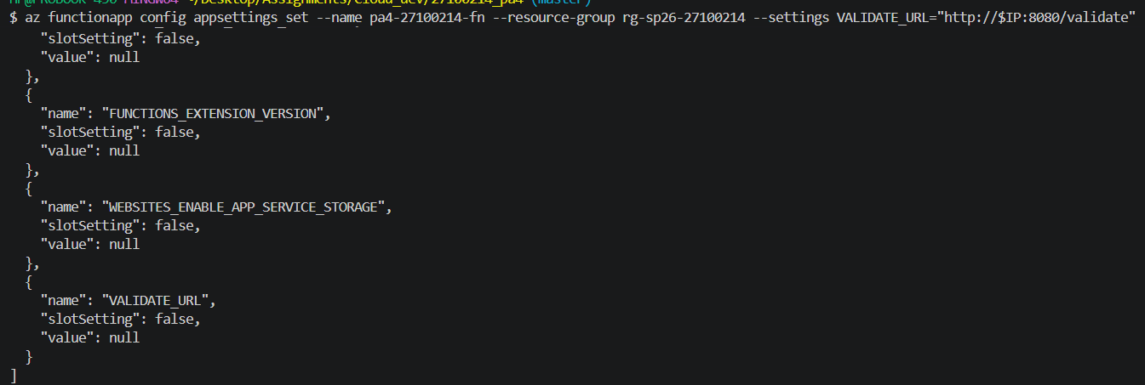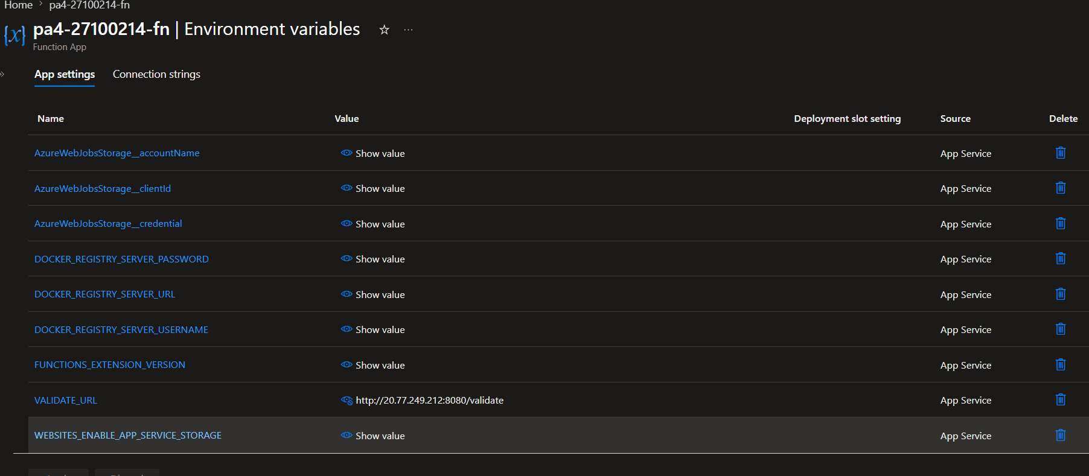
Task 6:
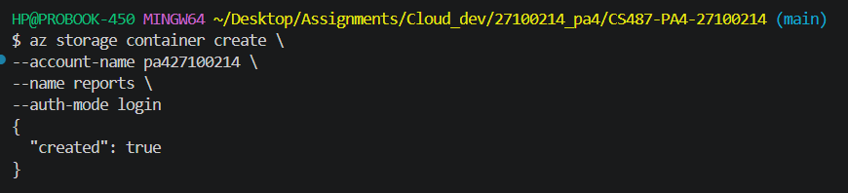
Assigned ID:
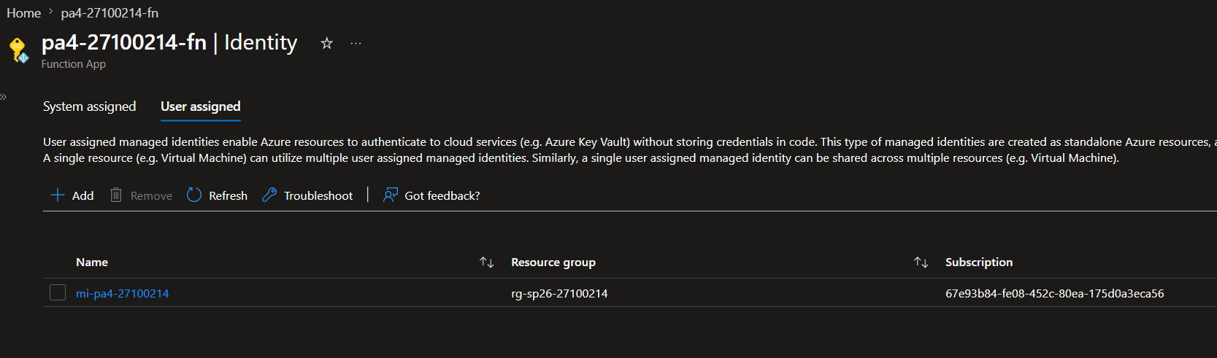
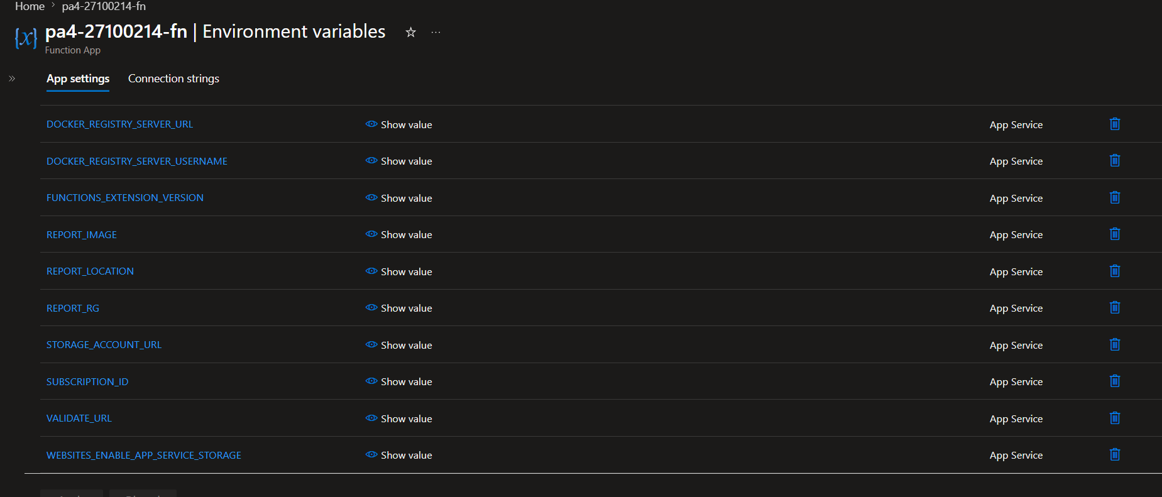
Task 7:
