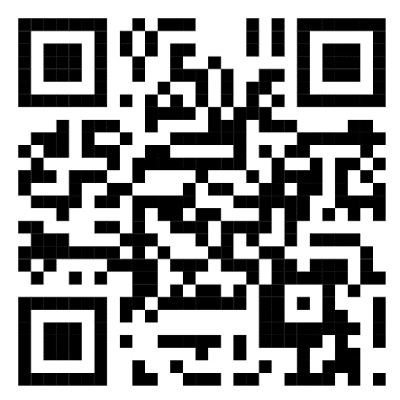Reliance Company

XYZ Street 123

1234, Bannerghatta, Python

Invoice date: [Date]

[Partner]

[Partner Street]

[Partner ZIP_City_Country]

Invoice Number:[Invoice_Number]

Service: Amount:. Single Price: Full Price:

[Service Description] [Amount] [Single Price] [Full Price]

Please Transfer the money to the bank account below!

Thank you for the Collaboration

Contact Information: Bank Account:

E-Mail: reliance@gmail.com Reciept: [Recipient]

Web:reliance@gmail.com Bank: [Bank]

IBAN: [IBAN]

BIC: [BIC]