**Computer Networks Report**



**File Transfer Application (GUI-Based) with multiple servers and clients**

**Group Members:**

**Murtaza Abidi (19k-0364)**

**Muhammad Bilal (19k-0297)**

**Introduction:**

Design and implementation of Internet file transfer application/protocol. The program will include several outlined below. We developed a file Transfer Protocol that is a standard communication protocol used for the transfer of computer files from a server to a client on a computer network. FTP is built on a client-server model architecture using separate control and data connections

between the client and the server.

**Methodology:**

* Client should be able to upload files to the server.
* Client also downloads files from server.
* Client can also view the list of files at server end.
* Client can also delete any file from server.
* When the file is uploaded or downloaded, it should be intact, i.e., it should retain its features. For instance, if it is executable, it should be able to run, or if it is an image, the image must be same as the original file.
* Client only needs to authenticate the server. The server need not authenticate client.

**Technical Specs**

* Python
* Eel for connecting front-end.

**Applications:**

* Google Drive
* Airforshare
* One Drive

**Screenshots of the working demo:**

1. Connecting Client to server:

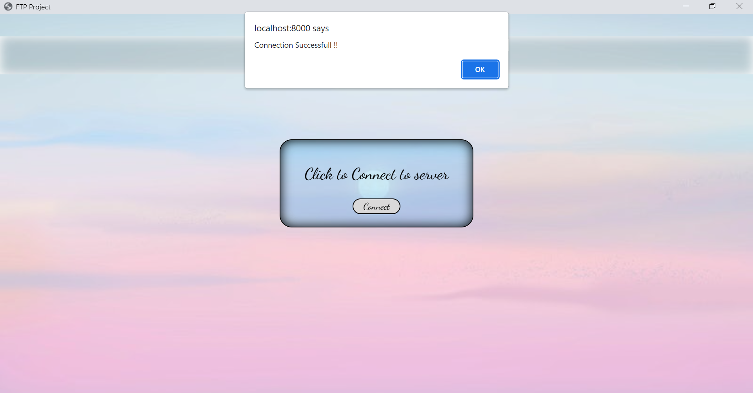

1. Uploading a file: 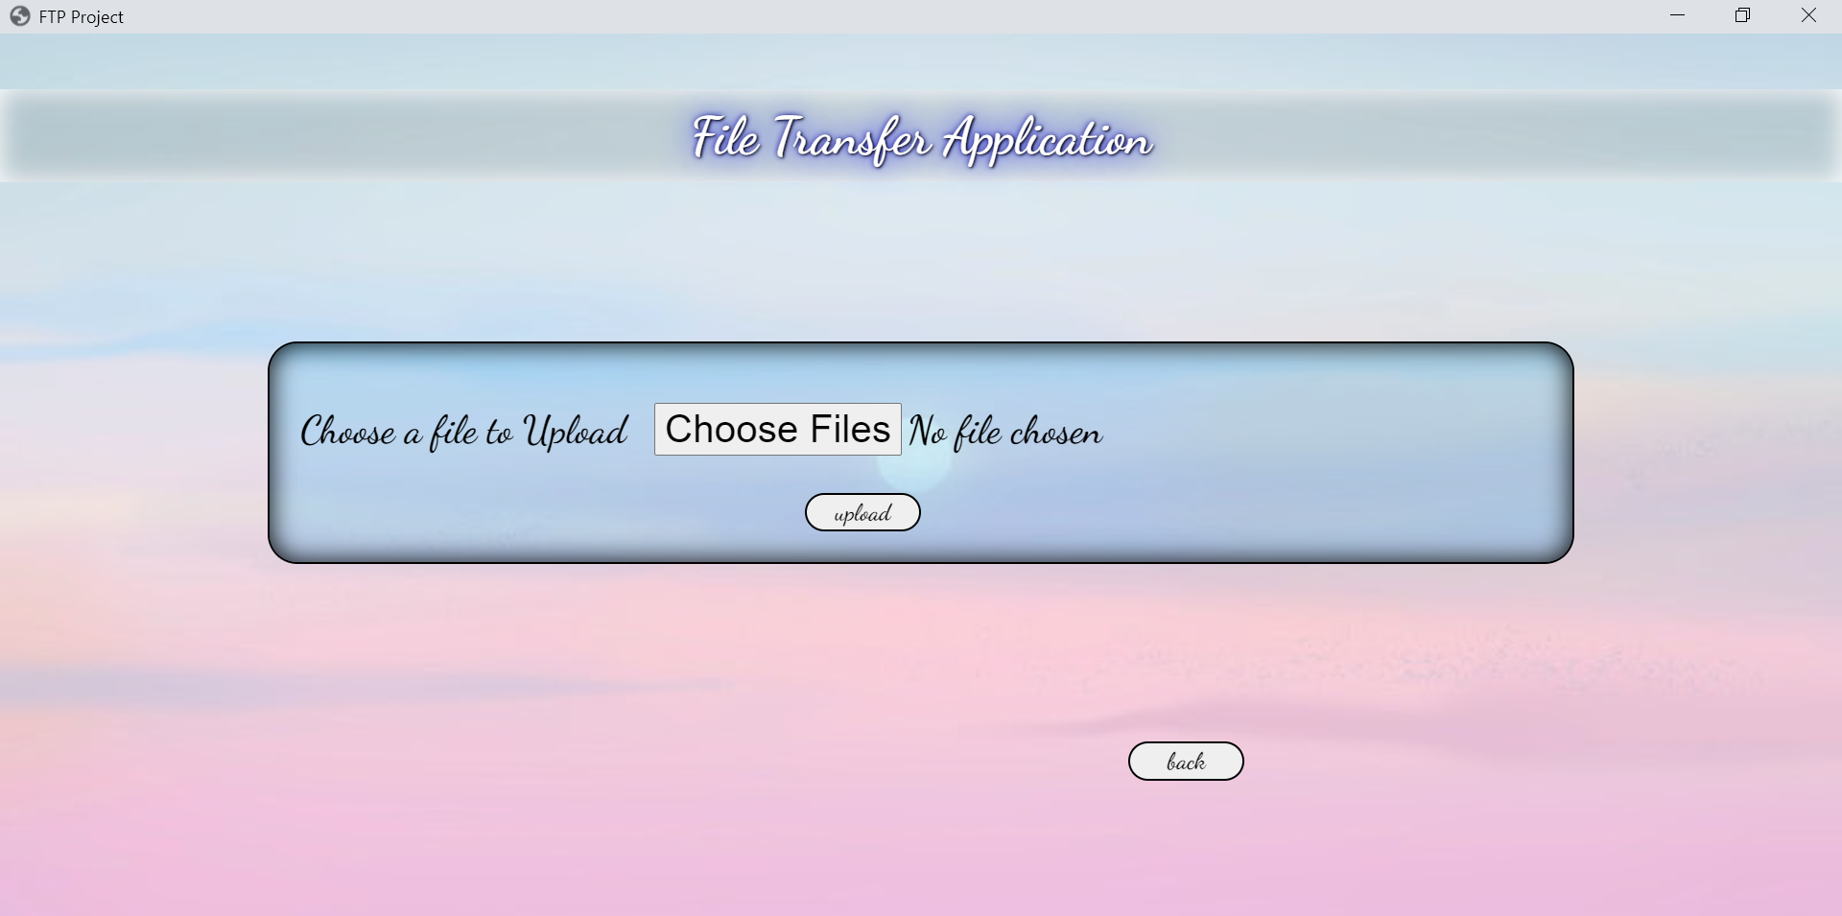
2. Downloading a file: 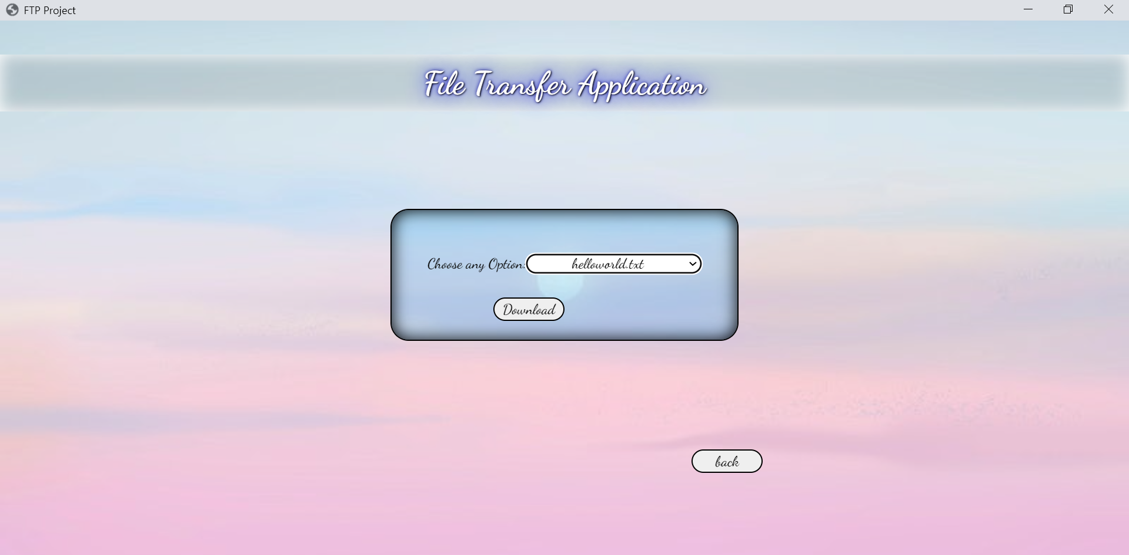
3. Deleting from Server: 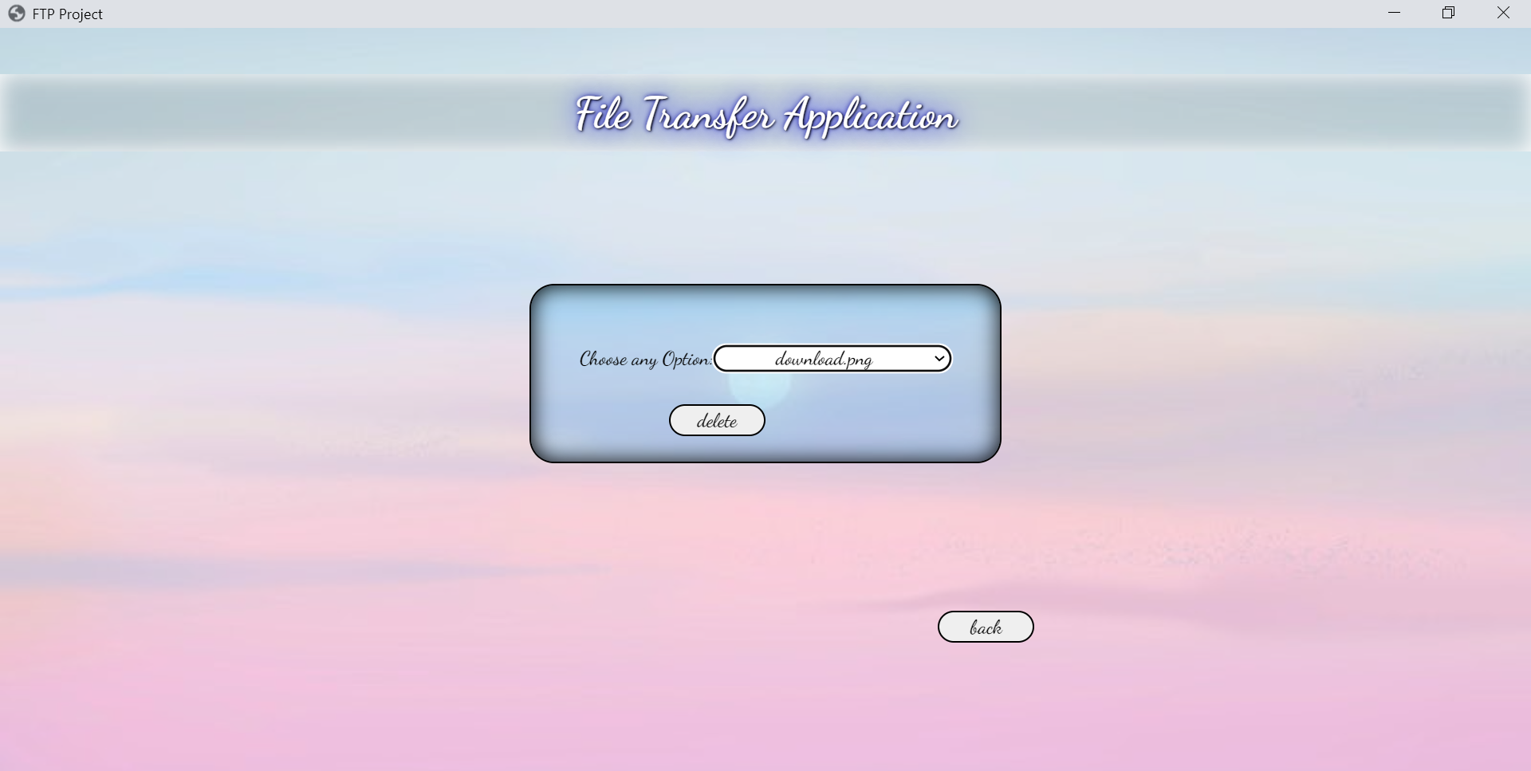
4. Listing files from server: 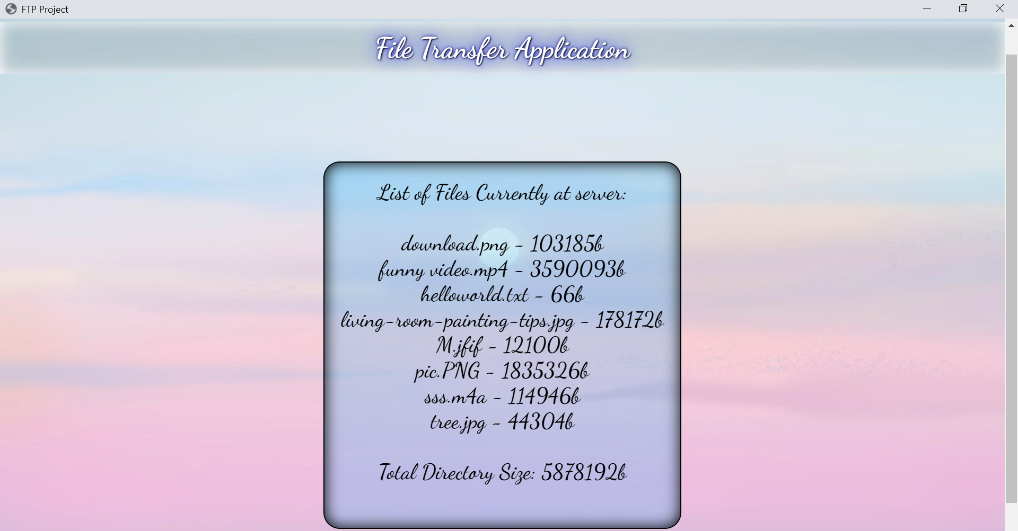

**Conclusion:**

We developed a file Transfer Protocol that is a standard communication protocol used for the transfer of computer files from a server to a client on a computer network. FTP is built on a client-server model architecture using separate control and data connections

between the client and the server.