**Normalization:**

**Without Normalization:**

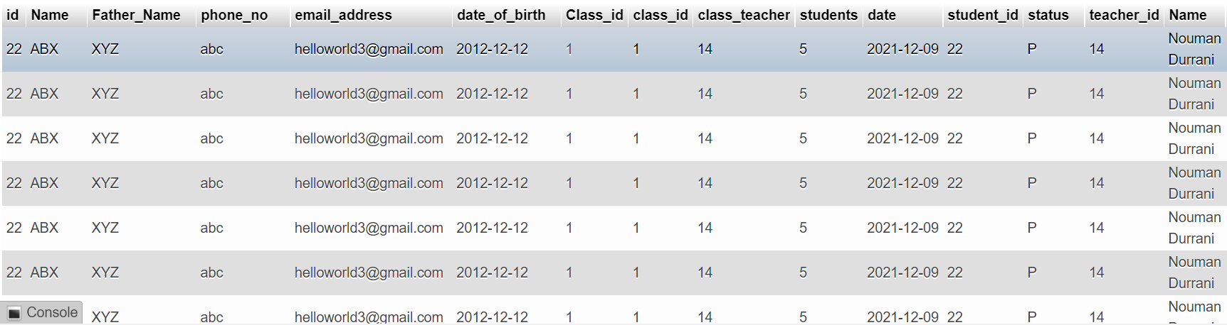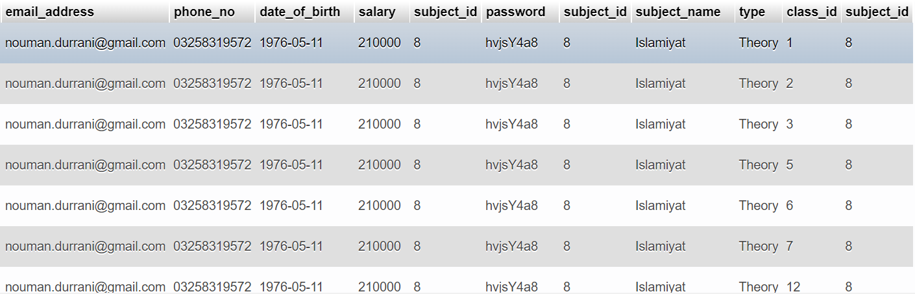

**After Normalization to BCNF:**

**Admin:**

|  |  |  |  |  |
| --- | --- | --- | --- | --- |
| Id | Username | Password | Email_address | Phone_no |

***Student_info:***

|  |  |  |  |  |  |  |
| --- | --- | --- | --- | --- | --- | --- |
| Id | Name | Father_Name | Phone_no | Email_address | Date_of_birth | Class_id |

**Teacher_info:**

|  |  |  |  |  |  |  |  |
| --- | --- | --- | --- | --- | --- | --- | --- |
| Teacher_id | Name | Email_address | Phone_no | Date_of_birth | Salary | Subject_id | password |

**Class_info:**

|  |  |  |
| --- | --- | --- |
| Class_id | Class_teacher | No_of_Students |

**Subject_info:**

|  |  |  |
| --- | --- | --- |
| Subject_id | Subject_name | Type |

**Class_subjects:**

|  |  |
| --- | --- |
| Class_id | Subject_id |

**Attendance_info:**

|  |  |  |
| --- | --- | --- |
| Class_id | Class_teacher | No_of_Students |