**Project Report**

**Database System**

***School Management System***

***K19-0364 Murtaza Abidi (Individual)***

**Project Description:**

In this School Management System Project student profile can be viewed and managed through the Admin and Teacher.

**Features:**

-> Login

-> Admin has access to Add/Modify/Delete any particular Data related to Student, Teacher, Subjects, Classes, Attendance.

-> Teacher can view and manage Student Profile, Attendance.

-> Students can view their Personal Information and academic records.

**Tools and Technologies**

HTML – CSS – JavaScript

For Database: PHP & MySQL

**ER-Diagram:**

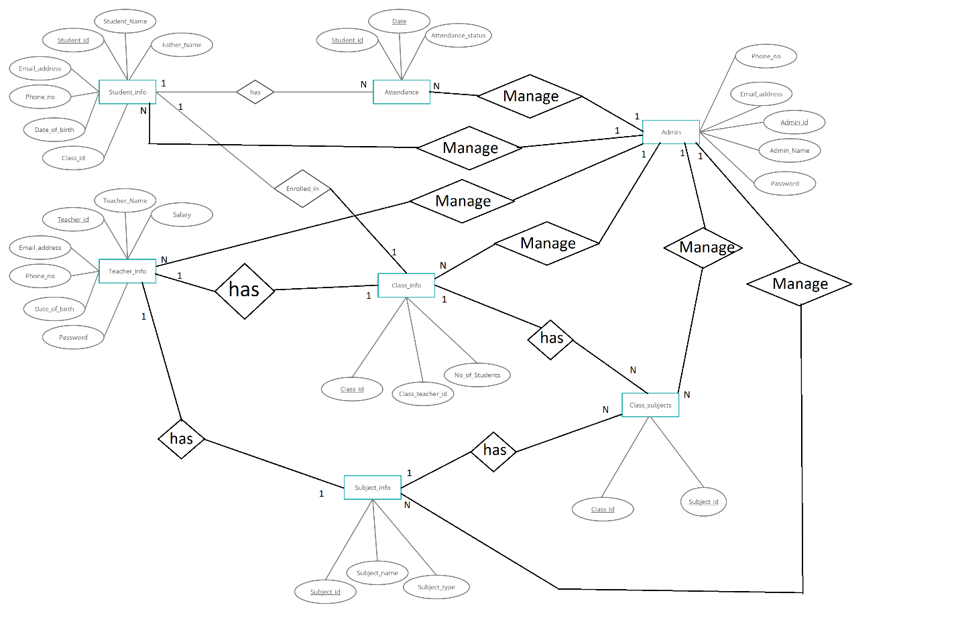

**Normalization:**

**Without Normalization:**

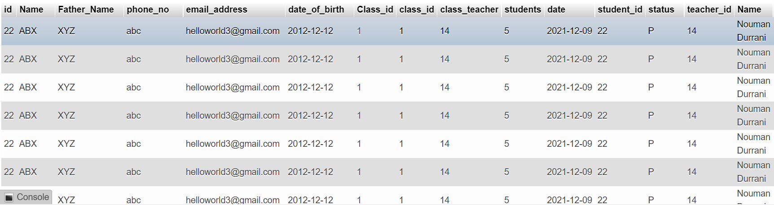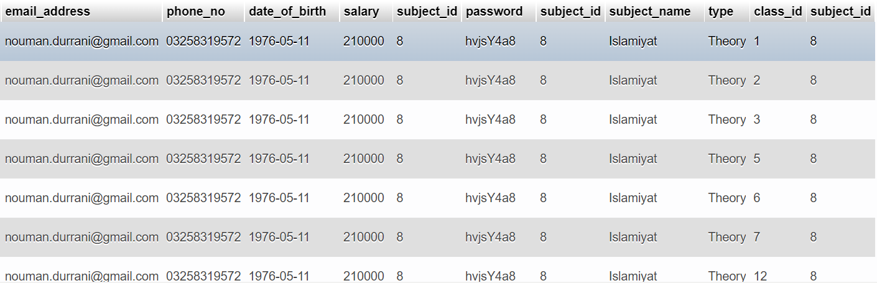

**After Normalization to BCNF:**

**Admin:**

|  |  |  |  |  |
| --- | --- | --- | --- | --- |
| Id | Username | Password | Email_address | Phone_no |

***Student_info:***

|  |  |  |  |  |  |  |
| --- | --- | --- | --- | --- | --- | --- |
| Id | Name | Father_Name | Phone_no | Email_address | Date_of_birth | Class_id |

**Teacher_info:**

|  |  |  |  |  |  |  |  |
| --- | --- | --- | --- | --- | --- | --- | --- |
| Teacher_id | Name | Email_address | Phone_no | Date_of_birth | Salary | Subject_id | password |

**Class_info:**

|  |  |  |
| --- | --- | --- |
| Class_id | Class_teacher | No_of_Students |

**Subject_info:**

|  |  |  |
| --- | --- | --- |
| Subject_id | Subject_name | Type |

**Class_subjects:**

|  |  |
| --- | --- |
| Class_id | Subject_id |

**Attendance_info:**

|  |  |  |
| --- | --- | --- |
| Class_id | Class_teacher | No_of_Students |

**Class Diagram:** 