**Name**: Murtaza Akil Mister

**Roll No:** CE071

**ID**: 20ITUOS088

**Batch**: A4

**Lab**: 10

**GitHub link**: <https://github.com/MurtazaMister/CE071_SDP/blob/master/Lab10>

Code:

Choose_location.dart

import 'package:flutter/material.dart';  
class ChooseLocation extends StatefulWidget {  
// const ChooseLocation({Key? key}) : super(key: key);  
 @override  
 State<ChooseLocation> createState() => _ChooseLocationState();  
}  
class _ChooseLocationState extends State<ChooseLocation> {  
 int counter = 0;  
 void getData() async {  
// below code is similar like to  
// simulate network request for a username  
// its just learning how flutter/dart response to Async  
 String username = await Future.delayed(Duration(seconds: 4), () {  
 return 'UNIVERSITY NAME : DDU';  
 });  
// print('in getData ...after future call....');  
// the following code is depends on 1st one ..but what happened at here?  
// suppose it is network simulation request to fetch out the bio-data of..  
// user name that is received by 1st request.....  
  
  
 String bio = await Future.delayed(Duration(seconds: 2), () {  
 return 'DDU IS ONE OF THE BEST UNIVERSITY OF GUJARAT FOR COMPUTER ENGINEERING STUDY';  
 });  
 print('$username -> $bio');  
 }  
 @override  
 void initState() {  
// *TODO: implement initState* super.initState();  
 print('INIT STATE FUNCTION RUN IN CHOOSE LOCATION...');  
 print('before getData call');  
 getData();  
 print('after getData call');  
 }  
 @override  
 Widget build(BuildContext context) {  
// print('BUILD FUNCTION RUN IN CHOOSE LOCATION...');  
 return Scaffold(  
 backgroundColor: Colors.*blueGrey*[200],  
// when we come/route from different screen IN APPBAR FLUTTER WILL DEFAULTLY  
// PLACED "BACK ARROW <- .....  
 appBar: AppBar(  
 backgroundColor: Colors.*deepPurpleAccent*,  
 title: Text('CHOOSE LOCATION'),  
 centerTitle: true,  
 elevation: 0,  
 ),  
 );  
 }  
}

Output:

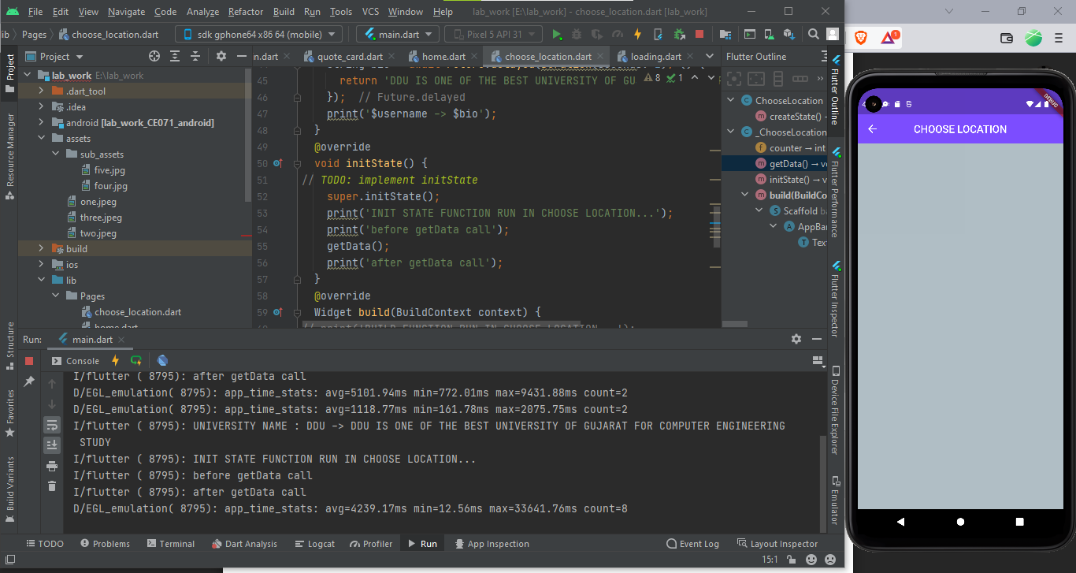

Code:

Adding dependencies in flutter

Loading.dart

import 'package:flutter/material.dart';  
import 'package:http/http.dart';  
import 'dart:convert';  
class Loading extends StatefulWidget {  
 @override  
 State<Loading> createState() => _LoadingState();  
}  
class _LoadingState extends State<Loading> {  
 void getData() async {  
 final response = await  
 get(Uri.*parse*('https://jsonplaceholder.typicode.com/albums/1'));  
 print(response.body); // it response in JSON form out put ...we need MAP  
// print(response.body.userId); // this will not work. because its not MAP  
// TO CONVERT JSON TO MAP..WE NEED TO IMPORT convert package....  
 Map data = jsonDecode(response.body);  
 print(data);  
 print(data['title']);  
 }  
 @override  
 void initState() {  
 super.initState();  
 getData();  
 }  
  
 @override  
 Widget build(BuildContext context) {  
 return Scaffold(  
 body: Text('LOADING SCREEN'),  
 );  
 }  
}

Output:

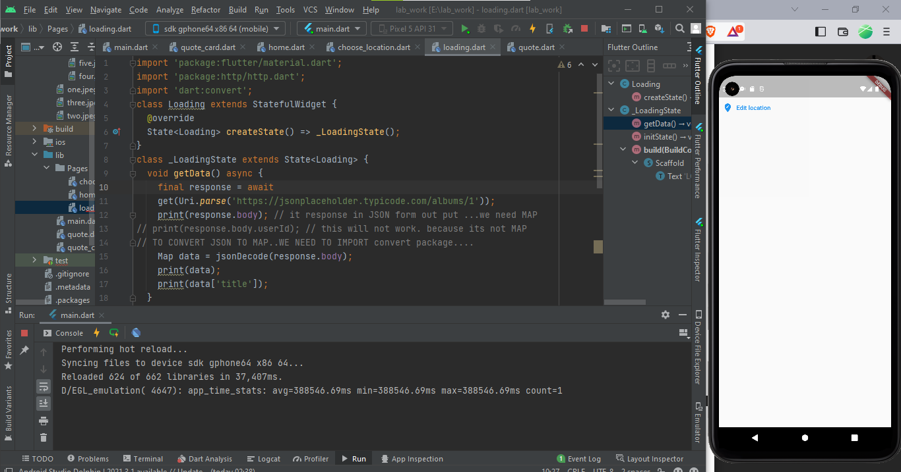

Code:

import 'package:flutter/material.dart';  
import 'package:http/http.dart';  
import 'dart:convert';  
class Loading extends StatefulWidget {  
 @override  
 State<Loading> createState() => _LoadingState();  
}  
class _LoadingState extends State<Loading> {  
 void getTime() async {  
// Make Request for time and receive response  
 Response response = await  
 get(Uri.*parse*('http://worldtimeapi.org/api/timezone/Asia/Kolkata'));  
 Map timeData = jsonDecode(response.body);  
 print(timeData);  
// Get particular property form timeData...  
 String dateTime = timeData['datetime'];  
 String offset = timeData['utc_offset']; //not dst_offset  
 print(dateTime);  
 print(offset);  
 DateTime currentTime = DateTime.*parse*(dateTime);  
 print(currentTime);  
/*  
DateTime currentOffset = DateTime.parse(offset);  
print(currentOffset);  
*/  
 String offsetHours = offset.substring(1,3);  
 print(offsetHours);  
 String offsetMinutes = offset.substring(4,6);  
 print(offsetMinutes);  
 currentTime = currentTime.add(Duration(minutes:  
 int.*parse*(offsetMinutes),hours:int.*parse*(offsetHours)));  
 print(currentTime);  
 }  
 @override  
 void initState() {  
 super.initState();  
 getTime();  
 }  
  
 @override  
 Widget build(BuildContext context) {  
 return Scaffold(  
 body: Text('LOADING SCREEN'),  
 );  
 }  
}

Output:

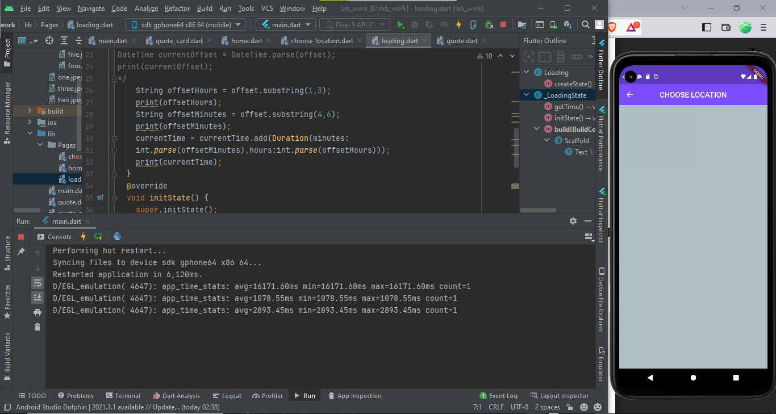

Code:

World_time.dart

import 'package:http/http.dart';  
import 'dart:convert';  
  
class WordTime {  
 String? location; // REAL LOCATION NAME FOR UI  
 String? time; // the time in that location..  
 String? flag; // flag images related to location country...do it your  
 // self  
 String? url; // end point of static url...which will change every time  
 // when location will change  
 WordTime({ this.location,this.flag,this.url });  
 Future<void> getTime() async {  
// Make Request for time and receive response  
 Response response = await get(Uri.*parse*('http://worldtimeapi.org/api/timezone/$url')); // Asia/Kolkata  
 Map timeData = jsonDecode(response.body);  
// Get particular property form timeData...  
 String dateTime = timeData['datetime'];  
 String offset = timeData['utc_offset']; //not dst_offset  
 String offsetHours = offset.substring(1,3);  
 String offsetMinutes = offset.substring(4,6);  
// create DateTime object  
 DateTime currenttime = DateTime.*parse*(dateTime);  
 currenttime = currenttime.add(  
 Duration(minutes:  
 int.*parse*(offsetMinutes),hours:int.*parse*(offsetHours)));  
//set the time property of class...  
 time = currenttime.toString();  
 }  
  
}

Output:

