**Name**: Murtaza Akil Mister

**Roll No**: CE071

**ID**: 20ITUOS088

**Batch**: A4 Lab: 11

**GitHub link**: https://github.com/MurtazaMister/CE071_SDP/blob/master/Lab11

Code Test - 1

//Lab :- 11

import 'package:flutter/material.dart';

import 'package:flutter_lab_11/pages/home.dart';

import 'package:flutter_lab_11/pages/choose_location.dart'; import 'package:flutter_lab_11/pages/loading.dart';

void main() => runApp(MaterialApp(

// home: Home(),

// instead of making home: property to make any page to initialize at beginning...

// we can use following code ....

// initialRoute: '/home',

initialRoute: '/', routes: {

'/': (context) => Loading(),

'/home': (context) => Home(),

'/location': (context) => ChooseLocation(),

}));

**main.dart**

import 'package:flutter/material.dart';

class ChooseLocation extends StatefulWidget {

// const ChooseLocation({Key? key}) : super(key: key); @override

State<ChooseLocation> createState() => _ChooseLocationState();

}

class _ChooseLocationState extends State<ChooseLocation> { int counter = 0;

void getData() async {

// below code is similar like to

// simulate network request for a username

// its just learning how flutter/dart response to Async

String username = await Future.delayed(Duration(seconds: 4), () { return 'UNIVERSITY NAME : DDU';

});

// print('in getData ...after future call. ');

// the following code is depends on 1st one ..but what happened at here?

// suppose it is network simulation request to fetch out the bio-data of..

// user name that is received by 1st request.....

String bio = await Future.delayed(Duration(seconds: 2), () { return 'DDU IS ONE OF THE BEST UNIVERSITY OF GUJARAT FOR COMPUTER

ENGINEERING STUDY';

});

print('$username -> $bio');

}

@override

void initState() {

// *TODO: implement initState*

super.initState();

print('INIT STATE FUNCTION RUN IN CHOOSE LOCATION...');

print('Before calling of getData'); getData();

print('After calling of getData');

}

@override

Widget build(BuildContext context) {

// print('BUILD FUNCTION RUN IN CHOOSE LOCATION...');

return Scaffold(

backgroundColor: Colors.*blueGrey*[200],

// when we come/route from different screen IN APPBAR FLUTTER WILL DEFAULTLY

// PLACED "BACK ARROW <- .....

appBar: AppBar(

backgroundColor: Colors.*deepPurpleAccent*, title: Text('CHOOSE LOCATION'),

centerTitle: true, elevation: 0,

),

/*

body: ElevatedButton( onPressed: () {

setState(() { counter += 1;

});

},

child: Text('COUNTER IS : $counter'),

),

*/

);

}

}

**pages/choose_location.dart**

import 'package:flutter/material.dart';

class Home extends StatefulWidget { @override

State<Home> createState() => _HomeState();

}

class _HomeState extends State<Home> { Map<dynamic, dynamic> data = {};

@override

Widget build(BuildContext context) {

data = ModalRoute.*of*(context)?.settings.arguments as Map; print(data);

return Scaffold( body: SafeArea(

child: Padding(

padding: const EdgeInsets.fromLTRB(0.0, 120.0, 0.0, 0.0), child: Column(

children: [ TextButton.icon(

onPressed: () {

Navigator.*pushNamed*(context, '/location');

},

icon: Icon(Icons.*edit_location*), label: Text('EDIT LOCATION'),

),

SizedBox(height: 24.0), Row(

mainAxisAlignment: MainAxisAlignment.center, children: [

Text(

data['location'], style: TextStyle(

letterSpacing: 2.0,

fontSize: 28.0,

),

)

],

),

SizedBox( height: 24.0,

),

Text(

data['time'], style: TextStyle(

fontSize: 70.0,

),

)

],

),

)),

);

}

}

**pages/home.dart**

import 'package:flutter/material.dart';

import 'package:flutter_lab_11/services/world_time.dart';

class Loading extends StatefulWidget { @override

State<Loading> createState() => _LoadingState();

}

class _LoadingState extends State<Loading> { String? time = 'LOADING. ';

void setWorldTime() async { WordTime timeinstance =

WordTime(location: 'kolkata', flag: 'india.png', url: 'Asia/Kolkata');

await timeinstance.getTime();

// print(timeinstance.time); setState(() {

time = timeinstance.time;

});

}

@override

void initState() { super.initState(); setWorldTime();

}

@override

Widget build(BuildContext context) { return Scaffold(

body: Padding(

padding: EdgeInsets.all(60.0), child: Text(time.toString()),

));

}

}

**pages/loading.dart**

import 'package:http/http.dart'; import 'dart:convert';

class WordTime {

String? location; // REAL LOCATION NAME FOR UI String? time; // the time in that location..

String? flag; // flag images related to location country...do it your self

String? url; // end point of static url...which will change every time when location will change

WordTime({ this.location,this.flag,this.url }); Future<void> getTime() async {

// Make Request for time and receive response Response response = await

Here the URL is removed…

get(Uri.*parse*(''));

Here the URL is removed…

// Asia/Kolkata

Map timeData = jsonDecode(response.body);

// Get particular property form timeData... String dateTime = timeData['datetime'];

String offset = timeData['utc_offset']; //not dst_offset String offsetHours = offset.substring(1,3);

String offsetMinutes = offset.substring(4,6);

// create DateTime object

DateTime currenttime = DateTime.*parse*(dateTime); currenttime = currenttime.add(

Duration(minutes: int.*parse*(offsetMinutes),hours:int.*parse*(offsetHours)));

//set the time property of class... time = currenttime.toString();

}

}

**services/world_time.dart**

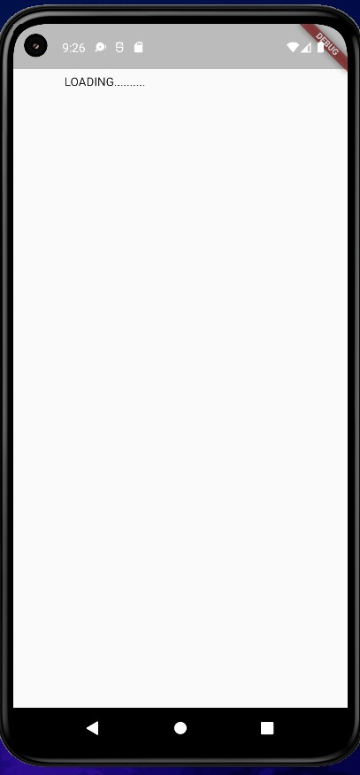**Output-**

To handle this TRY-CATCH blocks are needed:-

import 'package:http/http.dart'; import 'dart:convert';

class WordTime {

String? location; // REAL LOCATION NAME FOR UI String? time; // the time in that location..

String? flag; // flag images related to location country...do it your self

String?

url; // end point of static url...which will change every time when location will change

WordTime({this.location, this.flag, this.url});

Future<void> getTime() async { try {

// Make Request for time and receive response Response response = await

//From Here URL was removed

get(Uri.*parse*('')); // Asia/Kolkata

Map timeData = jsonDecode(response.body);

// Get particular property form timeData...

String dateTime = timeData['datetime'];

String offset = timeData['utc_offset']; //not dst_offset String offsetHours = offset.substring(1, 3);

String offsetMinutes = offset.substring(4, 6);

// create DateTime object

DateTime currenttime = DateTime.*parse*(dateTime); currenttime = currenttime.add(Duration(

minutes: int.*parse*(offsetMinutes), hours: int.*parse*(offsetHours)));

//set the time property of class... time = currenttime.toString();

}

catch(e){

print("Exception Caught : $e");

}

}

}

**Changed code of - services/world_time.dart**

***Syncing files to device sdk gphone64 x86 64...***

***I/flutter (12266): Exception Caught : Invalid argument(s): No host specified in URI***

Error from the RUN console…

**Output -**

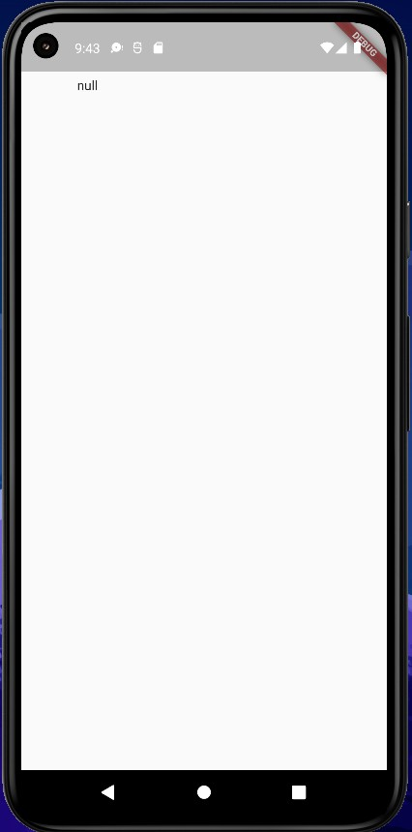

**Code Test - 2**

import 'package:http/http.dart'; import 'dart:convert';

class WordTime {

String? location; // REAL LOCATION NAME FOR UI String? time; // the time in that location..

String? flag; // flag images related to location country...do it your self

String?

url; // end point of static url...which will change every time when location will change

WordTime({this.location, this.flag, this.url});

Future<void> getTime() async { try {

// Make Request for time and receive response Response response = await

//From Here URL was removed

get(Uri.*parse*(['http://worldtimeapi.org/api/timezone/](http://worldtimeapi.org/api/timezone/%24url%27))%3B)$[url'));](http://worldtimeapi.org/api/timezone/%24url%27))%3B) // Asia/Kolkata

Map timeData = jsonDecode(response.body);

// Get particular property form timeData...

String dateTime = timeData['datetime'];

String offset = timeData['utc_offset']; //not dst_offset String offsetHours = offset.substring(1, 3);

String offsetMinutes = offset.substring(4, 6);

// create DateTime object

DateTime currenttime = DateTime.*parse*(dateTime); currenttime = currenttime.add(Duration(

minutes: int.*parse*(offsetMinutes), hours: int.*parse*(offsetHours)));

//set the time property of class... time = currenttime.toString();

}

catch(e){

print("Exception Caught : $e");

}

}

}

**Updated page of world_time.dart**

import 'package:flutter/material.dart';

import 'package:flutter_lab_11/services/world_time.dart';

class Loading extends StatefulWidget { @override

State<Loading> createState() => _LoadingState();

}

class _LoadingState extends State<Loading> { void setWorldTime() async {

WordTime timeinstance =

WordTime(location: 'kolkata', flag: 'india.png', url: 'Asia/Kolkata');

await timeinstance.getTime(); Navigator.*pushReplacementNamed*(context, '/home', arguments: {

'location' : timeinstance.location, 'flag' : timeinstance.flag,

'time': timeinstance.time,

});

}

@override

void initState() { super.initState(); setWorldTime();

}

@override

Widget build(BuildContext context) { return Scaffold(

body: Padding(

padding: EdgeInsets.all(50.0), child: Text("Loading..."),

));

}

}

**Updated page of loading.dart**

import 'package:flutter/material.dart';

class Home extends StatefulWidget { @override

State<Home> createState() => _HomeState();

}

class _HomeState extends State<Home> { Map<dynamic, dynamic> data = {};

@override

Widget build(BuildContext context) {

data = ModalRoute.*of*(context)?.settings.arguments as Map; print(data);

return Scaffold( body: SafeArea(

child: Padding(

padding: const EdgeInsets.fromLTRB(0.0, 120.0, 0.0, 0.0), child: Column(

children: [ TextButton.icon(

onPressed: () {

Navigator.*pushNamed*(context, '/location');

},

icon: Icon(Icons.*edit_location*), label: Text('EDIT LOCATION'),

),

SizedBox(height: 24.0), Row(

mainAxisAlignment: MainAxisAlignment.center, children: [

Text(

data['location'],

style: TextStyle( letterSpacing: 2.0,

fontSize: 28.0,

),

)

],

),

SizedBox( height: 24.0,

),

Text(

data['time'], style: TextStyle(

fontSize: 70.0,

),

)

],

),

)),

);

}

}

**Updated page of home.dart**

**Output**-

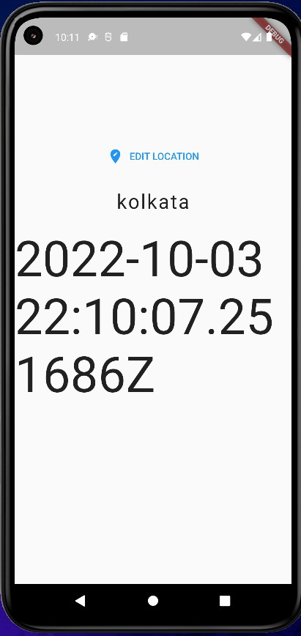

**Code Test-3**

import 'package:http/http.dart'; import 'dart:convert';

import 'package:intl/intl.dart';

class WordTime {

String? location; // REAL LOCATION NAME FOR UI String? time; // the time in that location..

String? flag; // flag images related to location country...do it your self

String?

url; // end point of static url...which will change every time when location will change

WordTime({this.location, this.flag, this.url});

Future<void> getTime() async { try {

// Make Request for time and receive response Response response = await

//From Here URL was removed

get(Uri.*parse*( ['http://worldtimeapi.org/api/timezone/](http://worldtimeapi.org/api/timezone/%24url%27))%3B)$[url'));](http://worldtimeapi.org/api/timezone/%24url%27))%3B) //

Asia/Kolkata

Map timeData = jsonDecode(response.body);

// Get particular property form timeData...

String dateTime = timeData['datetime'];

String offset = timeData['utc_offset']; //not dst_offset String offsetHours = offset.substring(1, 3);

String offsetMinutes = offset.substring(4, 6);

// create DateTime object

DateTime currenttime = DateTime.*parse*(dateTime); currenttime = currenttime.add(Duration(

minutes: int.*parse*(offsetMinutes), hours: int.*parse*(offsetHours)));

//set the time property of class...

// time = currenttime.toString();

time = DateFormat.jm().format(currenttime);

} catch (e) {

print("Exception Caught : $e");

}

}

}

**Updated page of world_time.dart**

import 'package:flutter/material.dart';

class Home extends StatefulWidget { @override

State<Home> createState() => _HomeState();

}

class _HomeState extends State<Home> { Map<dynamic, dynamic> data = {};

@override

Widget build(BuildContext context) {

data = ModalRoute.*of*(context)?.settings.arguments as Map; print(data);

return Padding(

padding: const EdgeInsets.all(8.0), child: Scaffold(

body: SafeArea( child: Padding(

padding: const EdgeInsets.fromLTRB(0.0, 120.0, 0.0, 0.0), child: Column(

children: [ TextButton.icon(

onPressed: () {

Navigator.*pushNamed*(context, '/location');

},

icon: Icon(Icons.*edit_location*), label: Text('EDIT LOCATION'),

),

SizedBox(height: 24.0), Row(

mainAxisAlignment: MainAxisAlignment.center, children: [

Text(

data['location'], style: TextStyle(

letterSpacing: 2.0,

fontSize: 28.0,

),

)

],

),

SizedBox( height: 24.0,

),

Text(

data['time'], style: TextStyle(

fontSize: 70.0,

),

)

],

),

)),

),

);

}

}

**Updated page of home.dart**

**Output**-

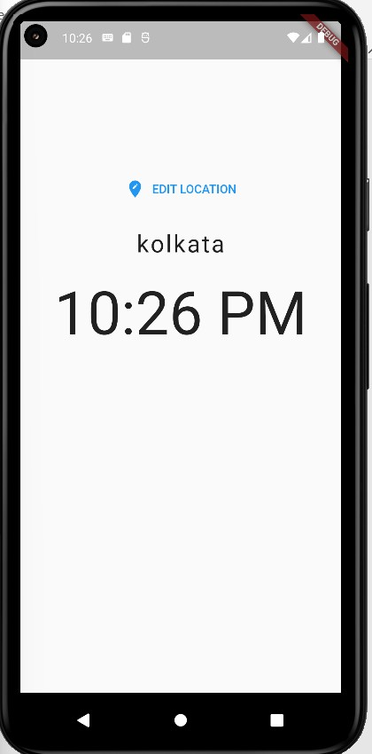

**Code Test - 4**

import 'package:flutter/material.dart';

import 'package:flutter_lab_11/services/world_time.dart'; import 'package:flutter_spinkit/flutter_spinkit.dart';

class Loading extends StatefulWidget { @override

State<Loading> createState() => _LoadingState();

}

class _LoadingState extends State<Loading> { void setWorldTime() async {

WordTime timeinstance =

WordTime(location: 'kolkata', flag: 'india.png', url: 'Asia/Kolkata');

await timeinstance.getTime(); Navigator.*pushReplacementNamed*(context, '/home', arguments: {

'location': timeinstance.location, 'flag': timeinstance.flag,

'time': timeinstance.time,

});

}

@override

void initState() { super.initState(); setWorldTime();

}

@override

Widget build(BuildContext context) { return Scaffold(

backgroundColor: Colors.*deepPurpleAccent*, body: Center(

child: SpinKitFadingCube( color: Colors.*white*, size: 90.0,

),

));

}

}

**Updated page of loading.dart**

**Output-**

