**Name**: Murtaza Akil Mister

**Roll No**: CE071

**ID**: 20ITUOS088

**Batch**: A4 Lab: 12

**GitHub link**: https://github.com/MurtazaMister/CE071_SDP/blob/master/Lab12

# Main.dart

import 'package:flutter/material.dart';

import 'pages/choose_location.dart'; import 'pages/home.dart';

import 'pages/loading.dart';

void main() => runApp(MaterialApp( debugShowCheckedModeBanner: false, initialRoute: '/loading',

routes: {

'/': (context) => Loading(),

'/home': (context) => Home(),

'/location': (context) => ChooseLocation(), '/loading': (context) => Loading(),

}));

# World_time.dart

import 'package:http/http.dart'; import 'dart:convert';

import 'package:intl/intl.dart';

class WordTime {

String? location; // REAL LOCATION NAME FOR UI String? time; // the time in that location..

String? flag; // flag images related to location country...do it your self String? url; // end point of static url...which will change every time when

bool? isDayTime; // for day time background image setting WordTime({this.location, this.flag, this.url});

Future<void> getTime() async { try {

// Make Request for time and receive response Response response = await get(Uri.parse(

'[http://worldtimeapi.org/api/timezone/$url'));](http://worldtimeapi.org/api/timezone/%24url%27))%3B) // Asia/Kolkata Map timeData = jsonDecode(response.body);

// Get particular property form timeData...

String dateTime = timeData['datetime'];

String offset = timeData['utc_offset']; //not dst_offset String offsetHours = offset.substring(1, 3);

String offsetMinutes = offset.substring(4, 6);

// create DateTime object

DateTime currenttime = DateTime.parse(dateTime); currenttime = currenttime.add(Duration(

minutes: int.parse(offsetMinutes), hours: int.parse(offsetHours)));

//set the time property of class... isDayTime =

(currenttime.hour > 11 && currenttime.hour < 20) ? true : false; time = DateFormat.jm().format(currenttime);

// time = currenttime.toString();

} catch (e) {

print('caught error : $e ');

time = 'could not get time data';

}

}

}

**Loading.dart**

import 'package:flutter/material.dart';

import 'package:lab_12/Services/world_time.dart'; import 'package:flutter_spinkit/flutter_spinkit.dart';

class Loading extends StatefulWidget { @override

State<Loading> createState() => _LoadingState();

}

class _LoadingState extends State<Loading> { void setWorldTime() async {

WordTime timeinstance =

WordTime(location: 'India',flag: 'india.png',url: 'Asia/Kolkata'); await timeinstance.getTime(); Navigator.pushReplacementNamed(context, '/home',arguments: {

'location' : timeinstance.location, 'flag' : timeinstance.flag,

'time' : timeinstance.time, 'isDayTime' : timeinstance.isDayTime,

});

}

@override

void initState() {

super.initState(); setWorldTime();

}

@override

Widget build(BuildContext context) { return Scaffold(

backgroundColor: Colors.deepPurpleAccent, body: Center(

child: SpinKitFadingCube( color: Colors.white, size: 90.0,

),

)

);

}

}

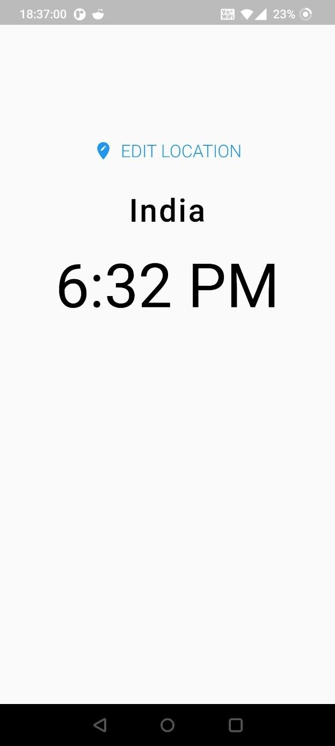

# Home.dart

## “Night.jpg”

import 'package:flutter/material.dart';

class Home extends StatefulWidget { @override

State<Home> createState() => _HomeState();

}

class _HomeState extends State<Home> { Map<dynamic, dynamic> data = {}; @override

Widget build(BuildContext context) { data = data.isNotEmpty

? data

: ModalRoute.of(context)?.settings.arguments as Map; print(data);

// set background images

String bgImage = data['isDayTime'] ? 'mrng.jpg' : 'night.jpg';

Color? appBgColor = data['isDayTime'] ? Colors.blue : Colors.indigo[900]; return Scaffold(

backgroundColor: appBgColor, body: SafeArea(

child: Container( decoration: BoxDecoration(

image: DecorationImage(

image: AssetImage('assets/images/night.jpg'), fit: BoxFit.cover,

)),

child: Padding(

padding: const EdgeInsets.fromLTRB(0.0, 120.0, 0.0, 0.0), child: Column(

children: [ TextButton.icon(

onPressed: () async { dynamic result =

await Navigator.pushNamed(context, '/location');

setState(() { data = {

'time': result['time'], 'location': result['location'], 'isDayTime': result['isDayTime'], 'flag': result['flag'],

};

});

},

icon: Icon( Icons.edit_location, color: Colors.grey[300],

),

label: Text( 'EDIT LOCATION',

style: TextStyle(

color: Colors.grey[300], fontWeight: FontWeight.w300, fontSize: 20,

),

),

),

SizedBox(height: 24.0), Row(

mainAxisAlignment: MainAxisAlignment.center, children: [

Text(

data['location'], style: TextStyle(

letterSpacing: 2.0,

fontSize: 36.0,

fontWeight: FontWeight.w500, color: Colors.white70,

),

)

],

),

SizedBox( height: 24.0,

),

Text(

data['time'], style: TextStyle(

fontSize: 70.0, color: Colors.white70,

),

)

],

),

),

)),

);

}

}

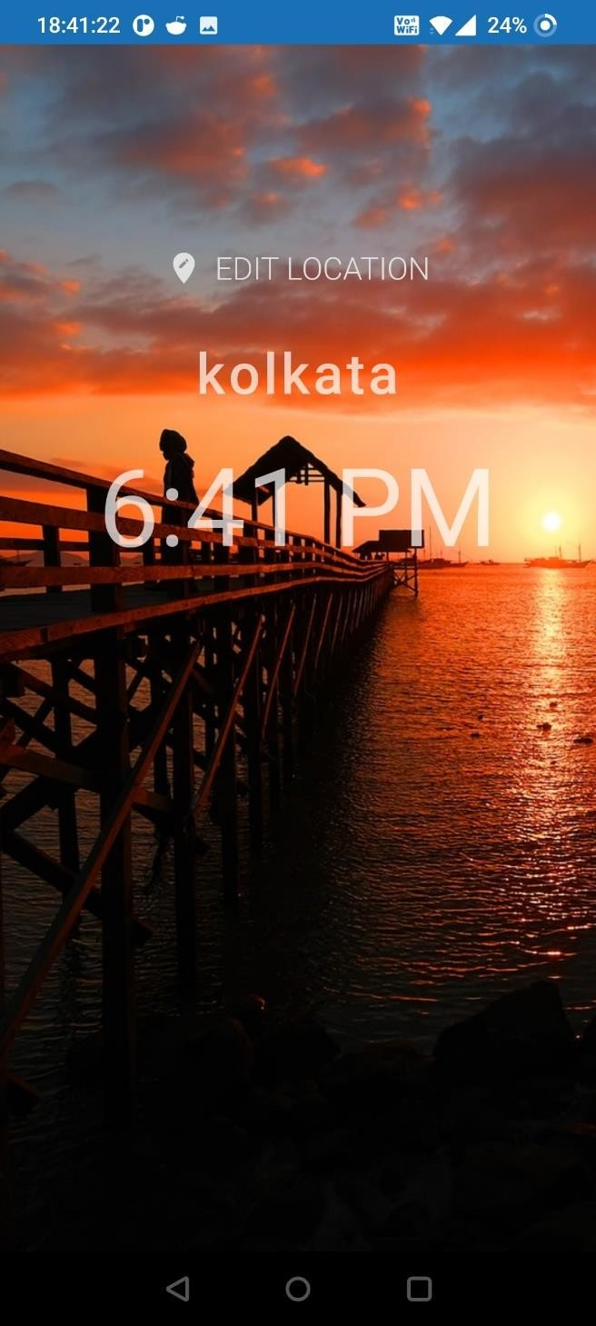

# Home.dart

## “Day.jpg”

import 'package:flutter/material.dart';

class Home extends StatefulWidget { @override

State<Home> createState() => _HomeState();

}

class _HomeState extends State<Home> { Map<dynamic, dynamic> data = {}; @override

Widget build(BuildContext context) { data = data.isNotEmpty

? data

: ModalRoute.of(context)?.settings.arguments as Map; print(data);

// set background images

String bgImage = data['isDayTime'] ? 'mrng.jpg' : 'night.jpg';

Color? appBgColor = data['isDayTime'] ? Colors.blue : Colors.indigo[900]; return Scaffold(

backgroundColor: appBgColor, body: SafeArea(

child: Container( decoration: BoxDecoration(

image: DecorationImage(

image: AssetImage('assets/images/day.jpg'), fit: BoxFit.cover,

)),

child: Padding(

padding: const EdgeInsets.fromLTRB(0.0, 120.0, 0.0, 0.0), child: Column(

children: [ TextButton.icon(

onPressed: () async { dynamic result =

await Navigator.pushNamed(context, '/location');

setState(() { data = {

'time': result['time'], 'location': result['location'], 'isDayTime': result['isDayTime'], 'flag': result['flag'],

};

});

},

icon: Icon( Icons.edit_location, color: Colors.grey[300],

),

label: Text( 'EDIT LOCATION',

style: TextStyle(

color: Colors.grey[300],

fontWeight: FontWeight.w300,

fontSize: 20,

),

),

),

SizedBox(height: 24.0), Row(

mainAxisAlignment: MainAxisAlignment.center, children: [

Text(

data['location'], style: TextStyle(

letterSpacing: 2.0,

fontSize: 36.0,

fontWeight: FontWeight.w500, color: Colors.white70,

),

)

],

),

SizedBox( height: 24.0,

),

Text(

data['time'], style: TextStyle(

fontSize: 70.0, color: Colors.white70,

),

)

],

),

),

)),

);

}

}

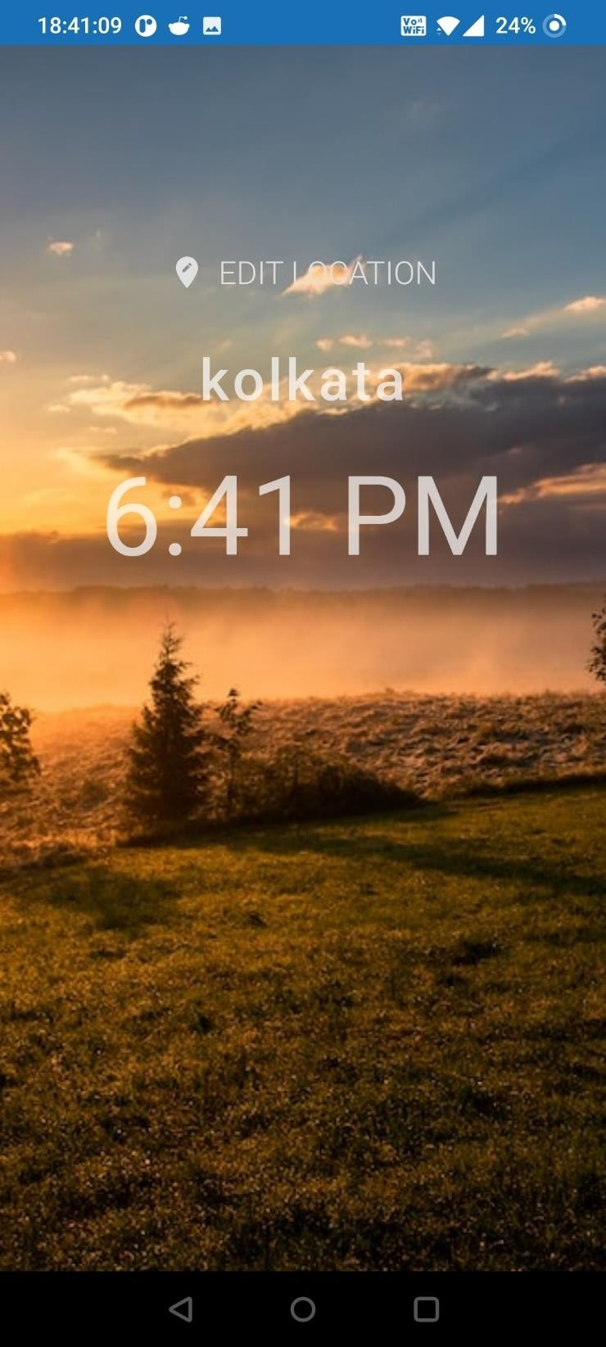

# Home.dart

## “using $bgImage”

import 'package:flutter/material.dart';

class Home extends StatefulWidget { @override

State<Home> createState() => _HomeState();

}

class _HomeState extends State<Home> { Map<dynamic, dynamic> data = {}; @override

Widget build(BuildContext context) { data = data.isNotEmpty

? data

: ModalRoute.of(context)?.settings.arguments as Map; print(data);

// set background images

String bgImage = data['isDayTime'] ? 'mrng.jpg' : 'night.jpg';

Color? appBgColor = data['isDayTime'] ? Colors.blue : Colors.indigo[900]; return Scaffold(

backgroundColor: appBgColor, body: SafeArea(

child: Container( decoration: BoxDecoration(

image: DecorationImage(

image: AssetImage('assets/images/$bgImage'), fit: BoxFit.cover,

)),

child: Padding(

padding: const EdgeInsets.fromLTRB(0.0, 120.0, 0.0, 0.0), child: Column(

children: [ TextButton.icon(

onPressed: () async { dynamic result =

await Navigator.pushNamed(context, '/location');

setState(() { data = {

'time': result['time'], 'location': result['location'], 'isDayTime': result['isDayTime'], 'flag': result['flag'],

};

});

},

icon: Icon( Icons.edit_location, color: Colors.grey[300],

),

label: Text( 'EDIT LOCATION',

style: TextStyle(

color: Colors.grey[300],

fontWeight: FontWeight.w300,

fontSize: 20,

),

),

),

SizedBox(height: 24.0), Row(

mainAxisAlignment: MainAxisAlignment.center, children: [

Text(

data['location'], style: TextStyle(

letterSpacing: 2.0,

fontSize: 36.0,

fontWeight: FontWeight.w500, color: Colors.white70,

),

)

],

),

SizedBox( height: 24.0,

),

Text(

data['time'], style: TextStyle(

fontSize: 70.0, color: Colors.white70,

),

)

],

),

),

)),

);

}

}

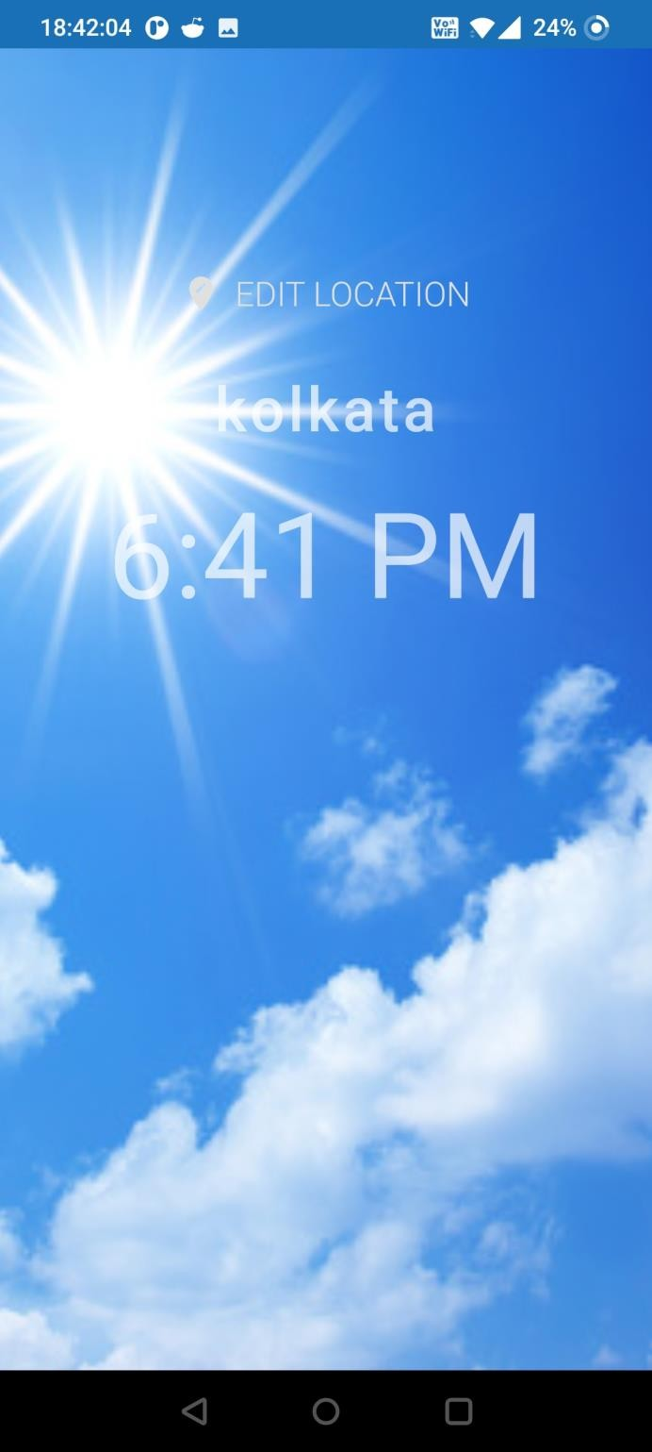

**Choose_location.dart**

import 'package:flutter/material.dart';

import 'package:lab_12/Services/world_time.dart';

class ChooseLocation extends StatefulWidget {

// const ChooseLocation({Key? key}) : super(key: key); @override

State<ChooseLocation> createState() => _ChooseLocationState();

}

class _ChooseLocationState extends State<ChooseLocation> { int counter = 0;

List<WordTime> locations = [

WordTime(location: 'kolkata', flag: 'india.png', url: 'Asia/Kolkata'), WordTime(location: 'Manila', flag: 'philippines.png', url: 'Asia/Manila'), WordTime(

location: 'Singapore', flag: 'singapore.png', url: 'Asia/Singapore'), WordTime(

location: 'Brisbane', flag: 'australia.png', url: 'Australia/Brisbane'),

WordTime(location: 'Madrid', flag: 'spain.png', url: 'Europe/Madrid'), WordTime(location: 'Vienna', flag: 'austria.png', url: 'Europe/Vienna'), WordTime(

location: 'Maldives', flag: 'maldives.png', url: 'Indian/Maldives'), WordTime(

location: 'Johannesburg', flag: 'south-africa.png', url: 'Africa/Johannesburg'),

WordTime(

location: 'Barbados', flag: 'barbados.png', url: 'America/Barbados'), WordTime(

location: 'Costa_Rica', flag: 'costa-rica.png', url: 'America/Costa_Rica'),

WordTime(location: 'Jamaica', flag: 'jamaica.png', url: 'America/Jamaica'),

WordTime(location: 'Phoenix', flag: 'usa.png', url: 'America/Phoenix'), WordTime(

location: 'Broken_Hill', flag: 'australia.png',

url: 'Australia/Broken_Hill'),

WordTime(location: 'Moscow', flag: 'russia.png', url: 'Europe/Moscow'),

];

void updateTime(index) async {

WordTime instance = locations[index]; await instance.getTime();

// navigate to home screen by popping instead of pushing new replica

// of home screen Navigator.pop(context, {

'location': instance.location, 'flag': instance.flag,

'time': instance.time, 'isDayTime': instance.isDayTime,

});

}

@override

Widget build(BuildContext context) {

// print('BUILD FUNCTION RUN IN CHOOSE LOCATION...');

return Scaffold(

backgroundColor: Colors.blueGrey[200],

// when we come/route from different screen IN APPBAR FLUTTER WILL DEFAULTLY

// PLACED "BACK ARROW <- .....

appBar: AppBar(

backgroundColor: Colors.deepPurpleAccent, title: Text('CHOOSE LOCATION'),

centerTitle: true, elevation: 0,

),

4.0),

body: ListView.builder( itemCount: locations.length, itemBuilder: (context, index) {

return Padding(

padding: const EdgeInsets.symmetric(vertical: 1.0, horizontal:

child: Card( child: ListTile(

onTap: () { updateTime(index);

},

title: Text(locations[index].location.toString()), leading: CircleAvatar(

backgroundImage: AssetImage('assets/flags/${locations[index].flag}'),

),

),

),

);

},

),

);

}

}

