**Name**: Murtaza Akil Mister

**Roll No**: CE071

**ID**: 20ITUOS088

**Batch**: A4

**Lab**: 6

Code:

import 'package:flutter/material.dart';  
  
void main()=> runApp(MaterialApp(  
 home: Text("Hello Flutter"),  
));

Output:

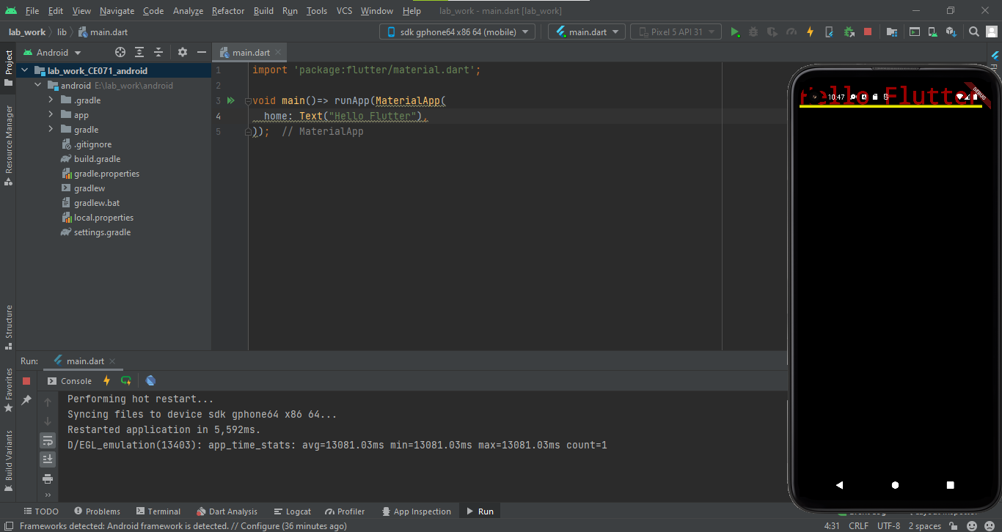

Code:

import 'package:flutter/material.dart';  
void main() => runApp(MaterialApp(  
home: Scaffold(  
appBar: AppBar(  
title: Text('HELLO World...This is my first app'),  
 centerTitle: true,  
),  
body: Center(  
child: Text('Good morning'),  
),  
floatingActionButton: FloatingActionButton(  
onPressed: () { },  
child: Text('click'),  
),  
)  
));

Output:

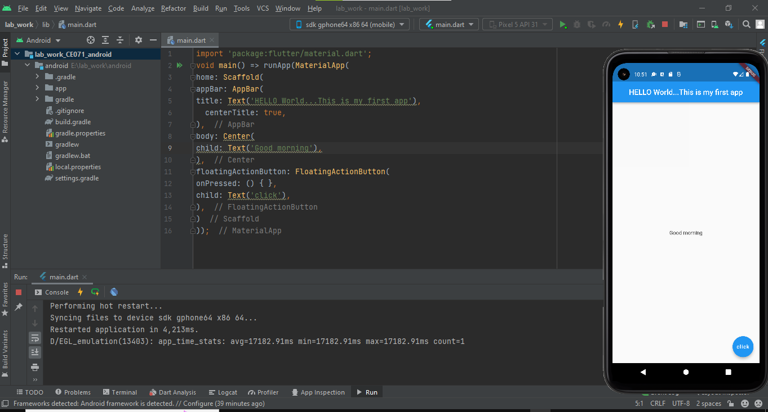

Code:

import 'package:flutter/material.dart';  
void main() => runApp(MaterialApp(  
home: Scaffold(  
appBar: AppBar(  
title: Text('HELLO World...This is my first app'),  
 centerTitle: true,  
 backgroundColor: Colors.*green*[300],  
),  
body: Center(  
child: Text('Good morning'),  
),  
floatingActionButton: FloatingActionButton(  
onPressed: () {}, // must required property...  
child: Text('click'),  
backgroundColor: Colors.*green*[600],  
),  
)  
));

Output:

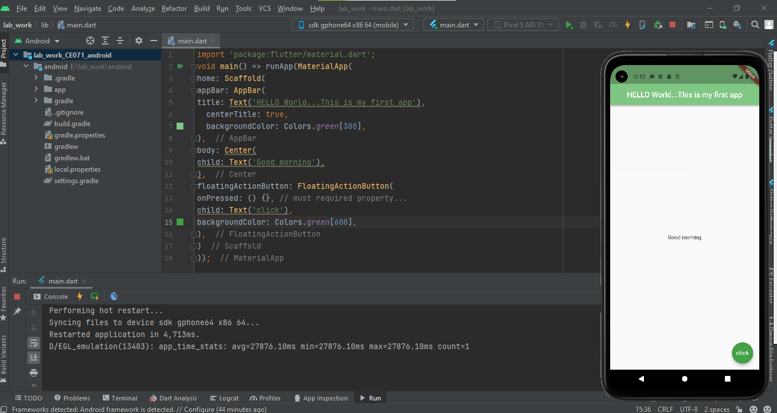

Code:

import 'package:flutter/material.dart';  
void main() => runApp(MaterialApp(  
 home: HomeScreen(),  
));  
// making your own custom stateless widget....  
// used in Hot reload and also useful in reuse...DRY feature  
class HomeScreen extends StatelessWidget {  
// const test1({Key? key}) : super(key: key);  
 @override  
 Widget build(BuildContext context) {  
 return Scaffold(  
 appBar: AppBar(  
 title: Text('HELLO World...This is my first app'),  
 centerTitle: true,  
 backgroundColor: Colors.*green*[300],  
 ),  
 body: Center(  
 child: Text('Good morning',  
 style: TextStyle(  
 fontSize: 24.0,  
 fontWeight: FontWeight.*bold*,  
 letterSpacing: 2.0,  
 color: Colors.*grey*[600],  
 fontFamily: 'Aboreto'  
 ),  
 ),  
 ),  
 floatingActionButton: FloatingActionButton(  
 onPressed: () {},  
 child: Text('Click'),  
 backgroundColor: Colors.*green*[600],  
 ),  
 );  
 }  
}

Output:

