**Name**: Murtaza Akil Mister

**Roll No**: CE071

**ID**: 20ITUOS088

**Batch**: A4

**Lab**: 6

**Github Link**: <https://github.com/MurtazaMister/CE071_SDP/tree/master/Lab7>

Code:

import 'package:flutter/material.dart';  
void main() => runApp(MaterialApp(  
 home: HomeScreen(),  
));  
  
class HomeScreen extends StatelessWidget {  
@override  
Widget build(BuildContext context) {  
 return Scaffold(  
 appBar: AppBar(  
 title: Text(  
 'HELLO FLUTTER...MY FIRST APP'),  
 centerTitle: true,  
 backgroundColor: Colors.*red*[600],  
 ),  
 body: Center(  
 child: Image(  
 image: AssetImage("assets/one.jpeg"),  
 )  
),  
floatingActionButton: FloatingActionButton(  
onPressed: () {},  
child: Text('Click'),  
backgroundColor: Colors.*red*[600],  
),  
);  
}  
}

Output:

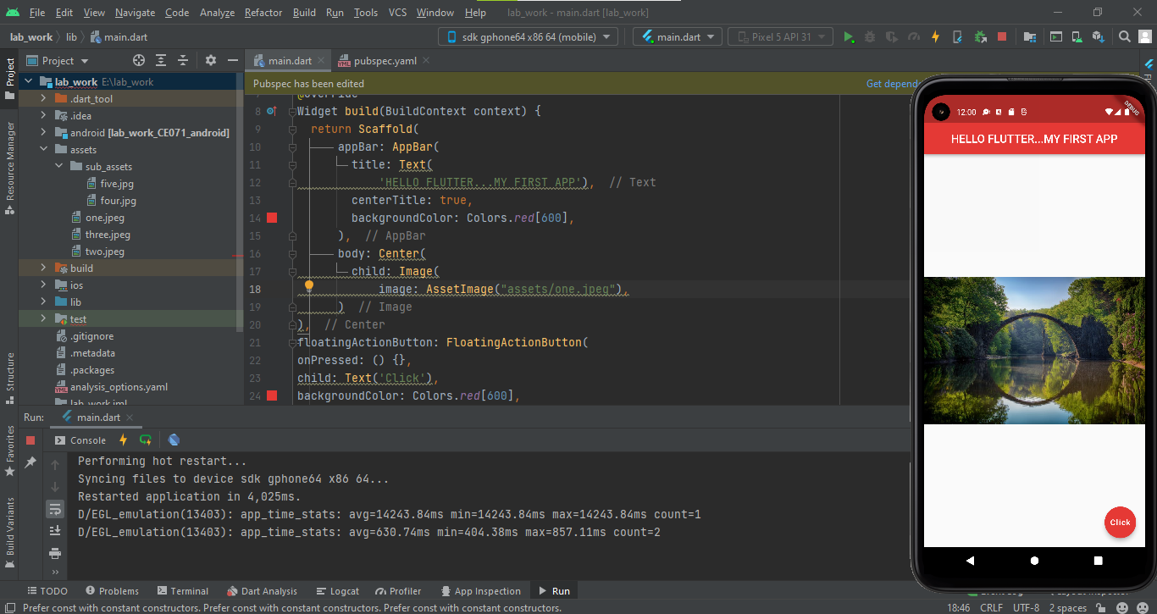

Code:

import 'package:flutter/material.dart';  
void main() => runApp(MaterialApp(  
 home: HomeScreen(),  
));  
  
class HomeScreen extends StatelessWidget {  
// const test1({Key? key}) : super(key: key);  
 @override  
 Widget build(BuildContext context) {  
 return Scaffold(  
 appBar: AppBar(  
 title: Text(  
 'BUTTONS WIDGET APP'),  
 centerTitle: true,  
 backgroundColor: Colors.*red*[600],  
 ),  
 body: Center(  
 child: ElevatedButton(  
 child: Text('Button'),  
 onPressed: () {},  
 style: ElevatedButton.*styleFrom*(  
 primary: Colors.*purple*[800],  
 padding: EdgeInsets.symmetric(horizontal: 50, vertical: 20),  
 textStyle: TextStyle(  
 fontSize: 40,  
  
 fontWeight: FontWeight.*bold*)),  
  
 ),  
 ),  
 floatingActionButton: FloatingActionButton(  
 onPressed: () {},  
 child: Text('Click'),  
 backgroundColor: Colors.*red*[600],  
 ),  
 );  
 }  
}

Output:

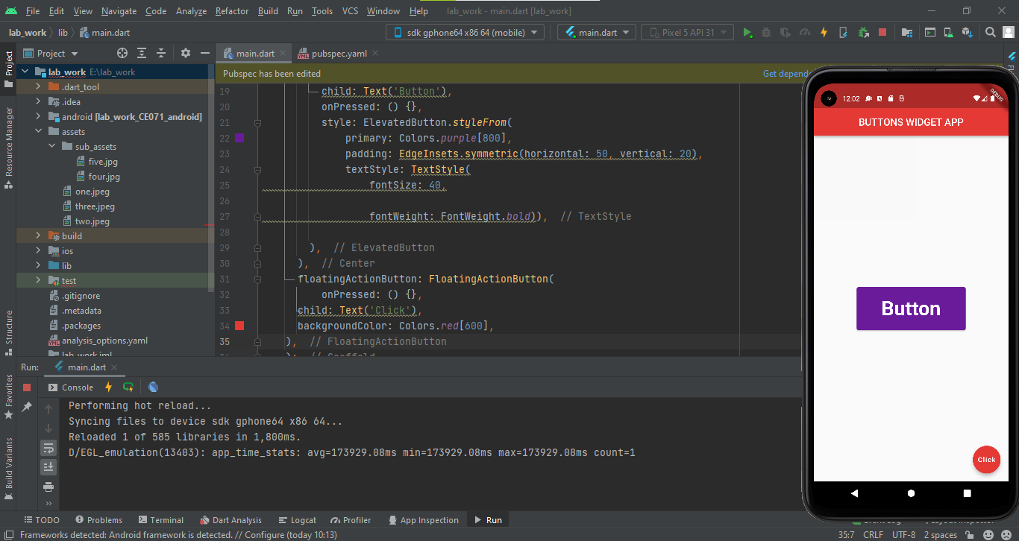

Code:

import 'package:flutter/material.dart';  
void main() => runApp(MaterialApp(  
 home: HomeScreen(),  
));  
  
class HomeScreen extends StatelessWidget {  
// const test1({Key? key}) : super(key: key);  
 @override  
 Widget build(BuildContext context) {  
 return Scaffold(  
 appBar: AppBar(  
 title: Text(  
 'BUTTONS WIDGET APP'),  
 centerTitle: true,  
 backgroundColor: Colors.*red*[600],  
 ),  
 body: Center(  
 child: TextButton.icon(  
 icon: Icon(  
 Icons.*photo_camera*,  
 color:Colors.*greenAccent*,  
 size: 50.0,  
 ),  
 label: Text(  
 "Gallery",  
 style: TextStyle(  
 color: Colors.*black*,  
 fontSize: 40.0,  
 letterSpacing: 2.0,  
 backgroundColor: Colors.*redAccent*,  
 ),  
 textAlign: TextAlign.start,  
 ),  
 onPressed: () {},  
 ),  
 ),  
 );  
 }  
}

Output:

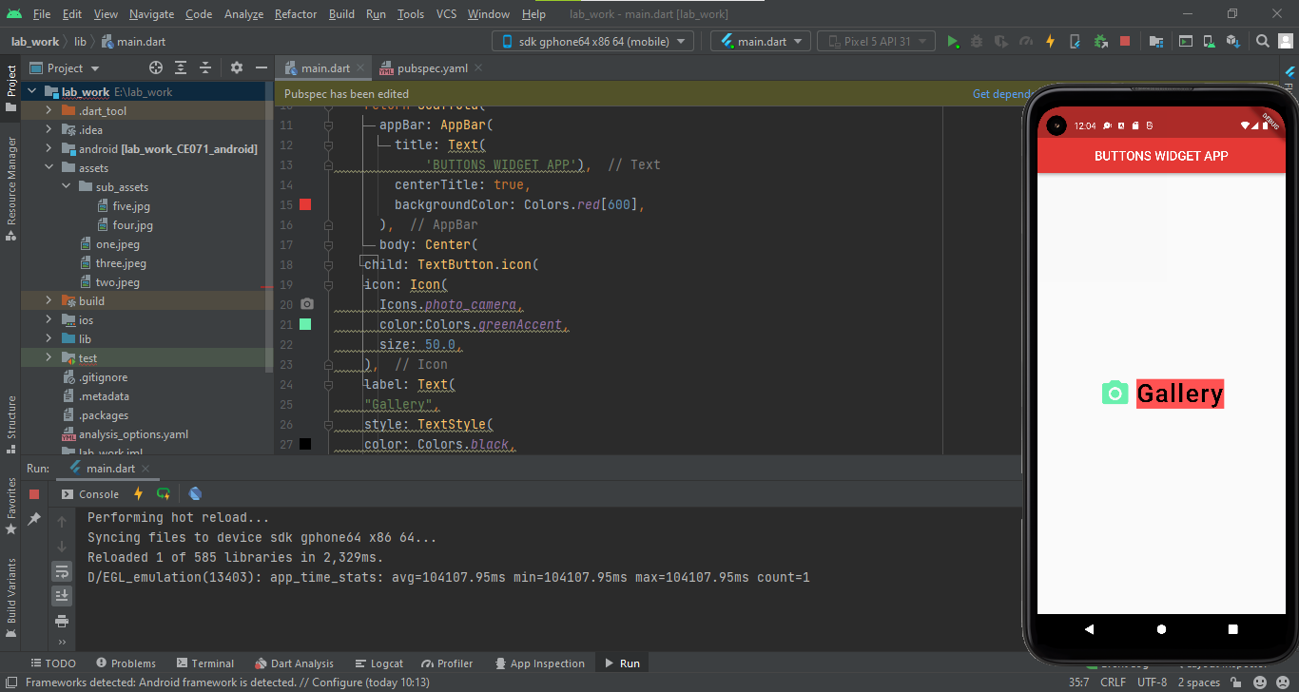

Code:

import 'package:flutter/material.dart';  
void main() => runApp(MaterialApp(  
 home: HomeScreen(),  
));  
  
class HomeScreen extends StatelessWidget {  
// const test1({Key? key}) : super(key: key);  
 @override  
 Widget build(BuildContext context) {  
 return Scaffold(  
 appBar: AppBar(  
 title: Text(  
 'BUTTONS WIDGET APP'),  
 centerTitle: true,  
 backgroundColor: Colors.*red*[600],  
 ),  
 body: Center(  
 child: Directionality(  
 textDirection: TextDirection.rtl,  
 child: TextButton.icon(  
 icon: Icon(  
 Icons.*photo_camera*,  
 color:Colors.*greenAccent*,  
 size: 50.0,  
 ),  
 label: Text(  
 "Gallery",  
 style: TextStyle(  
 color: Colors.*black*,  
 fontSize: 40.0,  
 letterSpacing: 2.0,  
 backgroundColor: Colors.*redAccent*,  
 ),  
 textAlign: TextAlign.start,  
 ),  
 onPressed: () {},  
 ),  
 ),  
 ),  
 );  
 }  
}

Output:

