**Name**: Murtaza Akil Mister

**Roll No**: CE071

**ID**: 20ITUOS088

**Batch**: A4

**Lab**: 9

**Github link**: <https://github.com/MurtazaMister/CE071_SDP/blob/master/Lab9>

Part 1

Code:

**main.dart**

import 'package:flutter/material.dart';  
//import 'package:lab8_2/quote.dart';  
import 'quote.dart'; // due to same directory file no need path  
import 'quote_card.dart';  
  
void main() => runApp(MaterialApp(  
 home: EchoList(),  
));  
class EchoList extends StatefulWidget {  
 const EchoList({Key? key}) : super(key: key);  
 @override  
 State<EchoList> createState() => _EchoListState();  
}  
class _EchoListState extends State<EchoList> {  
 List<Quote> quotes = [  
 Quote(text: 'The truth is really pure and never simple',author:  
 'Vijay Sahani'),  
 Quote(author: 'Nachiket Malhotra', text: 'I see humans but no humanity'),  
 Quote(text: 'The time is always right to do what is right',author:  
 'Ajoy Shantidas'),  
 ];  
  
 Widget quoteTemplate(quote){  
 return QuoteCard(quote: quote,);  
 }  
  
 @override  
 Widget build(BuildContext context) {  
 return Scaffold(  
 backgroundColor: Colors.*pink*[100],  
 appBar: AppBar(  
 title: Text('Quotes'),  
 centerTitle: true,  
 backgroundColor: Colors.*purple*[300],  
 ),  
 body: Column(  
// mainAxisAlignment: MainAxisAlignment.center,  
// crossAxisAlignment: CrossAxisAlignment.center,  
 children: quotes.map((quote) => QuoteCard(quote: quote)).toList(),  
 ),  
 );  
 }  
}

**quote.dart**

class Quote{  
 String text;  
 String author;  
  
 Quote({this.text='', this.author=''});  
}

**quote_card.dart**

import 'package:flutter/material.dart';  
import 'quote.dart';  
  
class QuoteCard extends StatelessWidget {  
 // const QuoteCard({  
 // Key? key,  
 // }) : super(key: key);  
  
 final Quote quote;  
 QuoteCard({required this.quote});  
  
 @override  
 Widget build(BuildContext context) {  
 return Card(  
 margin: EdgeInsets.fromLTRB(20.0, 30.0, 40.0, 10.0),  
 child: Padding(  
 padding: const EdgeInsets.all(12.0),  
 child: Column(  
 crossAxisAlignment: CrossAxisAlignment.stretch,  
 children: [  
 Text(  
 quote.text,  
 style: TextStyle(  
 fontSize: 23,  
  
 color: Colors.*deepPurple*,  
  
 ),  
 ),  
 SizedBox(height: 10),  
 Text(  
 quote.author,  
 style: TextStyle(  
 fontSize: 15,  
  
 color: Colors.*deepPurple*,  
  
 ),  
 ),  
 ],  
 ),  
 ),  
 );  
 }  
}

Output:

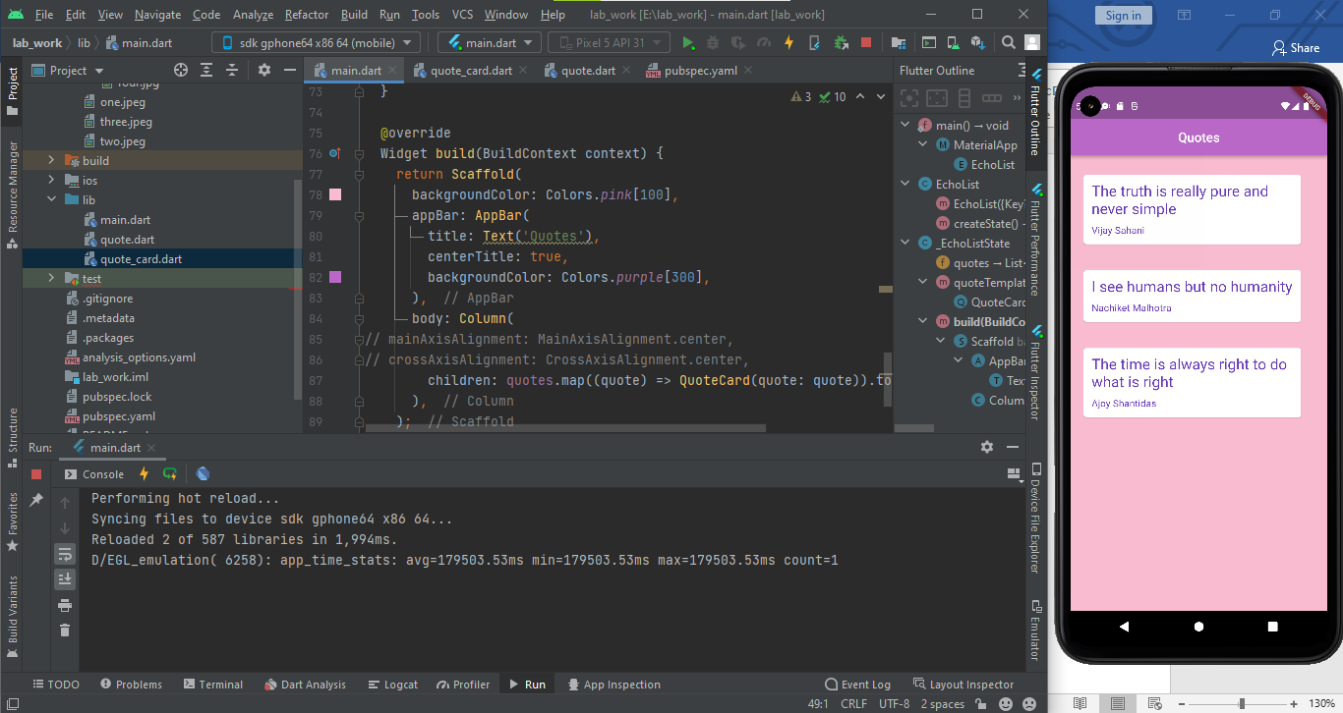

Code:

**Main.dart**

import 'package:flutter/material.dart';  
import 'quote.dart'; // Absolute path  
//import 'quote.dart'; // due to same directory file relative path will work  
import 'quote_card.dart'; // Relative path  
  
void main() => runApp(MaterialApp(  
 home: EchoList(),  
));  
class EchoList extends StatefulWidget {  
 @override  
 State<EchoList> createState() => _EchoListState();  
}  
class _EchoListState extends State<EchoList> {  
/*  
List<String> quotes = [  
'The truth is realy pure and never simple',  
'I see humans but no humanity',  
'The time is always right to do what is right'  
];  
// List<String> author = [];  
*/  
/* this will create error..because list is now not of string....  
List<String> quotes = [  
Quote(text: 'The truth is realy pure and never simple',author:  
'jignesh1'),  
];  
*/  
 List<Quote> quotes = [  
 Quote(text: 'The truth is realy pure and never simple', author:  
 'Nachiket'),  
 Quote(author: 'Jon', text: 'I see humans but no humanity'),  
 Quote(text: 'The time is always right to do what is right', author:  
 'Robert'),  
 ];  
  
/*  
Widget quoteTemplate(quote){  
return QuoteCard(quote: quote,);  
}  
*/  
 @override  
  
 Widget build(BuildContext context) {  
 return Scaffold(  
 backgroundColor: Colors.*lightBlueAccent*[100],  
 appBar: AppBar(  
 title: Text('Quotes'),  
 centerTitle: true,  
 backgroundColor: Colors.*orangeAccent*,  
 ),  
 body: Column(  
// mainAxisAlignment: MainAxisAlignment.center,  
// crossAxisAlignment: CrossAxisAlignment.center,  
// children: quotes.map((quote) => quoteTemplate(quote)).toList(),  
 children: quotes.map((quote) =>  
 QuoteCard(  
 quote: quote,  
 delete: () {  
 setState(() {  
 quotes.remove(quote);  
 });  
 },  
 )).toList(),  
 ),  
 );  
 }  
}

**quote.dart**

class Quote{  
 String text;  
 String author;  
  
 Quote({this.text='', this.author=''});  
}

**quote_card.dart**

import 'package:flutter/material.dart';  
import 'quote.dart'; // Absolute path  
class QuoteCard extends StatelessWidget {  
// Quote quote; // in StatelessWidget can't allowed variable ..  
 final Quote quote;  
// final void Function() delete; // or you can use following code also  
 final VoidCallback delete;  
 QuoteCard({required this.quote,required this.delete});  
 @override  
 Widget build(BuildContext context) {  
 return Card(  
 margin: EdgeInsets.fromLTRB(20.0, 30.0, 40.0, 10.0),  
 child: Padding(  
 padding: const EdgeInsets.all(12.0),  
 child: Column(  
 crossAxisAlignment: CrossAxisAlignment.stretch,  
 children: [  
 Text(  
 quote.text,  
 style: TextStyle(  
 fontSize: 20,  
 color: Colors.*deepPurple*,  
 ),  
 ),  
 SizedBox(height: 10),  
 Text(  
 quote.author,  
 style: TextStyle(  
  
 fontSize: 26,  
 color: Colors.*deepPurple*,  
 ),  
 ),  
 SizedBox(height: 8.0,),  
 TextButton.icon(  
/*  
our data doesn't exist inside this stateless widget class..  
data are in 'main.dart' file. ..  
*/  
 onPressed: delete,  
 icon: Icon(Icons.*delete*),  
 label: Text('Delete Quote'),  
 ),  
 ],  
 ),  
 ),  
 );  
 }  
}

Output:

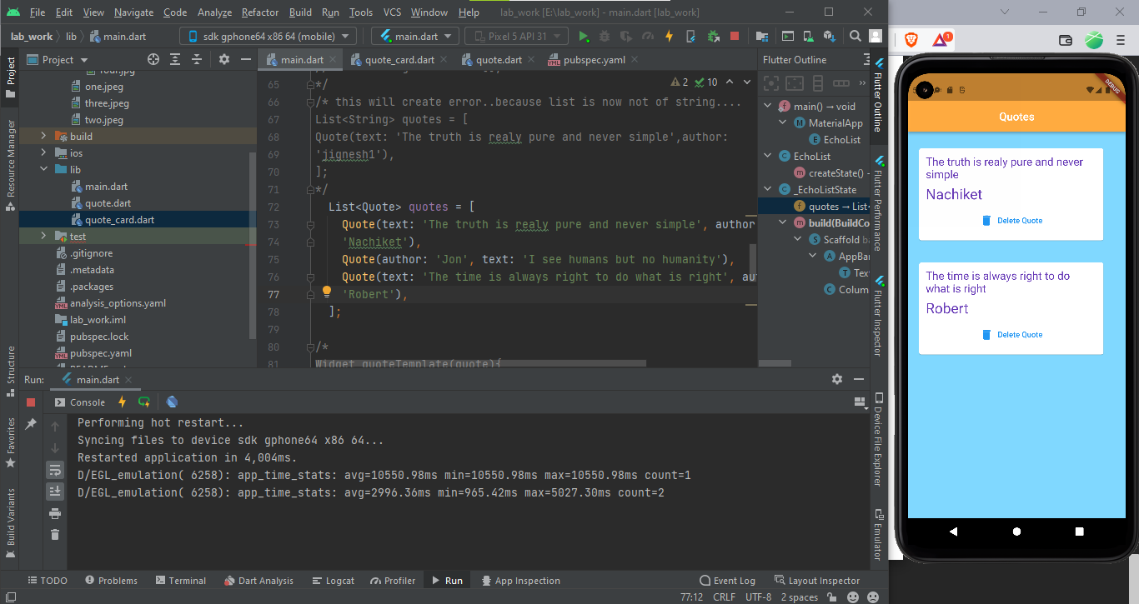

Part 2

Code:

**Main.dart**

import 'package:flutter/material.dart';  
import 'package:lab_work/Pages/home.dart';  
void main() => runApp(MaterialApp(  
 home: Home(),  
));

**Home.dart**

import 'package:flutter/material.dart';  
class Home extends StatefulWidget {  
 @override  
 State<Home> createState() => _HomeState();  
}  
class _HomeState extends State<Home> {  
 @override  
 Widget build(BuildContext context) {  
 return Scaffold(  
 body: SafeArea(child: Text('HOME SCREEN')),  
 );  
 }  
}

Output:

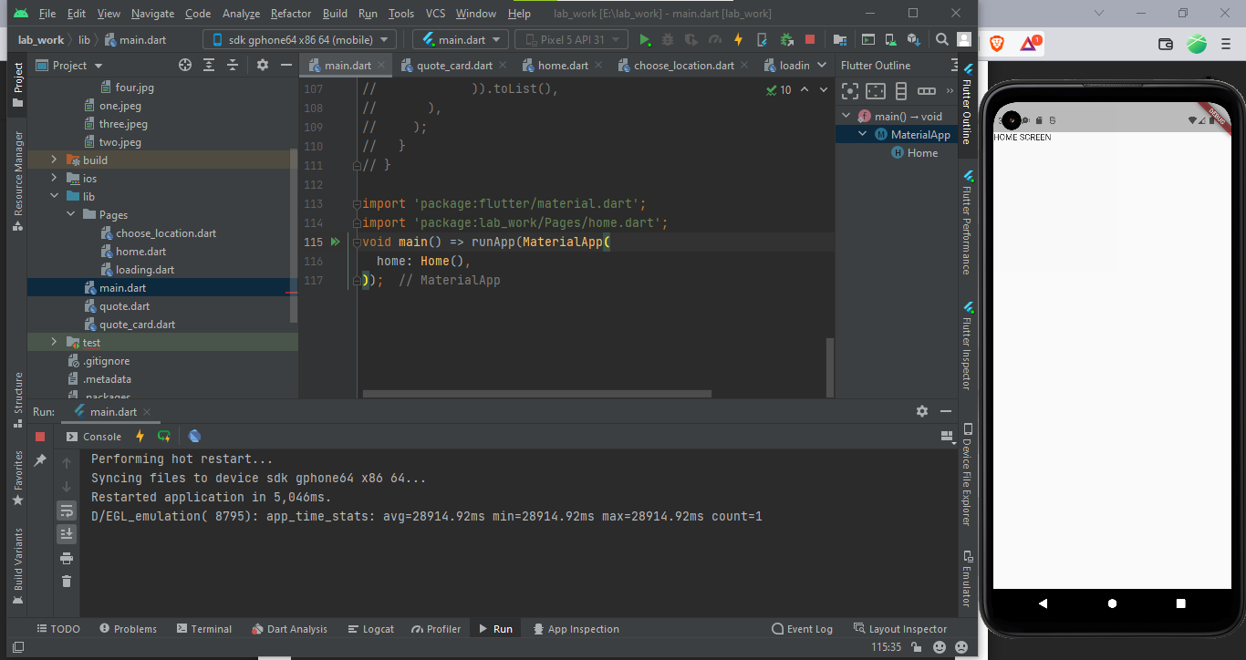

Code:

**Main.dart**

import 'package:flutter/material.dart';  
import 'package:lab_work/Pages/choose_location.dart';  
import 'package:lab_work/Pages/home.dart';  
import 'package:lab_work/Pages/loading.dart';  
  
void main() => runApp(MaterialApp(  
 initialRoute: '/home',  
 routes: {  
 '/': (context) => Loading(),  
 '/home': (context) => Home(),  
 '/location': (context) => ChooseLocation(),  
 }  
));

**Home.dart**

import 'package:flutter/material.dart';  
class Home extends StatefulWidget {  
 @override  
 State<Home> createState() => _HomeState();  
}  
class _HomeState extends State<Home> {  
 @override  
 Widget build(BuildContext context) {  
 return Scaffold(  
 body: SafeArea(child: Column(  
 children: [  
 TextButton.icon(  
 onPressed: (){  
 Navigator.*pushNamed*(context, '/location');  
 },  
 icon: Icon(Icons.*edit_location*),  
 label: Text("Edit location"),  
 )  
 ],  
 )),  
 );  
 }  
}

**Choose_location.dart**

import 'package:flutter/material.dart';  
class ChooseLocation extends StatefulWidget {  
// const ChooseLocation({Key? key}) : super(key: key);  
 @override  
 State<ChooseLocation> createState() => _ChooseLocationState();  
}  
class _ChooseLocationState extends State<ChooseLocation> {  
 @override  
 Widget build(BuildContext context) {  
 return Scaffold(  
 body: Text('CHOOSE LOCATION SCREEN'),  
 );  
 }  
}

**Loading.dart**

import 'package:flutter/material.dart';  
class Loading extends StatefulWidget {  
// const Loading({Key? key}) : super(key: key);  
 @override  
 State<Loading> createState() => _LoadingState();  
}  
class _LoadingState extends State<Loading> {  
 @override  
 Widget build(BuildContext context) {  
 return Scaffold(  
 body: Text('LOADING SCREEN'),  
 );  
 }  
}

Output:

