**Compiler Construction**

**CS-424**

**Assignment#1**



Murtaza Rasheed

2020388

**Procedure**

**Tokenization Strategy:**

* Utilizes regular expressions for efficient and flexible tokenization.
* Implements a finite state machine approach for systematic token recognition.

**Token Representation:**

* Employs a Token class encapsulating token type and lexeme.
* Allows for easy extension of the Token class to accommodate additional token attributes.

**Error Handling:**

* Detects and reports lexical errors, ensuring code integrity.
* Provides informative and user-friendly error messages for ease of debugging.

**Scanning Strategy:**

* Processes MiniLang code line by line for granular analysis.
* Sequentially tokenizes code within each line, ensuring accuracy.

**Flexibility and Extensibility:**

* Defines token patterns in a modular and extensible manner.
* Employs parameterized token patterns for customization to specific language features.

**Documentation and Readability:**

* Organizes code with clear functions and modular components for readability.
* Provides comprehensive documentation for understanding and extending scanner functionality.

**Examples and Results**

**Example1:**

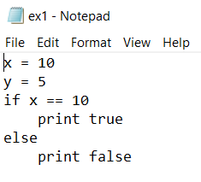

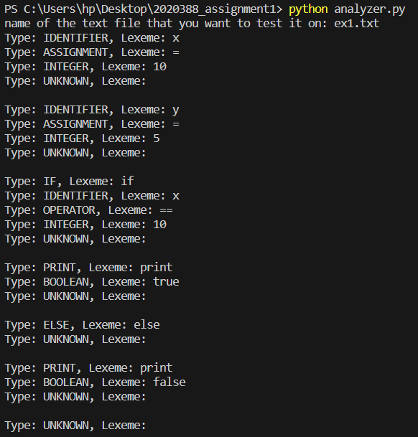

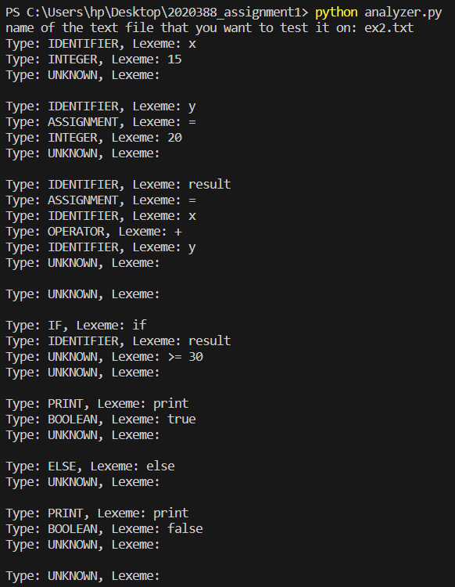**Example2:**

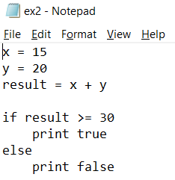

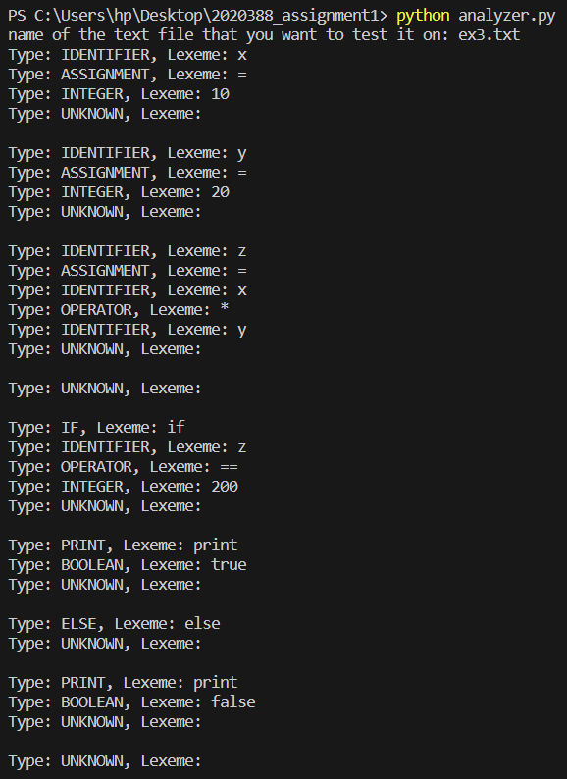**Example3:**

