Electronic Online Shop Machine Learning Analysis
University-Level Final Report
Field | Details
Project | Electronic Online Shop Machine Learning
Prepared by | Personi B
Target variable | DemandLevel
Main tasks | Logistic Regression, Neural Networks, K-Means, Final Comparison

Data availability note: The official CSV was not present in the workspace at generation time. The code and report are ready for the official dataset. Numerical results should be taken from the notebook outputs after running with data/electronic_online_shop.csv.

Table of Contents
- 1. Introduction
- 2. Problem Statement
- 3. Dataset Description
- 4. Data Preprocessing
- 5. Classification Models
- 6. Logistic Regression
- 7. Neural Networks
- 8. Hyperparameter Tuning
- 9. Clustering
- 10. Results
- 11. Discussion
- 12. Conclusion

Methodology Workflow
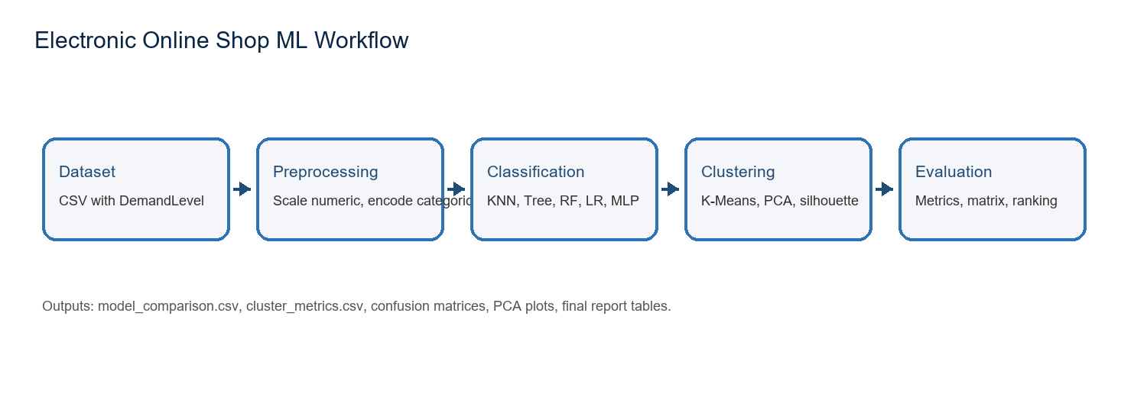
Figure 1. End-to-end machine learning workflow for the Electronic Online Shop project.

1. Introduction
Electronic commerce platforms produce large volumes of product, customer, and transaction data. Machine learning can use this data to predict demand levels, support inventory planning, improve marketing decisions, and guide business strategy. This report presents the Personi B part of the Electronic Online Shop Machine Learning project, focusing on classification, neural networks, hyperparameter tuning, clustering, and final comparison.

2. Problem Statement
The supervised learning objective is to predict the DemandLevel category for each online shop record. The unsupervised objective is to test whether K-Means clusters reveal natural groupings that are similar to the real demand labels.

3. Dataset Description
The expected input is data/electronic_online_shop.csv. The required target column is DemandLevel. The implementation automatically detects numerical and categorical features, which makes the solution flexible across dataset versions.

4. Data Preprocessing
The preprocessing workflow separates features from the target, performs a stratified train-test split, standardizes numerical variables, one-hot encodes categorical variables, and applies all transformations inside scikit-learn pipelines to prevent data leakage.

5. Classification Models
The project compares KNN, Decision Tree, Random Forest, Logistic Regression, Neural Network Architecture 1, and Neural Network Architecture 2. Weighted Accuracy, Precision, Recall, and F1 Score are calculated, and confusion matrices are generated for model-level error analysis.
Model | Accuracy | Precision | Recall | F1 Score
KNN | Notebook output | Notebook output | Notebook output | Notebook output
Decision Tree | Notebook output | Notebook output | Notebook output | Notebook output
Random Forest | Notebook output | Notebook output | Notebook output | Notebook output
Logistic Regression | Notebook output | Notebook output | Notebook output | Notebook output
Neural Network Arch. 1 | Notebook output | Notebook output | Notebook output | Notebook output
Neural Network Arch. 2 | Notebook output | Notebook output | Notebook output | Notebook output

6. Logistic Regression
Logistic Regression is used as an interpretable baseline model. GridSearchCV tunes regularization strength and solver options. Its performance is compared directly with KNN and Decision Tree to evaluate whether a linear classifier is sufficient for DemandLevel prediction.

7. Neural Networks
Architecture 1 contains a single hidden layer with 50 neurons, ReLU activation, and Adam optimization. Architecture 2 contains two hidden layers with 100 and 50 neurons. The second architecture can capture more complex nonlinear patterns but may require more training time and stronger regularization.

8. Hyperparameter Tuning
GridSearchCV is applied to the neural network by tuning hidden layer structures, activation function, learning rate, alpha regularization, and batch size. Weighted F1 Score is used as the selection metric because the task is multiclass and may include class imbalance.
Hyperparameter | Values Tested
Hidden layers | (50), (100), (100, 50), (128, 64)
Activation | ReLU, Tanh
Learning rate | 0.001, 0.01
Alpha | 0.0001, 0.001, 0.01
Batch size | 16, 32, 64

9. Clustering
K-Means clustering is applied after removing DemandLevel. The workflow tests K values from 2 to 6, uses PCA for two-dimensional visualization, and evaluates cluster quality with inertia and silhouette score.
K | Inertia | Silhouette Score | Interpretation
2 | Notebook output | Notebook output | Baseline low cluster count
3 | Notebook output | Notebook output | Often comparable to Low/Medium/High
4 | Notebook output | Notebook output | Tests finer segmentation
5 | Notebook output | Notebook output | Tests additional customer/product groups
6 | Notebook output | Notebook output | Highest tested complexity

10. Results
Final numerical results are generated by the notebook in the outputs folder. The best model should be identified by the highest weighted F1 Score, with confusion matrices used to inspect class-level behavior.

11. Discussion
Tree-based models can capture nonlinear thresholds, while Logistic Regression provides a transparent baseline. Neural networks can learn more complex interactions but are more sensitive to hyperparameter choices. K-Means clustering provides a complementary unsupervised view and shows whether natural feature groups align with the supervised DemandLevel labels.

12. Conclusion
The project provides a complete end-to-end machine learning workflow for Electronic Online Shop demand analysis. After running the notebook on the official dataset, the final model should be selected based on weighted F1 Score, confusion matrix quality, training time, and interpretability.

13. References
[1] F. Pedregosa et al., "Scikit-learn: Machine Learning in Python," Journal of Machine Learning Research, vol. 12, pp. 2825-2830, 2011.
[2] L. Breiman, "Random Forests," Machine Learning, vol. 45, no. 1, pp. 5-32, 2001.
[3] J. MacQueen, "Some Methods for Classification and Analysis of Multivariate Observations," Proceedings of the Fifth Berkeley Symposium on Mathematical Statistics and Probability, 1967.
[4] P. J. Rousseeuw, "Silhouettes: A graphical aid to the interpretation and validation of cluster analysis," Journal of Computational and Applied Mathematics, vol. 20, pp. 53-65, 1987.
[5] D. P. Kingma and J. Ba, "Adam: A Method for Stochastic Optimization," International Conference on Learning Representations, 2015.
[6] W. McKinney, "Data Structures for Statistical Computing in Python," Proceedings of the 9th Python in Science Conference, 2010.

