CSE 5334-002 | Project 2

Task Details:

Task A results

1. Data file used “HandWrittenLetters.txt”. Using first 30 images for train and remaining for test.
2. Generated data using the four classifiers:
3. SVM: 95.56%
4. KNearestNeighbor(K=5): 88.89%
5. Centroid: 86.67%
6. Linear Regression: 88.88%

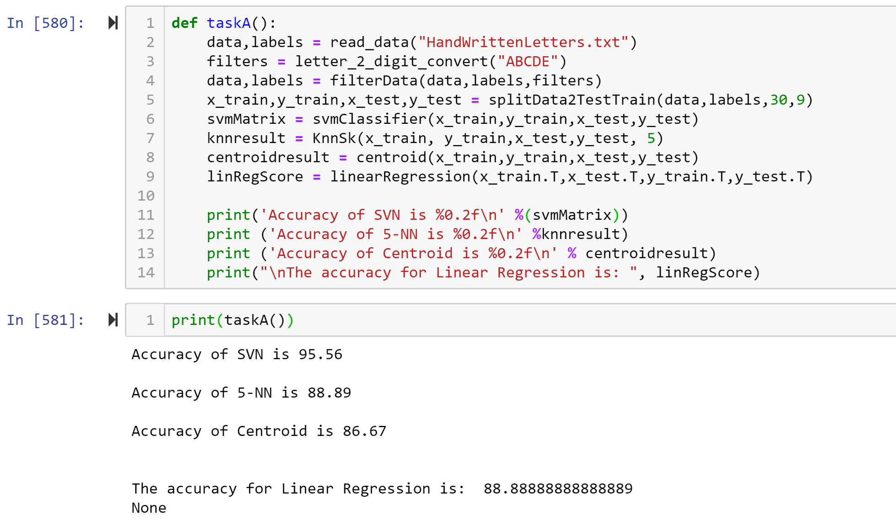

Task B results

1. Data file used “ATNTFaceImages400.txt”. Using statifiedKFold function.
2. Generated data using the four classifiers:
3. SVM: [100.0, 98.75, 100.0, 96.25, 96.25]
4. KNN [90.0, 90.0, 88.75, 91.25, 91.25]
5. centroid [93.75, 95.0, 93.75, 92.5, 87.5]
6. linear [96.25, 91.25, 96.25, 85.0, 87.5]

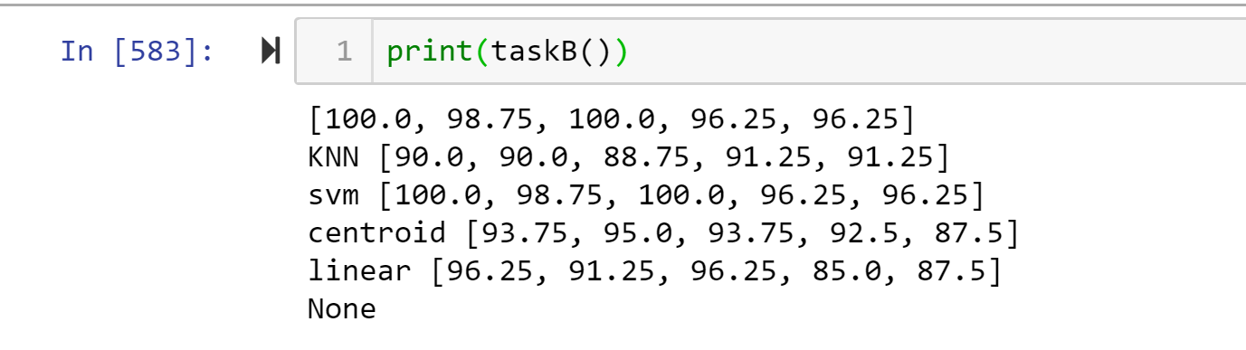

Task C results:

1. Data file used “HandWrittenLetters.txt”.
2. Generated result for centroid Classifier

Result : [31.045751633986928, 67.81609195402298, 69.44444444444444, 76.0233918128655, 77.97619047619048, 77.77777777777779, 83.33333333333334].

Graph Task(C):

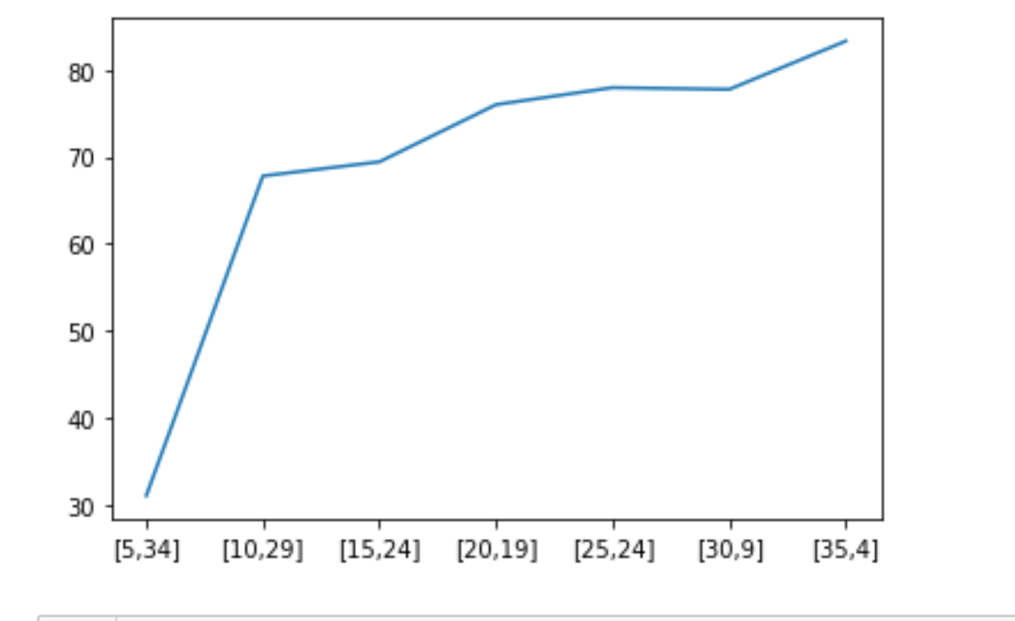

Task D :

1. Data file used “HandWrittenLetters.txt”.
2. Generated result for centroid Classifier

Result : [38.52941176470588,

55.172413793103445,

67.08333333333334,

79.47368421052632,

76.78571428571428,

78.88888888888889,

72.5]

Graph :

