Internal

Document Status: Approved

Released by:

Revision / Document History

Ver. | Date | Changed by | Modifications
1.0 | 01/12/2020 | Periyasamy Sengottian | Initial Version
1.1 | 07/12/2020 | Periyasamy Sengottian | Annexure 1 added

List of Abbreviations
CR Change Request
FLM First Level Management
KPI Key performance Indicator
KT Knowledge Transfer
MSR Monthly Status Report
ODC Offshore Development Center
BGSW Robert Bosch Engineering and Business Solutions Private Limited
RDBMS Relational Database management System
SOW Statement of Work
SPOC Single Point of Contact
SQA Software Quality Assurance

Table of Contents
1. Objective/Introduction Error! Bookmark not defined.
2. Scope Error! Bookmark not defined.
3. Brief Description Error! Bookmark not defined.
4. Others Error! Bookmark not defined.
5. Annexure Error! Bookmark not defined.

Introduction and Objectives - Executive Summary

Robert Bosch Engineering and Business Solutions Private Limited (BGSW) is one of the world's leading global supplier of technology and services, offering End to End Engineering Solutions, IT Solutions and Business Solutions.

The current requirement is catering to the development of the applications developed in AL/ ML technologies such as Python, NumPy and Pandas, Pytorch and TensorFlow etc. The project requires to develop advanced AI architectures incorporating state-of-the-art GenAI technologies (RAG, LLMs, fine tune LLMs, Fine tuning LLMs, etc)

The purpose of this document is to share the requirement details to service provider and to obtain Service Provider’s agreement and commitment to execute the project needs in a manner to fulfil the requirements.

The main objectives of this initiative are as follows:

Reduced Overall Costs: Utilizing Service Provider services with best in class resources, increased productivity, and stringent project management principles to reduce the overall cost of the service, solution and ownership.

The long-term objective is also to build a reliable partner for this service and related services in future.

Scope of Work

External associate will receive the tasks of requirement analysis and development or change requests.

The following are the detailed scope of activities which need to be executed by external associates. External associate should adhere the process and guidelines of the respective project. The details of the project would be discussed as part of the on boarding process.

- Refer Annexure 1 for the detailed scope of work

Not in Scope
Whatever not mentioned in the scope

Service Hours
External associate need follow the calendar of BGSW location specific working days and working hours (IST). BGSW defined festival holidays shall be availed based on the approval from the respective BGSW project manager.

Communication Model

- In general, Project related information shall be shared through formal Email. Meetings shall be planned through Skype or Microsoft Teams.
- If any project specific model is defined then external associate need to follow the same.

Target operating model
The Target operating model is as shown in Fig. 1.
FIG-1
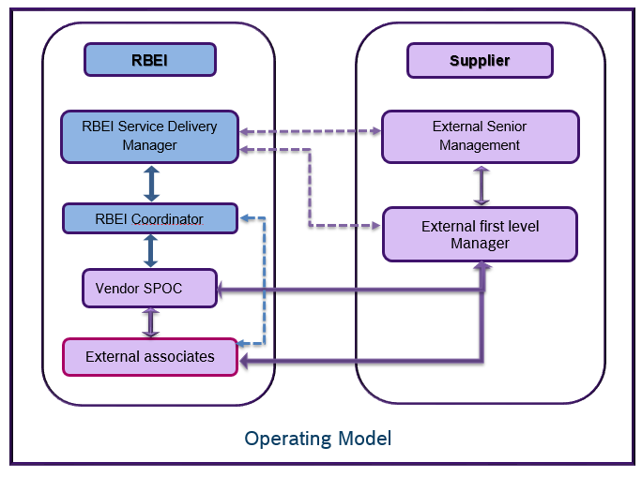

- The Service Provider will deploy the team in BGSW premises or Service provider’s ODC location to execute this service
- The external team will have a SPOC among the team member (preferred senior) to interface with the BGSW coordinator or BGSW Service Delivery Manager
- BGSW expects the Service Provider to nominate a First level Manager who will be the escalation point and Management contact in the Service Provider Organization
- External team is also expected to directly interact with customer in case required

Role of the Vendor SPOC / Team Lead
- Single point of contact (SPOC) for the BGSW Coordinator / BGSW Service Delivery Manager
- Mentor / Guide the external team for technical clarification
- Responsible for all the project deliverables of the team, from the initial transition phase, task allocation, tracking, BGSW QMS Adherence and clarifications.
- Review the tasks handled by the external team and ensure quality of the deliverables with in the timeline
- Coordination and administrative activities necessary to support the external team.
- Sending Weekly (every First working day of the week) and monthly status report (MSR) to BGSW Service Delivery Manager before 6th of every month in BGSW Specific format. Feedback of MSR will be provided by BGSW Service Delivery Manager

The detailed responsibilities from project perspective are elaborated in a subsequent section of the RFP.

Role of the Vendor – First Line Manager

The vendor-FLM will be responsible for the overall engagement of the Supplier with BGSW. The expectation is to be the single point of contact for BGSW for the following aspects:

- Nomination of suitable resources and facilitate evaluation by BGSW
- Support initial induction of the Supplier team
- Tracking the progress of the ScPL on project deliverables
- First Escalation level by BGSW on any issues
- Support to ScPL on any issue
- Handling changes in scope, resources and any other issues related to the Supplier’s area of activity

Project Organization with respect to Supplier

As depicted in Fig. below, the Supplier team will function as project team of BGSW, headed by the BGSW Service Delivery Manager.

Vendor SPOC
- Team Member1
- Team Member2
RBEI – Service Delivery Manager

Service Targets

KPI | Target to achieve | Measurement | Impact
On time Delivery (Development / CR) | Green : 100%  Amber : >= 95%  Red : < 95% | No. of Tasks delivered on or before the delivery date within the time period / Total no. of tasks planned for delivery within the time period * 100  Note :- Delay of more than 1 day for any task will also be considered as red | All the tasks should be delivered to BGSW on or before the delivery date. Delay will impact in Go live
BGSW Review / Testing defect Rate (Development /CR) | Green : Only Cosmetic / Improvement points  Yellow : <= 5 Minor defects  Red : > 5 Minor or any Major defects | No. of Defects raised in HPALM by BGSW coordinator within the time period | In General, major / minor / fatal errors should be avoided.  If any defects found by BGSW in 1st iteration then the defects from first iteration will only be verified on 2nd iteration.  Cosmetic / improvement points shall be accepted.  Avoid multiple iteration of reviews which will increase the effort of BGSW team.
On time Delivery (2nd Level Support) | >=90% (Green)  >=85 & < 90 (Yellow)  <85 (Red) | O1KPI1 Report from CI reporting. | All the tasks should be delivered on or before the timeline. Any delay will impact the KPI to customer
Ticket Reopen Rate (2nd Level Support) | <=2% (Green)  >2% & <=3% (Yellow)  >3% (Red) | O1KPI2 Report from CI reporting. | In General, ticket should not be reopened for the same issue. It will impact the agreed KPI to customer

2.1 Service Level Reporting
Vendor-SPOC need to send the Weekly Status Report and Monthly Status Report.

- Weekly Status Report
  - Details of Progress for all the activities during the week
  - Challenges and Process related issues
  - This report should be available every Monday or first working day of every week.

- Monthly Status Report(MSR)- This report contains the below information: -
  - Details of Progress Key activities during month
  - KPI reports for the reporting month
  - Task statistics
  - Highlights and lowlights
  - Major issues/key risks/ Outages during month
  - Concern areas and suggested action plans
  - Process / System Improvement achieved during month
  - Activities planned for the next reporting period

2.2 Service Level Review
- The review will be done on a monthly basis between Vendor-SPOC and BGSW Service Delivery manager and on a quarterly between Service Provider’s First Level Manager & BGSW Service Deliver Manager.
- This review can be done with short notice if project health is critical.

Escalation Matrix
For any escalation and deviation in services by externals, following escalation matrix will follow.

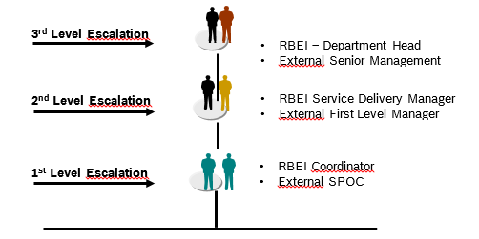

Skill requirements
- Refer Annexure 1

Delivery Model

4.1 Deliverables
- Refer Annexure 1

4.2 Acceptance criteria
- The deliverables are accepted if the source codes, process related records and documents are delivered to BGSW or BGSW customer without any errors on or before the due date

4.3 Roles and Responsibilities
Supplier
Role | Responsibility
Vendor SPOC | As defined in section 1.5.1
Vendor First level manager | As defined in Section 1.5.2
BGSW
Role | Responsibility
BGSW Delivery Manager | - Management Reviews  - Handling escalation
BGSW Service delivery manager | - Periodical review with Vendor SPOC  - Billing confirmation to Vendor SPOC  - Feedback to Service provider
BGSW Project manager | - Task planning  - Task / ticket allocation  - Review and Testing  - Feedback to Vendor SPOC  - Providing clarification on requirements

4.4 Quality Assurance

The Supplier team should comply with the Software Quality Assurance (SQA) Plan for every project. Our Approach to SQA for every engagement covers the following:

1. Product and Process Standards to be adopted
2. Work Product Review plan
3. Frequency of Audits to ensure quality compliance
4. Quality Assurance reporting that includes:
- Internal Quality audit report
- Metrics report
- Process Compliance report
- Having local copy of data or Data Sharing to external parties are against policy violation and External team to adhere on the confidentiality.

4.5 Project Communication

External associates need to follow the communication type and model defined by BGSW or customer as per the project plan

Communication Type/Media | From | To | Frequency | Things to be discussed
Monthly status reporting | Vendor–SPOC | BGSW Service Delivery Manager | Monthly | - Project status Issues  - Monthly Status Report
Weekly status reporting | Vendor-SPOC | BGSW Service Delivery Manager | Weekly | - Project status Issues  - Weekly Status Report
Senior Management Review | Vendor-SPOC  Vendor-FLM | BGSW Service Delivery Manager  BGSW Department Head | Quarterly | - Open Issue / Escalation  - Progress of external associate  - KPI targets and Achievements  - Project Feedback to Externals  - Area of Improvement

Resource requirements

5.1 Human resources
- Service Provider shall provide the agreed number of resources with the appropriate skills required to execute the project at BGSW Offshore location or at Service provider’s ODC location as agreed.
- BGSW expects all the resources to continue unchanged till completion of the project or termination of contract.
- Any changes in the resource should have minimum one month of overlapping period and knowledge transfer should be taken care by Vendor-SPOC. The cost for the overlapping period and Knowledge transfer shall be borne by Service provider.
- External associates leaves need to be managed by Vendor-SPOC and it should not affect the delivery date or quality. If any technical Support required for external associates then Vendor-SPOC need to arrange the technical Support for the same.
- Refer Annexure 1 for required human resource requirements

5.2 Hardware resources
- BGSW will provide the standard desktop / laptop required for the project.
- The External team should not carry Service Provider-provided or personal laptops to BGSW premises.
- In case external team is working from ODC then Service provider need to arrange the desktop / laptop.

5.3 Software resources
- BGSW shall ensure the availability of general operating system and project specific tools and software available in the BGSW provided desktops.

5.4 Transition
- Plan
  - After formal selection of Service Provider and acceptance of the external team, BGSW shall provide initial project-specific induction to the external team. This induction will be conducted for duration of 2 weeks.
  - The training includes all necessary information, documents, guidelines, processes involved in the project.
  - Access to the necessary systems for the external associates shall be arranged by BGSW coordinator during this phase.
  - BGSW expects the Service Provider to bear the costs of this transition and exclude the same from the service charges.
  - In case of any resource changes during project, Vendor-SPOC has to take care for knowledge transfer for the replaced resources and smooth transition
- Roles and responsibilities

Topics | Responsible | Remarks
Project Specific Induction training, documents, guidelines, process if any | BGSW Project Manager or Project Coordinator
Access rights to the Application, Servers, other necessary systems | BGSW Project Manager or Project Coordinator
Desktop / Laptop @ BGSW premises | BGSW Project Manager or Project Coordinator | If external associate works from BGSW premises
Documentation of Training | Vendor SPOC | It is mandatory for evaluation and also for knowledge management
Knowledge management | Vendor SPOC
Knowledge transfer in case of associate change | Vendor SPOC
Exploring the applications based on the training | Vendor SPOC

Effective Hand over -
- Reverse KT will be planned after each module or the entire training.
- External associate need to present all the topics covered in the training to BGSW team and Vendor SPOC
- The reverse KT will be evaluated by BGSW team and share the effectiveness of knowledge transfer.
- External team members need to explore the functionality based on the trainings and practice in test servers to be familiar on the functionality

Annexure – 1

Requirement ID (by Partner Manager)
Work Package (Competency required) | Python Development Skills
Language (Non English if any) | -
Work Location | Bangalore/Coimbatore
Department / Group | BD/SWD-FSB6
Expected Effort (PMO) | 12 months * 1(PMO)
Expected Start Date | Feb 1, 2026
Expected Project Duration (month) | 12
Service Hours (working time/shift/ time zone) | BGSW standard working time as per BGSW offshore working location
BGSW Delivery Responsible | Jaithmull Tikkam Chand (BD/SWD-FSB6) / Shanthi Prasad (BD/SWD-FSB3 BD/APA-IN-Sq1)
Mandatory:
Working experience on below:
1) Create Python scripts for data processing i.e clear, scalable, and efficient for new & existing applications using Python Modules – NumPy and Pandas
2) Build and integrate RESTful APIs to connect with other services & able to write and optimizing complex queries.
3) Proficient in scheduling jobs effectively.

Good to have:
1) Understanding of AI concepts, including machine learning, deep learning, NLP
2) Python modules - Pytorch and TensorFlow
3) Experience with Generative AI or LLMs. Develop advanced AI architectures incorporating state-of-the-art GenAI technologies (RAG, LLMs, fine tune LLMs, Fine tuning LLMs, etc)

S No | Technical Skills | Mandatory or Preferred? | Min yrs of Exp
1 | Python Modules | Mandatory | 2 - 3
2 | Agentic AI & Multi-Agent Systems(planning, reasoning, validation, execution) | Mandatory | 1 – 2
3 | Generative AI solutions and LLM Development | Mandatory | 1 – 2
4 | Workflow Automation & Platform Integrations | Mandatory | 1 – 2
5 | Build AI-powered web applications using Streamlit / Flask / FastAPI etc. | Mandatory | 1 – 2

Deliverable details :
S No | Deliverable Description | Expected Effort / Timelines
1 | - Requirement analysis & estimation documents  - Requirement specification documentation in template or in tool  - Unit test specification documentation  - Test results using test cases.  - Development process documents in repository  - Resolution to the Incident tickets  - Solution documentation | 160 hrs * 1 PMO * 12 months

Time & Material |  |  | SOW/ Work Package: | X

