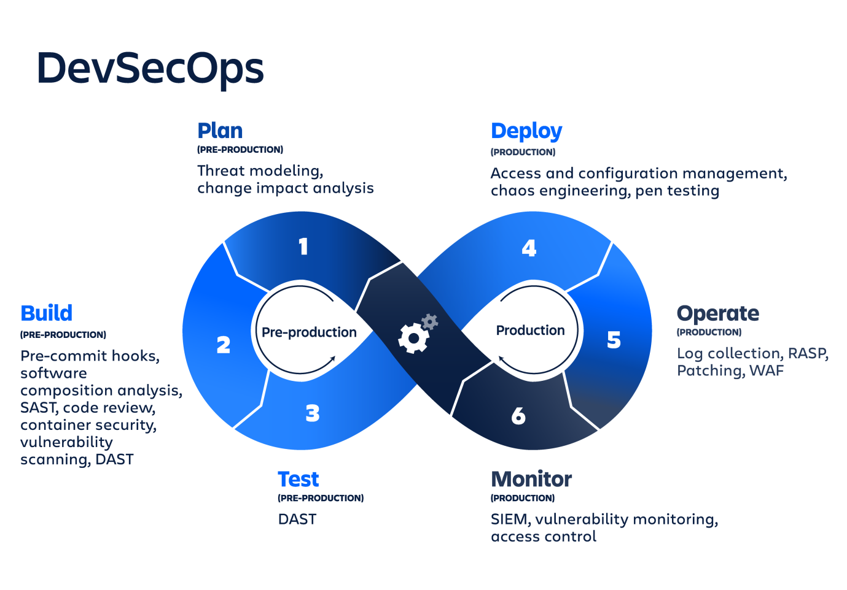

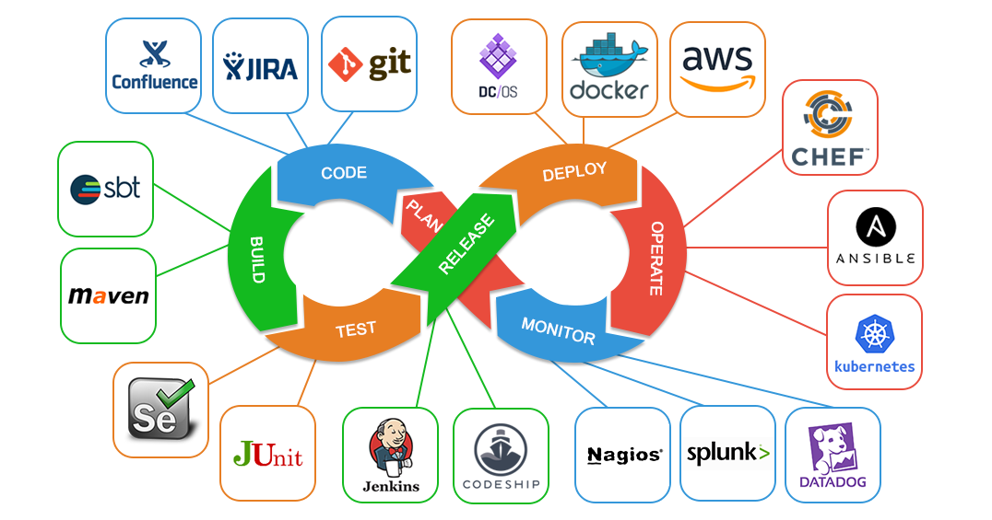

Git is a version control system.

Git helps you keep track of code changes.

Git is used to collaborate on code.