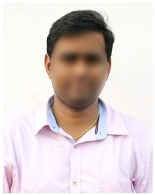**NAVEEN CHAPPA**

**Email Id:** naveenchxx@gmail.com

**Mobile:** 7352XXXX25.

**Address:** H No 12-2, Narayanaguda,

Hyderabad, Telangana 500027.

**CAREER OBJECTIVE**

* To obtain a challenging career in the IT industry and put all my efforts into the growth of the organization and have a great working environment.

**SUMMARY**

* An enthusiastic, punctual & carer minded individual with excellent communication and interpersonal skills.

**TECHNICAL PROFICIENCY**

* Languages: C, C++, JAVA,
* Databases: SQL, My SQL
* Web Technologies: Servlets, JSP
* Operating Systems: Windows 2000/Xp

**EDUCATIONAL QUALIFICATION**

* B.Tech Computer Science (CSE) from Andhra University.
* Intermediate from Sri Chaitanya Jr College.

**PROJECT WORK**

Title: XXXX

Duration: 2 months

Project Description:

**EXPERIENCE**

Fresher

**PERSONAL PROFILE**

Father’s Name : Raghuram Ch

Date of birth : 05 July 2000

Gender : Male

Nationality : Indian

Languages Known : English, Hindi & Telugu

Religion : Hindu

Hobbies : Reading Books

**DECLARATION**

I hereby declare that all the above mentioned information is true to the best of my knowledge and belief.

Place:

Date: **Naveen Chappa**