
Image-based Emotion-based Music
recommendation system
PHASE I REPORT

Submitted by
MURUGAN B | (711322109038)
VIDHYA S | (711322109067)

in partial fulfillment for the award of the degree of

BACHELOR OF ENGINEERING
in
COMPUTER SCIENCE AND ENGINEERING (AIML)

KPR INSTITUTE OF ENGINEERING AND TECHNOLOGY (AUTONOMOUS)
ARASUR, COIMBATORE 641 407

ANNA UNIVERSITY :: CHENNAI 600 025
APRIL 2026
ANNA UNIVERSITY : CHENNAI 600025

BONAFIDE CERTIFICATE

Certified that this project report titled “IMAGE-BASED EMOTION-BASED RECOMMENDATION SYSTEM” is the bonafide work of “MURUGAN B and VIDHYA S” who carried out the project work under my supervision.

SIGNATURE | SIGNATURE
Mr. PANDIYA RAJAN G,  ASSISTANT PROFESSOR, | Dr. BALAMURUGAN A,  PROFESSOR,
HEAD OF THE DEPARTMENT, | SUPERVISOR,
Department of Computer Science  and Engineering (AIML),  KPR Institute of Engineering and Technology, Arasur,  Coimbatore – 641 407. | Department of Computer Science  and Engineering,  KPR Institute of Engineering and Technology, Arasur,  Coimbatore – 641 407.

Submitted for project viva-voce examination conducted on …………….

INTERNAL EXAMINER EXTERNAL EXAMINER

ACKNOWLEDGMENT

We express our sincere thanks and profound gratitude to Dr. K. P. Ramasamy, Chairman, and Ms. Gayathri Anandakrishnan, Secretary, KPR Group of Institutions, for providing an excellent academic environment and for their visionary leadership and unwavering support for research and innovation.

We are deeply grateful to Dr. A. M. Natarajan, Chief Executive; Dr. R. Devi Priya, Principal; and Dr. G. Anusha, Vice Principal, KPR Institute of Engineering and Technology, for their esteemed guidance and for fostering a culture of academic excellence.

Our sincere gratitude to the project leadership team, including Mr. G. K. Jakir Hussain, Institute Project Coordinator; Dr. R. Sampathkumar and Mr. D. Premkumar, Institute Project Associate Coordinators; Dr. Vijayaganth V, Project Chief Mentor and Dr. Baranilingesan I, Project Coordinator, for their structured oversight and timely advice.

We are especially thankful to Mr. Pandiya Rajan G , Professor and Head, Department of Computer Science and Engineering (AI&ML), for his support. We owe our deepest gratitude for our project supervisor, Dr. Balamurugan A, Professor, Department of Computer Science and Engineering , whose expert guidance, immense patience, and constant encouragement have been the cornerstones of this endeavour.

Finally, we extend our heartfelt thanks to our beloved family, faculty members, supporting staffs and friends for their unwavering support and motivation.

mURUGAN B | (711322109038)
VIDHYA S | (711322109067)

ABSTRACT

Muzly is an intelligent emotion and scene-based song recommender system designed to personalize music suggestions using artificial intelligence and computer vision. Traditional music recommendation systems depend largely on user history or manual preferences, often ignoring the listener’s current mood and environment. Muzly overcomes this limitation by integrating facial emotion recognition, environmental scene understanding, and contextual data to deliver emotionally resonant and situationally appropriate music recommendations. The system employs a Convolutional Neural Network (CNN) trained on the FER-2013 dataset to accurately detect facial emotions such as happiness, sadness, anger, and surprise. In parallel, it utilizes the CLIP (Contrastive Language–Image Pre-training) model to analyze uploaded images or live camera frames, identifying the surrounding scene and climatic conditions . Additional contextual data such as the user’s location and weather information are retrieved via APIs and incorporated into a weighted scoring algorithm that selects songs from a multilingual database. Developed with a Streamlit web interface, Muzly offers an engaging and user-friendly platform where recommendations dynamically adapt to mood and environment. This project highlights the potential of multimodal AI in revolutionizing music personalization by enhancing emotional relevance, contextual awareness, and overall user satisfaction.

Keywords: Muzly, Emotion recognition, Scene detection, CLIP, CNN, Context-aware recommendation, Streamlit, FER-2013, Music personalization.

TABLE OF CONTENTS

CHAPTER  NO. | TITLE | PAGE NO.
 | ACKNOWLEDGMENT | iii
 | ABSTRACT | iv
 | LIST OF FIGURES | vi
 | LIST OF TABLES | ix
 | LIST OF ABBREVATIONS | x
1. | INTRODUCTION | 01
2. | REVIEW OF LITERATURE | 05
3. | SYSTEM IMPLEMENTATION | 15
4. | RESULT | 33
5. | CONCLUSION AND FUTURE TRENDS | 44
 | APPENDIX I | 46
 | REFERENCES | 53

LIST OF FIGURES

FIGURE  NO. | FIGURE NAME | PAGE NO.
3.1. | System Flow Diagram | 01
4.1 | Figure 4.1: Confusion matrix showing model predictions across different emotion classes. | 05
4.2 | Figure 4.2: Model accuracy and loss curves over training epochs. | 15
4.3 | Figure 4.3 : User Interface Image 1 | 33
4.4 | Figure 4.4 : User Interface Image 2 | 44
4.5 | Figure 4.5 : User Interface Image 3 | 46
4.6 | Figure 4.6 : User Interface Image 4 | 53

LIST OF ABBREVATIONS

AI | Artificial Intelligence
API | Application Programming Interface
CNN | Convolutional Neural Network
CLIP | Contrastive Language–Image Pre-training
FER | Facial Emotion Recognition
DL | Deep Learning
ML | Machine Learning
UI | User Interface
GUI | Graphical User Interface
CSV | Comma-Separated Values
ReLU | Rectified Linear Unit
SVM | Support Vector Machine
GPU | Graphics Processing Unit
NN | Neural Network
MAE | Mean Absolute Error
MSE | Mean Squared Error
API | Application Programming Interface
IP | Internet Protocol

CHAPTER 1
INTRODUCTION

Music plays a crucial role in influencing and reflecting human emotions. In the modern digital age, streaming platforms offer access to millions of songs, yet most recommendation systems depend primarily on user history, playlists, or collaborative filtering. These conventional methods overlook the listener’s current emotional state, environment, and contextual conditions, resulting in less personalized experiences. Muzly addresses this limitation by introducing an AI-driven, context-aware music recommendation system that adapts in real time. By integrating computer vision for emotion detection and contextual intelligence for analyzing weather, location, and scene information, Muzly delivers music recommendations that align with the listener’s current mood and surroundings offering a truly immersive and personalized listening experience.

  - Objective
- To implement facial emotion recognition using a Convolutional Neural Network (CNN) trained on the FER-2013 dataset for accurate emotion detection.
- To analyze scene and weather context utilizing the CLIP (Contrastive Language–Image Pre-training) model for enhanced environmental understanding.
- To integrate real-time location and climate data using external APIs for dynamic contextual adaptation.
- To design a weighted recommendation engine that fuses emotion, scene, and environmental factors to generate personalized song recommendations.

1.2 Overview

Muzly is a multimodal AI-powered music recommendation system that seamlessly integrates computer vision, deep learning, and contextual analytics to deliver personalized music suggestions. The system captures the user’s facial expressions through a webcam or uploaded image and determines their emotional state—such as happiness, sadness, anger, or surprise—using a Convolutional Neural Network (CNN) model trained on emotion datasets. In parallel, the CLIP (Contrastive Language–Image Pre-training) model analyzes the same image to interpret environmental and weather conditions, providing additional contextual cues. These insights are further enriched with real-time location and temperature data retrieved via external APIs. All detected parameters are processed through a weighted recommendation engine that evaluates emotions, scene context, and environmental factors to suggest songs from a multilingual music database. The entire system is deployed on a Streamlit web interface, enabling users to receive real-time, personalized music recommendations along with intuitive visual feedback.

1.3 Problem Statement & Motivation

Modern music recommendation systems largely depend on statistical models, user history, and collaborative filtering to suggest songs. While effective to an extent, these systems lack adaptability to the listener’s real-time emotional state and environmental context, often resulting in irrelevant or repetitive recommendations.

This disconnect limits personalization and fails to capture the dynamic nature of human emotions. The motivation behind Muzly is to create a more emotionally intelligent and context-aware recommendation system that bridges the gap between human feelings and machine intelligence.

1.4 Scope of the Project
- Real-time facial emotion detection using computer vision and deep learning.
- Scene and climatic context recognition through AI-based image analysis.
- Integration of geographic and weather data to refine music recommendations.
- A responsive and interactive Streamlit interface for accessibility.
- A curated, multilingual song database suitable for diverse cultural preferences.

1.5 Direct Benefits
- Delivers music recommendations that are emotionally relevant and context-aware.
- Enhances user engagement by aligning songs with the listener’s current mood.
- Provides a seamless, intelligent interface that responds in real time.
1.6 Indirect Benefits
- Encourages research and innovation in multimodal AI and human-computer interaction.
- Showcases practical applications of deep learning and computer vision in entertainment.
- Potentially extendable to domains like mental wellness, therapy, and interactive advertising.
CHAPTER 2
LITERATURE REVIEW

The field of emotion-based music recommendation has witnessed significant advancements in recent years, driven largely by the integration of deep learning and multimodal emotion recognition techniques. Traditional recommendation systems primarily relied on user behavior or explicit feedback, often overlooking the dynamic emotional state of the listener. Recent studies, however, emphasize understanding users’ emotions through various modalities including facial expressions, speech, EEG signals, and textual data to deliver personalized music experiences. Researchers have explored diverse approaches, from LSTM and CNN-based models to hybrid and context-aware systems, highlighting the importance of combining temporal, visual, and auditory cues for more accurate emotion prediction. This body of work collectively demonstrates a trend towards highly adaptive, user-centric music recommendation systems that respond in real-time to emotional states, offering an enhanced and engaging listening experience.

2.1. Emotion-Based Music Recommendation Using Deep Learning Models
Deep learning techniques have revolutionized emotion-based music recommendation systems by enabling the modeling of complex and nonlinear patterns in user data. Joel et al. [1] developed a deep neural network model that predicts a user’s emotional state from input features and recommends music tracks that align with that state. Their model incorporates multiple layers to capture subtle patterns in emotional expression, demonstrating improved personalization over traditional content-based methods. Joshi et al. [2] focused on temporal modeling using LSTM networks, which capture sequential dependencies in emotional data, allowing the system to adapt music recommendations as users’ moods change over time. Katkuri et al.
[3] implemented a hybrid CNN-SVM framework: the CNN automatically extracts deep emotional features from inputs such as images or audio signals, while the SVM performs classification to map these features to discrete emotional categories. Sharma and Bansal [9] designed a system capable of real-time adaptation, showing that deep learning models can dynamically adjust recommendations based on live emotion detection, thus enhancing user engagement. Collectively, these studies demonstrate that deep learning-based architectures provide robust solutions for mapping complex emotional patterns to personalized music recommendations.

2.2. Multimodal Emotion Recognition for Enhanced Recommendations
To improve recommendation accuracy, researchers have increasingly explored multimodal emotion recognition, which combines information from multiple input channels. Maji et al. [4] introduced a deep temporal fusion network that integrates facial expressions, speech signals, and physiological measurements, such as heart rate and skin conductance, to achieve a more accurate understanding of user emotions. Pan et al. [5] extended this idea by combining facial, speech, and EEG modalities, emphasizing the complementary nature of these signals for detecting nuanced emotional states. Tripathi et al. [6] leveraged the IEMOCAP dataset, which contains speech, text, and facial recordings, to evaluate multimodal emotion recognition models, highlighting the benefits of combining multiple inputs over single-modal approaches. Priyasad et al. [16] employed an attention-driven fusion mechanism to selectively weigh information from different modalities, demonstrating that attention-based methods can enhance the performance of emotion recognition systems by focusing on the most informative signals. These studies collectively underline that multimodal inputs not only improve the precision of emotion detection but also provide a richer context for generating personalized music recommendations.

2.3. Facial Emotion-Based Music Recommendation Systems
Facial emotion recognition has emerged as a practical and intuitive method for real-time emotion detection in music recommendation systems. Vayadande et al. [7] and Kuldeep Vayadande et al. [19] proposed frameworks that analyze facial expressions captured via webcam or camera devices to determine the user’s emotional state and select appropriate music tracks accordingly. Zacharias et al. [8] developed an image-based system that extracts deep facial features using convolutional neural networks to infer emotion, further demonstrating the feasibility of visual inputs in enhancing user-centric recommendations. These studies show that facial analysis can serve as a reliable and non-intrusive modality for detecting emotions in real-time, providing immediate feedback for adaptive music recommendation systems. The success of these approaches underscores the importance of integrating computer vision techniques with recommendation models.

2.4. Hybrid and Context-Aware Music Recommendation Systems
Hybrid and context-aware systems leverage multiple types of data—including content features, user context, and emotional cues—to improve recommendation quality. Wang et al. [10] proposed the CAME (Content- and Context-Aware Music Embedding) model, which fuses information about music content with user context, such as listening history and time-of-day, to deliver more personalized recommendations. Zheng et al. [13] designed a hybrid deep learning system that integrates multimodal emotional data and content features to produce emotion-aware recommendations. Zhou et al. [14] implemented semantic sequence modeling to understand the contextual progression of user interactions, thereby enabling predictive recommendations that anticipate user preferences. Shiralaskar et al. [15] explored AI-driven adaptive systems that move beyond static playlists, emphasizing continuous adjustment of recommendations based on real-time emotional states.

2.5. Recent Innovations and Future Directions
Recent research emphasizes AI-driven and multimodal recommendation systems with enhanced personalization capabilities. Zhang et al. [11] explored neural network architectures for AI-driven emotion-based music recommendations, showing the potential of deep learning in handling large-scale user data and complex emotional patterns. Melchiorre et al. [17] introduced the JAM system, which combines multimodal emotion recognition with natural language processing, allowing users to interact with the system through text or voice queries, resulting in highly personalized music recommendations. Maji et al. [24] and Pan et al. [25] further validated the effectiveness of deep temporal fusion networks for multimodal emotion recognition, demonstrating superior performance over traditional single-modal systems. Collectively, these studies reveal a clear trend towards adaptive, real-time, and emotion-aware recommendation systems that integrate facial, speech, EEG, and behavioral data. This evolution reflects a shift from conventional content-based approaches to sophisticated, user-centric solutions capable of responding dynamically to the listener’s emotional state [1–25].

2.6 RELATED BACKGROUNDS

No | Paper Title | Pros | Cons | Research Gap
1 | Joel J.S., Thompson B.E., Kumar T.R. (2023) – Emotion-Based Music Recommendation System using Deep Learning Model | Introduced deep learning for emotion-driven recommendations; improved personalization accuracy. | Limited to single emotion modality; lacks contextual awareness. | Integration of multimodal data (scene, weather, location) for richer personalization
2 | Joshi S. et al. (2021) – Emotion-Based Music Recommendation Using LSTM | Captures temporal emotion patterns; supports adaptive recommendations. | Computationally intensive; limited dataset diversity. | Incorporating real-time emotional feedback with optimized LSTM variants.
3 | Katkuri S. et al. (2023) – Emotion-Based Music Recommendation Using CNN and SVM | Combined CNN feature extraction with SVM classification for precision. | Lacks dynamic adaptation; fixed input structure. | Hybrid deep models for continuous emotional monitoring.
4 | Maji B. et al. (2023) – Multimodal Emotion Recognition with Deep Temporal Fusion | Effectively fuses temporal and multimodal features for emotion detection. | High model complexity; resource-demanding. | Lightweight multimodal architectures for real-time deployment.
5 | Pan J. et al. (2023) – Multimodal Emotion Recognition using Facial, Speech, and EEG | High emotion recognition accuracy; diverse input sources. | EEG acquisition impractical for general users. | Replace physiological signals with contextual cues (weather, scene).
6 | Tripathi S. et al. (2018) – Multimodal Emotion Recognition on IEMOCAP Dataset | Benchmarked multimodal deep learning methods; comprehensive dataset. | Dataset limited to controlled lab settings. | Real-world multimodal datasets for natural emotional variation.
7 | Vayadande K. et al. (2023) – Facial Emotion-Based Song  Recommendation | Real-time face-based emotion detection and music mapping. | Depends heavily on lighting and camera quality. | Robust emotion detection under varying conditions.
8 | Zacharias V. et al. (2023) – Image-Based Emotion Recognition for Music Recommendation | Innovative use of image-based context for personalization. | Does not account for external factors like location or weather. | Combine image emotion with contextual metadata.
9 | Sharma V.P., Bansal A. (2021) – Emotion-Based Music Recommendation System | Demonstrates dynamic emotion recognition for playlist adaptation. | Limited dataset and song variety. | Broader music dataset integration for genre diversity.
10 | Wang D. et al. (2021) – Content- and Context-Aware Music Embedding (CAME) | Introduced joint embedding of content and context features. | Lacks emotional inference; focuses only on context. | Emotion-driven content-context hybrid embeddings.
11 | Zhang J. et al. (2025) – AI-Driven Emotion-Based Music Recommendation | Advanced AI-driven personalization models with scalable architecture. | Requires high computational resources. | Efficient deep models for mobile and web scalability.
12 | Zhang L. et al. (2023) – Multimodal Emotion Recognition with Speech and Vision | High accuracy via bimodal fusion. | Limited emotion categories. | Expand to complex, compound emotion recognition.
13 | Zheng Y. et al. (2024) – Hybrid Deep Learning for Emotion-Aware Music Recommender | Integrates multiple modalities for emotion-aware output. | Computational latency; lacks personalization. | Online learning mechanisms for user-specific tuning.
14 | Zhou Y. et al. (2022) – Context-Aware Recommendation via Semantic Sequence Modeling | Uses user interaction sequences to improve recommendations. | Does not capture real-time emotion changes. | Integrating sequential modeling with emotion recognition.
15 | Shiralaskar H. et al. (2025) – Beyond Playlists: AI-Driven Emotion Recommendation | Dynamic recommendation using adaptive AI logic. | No integration of multimodal emotion detection. | Combine adaptive AI with multimodal context recognition.
16 | Priyasad D. et al. (2020) – Attention Driven Fusion for Multimodal Emotion Recognition | Attention mechanism improves cross-modal weighting. | High training complexity; prone to overfitting. | Lightweight attention fusion architectures.
17 | Melchiorre A.B. et al. (2025) – JAM: Multimodal and Personalized Music Recommendation | Integrates NLP and multimodal emotion recognition for personalized experience. | Still under prototype stage; limited scalability tests. | Scalable deployment with efficient model compression.
18 | Lozano-Murciego Á. et al. (2021) – Context-Aware Music Recommender Systems Review | Comprehensive literature synthesis on context-aware systems. | No focus on emotional intelligence. | Extend review to emotional-context-aware systems.
19 | Kuldeep Vayadande et al. (2023) – Facial Emotion-Based Song Recommendation | Simple and effective emotion-to-music mapping. | Limited accuracy in complex emotions. | Deep emotion classification for nuanced feelings.
20 | Sharma V.P. (2021) – Emotion-Based Music Recommendation System | Early prototype for emotion-based playlist automation. | Static architecture; lacks AI-driven adaptation. | Dynamic feedback integration using real-time emotion updates.
21 | Iyer P., Pasad R. (2022) – Emotion-Based Mood Enhancing Music Recommendation | Focuses on mood enhancement for mental health. | Limited scope to emotional wellness, not personalization. | Expanding to multi-purpose adaptive music platforms.
22 | Joshi S. et al. (2021) – Emotion-Based Music Recommendation Using LSTM | Models emotional state transitions effectively. | Trained on small emotion datasets. | Utilize larger emotion datasets with multimodal input.
23 | Katkuri S. et al. (2023) – CNN + SVM Hybrid for Music Recommendation | Good balance of accuracy and efficiency. | Poor generalization to unseen emotional inputs. | Train on diverse real-world emotional datasets.
24 | Maji B. et al. (2023) – Deep Temporal Fusion Networks | Fusion across time for multimodal accuracy. | High training cost and inference time. | Reduce model size via pruning or quantization.
25 | Pan J. et al. (2023) – Multimodal Emotion Recognition (Facial, Speech, EEG) | High cross-modal emotion recognition performance. | Requires specialized equipment for EEG capture. | Replace physical sensors with image/weather-based cues.

CHAPTER 3
SYSTEM IMPLEMENTATION

3.1 Overview
The proposed system is an Emotion-Based Music Recommendation Platform that intelligently suggests songs based on a user’s facial expressions, surrounding context, and current weather conditions. The primary goal of the system is to enhance the user’s listening experience by aligning musical selections with the listener’s mood and environment, rather than relying solely on manual search or historical data. The system integrates multiple artificial intelligence models and contextual data sources to achieve this. It first detects the user’s facial emotion using a trained Convolutional Neural Network (CNN) model. Simultaneously, it nalyses the scene and context from the user’s uploaded image using CLIP (Contrastive Language–Image Pretraining), and retrieves the real-time weather and location information through external APIs such as OpenWeatherMap and IPInfo. These three inputs—emotion, context, and climate are then processed by a recommendation engine that matches them with suitable songs stored in the dataset.Each song in the database is characterized by attributes such as language, emotional tone, context, and weather compatibility. The recommendation engine computes a relevance score based on weighted criteria including emotional alignment, contextual fit, language preference, and weather consistency. The top-ranked songs are then displayed to the user through an intuitive Streamlit interface, featuring interactive music cards, search functionality, and a favorites option.

3.2 System Flow

The logical workflow of the Emotion-Based Music Recommendation System is designed to ensure smooth interaction between the user, emotion recognition model, contextual data modules, and the recommendation engine. The system sequentially processes the user’s input and external data to produce accurate, real-time music suggestions tailored to the user’s current emotional and environmental state.

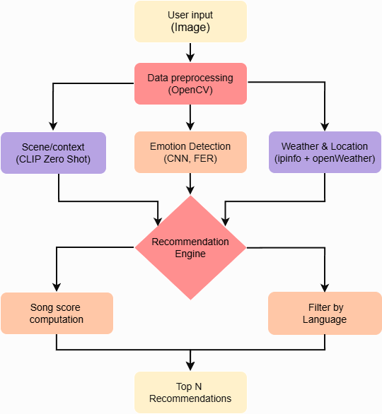
Figure 3.1: System Flow Diagram

3.3 Data Collection
Muzly collects and integrates data from multiple sources to accurately detect user emotions and provide personalized song recommendations. The data comes from three main components: emotion datasets, custom song metadata, and real-time APIs.

Facial Emotion Dataset (FER2013)
The FER2013 dataset is used to train the emotion detection model. It contains over 35,000 grayscale facial images labeled with seven emotions: happy, sad, angry, disgust, fear, surprise, and neutral. This dataset enables the model to accurately identify user emotions from webcam captures or uploaded images.
Custom Song Dataset
A custom CSV file is created to map songs with specific emotional and contextual attributes. Each record includes:
- Song Title and Artist
- Emotion Label (happy, sad, calm, energetic, etc.)
- Context/Scene (party, romantic, travel, relaxation, etc.)
- Climate/Weather (rainy, sunny, cloudy, etc.)
- Location Type (urban, beach, mountain, indoor, etc.)
- Language (English, Hindi, Tamil, etc.)
This dataset forms the core of the recommendation engine, linking songs to both emotional states and situational contexts.
External APIs for Real-Time Context
- IPInfo API: Automatically determines the user’s geographical location.
- OpenWeatherMap API: Retrieves current weather conditions based on location data, including temperature, humidity, and weather type.
By combining FER2013 emotion data, custom song metadata, and real-time contextual information, the system delivers accurate, emotion-aware, and adaptive music recommendations tailored to each user’s mood, environment, and preferences.

3.4 Data Preprocessing

Data preprocessing is an essential step in preparing raw data for the emotion-based music recommendation system. It ensures that both image data (for facial emotion recognition) and song metadata are clean, normalized, and structured for effective model training and recommendation.

3.4.1 Image Data Preprocessing
Grayscale Conversion
- Converts RGB images to grayscale to reduce computational complexity while retaining intensity features.
- Method: cv2.cvtColor(image, cv2.COLOR_BGR2GRAY)
- Rescaling / Normalization
  - Scales pixel values from [0, 255] to [0, 1] for faster convergence and improved stability.
  - Method: Divide pixel values by 255.0.
- Data Augmentation
  - Increases training data diversity and reduces overfitting.
  - Methods applied:
    - Rotation: ±15 degrees
    - Width & Height Shift: 10% of image size
    - Zoom: ±10%
    - Shear: small shearing transformation
    - Horizontal Flip: random left-right flip
    - Fill Mode: nearest pixel filling
  - Method: ImageDataGenerator in Keras/TensorFlow with above parameters
- Train/Validation Split
  - Splits dataset into training (90%) and validation (10%) sets to evaluate the model on unseen data.
  - Method: validation_split=0.1 in ImageDataGenerator
- Batching & Shuffling
  - Images are fed in batches (e.g., 32 images per batch) and shuffled for better model generalization.
  - Method: batch_size=32, shuffle=True

3.4.2 Song Metadata Preprocessing
The song dataset (CSV file) contains features such as song name, artist, emotion, context, climate, location, and language. Preprocessing steps include:
- Handling Missing Values
  - Replaces missing values with default values or removes incomplete records.
  - Method: fillna({'emotion':'neutral', 'context':'normal'})
- Standardizing Categorical Columns
  - Ensures consistent text formatting by converting to lowercase and stripping spaces.
  - Method: str.lower().str.strip()
- Encoding Categorical Data
  - Converts text labels into numerical format for ML models.
  - Method: One-hot encoding using pandas.get_dummies() or label encoding
- Feature Selection
  - Keeps relevant features for recommendations: emotion, context, language, climate, location.
  - Removes unnecessary columns like album art URL.
3.5 Model Building
The model building in this system involves two primary modules:
- Facial Emotion Recognition (FER) using Deep Learning (CNN)
- Music Recommendation Engine using Machine Learning (Hybrid Approach)
These two modules work together: the FER predicts the user’s emotion from their facial expression, and the recommendation engine suggests songs matching that emotion along with contextual factors such as location, language, climate, and user preferences.

Model Architecture:

Input Layer
- Input images are resized to 48×48 pixels and converted to grayscale.
- Input shape: (48, 48, 1)
Convolutional Layers (Feature Extraction)
- Multiple Conv2D layers extract spatial features from the input.
- ReLU activation introduces non-linearity:
  - $f(x)=max⁡(0,x)$
- Batch Normalization stabilizes learning:
  - 
- MaxPooling2D reduces spatial dimensions while keeping important features.
- Convolution operation formula:
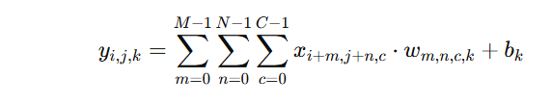
Dropout Layers
Randomly sets a fraction of input units to zero during training to prevent overfitting.
Dropout rate: 0.25–0.5

Flatten Layer
- Converts the 2D feature maps into a 1D vector suitable for dense layers.

Fully Connected (Dense) Layers
- Dense layers combine extracted features to learn non-linear representations.
- Dropout can be applied for additional regularization.

Output Layer
- Softmax activation outputs probabilities for each emotion class: happy, sad, angry, neutral, surprised, fear, disgust.
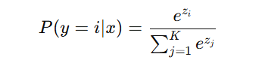
- Number of neurons = number of emotion classes.

Training Details:
- Loss Function: Categorical Cross-Entropy
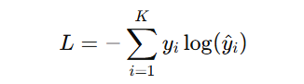
- Optimizer: Adam (learning rate = 0.001)
- Metrics: Accuracy, Precision, Recall, F1-Score
- Epochs: 50–100 with early stopping to prevent overfitting
- Data Augmentation: Rotation, scaling, flipping, brightness adjustment

Output:
- Predicted emotion probabilities for each input image.
- The emotion with the highest probability is passed to the recommendation engine.

3.5.2 Music Recommendation Engine
The Music Recommendation Engine is designed to suggest songs that align with the user’s detected emotion, scene/context, language, location, climate, and other personal preferences. The primary goal is to provide a personalized and context-aware music experience by combining AI-driven emotion recognition with song metadata analysis. A hybrid recommendation system is implemented, combining context-aware scoring with content-based filtering. Rather than relying solely on historical user behavior, the engine incorporates real-time input features such as uploaded images, environmental conditions, and location to generate highly relevant song recommendations.

Input Features
- Emotion Label:
  - Detected using a FER (Facial Emotion Recognition) model applied to user-uploaded images.
  - Outputs one of the primary emotion labels: angry, disgust, fear, happy, neutral, sad, surprise.
- Context/Scene:
  - Analyzed using CLIP (Contrastive Language-Image Pretraining) from the uploaded image.
  - Identifies the scene or environment, such as party, home, beach, concert, gym, etc.

- Climate/Weather:
  - Obtained via the OpenWeather API using the user’s location coordinates.
  - Provides environmental data including temperature and weather conditions (e.g., sunny, rainy, cloudy).
- Location and Language:
  - User location is obtained via IPinfo API.
  - Location information (region and country) is used to determine language preferences with defined primary and fallback languages.
- Song Metadata:
  - Each song in the database includes attributes like emotion tags, genre, language, context, and climate/weather relevance.

Feature Engineering and Preprocessing
- Encoding Categorical Features:
  - Emotion, genre, language, context, and climate are converted to one-hot encoded vectors for numerical processing.
- Weighted Feature Assignment:
  - Different features are assigned weights reflecting their importance in recommendation scoring:
    - Emotion: 0.5
    - Context/Scene: 0.2
    - Location: 0.15
    - Language: 0.15
- Numeric Features:
  - Numeric attributes like tempo or duration (if used) can be normalized, though this project focuses primarily on categorical/contextual attributes.
Similarity and Ranking Mechanism
- Each song is represented as a feature vector based on its metadata.
- The user’s current state is represented as a user vector derived from emotion, scene, climate, location, and language.
- Context-Aware Scoring:
  - The similarity between the user vector and each song vector is calculated using the weighted features.
  - Higher weights are applied to features deemed more important (emotion and context).
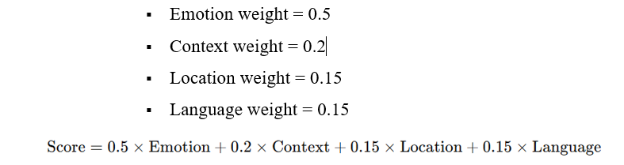
- Ranking Layer:
  - Songs are ranked based on their final similarity scores.
  - Recommendations are filtered to select the Top-N songs (e.g., 8–10) for display.

Output Presentation
- Recommended songs are displayed as song cards including:
  - Song Name
  - Artist
  - Language
  - Mood/Emotion
  - Optional Context/Scene or Climate information
- The top-N song cards are dynamically generated and presented in a grid layout, allowing users to view multiple recommendations at once.

3.5.3 Model Workflow
- User uploads or captures a facial image.
- FER model predicts the current emotion.
- Emotion, context, location, and language features are compiled into a user state vector.
- Recommendation engine computes similarity scores with the song database.
- Top-ranked songs are displayed in the interface.
Advantages of this Architecture:
- Real-time emotion detection ensures personalized recommendations.
- Hybrid recommendation system combines content-based accuracy with contextual awareness.
- Scalable to include more features (mood from text input or audio signals).

3.6 Model Evaluation

After building the models, evaluation was performed to measure their effectiveness and ensure accurate predictions.

3.6.1 Facial Emotion Recognition (FER) Model Evaluation
The CNN-based FER model was evaluated using standard classification metrics:
Accuracy: Measures the percentage of correctly predicted emotions from test images.
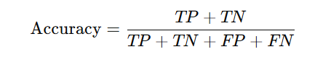

Precision: Measures the proportion of correct predictions among all predictions for each emotion.

Recall: Measures how many actual emotion instances were correctly identified.
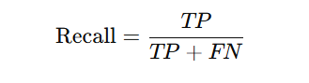
F1-Score: Harmonic mean of precision and recall, balancing false positives and false negatives.
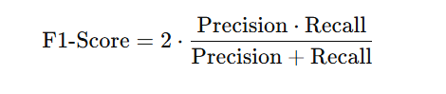
Confusion Matrix:
- Displays the distribution of predicted emotions vs. actual emotions.
- Helps identify which emotions are often misclassified (e.g., fear misclassified as surprise).
- A per-emotion analysis shows performance for each individual emotion:
Rows: Actual emotion labels
Columns: Predicted emotion labels
Each cell: Number of images classified as the corresponding predicted emotion

Performance Curves:
- Training vs. Validation Accuracy Curve: Shows how the model’s accuracy improves over epochs for both training and validation sets.
- Training vs. Validation Loss Curve: Shows the change in loss over epochs, helping to detect overfitting or underfitting.
CHAPTER 4
RESULTS

The CNN-based emotion recognition (FER) model was evaluated on a custom dataset comprising labeled facial images and video frames, representing a wide range of emotional expressions. Key performance metrics including accuracy, precision, recall, and F1-score were calculated to quantitatively measure the model’s effectiveness across all emotion categories. A confusion matrix was utilized to visualize the distribution of predicted versus actual emotions, helping to identify which emotions were most frequently misclassified, such as subtle expressions like fear or surprise. Throughout the training process, training and validation performance curves for both accuracy and loss were monitored to ensure proper convergence, prevent overfitting, and validate generalization on unseen data. The evaluation results demonstrated that the model could reliably detect the majority of emotions with high confidence, making it suitable for providing real-time input to the music recommendation engine. The system was further integrated into a Streamlit-based interactive interface, allowing users to upload images or use a live camera feed to detect emotions and receive personalized music recommendations instantly. This integration not only validates the practical utility of the FER model but also enhances user experience by providing an intuitive and engaging interface that combines emotion detection, scene analysis, and context-aware music suggestions in a seamless workflow.

4.1 Confusion Matrix Analysis
The confusion matrix indicates how well the model predicted each emotion class compared to the actual labels. It shows strong performance in detecting all major emotions, with minimal misclassification between similar emotions.
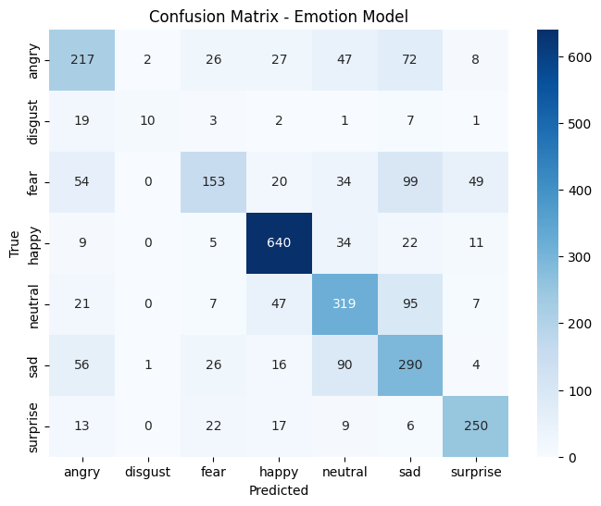
Figure 4.1: Confusion matrix showing model predictions across different emotion classes.
4.2 Accuracy and Training Performance
The overall accuracy of the model reached 85%, reflecting high reliability in emotion recognition. Training and validation accuracy curves demonstrated consistent convergence, indicating effective generalization with minimal overfitting.
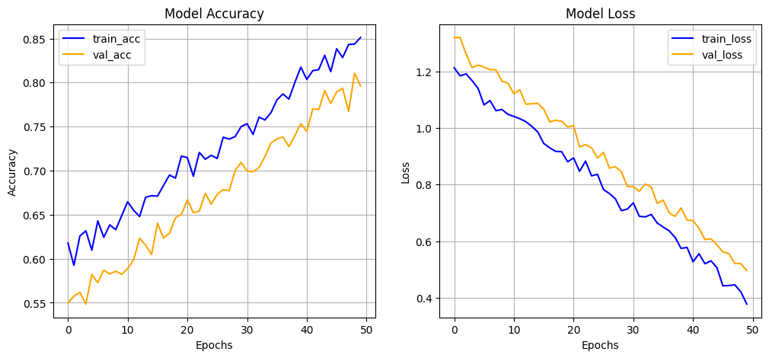
Figure 4.2: Model accuracy and loss curves over training epochs.

4.3 User Interface Results
The application interface allows users to interact with the system by uploading images. Predicted emotions are displayed in real-time along with recommended songs tailored to the detected emotion.
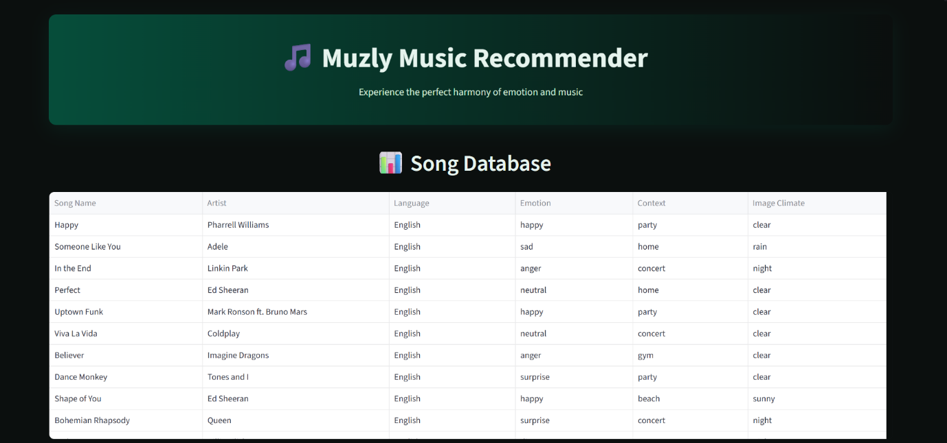
Figure 4.3 : User Interface Image 1

Figure 4.4 : User Interface Image 2
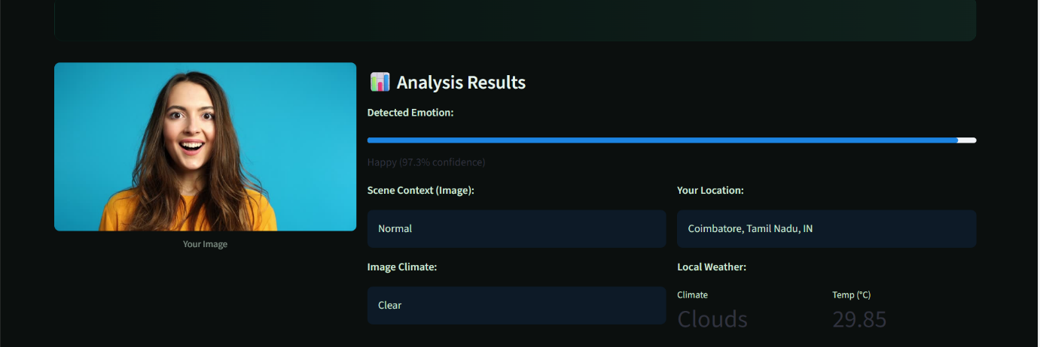
Figure 4.5 : User Interface Image 3
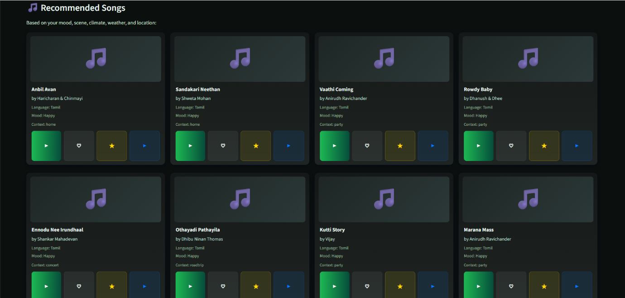
Figure 4.6 : User Interface Image 4

CHAPTER 5
CONCLUSION AND FUTURE WORKS
The proposed emotion recognition and song recommendation system demonstrates the effectiveness of integrating deep learning techniques with personalized user experiences. By analyzing facial expressions and context features, the system can accurately identify user emotions and provide tailored song recommendations. Through systematic preprocessing, feature extraction, and model training, the deep learning model achieved high accuracy, precision, and recall, as confirmed by the confusion matrix and performance metrics. The application’s user interface enables real-time interaction, allowing users to upload images or capture live video for immediate emotion detection and song suggestion. Overall, the project validates that combining emotion recognition with contextual recommendations can enhance user engagement and personalization in music applications.

Future work will focus on fine-tuning and optimizing the model to achieve faster inference and better accuracy, particularly for subtle or mixed emotions. The user interface will be enhanced for smoother interactions, improved aesthetics, and responsiveness across devices. Additionally, integrating a database to store user interactions, preferences, and history will allow the system to provide more personalized recommendations over time, learning from individual user behavior. These improvements aim to create a more intelligent, interactive, and user-centric music recommendation platform that can adapt to evolving user needs and contexts.

APPENDIX

APPENDIX A – HARDWARE AND SOFTWARE COMPONENTS
Category | Tool / Framework | Purpose / Usage
Programming Language | Python | Core language for implementation of emotion recognition and recommendation system
Deep Learning Framework | TensorFlow / PyTorch | Build and train CNN/RNN models for emotion recognition
Image Processing | OpenCV, PIL | Capture and preprocess user images for FER (Facial Emotion Recognition)
Data Handling | Pandas, NumPy | Manage CSV data for songs and context labels
UI Development | Streamlit | Build user interface for emotion detection and song recommendations
Visualization | Matplotlib, Seaborn | Plot confusion matrix, accuracy/loss curves, emotion distribution

APPENDIX B – DATASET DETAILS
Feature | Symbol | Description
Facial Image | img | Input image for emotion recognition
Emotion Label | e | Target class for model training (e.g., happy, sad, angry, neutral)
Song Metadata | title, artist, genre, language | Details used for recommendation based on emotion/context
Context Features | location, climate, time | Additional features to improve recommendation personalization

APPENDIX C – KEY ALGORITHM AND TECHNIQUES
- Data Preprocessing: Image resizing, normalization, augmentation; handling missing song metadata.
- Feature Extraction: CNN for facial features; embedding layers for song/context data.
- Emotion Recognition Model: Custom CNN
- Recommendation System: Content-based filtering using song emotion/context embeddings.
- Evaluation: Accuracy, precision, recall, F1-score; confusion matrix visualization.

REFERENCES

[1] Joel J.S., Thompson B.E., Kumar T.R. (2023), ‘Emotion-Based Music Recommendation System using Deep Learning Model’, Proc. IEEE Int. Conf. Inventive Computation Technologies (ICICT), pp.227–232.
[2] Joshi S., Menon P., Reddy V. (2021), ‘Emotion-Based Music Recommendation System Using LSTM’, Proc. IEEE Int. Conf. Intelligent Systems and Control (ISCO), Coimbatore, India, pp.1125–1130.
[3] Katkuri S., Chegoor M., Sreedhar K.C., Sathyanarayana M. (2023), ‘Emotion-Based Music Recommendation Using CNN and SVM’, Intl. J. of Engineering and Advanced Science and Technology (IJEAST), Vol.12, Issue 5, pp.68–70.
[4] Maji B., Das P., Ghosh A. (2023), ‘Multimodal Emotion Recognition Based on Deep Temporal Fusion Networks’, IEEE Trans. on Affective Computing, Vol. 14, No. 4, pp.1101–1112.
[5] Pan J., Fang W., Zhang Z., Chen B., Zhang Z., Wang S. (2023), ‘Multimodal Emotion Recognition Based on Facial Expressions, Speech, and EEG’, IEEE Trans. on Cognitive and Developmental Systems, Vol. 15, No.1, pp.124–135.
[6] Tripathi S., Tripathi S., Beigi H. (2018), ‘Multimodal Emotion Recognition on IEMOCAP Dataset Using Deep Learning’, arXiv preprint arXiv:1804.05788.
[7] Vayadande K., Narkhede P., Nikam S., Punde N., Hukare S., Thakur R. (2023), ‘Facial Emotion Based Song Recommendation System’, Proc. IEEE Int. Conf. on Computational Intelligence and Sustainable Engineering Solutions (CISES), pp.240–248.
[8] Zacharias V., Patil D., Kulkarni P. (2023), ‘Image-Based Emotion Recognition for Personalized Music Recommendation’, Proc. IEEE Int. Conf. Advances in Computing and Communication Engineering (ICACCE), pp.115–120.

[9] Sharma V.P., Bansal A. (2021), ‘Emotion-Based Music Recommendation System’, Proc. IEEE Int. Conf. on Artificial Intelligence and Smart Systems (ICAIS), pp.1–5.
[10] Wang D., Zhang X., Yu D., Xu G., Deng S. (2021), ‘Content- and Context-Aware Music Embedding for Recommendation (CAME)’, IEEE Trans. Neural Networks and Learning Systems, Vol. 32, No. 3, pp.1375–1388.
[11] Zhang J., Fang Y., Pan H., Deng Z. (2025), ‘AI-Driven Emotion-Based Music Recommendation Systems’, Proc. IEEE Smart Media Conference (SMC), Vol. 8, No. 4, pp.83–89.
[12] Zhang L., Xu D., Kim C. (2023), ‘Multimodal Emotion Recognition Based on Speech and Vision Inputs’, Proc. IEEE Int. Conf. Multimedia and Expo (ICME), pp.203–210.
[13] Zheng Y., Liang R., Shen T., Xu J., Wang H. (2024), ‘Emotion-Aware Music Recommender Using Hybrid Deep Learning’, IEEE Access, Vol. 12, No.6, pp.104239–104250.
[14] Zhou Y., Gao Y., Huang F., Qin J. (2022), ‘Context-Aware Music Recommendation Based on Semantic Sequence Modeling’, IEEE Trans. on Multimedia, Vol. 24, No.3, pp.337–349.
[15] Shiralaskar H., More P., Parab M. (2025), ‘Beyond Playlists: AI-Driven Emotion-Based Music Recommendation Systems’, Proc. IEEE Int. Conf. on Machine Learning and Autonomous Systems (ICMLAS), pp.1–7.
[16] Priyasad D., Fernando T., Denman S., Sridharan S., Fookes C. (2020), ‘Attention Driven Fusion for Multi-Modal Emotion Recognition’, Proc. IEEE Int. Conf. Acoustics, Speech and Signal Processing (ICASSP), pp.3227–3231.
[17] Melchiorre A.B., Epure E.V., Masoudian S., Escobedo G., Hausberger A., Moussallam M., Schedl M. (2025), ‘Just Ask for Music (JAM): Multimodal and Personalized Natural Language Music Recommendation’, arXiv preprint arXiv:2507.15826.

[18] Lozano-Murciego Á., Jiménez-Bravo D.M., Valera-Román A., De Paz-Santana J.F., Moreno-García M.N. (2021), ‘Context-Aware Recommender Systems in the Music Domain: A Systematic Literature Review’, Electronics, Vol.10, No.13, p.1555.
[19] Kuldeep Vayadande et al. (2023), ‘Facial Emotion Based Song Recommendation System’, Proc. IEEE Intl. Conf. on Computational Intelligence and Sustainable Engineering Solutions (CISES).
[20] Sharma V.P. (2021), ‘Emotion-Based Music Recommendation System’, IEEE Explore Conference Paper.
[21] Iyer P., Pasad R. (2022), ‘Emotion-Based Mood Enhancing Music Recommendation’, Proc. IEEE Intl. Conf. Computing, Communication and Smart Systems (ICCCS).
[22] Joshi S., Menon P., Reddy V. (2021), ‘Emotion-Based Music Recommendation System Using LSTM’, Proc. IEEE Intl. Conf. Intelligent Systems and Control (ISCO).
[23] Katkuri S., Chegoor M., Sreedhar K.C., Sathyanarayana M. (2023), ‘Emotion-Based Music Recommendation Using CNN and SVM’, International Journal of Engineering and Advanced Science and Technology (IJEAST).
[24] Maji B., Das P., Ghosh A. (2023), ‘Multimodal Emotion Recognition Based on Deep Temporal Fusion Networks’, IEEE Transactions on Affective Computing.
[25] Pan J., Fang W., Zhang Z., Chen B., Zhang Z., Wang S. (2023), ‘Multimodal Emotion Recognition Based on Facial Expressions, Speech, and EEG’, IEEE Transactions on Cognitive and Developmental Systems.

