CHAPTER 1
INTRODUCTION

Music profoundly shapes and reflects human emotions, making it an essential component of personal expression and daily experience. In today’s digital era, streaming platforms provide access to vast libraries of songs, yet most recommendation systems still rely heavily on user history, predefined playlists, or collaborative filtering techniques. Such approaches often fail to consider the listener’s immediate emotional state, environmental context, or surrounding conditions, leading to suggestions that feel generic or disconnected from the moment. Muzly bridges this gap by offering an AI-driven, context-aware music recommendation system capable of adapting in real time. By integrating computer vision for facial emotion detection with contextual intelligence derived from scene analysis, weather conditions, and location awareness, Muzly generates music recommendations that genuinely resonate with the user’s present mood and environment.

  - OBJECTIVE
- To develop a robust facial emotion recognition module powered by a CNN trained on the FER-2013 dataset, enabling accurate identification of emotional states.
- To improve contextual awareness by employing the CLIP architecture tofor scene analysis and extraction of weather-related cues from user images.
- To integrate real-time contextual inputs—such as geographic location and live climate data via external APIs to provide continuously adaptive music recommendations.
- To create a weighted, context-sensitive recommendation system that seamlessly combines emotional cues, scene details, location insights, and environmental factors to generate highly personalized music suggestions.
  - OVERVIEW
Muzly is a sophisticated multimodal music recommendation platform powered by AI, combining computer vision, deep learning, and contextual analysis to generate highly personalized song suggestions. It evaluates the user’s facial expressions—taken from an uploaded photo or live camera feed—and uses a CNN trained on annotated emotion datasets to detect feelings such as joy, sadness, anger, or surprise.In parallel, the CLIP model examines the same image to interpret the surrounding scene and infer climatic conditions, providing deeper environmental context. These visual insights are further enriched with real-time location and weather information retrieved through external APIs. All extracted parameters are processed by a weighted recommendation engine that intelligently combines emotional cues, scene understanding, climatic factors, and language preferences to suggest suitable songs from a multilingual database. The entire system is delivered through a modern, responsive user interface built using React, offering users a smooth, interactive, and visually engaging experience. This frontend integrates seamlessly with the backend services, enabling real-time analysis and dynamic music recommendations supported by clear, intuitive visual feedback.

  - SCOPE OF THE PROJECT
- Real-time recognition of user emotions through computer vision and deep learning methods, enabling accurate analysis of facial expressions.
- Scene and climatic context analysis through AI-driven image interpretation to understand the user’s environment and surrounding conditions.
- A curated, multilingual song database designed to accommodate diverse cultural and linguistic preferences.
- A weighted recommendation engine that intelligently combines emotional cues, scene context, language preferences, and climate factors to generate highly accurate and context-aware music suggestions.
- High-performance backend implementation using FastAPI, providing rapid request handling, low latency music recommendations, and smooth

The remaining sections of this project are structured to provide a clear and sequential understanding of the system’s development:
- Chapter 2 presents the Literature Review, where existing research, methodologies, and technological approaches related to emotion recognition and music recommendation are discussed to establish the foundation for Muzly.
- Chapter 3 focuses on System Implementation, explaining how the various components—such as the facial emotion recognition model, contextual analysis modules, and the recommendation engine—were designed, developed, and integrated into a unified platform.
- Chapter 4 covers the Results and Evaluation, showcasing the performance of the implemented models through accuracy metrics, evaluation graphs, and system-level testing outcomes.
- Chapter 5 provides the Conclusion and Future Work, summarizing the key findings of the project and outlining potential enhancements and directions for further development.
CHAPTER 2
LITERATURE REVIEW

The field of emotion-based music recommendation has witnessed significant advancements during the past few years, chiefly propelled by progress in deep learning technologies and multimodal emotion recognition techniques. Traditional recommendation systems primarily relied on user behavior or explicit feedback, often overlooking the dynamic emotional state of the listener. Recent studies, however, emphasize understanding users’ emotions through various modalities including facial expressions, speech, EEG signals, and textual data to deliver personalized music experiences. Studies such as that by Lozano-Murciego et al. [18] further highlights how modern music recommender systems increasingly incorporate contextual and emotional information to improve personalization. Additionally, researchers have explored diverse approaches, from LSTM- and CNN-based models to hybrid and context-aware systems, demonstrating that combining temporal, visual, and auditory cues leads to more accurate emotion prediction. This body of work collectively demonstrates a trend toward highly adaptive, user-centric recommendation systems capable of responding in real time to emotional states, offering an enhanced and engaging listening experience.

2.1. EMOTION-BASED MUSIC RECOMMENDATION
Deep learning approaches have revolutionized emotion-based music recommendation systems by enabling the modeling of complex and nonlinear patterns in user data. Joshi et al. (2021) focused on temporal modeling using LSTM networks to capture sequential emotional changes over time. Katkuri et al. (2023) implemented a hybrid CNN-SVM framework where the CNN extracts emotional features while the SVM performs classification. Their journal extension further validated the idea by experimenting with different feature extraction strategies to improve classification robustness. Sharma and Bansal (2021) designed a system capable of real-time adaptation. Iyer and Pasad (2022) also contributed to this domain by proposing a mood-enhancing recommendation pipeline that incorporates emotional context with listening behavior patterns. Collectively, these studies demonstrate that deep learning-based architectures provide robust solutions for mapping complex emotional patterns to personalized music recommendations.
2.2. MULTIMODAL EMOTION RECOGNITION
To improve recommendation accuracy, researchers have increasingly explored multimodal emotion detection, combining cues from multiple input channels. Maji et al. (2023) introduced a deep temporal fusion network that integrates facial expressions, speech signals, and physiological measurements for richer emotional understanding. Pan et al. (2023) extended this idea by combining facial, speech, and EEG modalities to enhance recognition of subtle emotional states. Tripathi et al. (2018) evaluated multimodal emotion models on the IEMOCAP dataset, demonstrating the strengths of integrating speech, text, and facial cues. Priyasad et al. (2020) employed attention-driven fusion to selectively prioritize informative signals. Zhang, Xu, and Kim (2023) advanced the field further by proposing a multimodal architecture that integrates speech and visual cues, demonstrating that complementary modalities improve emotion classification accuracy.

2.3. FACIAL EMOTION-BASED MUSIC RECOMMENDATION
Facial emotion recognition has emerged as a practical and intuitive method for real-time emotion detection in music recommendation systems. Vayadande et al. (2023) proposed camera-based frameworks that analyze facial expressions to determine emotional states. Zacharias et al. (2023) demonstrated the effectiveness of CNN-based visual models for extracting detailed facial features, further validating facial analysis as a reliable modality for real-time recommendation. These studies collectively show that facial expression analysis provides a non-intrusive and immediate means of identifying user emotions, underscoring the value of integrating computer vision techniques into music recommender systems.

2.4. HYBRID AND CONTEXT-AWARE RECOMMENDATION
Hybrid and context-aware systems leverage multiple sources of data including content features, user behavior, emotional cues, and environmental context—to improve recommendation quality. Wang et al. (2021) introduced the CAME model, which integrates music content with contextual factors such as time and user behavior. Zheng et al. (2024) designed a hybrid deep learning architecture combining multimodal emotional data with content-based features. Zhou et al. (2022) applied semantic sequence modeling to learn contextual listening patterns. Iyer and Pasad (2022) also align with this category by integrating emotional and situational context to enhance user satisfaction. Together, these frameworks demonstrate how hybrid strategies can significantly enrich recommendation accuracy by incorporating diverse signals.

2.5. RECENT INNOVATIONS AND FUTURE DIRECTIONS
Recent studies emphasize AI-driven and multimodal recommendation systems with enhanced personalization capabilities. Zhang et al. (2025) analyzed neural network architectures optimized for emotion-aware music recommendation, demonstrating the potential of deep AI models in handling large-scale user data. Melchiorre et al. (2025) proposed the JAM system, which integrates multimodal emotion recognition with natural language interfaces for conversational music recommendation. Maji et al. (2023) and Pan et al. (2023) confirmed the effectiveness of deep temporal fusion models for multimodal emotion recognition. Lozano-Murciego et al. (2021) reinforced the importance of context-awareness through their systematic review.

TABLE 1 : REVIEW OF RELATED WORK
No | Paper Title | Pros | Cons | Observations
1 | Joel J.S., Thompson B.E., Kumar T.R. (2023) – Emotion-Based Music Recommendation System using DL Model | Introduced deep learning for emotion-driven recommendations; improved personalization accuracy. | Limited to single emotion modality; lacks contextual awareness. | Integration of multimodal data (scene, weather, location) for richer personalization
2 | Joshi S. et al. (2021) – Emotion-Based Music Recommendation Using LSTM | Captures temporal emotion patterns; supports adaptive recommendations. | Limited dataset diversity. | Incorporating emotional feedback with LSTM variants
3 | Katkuri S. et al. (2023) – Emotion-Based Music Recommendation Using CNN and SVM | Combined CNN feature extraction with SVM classification for precision. | Lacks dynamic adaptation; fixed input structure. | Hybrid deep models for continuous emotional monitoring
4 | Maji B. et al. (2023) – Multimodal Emotion Recognition with Deep Temporal Fusion | Effectively fuses temporal and multimodal features. | High model complexity. | Lightweight multimodal architecture
5 | Pan J. et al. (2023) – Multimodal Emotion Recognition using Facial, Speech, and EEG | High emotion recognition accuracy; diverse input sources. | EEG acquisition impractical for general users. | Replace physiological signals with contextual cues (weather, scene)
6 | Tripathi S. et al. (2018) – Multimodal Emotion Recognition on IEMOCAP Dataset | Benchmarked multimodal deep learning methods; comprehensive dataset. | Dataset limited to controlled lab settings. | Real-world multimodal datasets for natural emotional variation
7 | Vayadande K. et al. (2023) – Facial Emotion-Based Song Recommendation | Real-time face-based emotion detection and music mapping. | Depends heavily on lighting and camera quality. | Robust emotion detection under varying conditions
8 | Zacharias V. et al. (2023) – Image-Based Emotion Recognition for Music Recommendation | Innovative use of image-based context for personalization. | Does not account for external factors like location or weather. | Combine image emotion with contextual metadata
9 | Sharma V.P., Bansal A. (2021) – Emotion-Based Music Recommendation System | Demonstrates dynamic emotion recognition for playlist adaptation. | Limited dataset and song variety. | Broader music dataset integration for genre diversity
10 | Wang D. et al. (2021) – Content- and Context-Aware Music Embedding (CAME) | Introduced joint embedding of content and context features. | Lacks emotional inference; focuses only on context. | Emotion-driven content-context hybrid embeddings
11 | Zhang J. et al. (2025) – AI-Driven Emotion-Based Music Recommendation | Advanced AI-driven personalization models with scalable architecture. | Requires high computational resources. | Efficient deep models for mobile and web scalability
12 | Zhang L. et al. (2023) – Multimodal Emotion Recognition with Speech and Vision | High accuracy via bimodal fusion. | Limited emotion categories. | Expand to complex, compound emotion recognition
13 | Zheng Y. et al. (2024) – Hybrid Deep Learning for Emotion-Aware Music Recommender | Integrates multiple modalities for emotion-aware output. | Computational latency; lacks personalization. | Online learning mechanisms for user-specific tuning
14 | Zhou Y. et al. (2022) – Context-Aware Recommendation via Semantic Sequence Modeling | Uses user interaction sequences to improve recommendations. | Does not capture real-time emotion changes. | Integrating sequential modeling with emotion recognition
15 | Shiralaskar H. et al. (2025) – Beyond Playlists: AI-Driven Emotion Recommendation | Dynamic recommendation using adaptive AI logic. | No integration of multimodal emotion detection. | Combine adaptive AI with multimodal context recognition
16 | Priyasad D. et al. (2020) – Attention Driven Fusion for Multimodal Emotion Recognition | Attention mechanism improves cross-modal weighting. | High training complexity; prone to overfitting. | Lightweight attention fusion architectures
17 | Melchiorre A.B. et al. (2025) – JAM: Multimodal and Personalized Music Recommendation | Integrates NLP and multimodal emotion recognition for personalized experience. | Still under prototype stage; limited scalability tests. | Scalable deployment with efficient model compression
18 | Lozano-Murciego Á. et al. (2021) – Context-Aware Music Recommender Systems Review | Comprehensive literature synthesis on context-aware systems. | No focus on emotional intelligence. | Extend review to emotional-context-aware systems
19 | Vayadande K. et al. (2023) – Facial Emotion-Based Song Recommendation | Simple and effective emotion-to-music mapping. | Limited accuracy in complex emotions. | Deep emotion classification for nuanced feelings

The survey findings can be summarized through the following core observations:
- Deep learning models—ranging from CNNs and LSTMs to hybrid architectures have proven highly effective in capturing complex emotional patterns, enabling more accurate, adaptive, and music recommendations.
- Combining multiple input channels such as facial cues, speech, physiological data, and attention-based fusion significantly improves emotion recognition accuracy, providing richer context for more precise music recommendations.
- Facial expression analysis offers a practical, real-time, and non-intrusive approach to detecting user emotions, making it a powerful input modality for adaptive music recommendation systems.
- Hybrid and context-aware approaches enhance recommendation quality by integrating emotional signals with contextual factors like behavior, and environment resulting in highly personalized suggestions.
- Current trends highlight the shift toward multimodal, AI-driven, and real-time emotion-aware systems capable of dynamically responding to users’ emotional and environmental states.

2.6 MOTIVATION
Recent studies in emotion recognition and music recommendation highlight a clear shift toward systems that understand users not only through their preferences, but through their emotional and contextual states. Analysis across deep learning, multimodal emotion fusion, and context-aware recommendation models consistently shows that incorporating cues such as facial expressions, speech patterns, physiological signals, surrounding scenes, and environmental factors leads to more accurate and meaningful predictions of user needs. By integrating facial emotion recognition, scene understanding, and contextual data, Muzly aims to create a deep personalized recommendation experience.

2.7 PROBLEM STATEMENT
Despite significant advancements in music recommendation technologies, most existing systems continue to rely heavily on static user profiles, historical listening patterns, and collaborative filtering methods. These techniques lack the ability to interpret the listener’s real-time emotional state, surrounding environment, or contextual influences such as weather, social setting, or current activity. As demonstrated across recent studies in multimodal emotion recognition and context-aware recommendation systems, emotional and situational cues play a vital role in shaping human music preferences. However, traditional systems fail to incorporate these dynamic factors, resulting in recommendations that may feel generic, emotionally detached, or unsuitable for the user’s present state. The core problem addressed in this project is the absence of a unified, intelligent framework capable of integrating facial emotion analysis, scene understanding, and contextual data to generate adaptive, emotionally aligned music recommendations.

Overall, the reviewed literature shows substantial advancements in systems that personalize music based on emotional and contextual signals, largely driven by deep learning and multimodal techniques. Despite this progress, many existing approaches still fall short in offering real-time adaptation and fully combining emotional and contextual factors. These limitations emphasize the need for a comprehensive framework that unifies emotion analysis with contextual awareness an aim central to the design of Muzly. This chapter therefore provides the groundwork for building a more dynamic and user-focused recommendation system that aligns music selections with the listener’s immediate emotional state and surroundings.

CHAPTER 3
SYSTEM IMPLEMENTATION

The proposed system is an Emotion- and Scene-Based Music Recommendation Platform designed to intelligently suggest songs according to the user’s facial expressions, environmental context, and current weather conditions. The primary objective is to elevate the user’s listening experience by generating music recommendations that align with the listener’s real-time mood and surroundings, rather than depending solely on historical preferences or manual song selection. To achieve this, the system integrates multiple artificial intelligence models and contextual data sources into a unified workflow. First, the user’s facial emotion is detected using a Convolutional Neural Network that has been trained on standard emotion-recognition datasets. In parallel, the CLIP model analyzes the uploaded image to infer the surrounding scene such as home, outdoor, party,and identifies visual cues related to climatic conditions.Additional context is incorporated by retrieving the user’s real-time location and weather information through external APIs such as OpenWeatherMap and IPInfo.
These multimodal inputs -emotion, scene context, and climate—are processed by a weighted recommendation engine that evaluates each factor against the attributes of songs stored in the database. Each song entry is enriched with metadata including language, emotional tone, contextual suitability, and climate compatibility.The recommendation engine computes a relevance score based on weighted criteria such as emotional alignment, scene-context match, language preference, and environmental consistency. The songs with the best scores are subsequently shown to the user through a modern, responsive user interface built using React, featuring an interactive layout, smooth animations, real-time previews, and dynamic music card displays.This integrated system delivers a context-aware music recommendation experience.
3.1 SYSTEM FLOW

The logical workflow of the Emotion-Based Music Recommendation System is designed to ensure smooth interaction between the user, the emotion recognition model, contextual data modules, and the recommendation engine. As illustrated in Figure 3.1 (System Flow Diagram), the system processes the user’s input and relevant external data in a sequential manner to generate accurate, real-time music recommendations that reflect the user’s current emotional and environmental state.

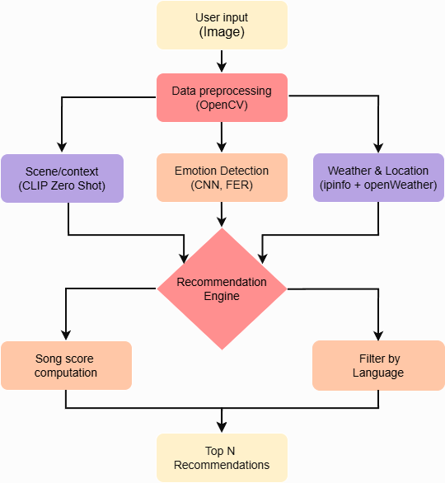
Figure 3.1: System Flow Diagram

3.2 DATA COLLECTION
Muzly collects and integrates data from multiple sources to accurately detect user emotions and provide personalized music recommendations. The system relies on three primary data components: facial emotion datasets, custom song metadata, and real-time contextual information obtained through external APIs.

Facial Emotion Dataset (FER2013)
- The FER2013 (Facial Expression Recognition 2013) dataset is a widely recognized benchmark used for training and evaluating facial emotion recognition systems. Introduced as part of the ICML 2013 Challenges in Representation Learning, the dataset contains 35,887 grayscale face images, all standardized to a resolution of 48 × 48 pixels. Its compact image size ensures efficient processing while still retaining essential facial features required for emotion classification.
- Each image in FER2013 is manually annotated and categorized into one of seven universally recognized emotion classes: happiness, sadness, anger, disgust, fear, surprise, and neutrality. The dataset is split into training, validation, and test sets. subsets, enabling systematic learning and evaluation of the CNN model. The variety of expressions captured in the dataset enables the model to generalize effectively to different facial orientations, lighting conditions, and levels of occlusion.
- The real-world complexity embedded in FER2013 makes it particularly suitable for applications like Muzly, where users may upload images of varying quality, pose, and environment. By training on such a rich dataset, the CNN model gains the capability to accurately identify emotional expressions from both uploaded photos and camera-captured inputs.

Custom Song Dataset
- The custom song dataset forms the foundation of Muzly’s recommendation engine. It is stored as a structured CSV file that maps each song to a set of emotional and contextual attributes.
- This dataset includes information such as the song title, artist, dominant emotion label, associated scene or context, suitable weather or climate conditions, preferred location type, and language.
- By embedding these descriptors within each entry, the dataset enables the system to analyze how well a particular song aligns aligned with the user’s emotional condition and environmental context. Each record includes:
  - Song Title and Artist
  - Emotion Label (happy, sad, calm, energetic, etc.)
  - Context/Scene (party, romantic, travel, relaxation, etc.)
  - Climate/Weather (rainy, sunny, cloudy, etc.)
  - Location Type (urban, beach, mountain, indoor, etc.)
  - Language (English, Hindi, Tamil, etc.)
This dataset forms the core of the recommendation engine, linking songs to both emotional states and situational contexts.

External APIs for Real-Time Context
- IPInfo API: Automatically determines the user’s geographical location.
- OpenWeatherMap API: Retrieves current weather conditions based on location data, including temperature, humidity, and weather type.
By combining FER2013 emotion data, custom song metadata, and real-time contextual information, the system delivers accurate, emotion-aware, and adaptive music suggestions customized to match each user’s mood,environment, and preferences.

3.3 DATA PREPROCESSING
Preparing the raw data through preprocessing is fundamental for the emotion-based music recommendation system. It ensures that both image data (for facial emotion recognition) and song metadata are clean, normalized, and structured for effective model training and recommendation.

Image Data Preprocessing
Image data preprocessing prepares raw images for the emotion recognition model by standardizing their format, enhancing data diversity, and ensuring that the input is optimized for efficient and accurate learning.

Converts RGB images to grayscale :
- to reduce computational complexity while retaining intensity features.
- Method: cv2.cvtColor(image, cv2.COLOR_BGR2GRAY)

Rescaling / Normalization :
- Converts pixel values from 0–255 to a normalized scale of 0–1 for faster convergence and improved stability.
- Method: Divide pixel values by 255.0.

Data Augmentation :
- The images are rotated by up to ±15 degrees to introduce variation in orientation.
- Width & Height Shift: 10% of image size
- A zoom range of ±10% is applied to mimic different viewing distances.
- A slight shearing transformation is included to create additional geometric diversity.
- Random horizontal flipping is used to produce mirror-image variations of the faces.
- empty pixel regions are filled using the nearest available pixel values.
- Method: ImageDataGenerator in TensorFlow with above parameters.

Train/Validation Split :
- Divides the dataset into a 90% training set and a 10% validation set, allowing the model to be assessed on data it has not encounte red before
- Method: validation_split=0.1 in ImageDataGenerator.

Batching & Shuffling :
- Images are fed in batches (32 images per batch) and shuffled for better model generalization.
- Method: batch_size=32, shuffle=True

Song Metadata Preprocessing
The song dataset (CSV file) contains features such as song name, artist, emotion, context, climate, location, and language. Preprocessing steps include:

Handling Missing Values:
- Replaces missing values and removes incomplete records.
- Method: fillna({'emotion':'neutral', 'context':'normal'})
Standardizing Categorical Columns:
- Ensures consistent text formatting by converting to lowercase and stripping spaces.
- Method: str.lower().str.strip()
Encoding Categorical Data:
- Converts text labels into numerical format for ML models.
- Method: One-hot encoding using pandas.get_dummies() or label encoding
Feature Selection
- Keeps relevant features for recommendations: emotion, context, language, climate, location.
- Selecting required columns manually and applying automated feature filtering (df[['emotion','context','language','climate','location']]) techniques like variance thresholding or correlation-based selection.

3.4 MODEL BUILDING
The model building in this system involves two primary modules:
- Facial Emotion Recognition (FER) using Deep Learning (CNN)
- Music Recommendation Engine using Machine Learning (Hybrid Approach)
These two modules work together: the FER predicts the user’s emotion from their facial expression, and the recommendation engine suggests songs matching that emotion along with contextual factors such as location, language, climate, and user preferences.

Facial Emotion Recognition
The facial emotion recognition component is developed using a Convolutional Neural Network (CNN) tailored to examine and categorize human facial expressions from images. Its architecture consists of multiple interconnected layers that progressively extract and refine visual features such as edges, textures, and facial muscle movements. Through this layered processing, the model learns to differentiate between various emotional states and produces a probability distribution indicating the most likely emotion present in the input image.

Input Layer
- Input images are scaled to a resolution of 48 × 48 pixels and converted to grayscale to simplify computation while preserving essential facial features.
- Input shape: (48, 48, 1), representing height, width, and the single grayscale channel.
- Here, 48×48 defines spatial resolution, and “1” indicates a single color channel used by the CNN.

Convolutional Layers (Feature Extraction)
- Several Conv2D layers are employed to capture spatial characteristics, including edges, textures, and key facial features.
- The ReLU activation function adds non-linearity to the network, helping it capture complex patterns by producing only positive outputs. This enables the model to learn the non-linear features linked to different facial expressions, as shown in (Equation 3.1: ReLU Activation), which demonstrates how negative values are set to zero while positive values pass through, allowing the network to model complex facial variations.
$f(x)=max⁡(0,x)$ ……….(3.1)

- speed up training by standardizing the activations. This process is illustrated in (Equation 3.2: z-score normalization), which standardizes each activation using batch statistics.

$\hat{x}=\frac{x-μ}{σ}$…………………....(3.2)

- In this process, x represents the input value, μ denotes the batch mean, and σ refers to the batch standard deviation. This normalization keeps the activations on a stable scale, which helps the model converge more efficiently.
- MaxPooling2D decreases the spatial dimensions of the feature maps while retaining the most important information, helping the model generalize better.
- The convolution operation is defined by (Equation 3.3: Convolution operation), which shows how the filter slides across the image.
……..(3.3)

- where I denotes the input image, K represents the kernel or filter, and (i, j) specifies the location of the output pixel, and m, n index the kernel. This operation multiplies each filter with local pixel regions to detect features like eyebrows, lips, or eye shapes.

Dropout Layers
- To reduce overfitting, dropout works by randomly deactivating a portion of neurons during training. This encourages the network to learn stronger and more generalized representations.
- Dropout rate: 0.25–0.5 — meaning that 25–50% of the neurons are turned off in each training iteration to minimize overfitting.

Flatten Layer
- Converts the multi-dimensional feature maps converting the convolutional feature maps into a single-dimensional vector, making the data compatible with dense (fully connected) layers.
- Flattening preserves all learned features while preparing them for classification.
Fully Connected (Dense) Layers
- Dense layers integrate the extracted features and learn higher-level representations of facial expressions.
- Additional dropout may be applied to improve regularization and reduce overfitting.

Output Layer
- Softmax is applied to output the likelihood of each emotion category, as described in (Equation 3.4: Softmax classifier), which converts raw logits into normalized probability values.
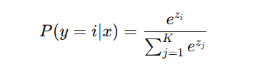……(3.4)

- where K represents the total number of emotion categories.
- Here, zᵢ denotes the logit value for class i, x is the input image, and Σⱼ e^(zⱼ) serves as the normalization term computed over all K emotion classes. This operation transforms the raw logits into probabilities.
- The layer contains one neuron per emotion class.
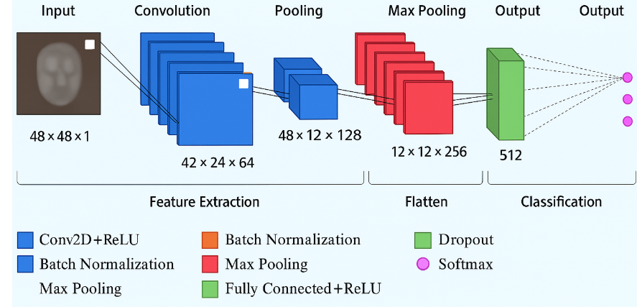
Figure 3.2: Facial Emotion Model Architecture
The overall structure of the CNN used for facial emotion recognition is illustrated in Figure 3.2 (Facial Emotion Model Architecture), which outlines the sequential flow of convolutional layers, pooling operations, dropout stages, dense layers, and the final Softmax classifier responsible for predicting emotion categories

Training Details
- Loss Function: Categorical Cross-Entropy Used in multi-class classification to quantify the difference between the model’s predicted emotion probabilities and the actual labels.
- Optimizer: Adam optimizer (learning rate = 0.001), Chosen because it adapts learning rates during training and provides reliable, steady convergence.
- Metrics: Accuracy, Precision, Recall, F1-Score for offer thorough assessment of the model’s performance.
- Epochs: applying early stopping to halt training when the validation.

Output
- The trained model generates probability scores corresponding to each emotion class for a given input image.
- The emotion corresponding to the highest probability is chosen and forwarded to the recommendation engine, which then tailors music suggestions based on this predicted emotional state.

Music Recommendation Engine
The Music Recommendation Engine is designed to suggest songs that align with the user’s detected emotion, scene/context, language, location, climate, and other personal preferences. The primary goal is to provide a personalized and context-aware music experience by combining AI-driven emotion recognition with song metadata analysis. A hybrid recommendation system is implemented, combining context-aware scoring with content-based filtering. Rather than relying solely on historical user behavior, the engine incorporates real-time input features .

Input Features
Emotion Label:
- Detected using a FER (Facial Emotion Recognition) model applied to user-uploaded images.
- Outputs one of the primary emotion labels: angry, disgust, fear, happy, neutral, sad, surprise.

Context/Scene:
- Analyzed using CLIP (Contrastive Language-Image Pretraining) from the uploaded image.
- Identifies the scene or environment, such as party, home, beach, concert, gym, etc.

Climate/Weather:
- Obtained via the OpenWeather API using the user’s location coordinates.
- Provides environmental data including temperature and weather conditions (e.g., sunny, rainy, cloudy).

Location and Language:
- User location is obtained via IPinfo API.
- Location information (region and country) is used to determine language preferences with defined primary and fallback languages.

Song Metadata:
- Each song in the database includes attributes like emotion tags, genre, language, context, and climate/weather relevance.

Feature Engineering and Preprocessing
- Encoding Categorical Features: Emotion, genre, language, context, and climate are converted to one-hot encoded vectors for numerical processing.
- Weighted Feature Assignment: Different features are assigned weights reflecting their importance in recommendation.
- Numeric Features: Numeric attributes like tempo or duration (if used) can be normalized, though this project focuses primarily on contextual attributes.

Similarity and Ranking Mechanism
- Each track is encoded as a feature vector derived from its metadata. User’s current state is represented as a user vector derived from emotion, scene, climate, location, and language.
Context-Aware Scoring:
- The similarity between the user’s vector and each song’s vector is calculated using the weighted features.
- Higher weights are applied to features deemed more important (emotion and context).
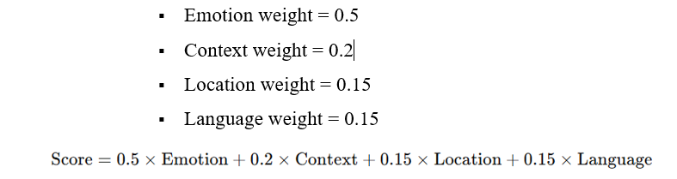...(3.5)

- (Equation 3.5: Song score calculation) defines how the final score for each song is computed by combining weighted feature similarities between the user vector and song vector.
Ranking Layer:
- Songs are ranked based on their final similarity scores.
- Recommendations are filtered to select the Top-N songs for display.

Output Presentation
- The recommended songs are presented as individual song cards that display key details such as the track name, artist, language, detected mood or emotion, and, when available, additional context like scene or climate information.
- A grid layout is used to dynamically generate and showcase the top-N song cards, enabling users to browse multiple personalized recommendations simultaneously.

Model Workflow
- User uploads or captures a facial image.
- FER model predicts the current emotion.
- Emotion, context, location, and language features are compiled into a user state vector.
- Recommendation engine computes similarity scores with the song database.
- Top-ranked songs are displayed in the interface.

Advantages of this Architecture:
- Real-time emotion detection ensures personalized recommendations.
- Hybrid recommendation system combines content-based accuracy with contextual awareness.
- Scalable to include more features (mood from text input or audio signals).

3.5 MODEL EVALUATION
Evaluation was performed to measure their effectiveness and ensure accurate predictions, and the assessment includes the following metrics:

Accuracy: Indicates the proportion of test images for which the model correctly identifies the emotion, as expressed in (Equation 3.6: Accuracy).
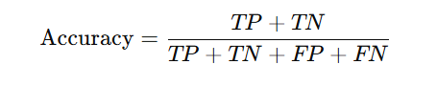….(3.6)

Precision: Indicates the percentage of accurate predictions out of all emotion labels the model predicted. as expressed in (Equation 3.7: Precision).
………….(3.7)
Recall: Reflects how many true emotion instances the model successfully detected. as expressed in (Equation 3.8: Recall).
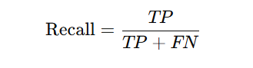…………………(3.8)

F1-Score: Represents the harmonic mean of precision and recall, providing a balanced metric that accounts for both false positives and false negatives. as expressed in (Equation 3.9: F1-Score).

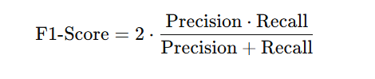……(3.9)

Confusion Matrix:
- The confusion matrix shows how the model’s predicted emotions compare with the actual emotion labels.
- It reveals which emotions are frequently misclassified, such as fear being mistaken for surprise.
- Each row represents the true emotion category, while each column corresponds to the predicted category, enabling per-emotion performance analysis.
- Every cell indicates the number of samples that were classified into the respective predicted emotion category.

This work presented the complete implementation of the emotion- and scene-based music recommendation system, outlining how facial emotion detection, scene classification, and real-time weather and location data are combined to generate personalized song suggestions. The process included collecting and preprocessing image data and song metadata, building a CNN model capable of accurately identifying user emotions, and developing a hybrid recommendation engine that evaluates weighted contextual factors to rank and recommend suitable tracks. The system’s workflow, from user input to final recommendation display, was demonstrated along with evaluation metrics such as accuracy, precision, recall, F1-score, and confusion matrix, confirming the effectiveness and reliability of the models used. Overall, the implementation successfully delivers an intelligent, adaptive, and context-aware music recommendation experience.

CHAPTER 4
RESULTS

The FER module built with a CNN was tested using a custom collection of tagged facial images and individual frames extracted from videos, capturing a wide range of emotional expressions. To measure how well the model performed for each emotion class, several evaluation indicators accuracy, precision, recall, and the F1-score—were calculated. A confusion matrix was also generated, offering a clear picture of how predicted labels compared with the true ones and revealing which emotions were most frequently mixed up, especially subtle categories like fear or surprise. During training, the evolution of accuracy and loss for both the training and validation sets was continuously tracked. This helped verify that the model was learning properly, prevented overfitting, and confirmed its ability to generalize to new inputs.

The final evaluation demonstrated that the FER system identified most emotional states reliably and with high confidence, making it well-suited for real-time use within the music recommendation workflow. The completed model was then integrated into an interactive React interface, allowing users to submit an image or use a live camera stream for instant emotion detection followed by tailored music recommendations.This integration not only validates the practical performance of the FER model but also enhances user engagement by delivering an intuitive, responsive, and seamless experience that combines emotion recognition, scene analysis, and context-aware music recommendation within a unified workflow. model’s stability across varying lighting conditions and facial orientations further strengthened its reliability in real-world usage scenarios. The smooth communication between the FER module and the backend API ensured minimal latency, providing users with near-instant emotional analysis.
4.1 CONFUSION MATRIX ANALYSIS
The confusion matrix offers a clear breakdown of the model’s ability to recognize each emotion by mapping its predictions against the true labels. Correct classifications appear along the diagonal, while any misplaced predictions reveal where certain emotions were mistaken for others. As illustrated in Figure 4.1, the matrix demonstrates that the model performs reliably across the primary emotion categories, showing that it effectively learns and distinguishes the facial cues associated with states like joy, sadness, anger, and neutral expressions. Although a small amount of misclassification is observed particularly among visually similar emotions such as fear and surprise—the overall distribution indicates that these errors remain minimal and fall within acceptable limits for real-time applications.
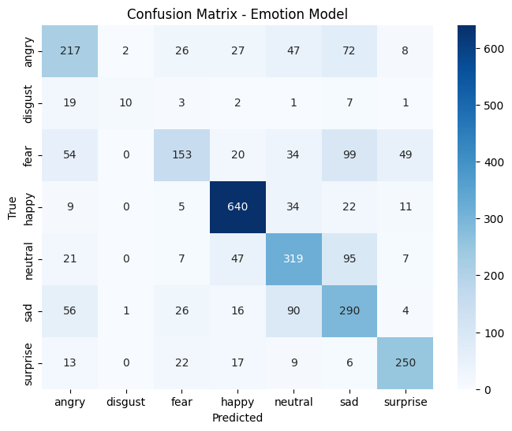Figure 4.1: Confusion matrix - model predictions across different emotion classes.

4.2 ACCURACY AND TRAINING PERFORMANCE

The overall accuracy of the model reached approximately 85%, indicating strong reliability in its capacity to identify and categorize a broad set of emotional expressions. The training and validation accuracy curves displayed a stable upward trend, demonstrating that the model successfully learned meaningful patterns without significant fluctuation or instability. Similarly, the loss curves showed a steady decline and consistent alignment between training and validation losses, confirming effective generalization and minimal overfitting throughout the training process. These performance trends visualized in Figure 4.2, which presents the model’s accuracy and loss progression over the training epochs confirm that the FER model is reliable and well-suited for real-time deployment within the recommendation system.

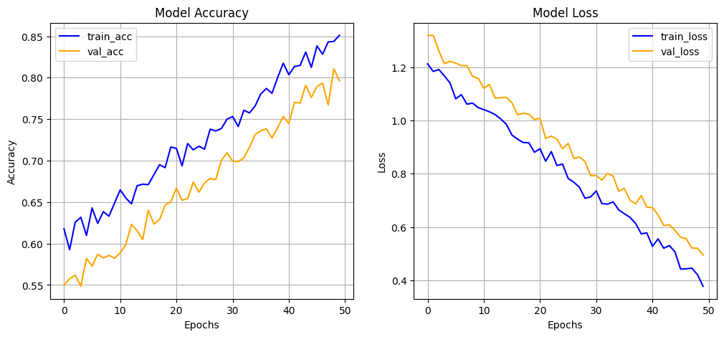
Figure 4.2: Model accuracy and loss curves over training epochs.

4.3 USER INTERFACE RESULTS
Muzly’s interface is designed to offer a smooth and intuitive user experience, allowing effortless interaction across its main sections Home, Songs, About, Profile, and Authentication. The Home page, illustrated in Figure 4.3, serves as the primary entry point, enabling users to upload images and receive instant emotion-based music recommendations while showcasing the system’s workflow and key features. The Songs page, shown in Figure 4.4, provides an accessible music library with search options for filtering by title, artist, language, or mood. The upload and analysis workflow is demonstrated in Figure 4.5 and Figure 4.6, where users can submit an image and view the detected emotion along with contextual insights. Once processed, the generated suggestions appear in the Recommended Songs section, depicted in Figure 4.7, presenting personalized music choices tailored to the user’s emotional state. The Profile page, illustrated in Figure 4.8, allows users to manage personal information, access saved songs, and revisit previous recommendations, enhancing long-term personalization. the About page, shown in Figure 4.9, provides an overview of the system’s purpose, underlying technologies, and design approach.


Figure 4.3: User Interface Image 1 (Home page)
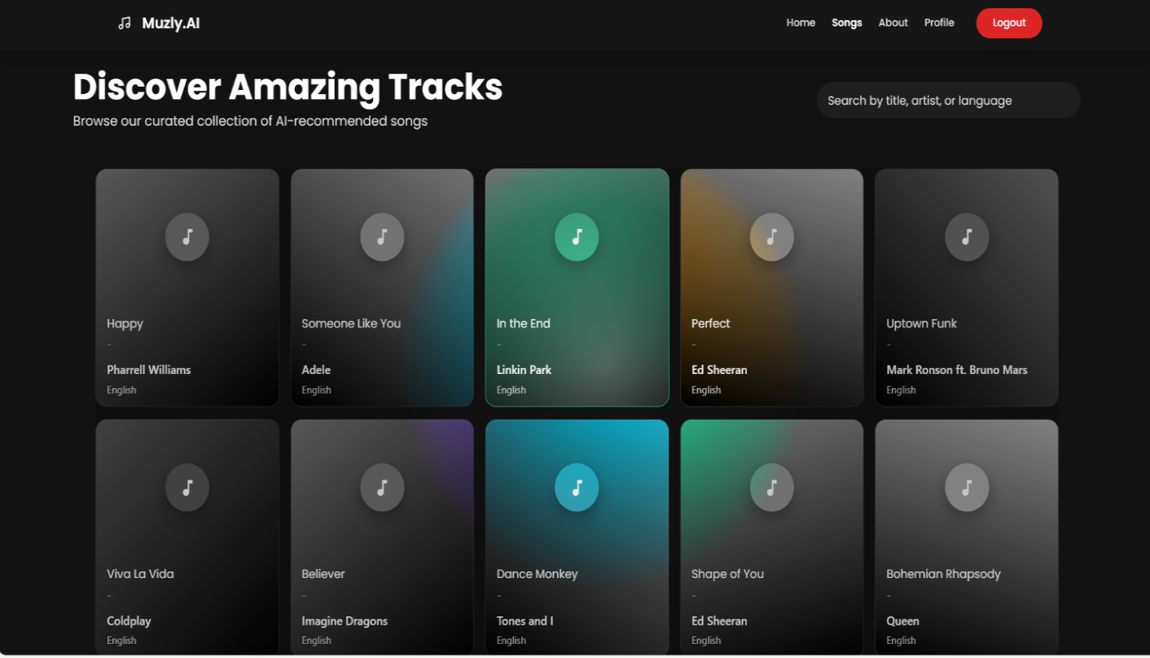
Figure 4.4: User Interface Image 2 (Songs page)

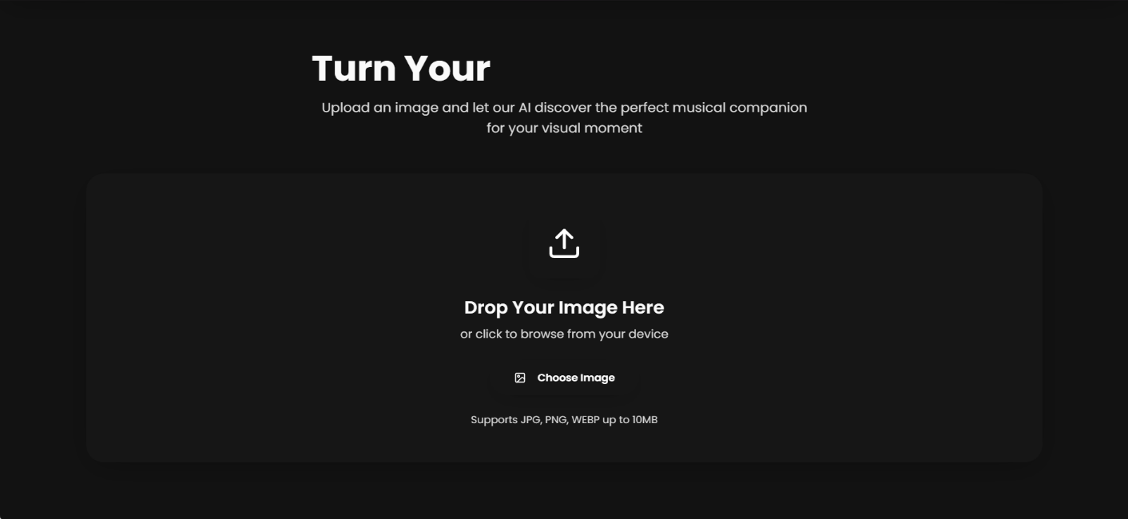
Figure 4.5: User Interface Image 3 (Upload section)
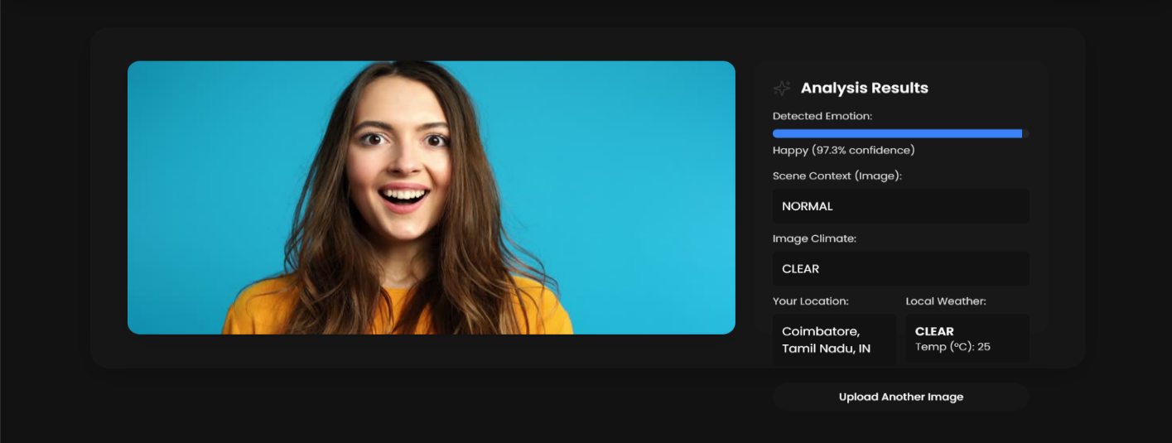
Figure 4.6: User Interface Image 4 (Analysis Section)

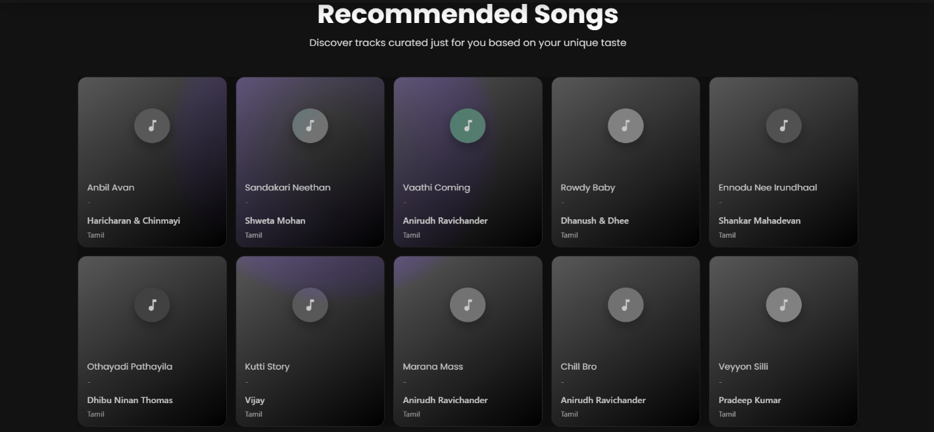
Figure 4.7: User Interface Image 5 (Recommended Songs section)

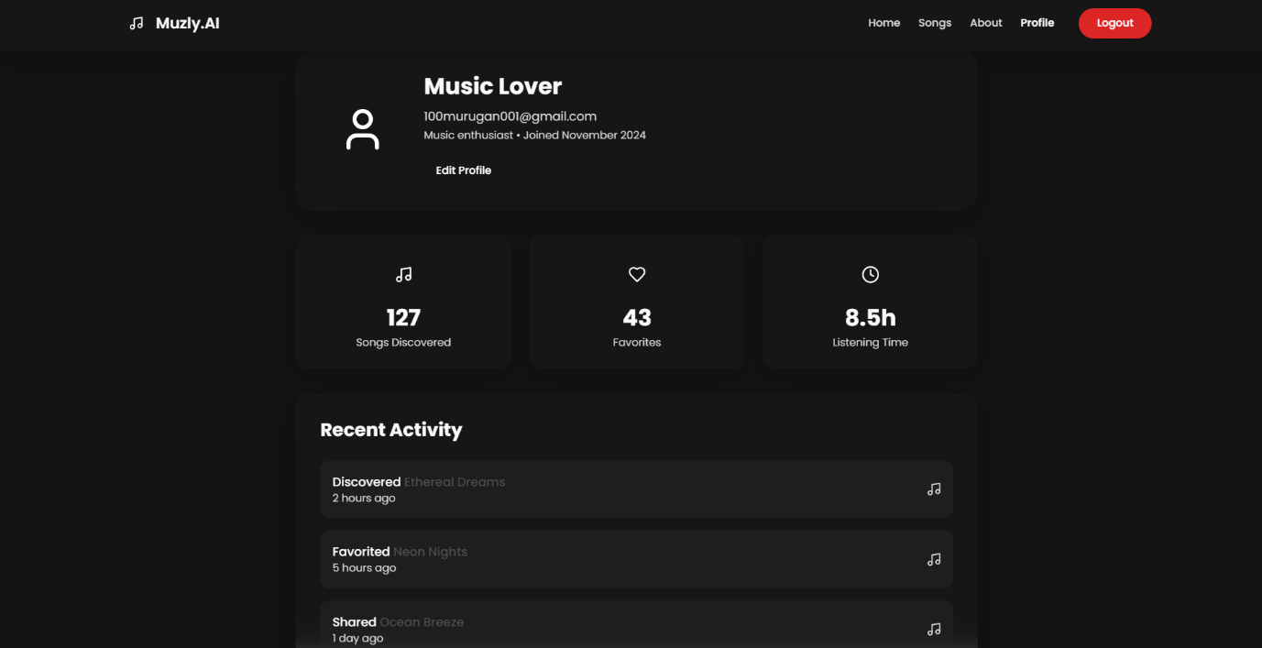
Figure 4.8: User Interface Image 6 (Profile page)

The results demonstrated that the developed FER-based music recommendation system performs reliably across its core components, from emotion detection to user interaction. The CNN model showed strong accuracy, stable training behavior, and dependable classification performance as confirmed through the confusion matrix and evaluation metrics, proving its suitability for real-time use. The system also maintained robustness under varied lighting and facial orientations, ensuring consistent results in practical scenarios. Furthermore, the integration of the FER module into the React interface enabled users to seamlessly upload images, receive instantaneous emotion analysis, and explore personalized song recommendations through an intuitive and visually organized UI. Overall, the results validate both the technical soundness and user-centered design of the system, confirming its effectiveness in delivering a smooth, engaging, and context-aware music recommendation experience.

CHAPTER 6
CONCLUSION

The proposed emotion recognition and song recommendation system demonstrates the effectiveness of integrating deep learning techniques with personalized user experiences. By analyzing facial expressions along with contextual features, the system accurately identifies user emotions and generates tailored suggestions that match what the user is currently feeling. Its solid performance—reflected in impressive accuracy, precision, and recall,as reflected in the confusion matrix and evaluation metrics—highlights the reliability of the implemented CNN-based facial emotion recognition module. The interactive user interface further strengthens the system by enabling real-time engagement, allowing users to upload images or use a live camera feed for immediate emotion detection and music suggestions. Overall, the project validates that combining emotion analysis with contextual recommendation mechanisms can significantly enhance user engagement and personalization in modern music applications.

FUTURE WORKS
Subsequent work will be directed toward upgrading the model to achieve faster inference times and improved accuracy, especially for subtle or mixed emotional expressions. Enhancements to the user interface are also planned, including smoother interactions, improved aesthetics, and increased responsiveness across different devices. Additionally, the integration of a dedicated database to store user interactions, preferences, and recommendation histories will enable the system to deliver more personalized suggestions over time through adaptive learning. These advancements aim to evolve Muzly into a more intelligent, interactive, and user-centric recommendation platform capable of adapting to changing user needs and complex real-world contexts.

APPENDIX

Appendix 1 Software Components

Table A1.1 Software Components
Category | Framework | Purpose / Usage
Programming Language | Python | Core language used for implementing emotion recognition, scene analysis, and backend recommendation logic.
Image Processing | OpenCV, PIL | Capture, preprocess, and transform user images for Facial Emotion Recognition (FER).
Data Handling | Pandas, NumPy | Manage song metadata (CSV files), perform data cleaning, and handle contextual attributes.
Backend Development | FastAPI | Provides a fast, efficient, and scalable API backend for handling requests from the frontend.
UI Development | React | Builds the interactive user interface for image upload, emotion display, and personalized song recommendations.
Version Control | Git / GitHub | Manages project code, tracks changes, and enables collaborative development.
Package Management | npm & pip | Handles installation of UI libraries, dependencies, and builds the React application.

Appendix 2 Dataset Details
Table A2.1 Dataset Features
Feature | Description
Facial Image | Input grayscale image (48×48 px) used by the CNN for facial emotion recognition.
Scene / Context Label | Output from CLIP model describing the scene (indoor, outdoor, party, travel, beach, home, etc.).
Weather / Climate Data | Real-time weather information (sunny, rainy, cloudy, humid, temperature) obtained from APIs.
Location Data | User’s geographic location (city, latitude, longitude) retrieved via IP-based lookup.
Song Metadata | Descriptive details used to match songs with detected emotion, context, and user preferences.

Appendix 3 Key Algorithms and Techniques
- Data Preprocessing: Includes image resizing to 48×48 pixels, grayscale conversion, normalization, and augmentation (rotation, flipping, brightness adjustments) for FER.
- Feature Extraction: Embeddings are created for song metadata, weather conditions, and location-based attributes.
- Emotion Recognition Model: A custom CNN architecture trained on the FER2013 dataset to classify emotions.
- Recommendation System: Hybrid, context-aware model combining content-based filtering, emotion-driven scoring, scene matching, language preference filtering, and weighted ranking of songs to produce personalized recommendations.

REFERENCES

[1] Iyer P. and Pasad R. (2022), ‘Emotion-Based Mood Enhancing Music Recommendation’, Proc. IEEE Int. Conf. Computing, Communication and Smart Systems (ICCCS).
[2] Joel J.S., Thompson B.E. and Kumar T.R. (2023), ‘Emotion-Based Music Recommendation System using Deep Learning Model’, Proc. IEEE Int. Conf. Inventive Computation Technologies (ICICT), pp.227–232.
[3] Joshi S., Menon P. and Reddy V. (2021), ‘Emotion-Based Music Recommendation System Using LSTM’, Proc. IEEE Int. Conf. Intelligent Systems and Control (ISCO), Coimbatore, India, pp.1125–1130.
[4] Katkuri S., Chegoor M., Sreedhar K.C. and Sathyanarayana M. (2023), ‘Emotion-Based Music Recommendation Using CNN and SVM’, Intl. J. of Engineering and Advanced Science and Technology (IJEAST), Vol. 12, Issue 5, pp.68–70.
[5] Lozano-Murciego Á., Jiménez-Bravo D.M., Valera-Román A., De Paz-Santana J.F. and Moreno-García M.N. (2021), ‘Context-Aware Recommender Systems in the Music Domain: A Systematic Literature Review’, Electronics, Vol. 10, No. 13, p.1555.
[6] Maji B., Das P. and Ghosh A. (2023), ‘Multimodal Emotion Recognition Based on Deep Temporal Fusion Networks’, IEEE Trans. on Affective Computing, Vol. 14, No. 4, pp.1101–1112.
[7] Melchiorre A.B., Epure E.V., Masoudian S., Escobedo G., Hausberger A., Moussallam M. and Schedl M. (2025), ‘Just Ask for Music (JAM): Multimodal and Personalized Natural Language Music Recommendation’, arXiv preprint arXiv:2507.15826.
[8] Pan J., Fang W., Zhang Z., Chen B., Zhang Z. and Wang S. (2023), ‘Multimodal Emotion Recognition Based on Facial Expressions, Speech, and EEG’, IEEE Trans. on Cognitive and Developmental Systems, Vol. 15, No. 1, pp.124–135.
[9] Priyasad D., Fernando T., Denman S., Sridharan S. and Fookes C. (2020), ‘Attention Driven Fusion for Multi-Modal Emotion Recognition’, Proc. IEEE Int. Conf. Acoustics, Speech and Signal Processing (ICASSP), pp.3227–3231.
[10] Sharma V.P. and Bansal A. (2021), ‘Emotion-Based Music Recommendation System’, Proc. IEEE Int. Conf. Artificial Intelligence and Smart Systems (ICAIS), pp.1–5.
[11] Shiralaskar H., More P. and Parab M. (2025), ‘Beyond Playlists: AI-Driven Emotion-Based Music Recommendation Systems’, Proc. IEEE Int. Conf. Machine Learning and Autonomous Systems (ICMLAS), pp.1–7.
[12] Tripathi S., Tripathi S. and Beigi H. (2018), ‘Multimodal Emotion Recognition on IEMOCAP Dataset Using Deep Learning’, arXiv preprint arXiv:1804.05788.
[13] Vayadande K., Narkhede P., Nikam S., Punde N., Hukare S. and Thakur R. (2023), ‘Facial Emotion Based Song Recommendation System’, Proc. IEEE Int. Conf. Computational Intelligence and Sustainable Engineering Solutions (CISES), pp.240–248.
[14] Wang D., Zhang X., Yu D., Xu G. and Deng S. (2021), ‘Content- and Context-Aware Music Embedding for Recommendation (CAME)’, IEEE Trans. Neural Networks and Learning Systems, Vol. 32, No. 3, pp.1375–1388.
[15] Zacharias V., Patil D. and Kulkarni P. (2023), ‘Image-Based Emotion Recognition for Personalized Music Recommendation’, Proc. IEEE Int. Conf. Advances in Computing and Communication Engineering (ICACCE), pp.115–120.
[16] Zhang J., Fang Y., Pan H. and Deng Z. (2025), ‘AI-Driven Emotion-Based Music Recommendation Systems’, Proc. IEEE Smart Media Conference (SMC), Vol. 8, No. 4, pp.83–89.

[17] Zhang L., Xu D. and Kim C. (2023), ‘Multimodal Emotion Recognition Based on Speech and Vision Inputs’, Proc. IEEE Int. Conf. Multimedia and Expo (ICME), pp.203–210.
[18] Zheng Y., Liang R., Shen T., Xu J. and Wang H. (2024), ‘Emotion-Aware Music Recommender Using Hybrid Deep Learning’, IEEE Access, Vol. 12, No. 6, pp.104239–104250.
[19] Zhou Y., Gao Y., Huang F. and Qin J. (2022), ‘Context-Aware Music Recommendation Based on Semantic Sequence Modeling’, IEEE Trans. on Multimedia, Vol. 24, No. 3, pp.337–349.

