HTML NOTES

==================

->The abbrevation of HTML is Hyper Text Markup Language.

->In 1991 Tim Berners Lee introduced html1.

->In 1995 he published html2.

->In 1999 he published html4.

->Html5 came into the picture in the year 2014.

->Html is used to structure the web page.

->Basic structure of html

---------------------------

<HTML>

<HEAD>

<TITLE>

</TITLE>

</HEAD>

<BODY>

</BODY>

</HTML>

->Tags

-----------

It is the keyword or reserved word enclosed within a angular bracket.

Ex-<html>,<head>,<body>,etc...

It is used to give instructions to the browser.

->There are 2 types of tags

a)Paired tag

b)Unpaired tag

a)Paired tag ->It contains both start and end tag.It is also called as Container tag.

Ex-<html>.....</html>

b)Unpaired tag ->It contains only start tag.It is also called as Empty tag/Self closing tag.

Ex-<br>,<img>,etc.

->Elements

--------------

The content within opening and closing tag are called as elements.

Ex- <p>Friends Forever</p>

->Basic tags

---------------

Tag Description

<!DOCTYPE> Defines the document type

<html> Defines an HTML document

<head> Defines information about the document

<title> Defines a title for the document

<body> Defines the document's body

<h1>to<h6> Defines HTML headings

<p> Defines a paragraph

<br> Inserts a single line break

<!--...--> Defines a comment

->Attributes

---------------

It provides additional information about an element.

They are always specified in the start tag.

Attributes usually comes in name/value pair.

Ex-<p align="left>.....</p>

There are 4 types of attributes:

a)id =Specifies a unique id for an element.

Ex-<p id="idname">........</p>

b)title=Specifies extra information about an element.

Ex- <p title="Html notes">.............</p>

c)class=Specifies one or more classnames for an element (refers to a class in a style sheet).

Ex-<p class="classname1 classname2 classname3">.......</p>

d)style=The style attribute is used to specify the styling of an element, like color, font, size etc.

Ex- <p style="color:red">........</p>

->Grouping Elements

---------------------

Block-Level Elements

A block-level element always starts on a new line and takes up the full width available(stretches out to the left and right as far as it can).

The <div> element is a block-level element.

The <div> element is often used as a container for other HTML elements.

The <div> tag takes up the entire width of the screen.

Ex-<div>Hello World</div>.

Inline Elements

An inline element does not start on a new line and only takes up as much width as necessary.

This is an inline <span> element inside a paragraph.

The <span> element is often used as a container for some text.

The <span> tag conforms to the width of whatever element it contains.

Ex-<span>Hello World</span>.

->Lists

----------

Each list item starts with the <li> tag.

There are 4 types of lists in html

a)Ordered List

b)Unordered List

c)Definition List

d)Nested List

a)Ordered List

----------------

An ordered list starts with the <ol> tag.

Type Description

type="1" The list items will be numbered with numbers(default).

type="A" The list items will be numbered with uppercase letters.

type="a" The list items will be numbered with lowercase letters.

type="I" The list items will be numbered with uppercase roman numbers.

type="i" The list items will be numbered with lowercase roman numbers.

b)Unordered List

------------------

An unordered list starts with the <ul> tag.

Type Description

disc Sets the list item marker to a bullet(default).

circle Sets the list item marker to a circle.

square Sets the list item marker to a square.

none The list items will not be marked.

c)Definition List

------------------

Type Description

<dl> defines start of the list.

<dt> definition term.

<dd> defining defination.

d)Nested List

------------------

A nested list is a list within a list.

->Anchors and Hyperlinks

----------------------------

* Anchor tag

Html uses the <a>(anchor) tag to create a link to another document.

An anchor tag can point to any resource on the Web.

Syntax-<a href="url">.....</a>

* Href Attribute

It is used to address the document to link to,and the content between the open and close of the anchor tag will be displayed as a hyperlink.

->Image Handling

------------------

<img src = "image-file.jpg">

where img=name

src=Attribute

image-file.jpg=value

->Tables

----------

The html tables allows us to arrange the data into rows and columns.

Html tables are created using the <table> tag.

Table row is definied using <tr> tag.

Table header is defined using <th> tag.

Table data/cell is definedusing <td> tag.

->Forms

----------

The <form> tag is used to create an HTML form for user input.

The <form> element can contain one or more of the following form elements:

<input>,<textarea>,<button>,<select>,<option>,<optgroup>,<fieldset>,<label>,<output>

Syntax-<form action="Script URL" method="GET/POST">......</form>

->Form Controls

------------------

There are different types of form controls that you can use to collect data using HTML form −

1.Text Input Controls

2.Checkboxes Controls

3.Radio Box Controls

4.Select Box Controls

5.File Select boxes

6.Hidden Controls

7.Clickable Buttons

8.Submit and Reset Button

->Form input types

--------------------------

Here are the different input types you can use in HTML:

1.<input type="button"> defines a button.

2.<input type="checkbox"> defines a checkbox.Checkboxes let a user select ZERO or MORE options of a limited number of choices.

3.<input type="color"> is used for input fields that should contain a color.

4.<input type="date"> is used for input fields that should contain a date.

5.<input type="datetime-local"> specifies a date and time input field, with no time zone.

6.<input type="email"> is used for input fields that should contain an e-mail address.

7.<input type="file"> defines a file-select field and a "Browse" button for file uploads.

8.<input type="month"> allows the user to select a month and year.

9.<input type="number"> defines a numeric input field.

10.<input type="password"> defines a password field.

11.<input type="radio"> defines a radio button.Radio buttons let a user select ONLY ONE of a limited number of choices.

12.<input type="range"> defines a control for entering a number whose exact value is not important (like a slider control).Default range is 0 to 100. However, you can set restrictions on what numbers are accepted with the min, max, and step attributes.

13.<input type="reset"> defines a reset button that will reset all form values to their default values.

14.<input type="search"> is used for search fields (a search field behaves like a regular text field).

15.<input type="submit"> defines a button for submitting form data to a form-handler.

16.<input type="tel"> is used for input fields that should contain a telephone number.

17.<input type="text"> defines a single-line text input field.

18.<input type="time"> allows the user to select a time (no time zone).

19.<input type="url"> is used for input fields that should contain a URL address.

20.<input type="week"> allows the user to select a week and year.

CSS(Cascading style sheets)

===============================

1.It is a style sheet language which is used to describe the look

and formatting of a document written in markup language.

2.It is generally used with HTML to change the style of web

pages and user interfaces

selectors:

CSS selectors are used to "find" (or select) the HTML elements you want to style.

We can divide CSS selectors into five categories:

+++Simple selectors (select elements based on name, id, class)

+++Combinator selectors (select elements based on a specific relationship between them)

+++Pseudo-class selectors (select elements based on a certain state)

+++Pseudo-elements selectors (select and style a part of an element)

+++Attribute selectors (select elements based on an attribute or attribute value)

syntax:

selector{

property : value;

}

Element Selector

Universal Selector

Attribute Selector

Class Selector

Id Selector

Pseudo Classes

WAYS TO ADD CSS:

====================

There are three ways to add css to HTML

1 Inline Styles

Inline CSS is used to apply CSS on a single line or element.

For example:

<p style="color : blue">Hello CSS</p>

2 Head Styles / Internal Styles

Internal CSS is used to apply CSS on a single document or page. It can affect all the elements of the page.

It is written inside the style tag within head section of html.

<style>

p{color:blue}

</style>

3 External Styles

External CSS is used to apply CSS on multiple pages or all pages. Here,

we write all the CSS code in a css file.

BOOTSTRAP

===========

Bootstrap is an open source toolkit for developing with HTML, CSS, and JS.

It is a free and opensource css framework used to build responsive mobile first web-pages.

Bootsrap grid system:

----------------------

The screen is basically divided in to 12 parts

classes based on device size:

1.col-12 -----> extra small devices <576px

2.col-sm-12----->small devices >=576px

3.col-md-12 ----->medium device >=768px

4.col-lg-12 ----->large device >=992px

5.xol-xl-12 ------> extra large device >=1200px

in bootstrap 3 col-xs-12 ---> col-12 in BS4.

Display: inline-block allows to set height and width of the element ,top and margins are respected.

float:left floats elements to left of the container.

float:right floats elements to the right of container.

Ways of dividing:

4 4 4

3 6 3

6 3 3

2 8 2

8 2 2

3 3 3 3

and so on.

Internally the bootstrap classes has some css.(check by inspecting in browser)

Color codes:

----------------

success – green

danger - red

warning – orange

primary – blue

info - blue(variant)

secondary – gray

dark – black

light -white

how to apply ---> bg-code_name,text-code_name,link-code_name

e.g bg-success

extensions to install in vscode ----> bs3 snippets,bs4 snippets

GO THROUGH BOOTSTRAP DOCUMENTATIONS.

Files to linked ---> link bootstrap.min.css(for css),2 scripts(for js)(Ref to code)

GIT

================

GIT is a version control system.(VCS)

It is used to track the changes in files and folders.

To collaborate in teams.

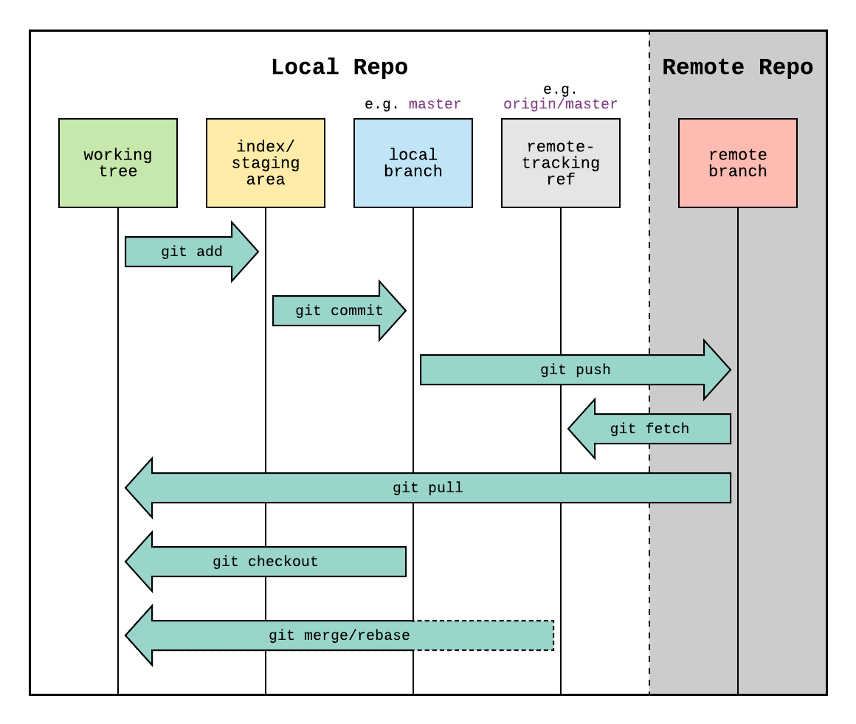

Types of VCS:

1.centralised

2.Distributed

1.centralised

here everyone should always be connected to the server.

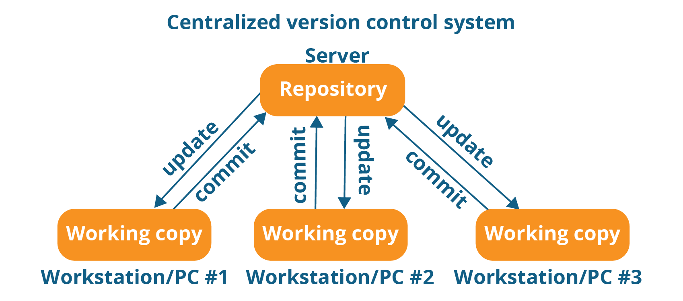

2.distributed

need to be connected only when pushing and pulling.

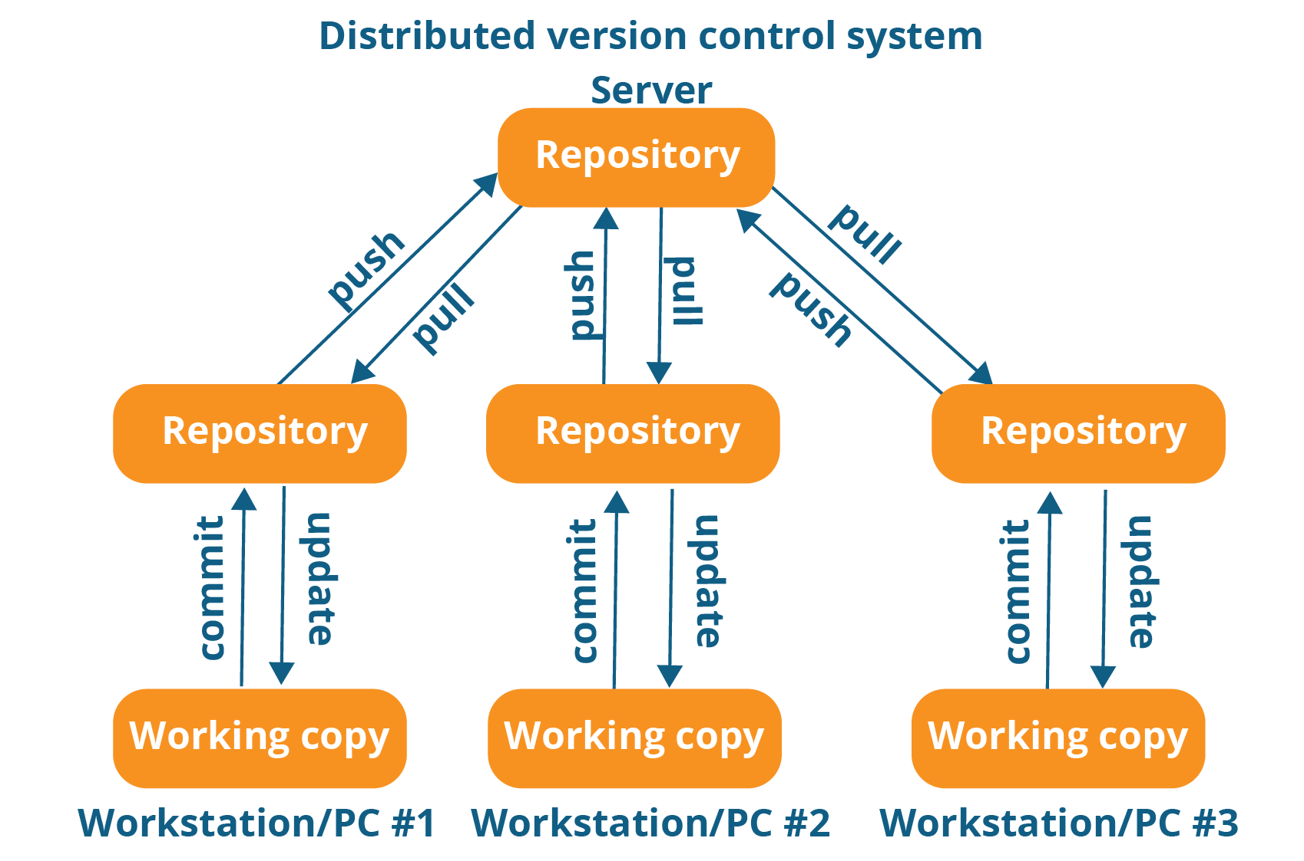

GITHUB:

it is a website to upload the repositories online.

---->it provides backup

---->provides visual interface to repo

---->makes collaboration easier.

GIT IS NOT RELATED TO GITHUB.

GIT COMMANDS:

=============

git init

git status

git add

git commit -m ‘message’

GIT is a combination of both centralised and distributed vcs.

SDLC

=============

start ------> stages/phases------->End

|

v

dedicated functionality

SDLC is unidirectional

1.Requirement analysis

BRD (Business requirement document)

2.design  
 functional design

FSD(functional design document)

technical design

TSD(Technical Design document)

3.development

4.unit testing

5.application testing

6.deployment

7.support

UNIT Testing is done by the developer.

Application testing

Tester comes in to picture

1.functionality testing

2.non-functionality testing

3.user acceptance testing

4.crowd beta testing(TY spec)

learn -----> WaterFall Method , Agile Method.