**Differences between Window object and Document**

In this blog, we will see the difference between Window object and Document object.

**Window Object**

Windows is a parent. It contains my child like documents etc. Documents contain many tag. Window is supreme position in web browser.

Windows use to create a responsive web page

JavaScript Window is a global Interface which is used to control the browser window and perform various operations on browser.

It represents the browser window in which you are seeing the content.

We can create alert message using methods. Many properties and methods in the window object in java script.

Window loaded before the document because window container document.

First loaded in browser is window and the properties related to that window are stored in the window object

We can vary or adjust web browser size using windows method. We can create many popup message in windows, we can open new tabs in browser.

**Some window object properties**:

* closed
* console
* documents
* frames
* location
* inner height
* inner length
* history
* navigation

**Window object methods :**

* alert()
* prompt()
* open()
* close()
* print()
* confirm()

**Document Object**

Documents is one of the child of window. Document also object inside a window

Document is loaded inside the window or browser.

Document is loaded after the loading window because the window contains a document.

HTML tags are inside the document. Like a body tag, a tag, h tags, img tag, div tag etc. it have properties and methods and tags

We can access the html tags using documents and we can alter the tags

Window gets loaded then will be document loaded inside that window, and the properties related to that document is stored in the document object.

Document object also have many child, and functions.

Some html tags:

* body
* head
* div
* a
* input
* form
* script
* table
* br

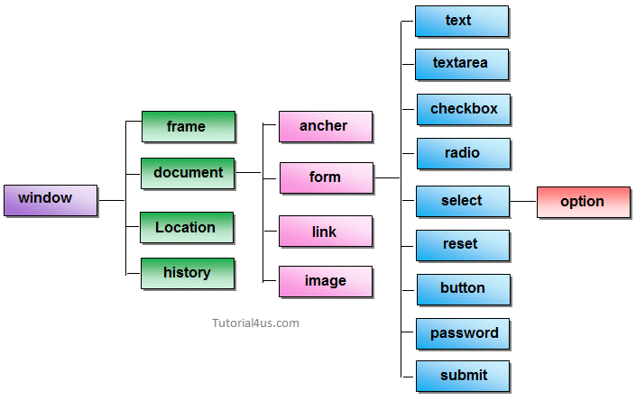

Img : javascript object hierarchy (img source: tutorial4us.com)