**BUYALL - Final Project**

**User Screen**

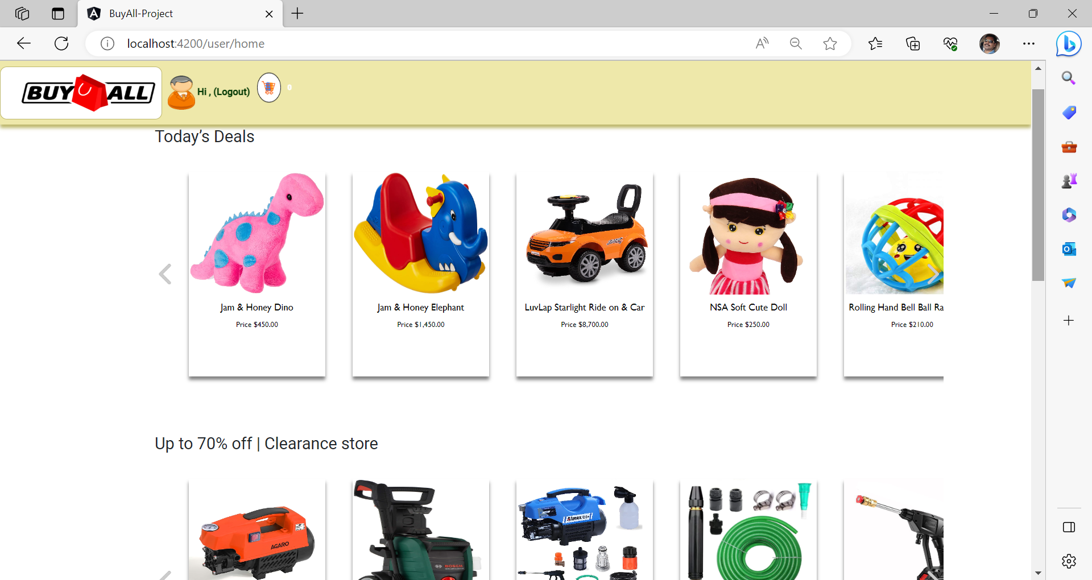

**Details Screen**

**Login Screen**

**New user registration screen**

**Dashboard – Admin Screen**

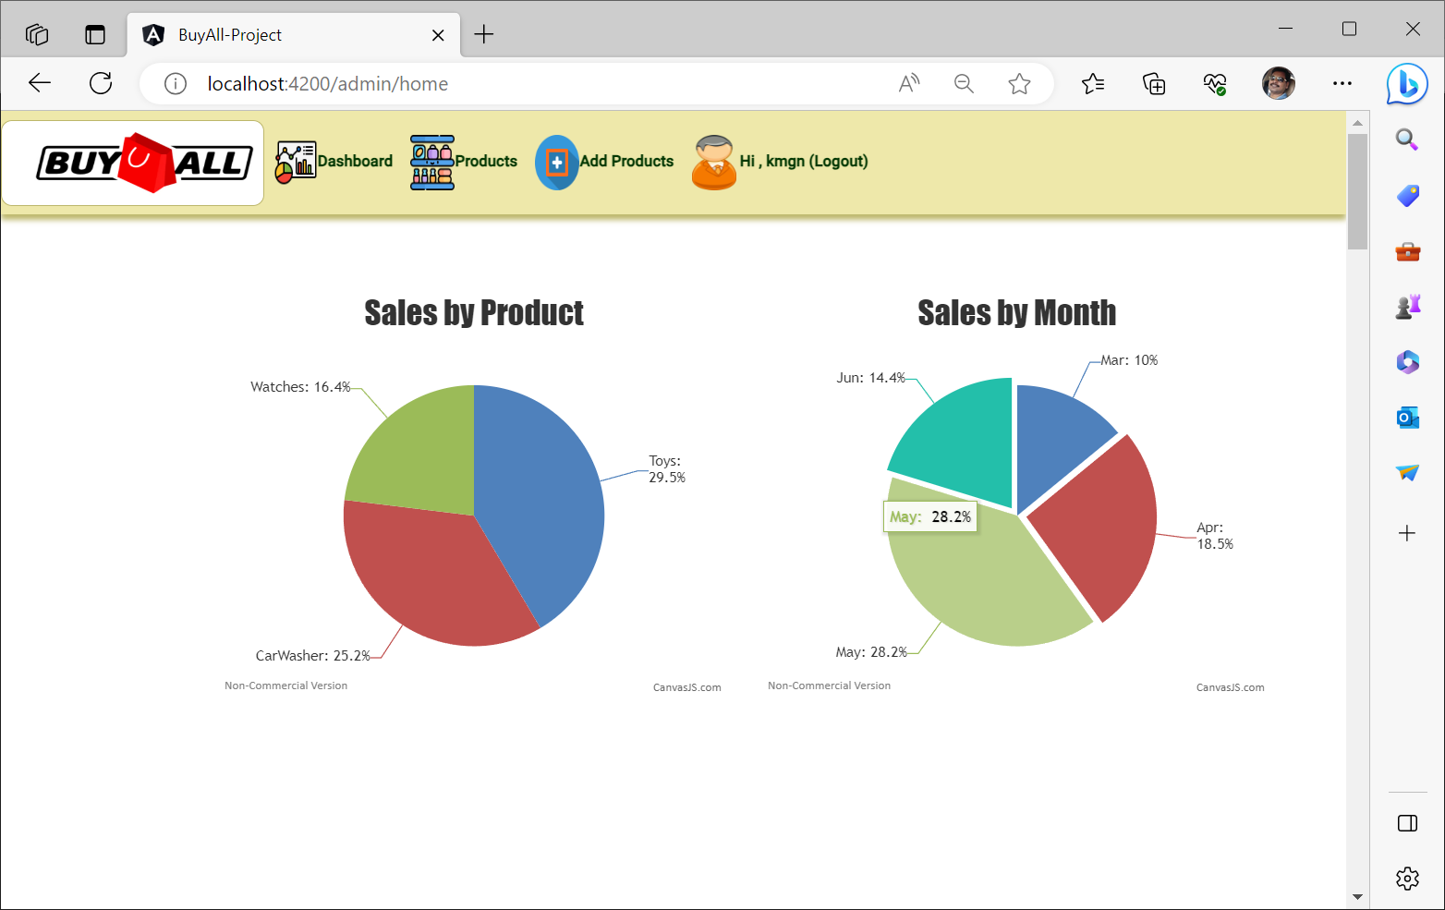

**Products Screen - Admin**

