Hi Team,

I have installed Fluid NC in ESP32 board pictured below.

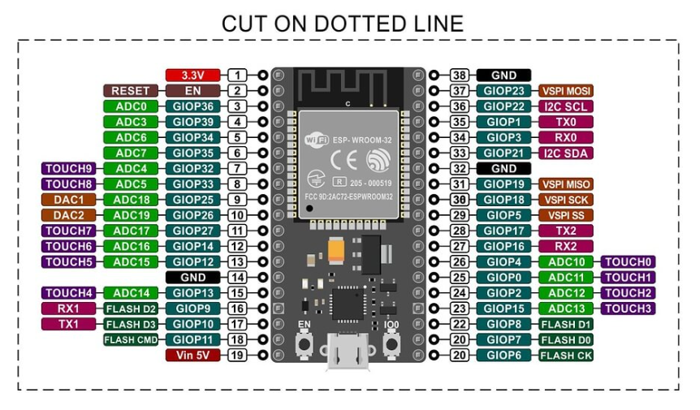

Uploaded the below yaml file.



In Light Burn, we have 3 options of GRBL.

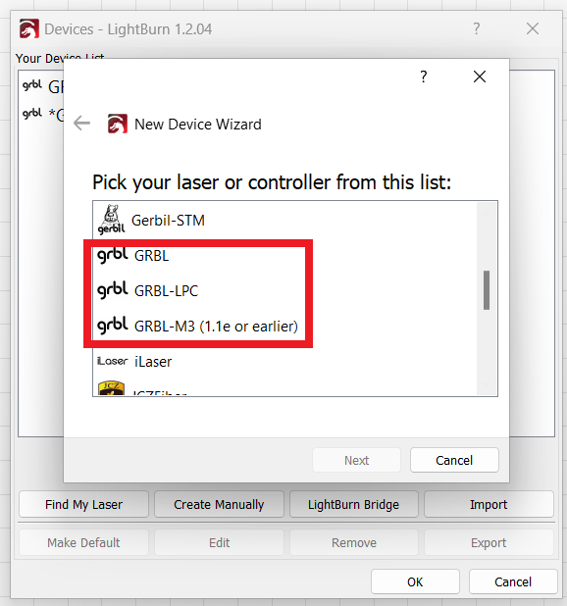

Among them, GRBL-M3 (1.1e or earlier) works fine.

Below are the screen shots:

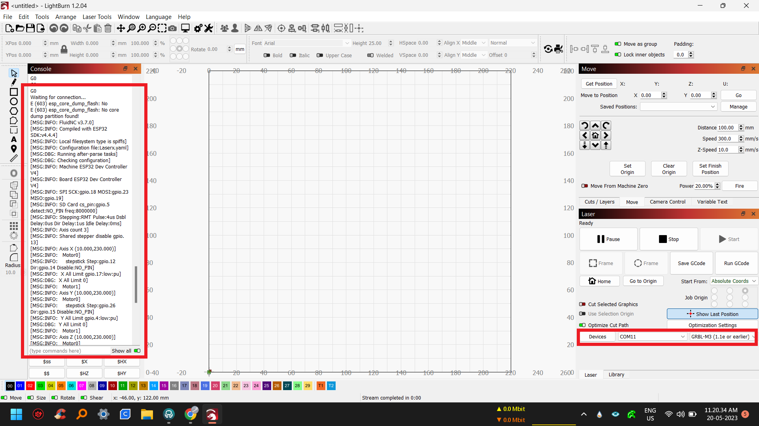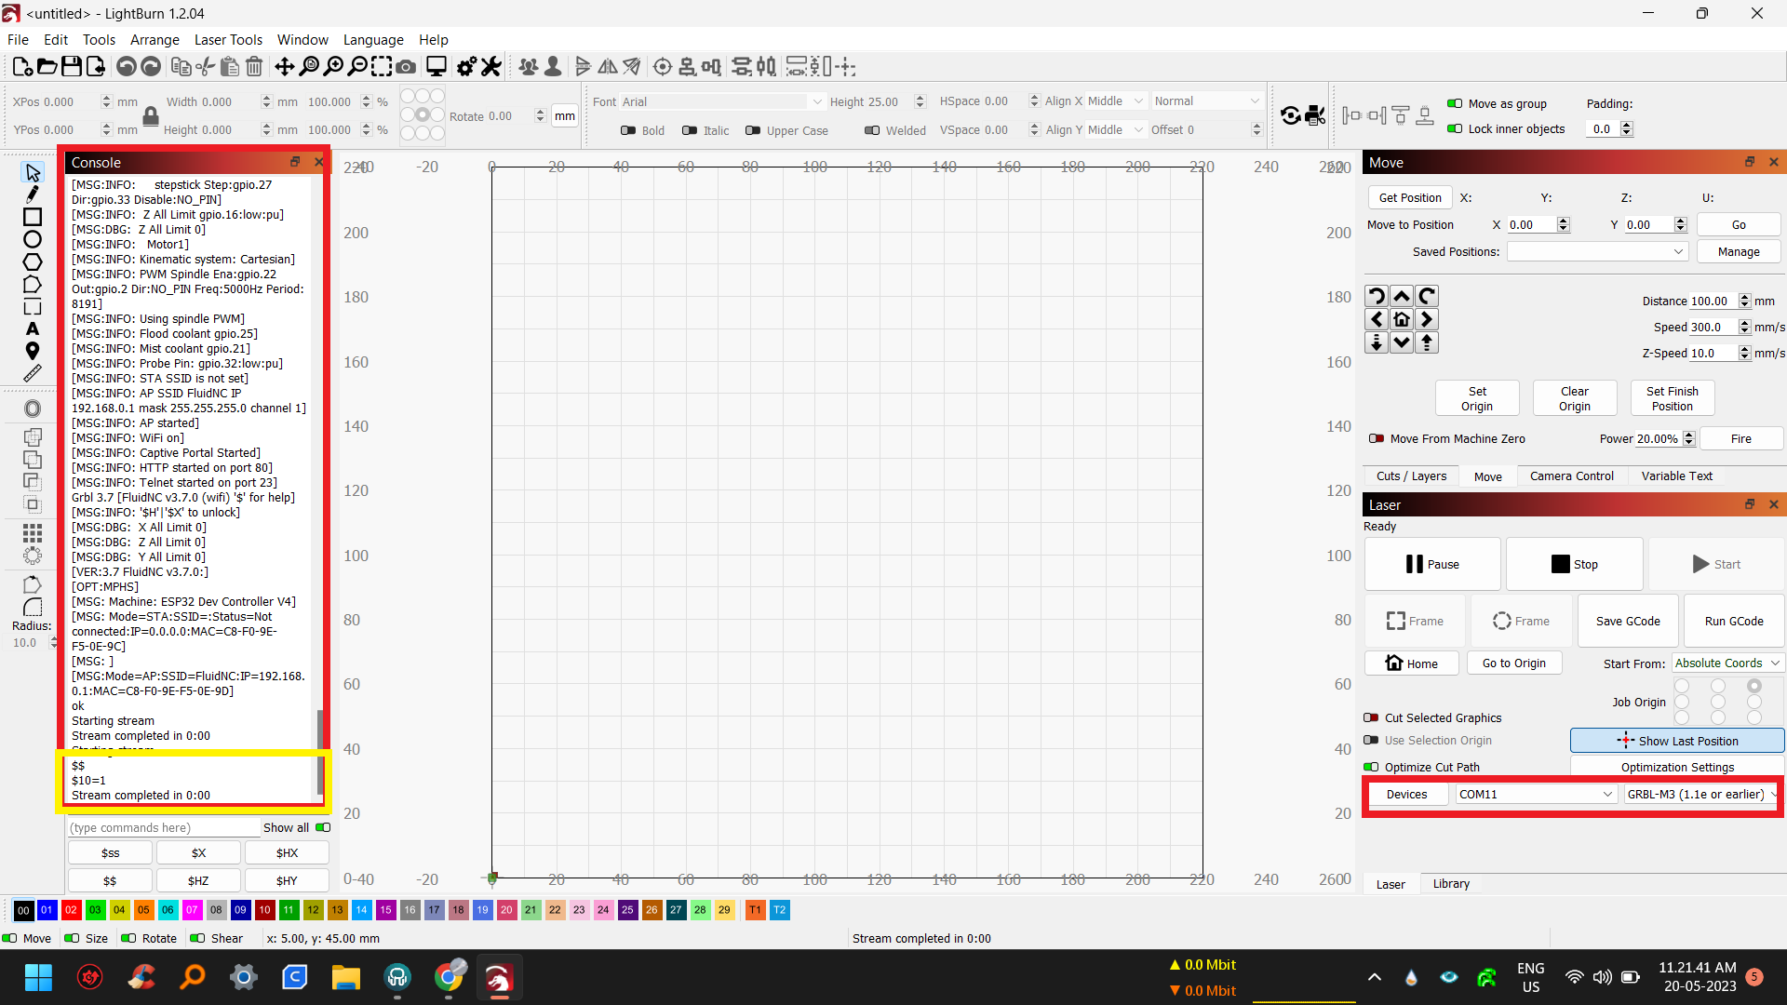

But as am trying to build laser machine, I want to achieve a laser mode functionality of **M4 Dynamic Laser Power Mode** which is achievable in GRBL (1.1f or later).

[https://docs.lightburnsoftware.com/CommonGrblSetups.html#grbl-flavors](https://docs.lightburnsoftware.com/CommonGrblSetups.html%23grbl-flavors)

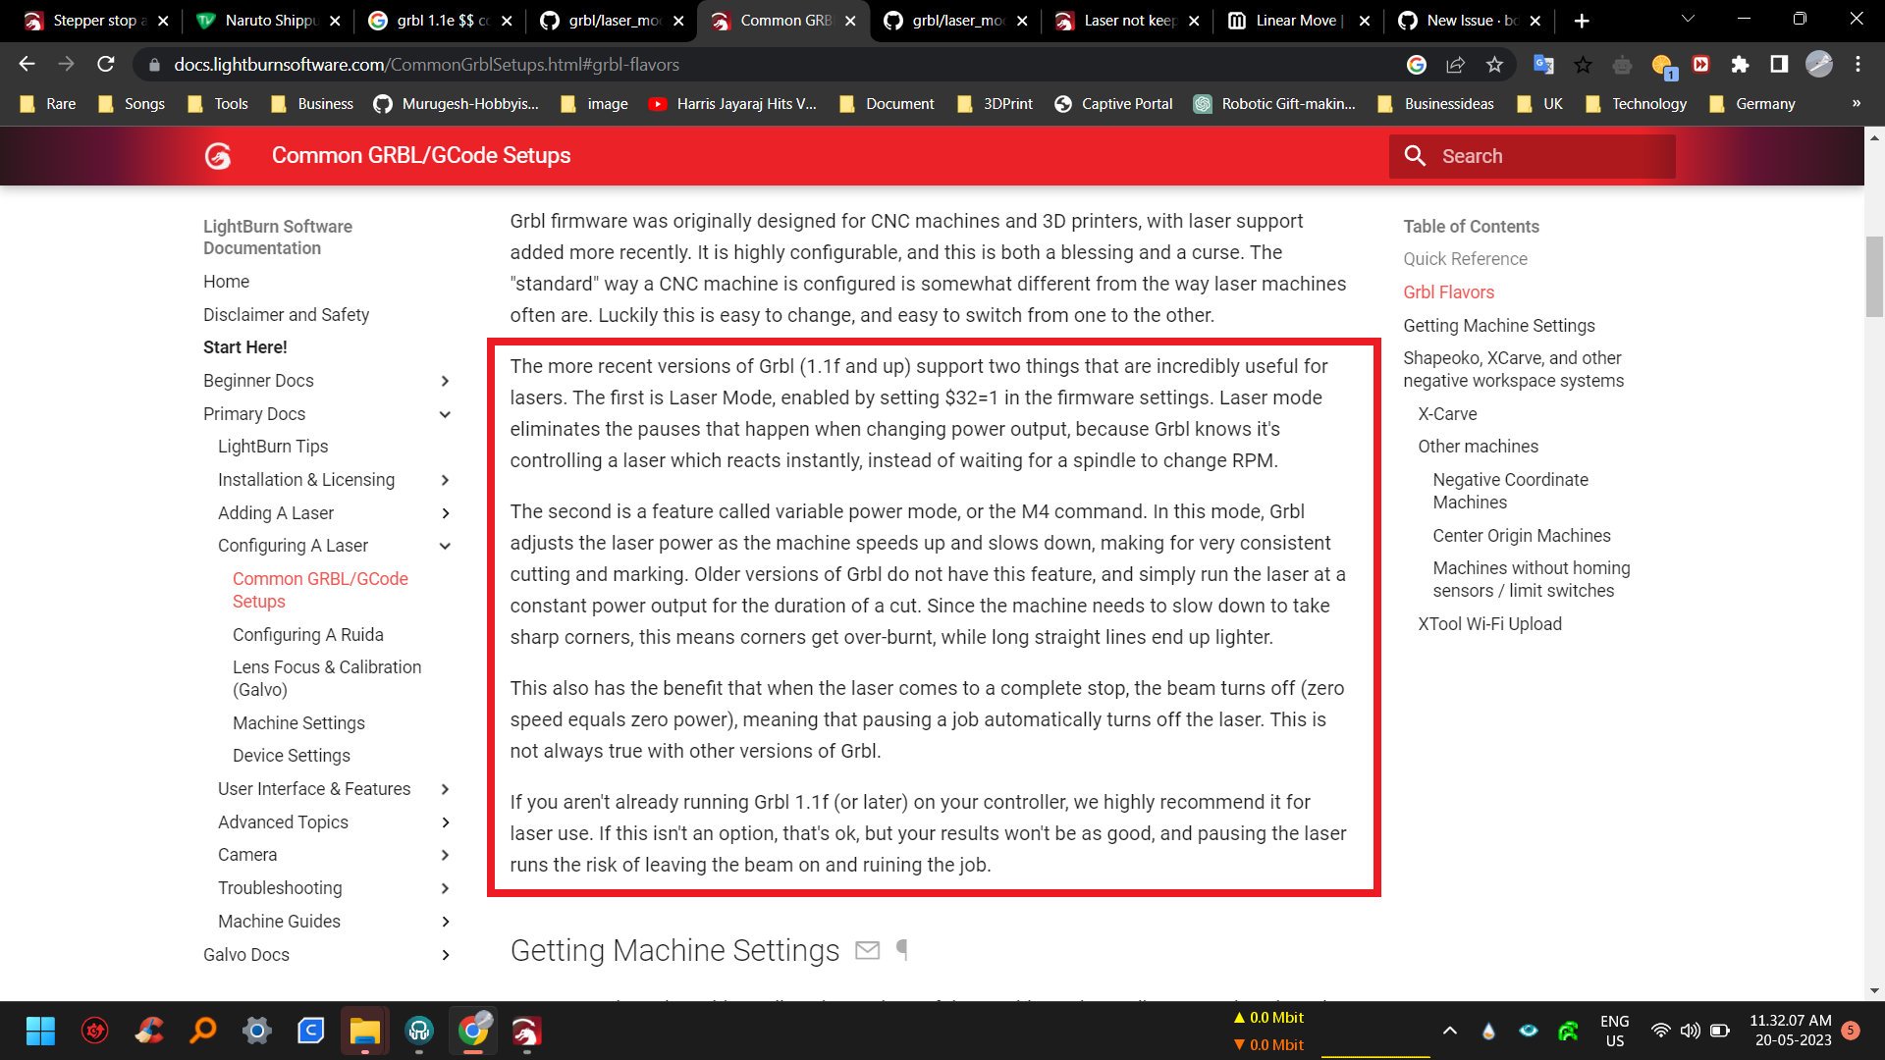

<https://github.com/gnea/grbl/blob/master/doc/markdown/laser_mode.md>

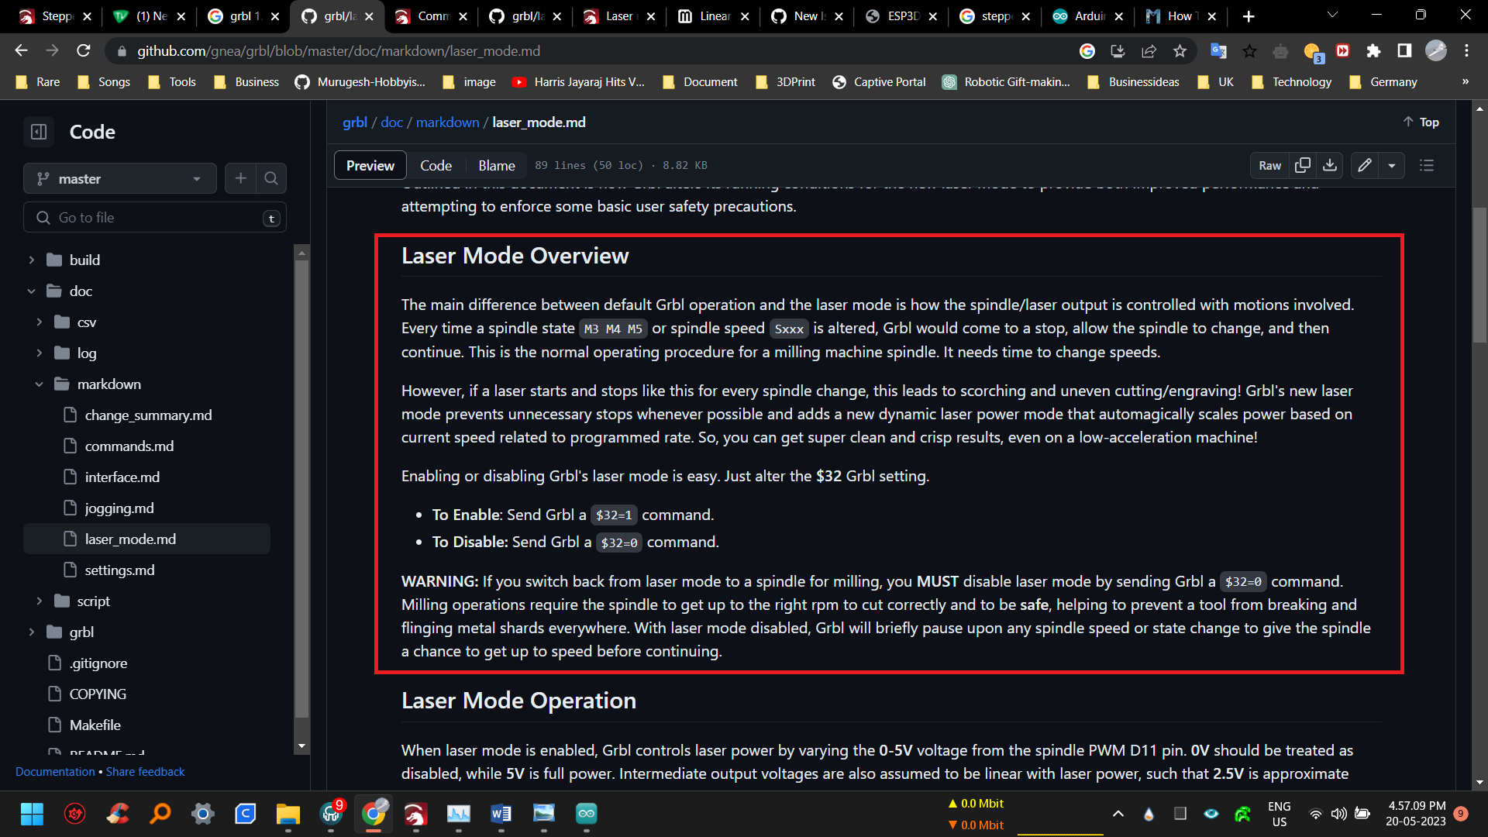

So I tried using the GRBL (1.1f or later).

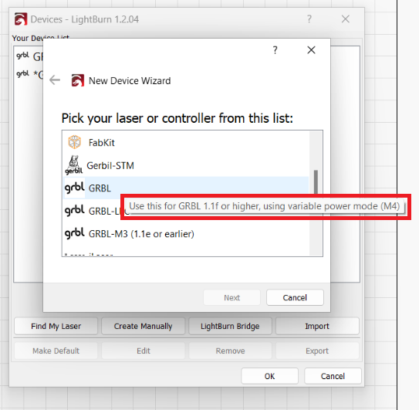

But am unable to connect with the Fluid NC. Loads firmware and start generating G0 command irrespective of any inputs.

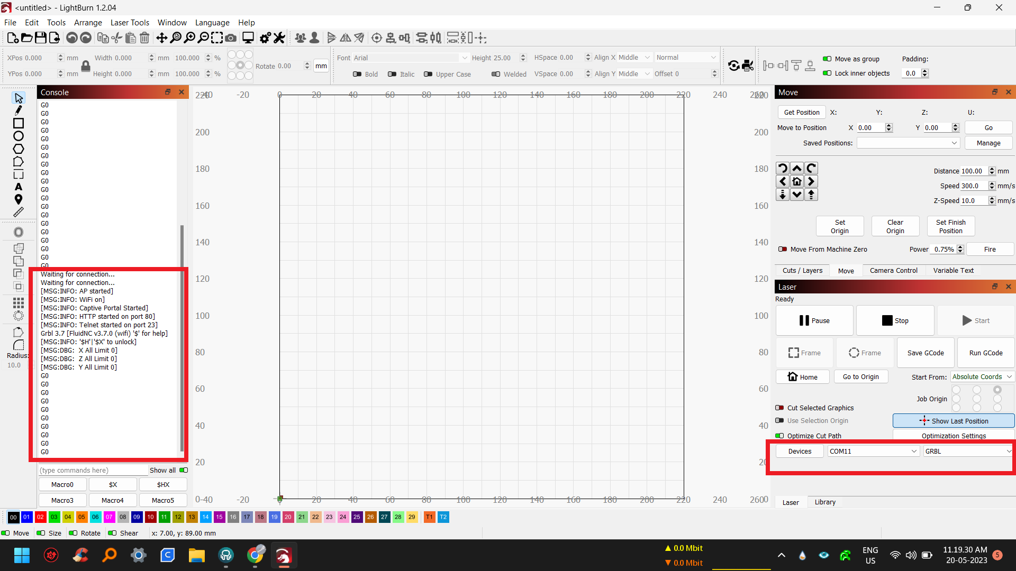

Please help me to connect with GRBL (1.1f or later) in Light Burn with this ESP32 - Fluid NC.