About the Workshop
This hands-on workshop is designed to introduce Mechanical Engineering students to the fundamentals of robotics, autonomous systems, and IoT-enabled machines using an advanced line follower robot.
The workshop demonstrates how a mobile robot senses its environment, makes motion decisions, and executes autonomous movement using motors, motor drivers, PWM speed control, and multiple sensors. Advanced enhancements such as LiDAR-based obstacle detection, sensor prioritization, and remote monitoring are used to relate the robot to real-world autonomous vehicle concepts.
The program focuses on mechanical motion, actuator behavior, and system-level automation, avoiding software-heavy or purely theoretical treatment.

Workshop Coverage

Advanced Line Follower Robot
- DC motor construction and operation
- Motor driver fundamentals and current handling
- PWM-based speed control and duty cycle effect
- Differential drive motion principle
- IR sensor working principle for line tracking
- Sensor mounting and alignment considerations
- LiDAR-based environment sensing
- Obstacle detection and safety stop logic
- Sensor priority and basic sensor fusion
- Speed reduction and stop zones
- Introduction to autonomous driving concepts
- WiFi-based robot status monitoring (optional)

Demonstrations Performed
- Autonomous line following without human control
- Speed variation using PWM control
- Obstacle detection using LiDAR
- Safety stop and resume logic
- Priority-based decision making between IR sensors and LiDAR
- Live display of robot operating status

Expected Outcomes
Participants will gain:
- Understanding of mobile robot motion as a mechanical process
- Practical knowledge of motors, motor drivers, and PWM speed control
- Hands-on exposure to sensor-based autonomous behavior
- Awareness of LiDAR-based perception and safety systems
- Understanding of how autonomous vehicles combine multiple sensors
- Ability to relate a simple robot to real-world autonomous systems
- Improved confidence in automation and robotics fundamentals

Target Audience / Beneficiaries
- UG students in Mechanical Engineering
- PG students in Automation, Mechatronics, and Manufacturing disciplines
- Mechanical students seeking practical exposure to robotics and autonomy
- Faculty members planning to introduce robotics-based lab modules
- Institutions aiming to provide foundational autonomous systems training

Workshop Philosophy
- Focus on motion, actuation, and sensing, not complex coding
- Learn through physical robot behavior, not simulations alone
- Demonstrate autonomy and safety using a simple mobile robot
- Build strong foundations for advanced robotics and autonomous systems

Advanced Line Follower Robot with Autonomous Enhancements

Day 1 – Fundamentals and Core Robot Build

Forenoon Session
9:30 AM – 1:00 PM
Topics Covered
- Introduction to mobile robots and automation flow
- DC motor basics for mobile robots
- Speed control architectures
- PWM fundamentals and duty cycle control
- Power electronics basics for motor driving
- Motor driver fundamentals
- Basic programming concepts for motion control
Learning Focus
- How speed is controlled electrically and mechanically
- Why motor drivers are required
- Relationship between PWM, speed, and robot motion

Afternoon Session
2:00 PM – 5:30 PM
Topics Covered
- Sensor types used in mobile robots
  - IR sensors
  - LDRs and basic comparison
- Chassis assembly and wheel alignment
- Motor mounting and wiring through drivers
- Sensor placement and integration
- Programming logic for line detection and correction
Hands-On Activity
- Complete assembly of the line follower robot
- Upload and test line-following program
- Robot runs on a defined route map
- Robot successfully follows the given path autonomously
Outcome of Day 1
- Fully functional line follower robot
- Clear understanding of motors, drivers, PWM, and sensors

Day 2 – Advanced Sensors and Autonomous Behavior

Forenoon Session
9:30 AM – 1:00 PM
Topics Covered
- Limitations of basic line follower robots
- Introduction to advanced industrial sensors
- LiDAR working principle and environment sensing
- Obstacle detection and safety logic
- Overview of communication technologies
  - LoRa
  - GPS
  - WiFi
  - Bluetooth
- Basics of wireless control and monitoring
Learning Focus
- How real autonomous systems sense their surroundings
- Role of LiDAR in safety and perception
- Difference between control and monitoring

Afternoon Session
2:00 PM – 5:30 PM
Topics Covered
- Integration of LiDAR with line follower robot
- Sensor priority and basic sensor fusion
- Autonomous decision making logic
- Wireless start, stop, or status monitoring
- Debugging and system-level problem solving
Hands-On Challenge Session
- Convert basic line follower into an autonomous mobile robot
- Robot follows line while avoiding obstacles using LiDAR
- Students solve real-time challenges such as
  - Obstacle on path
  - Speed adjustment zones
  - Sensor conflict handling
Outcome of Day 2
- Advanced autonomous line follower robot
- Strong understanding of how multiple sensors work together
- Practical exposure to autonomous decision making

Final Workshop Outcome
By the end of the workshop, participants will be able to:
- Understand mobile robot motion and speed control
- Use PWM and motor drivers effectively
- Integrate multiple sensors into a robot
- Implement LiDAR-based obstacle detection
- Understand fundamentals of autonomous systems
- Relate simple robots to real-world autonomous vehicles

Fundamentals
- What is a robot?
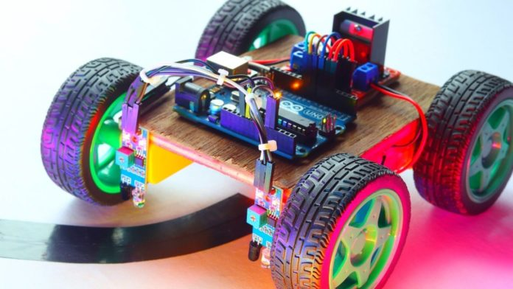

- What are sensors?
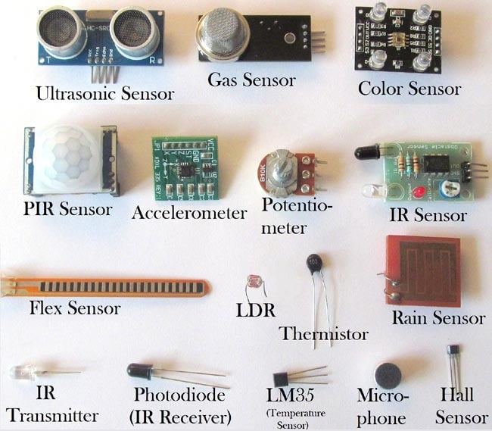
- Types of sensors (digital, analog, etc.)
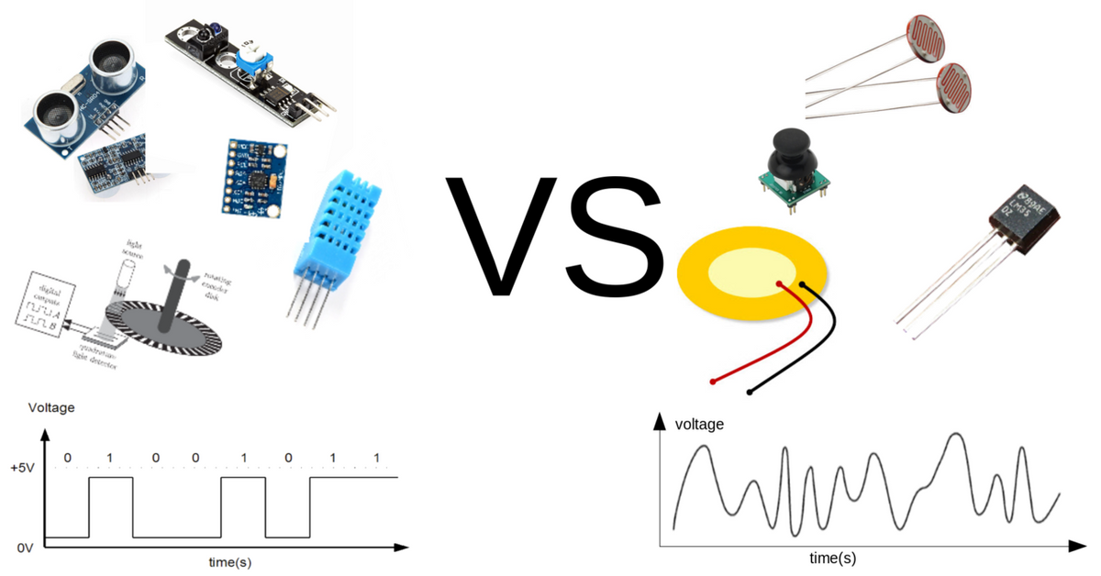

- Microcontroller vs Processor
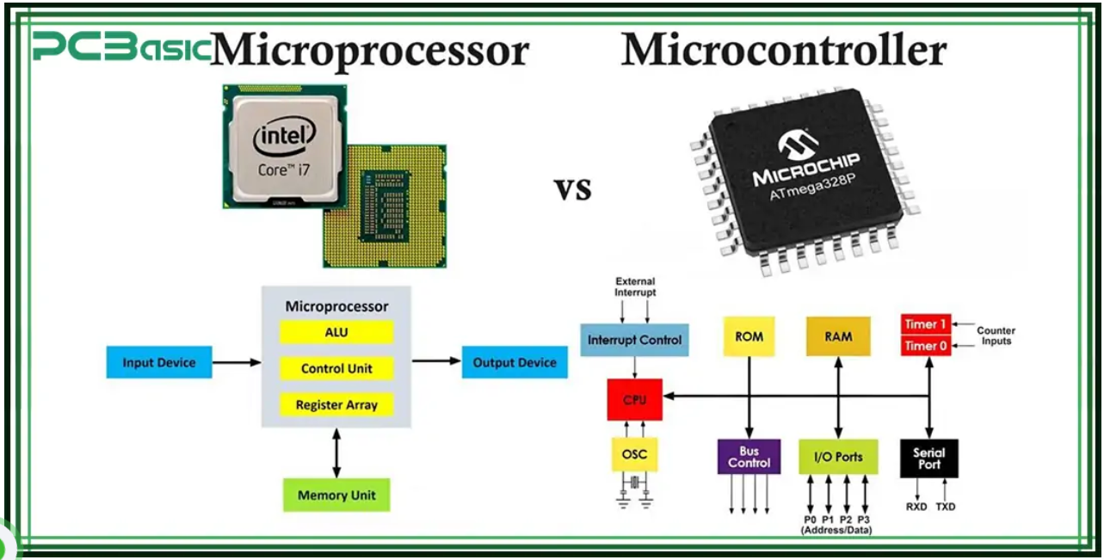

- Control systems
(open loop and closed loop)
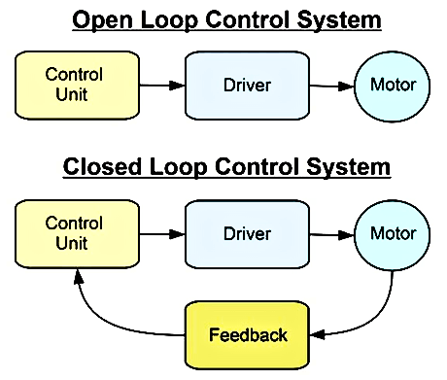

- Electricity basics (voltage and current)
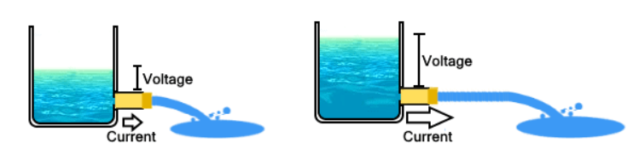

- Signal types (digital and analog)

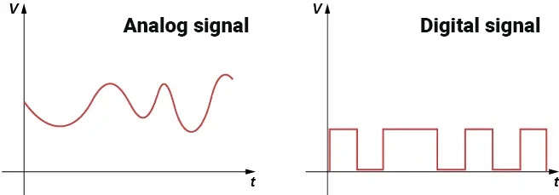
- Communication types (WiFi, Bluetooth, 2-wire, 1-wire, etc.)
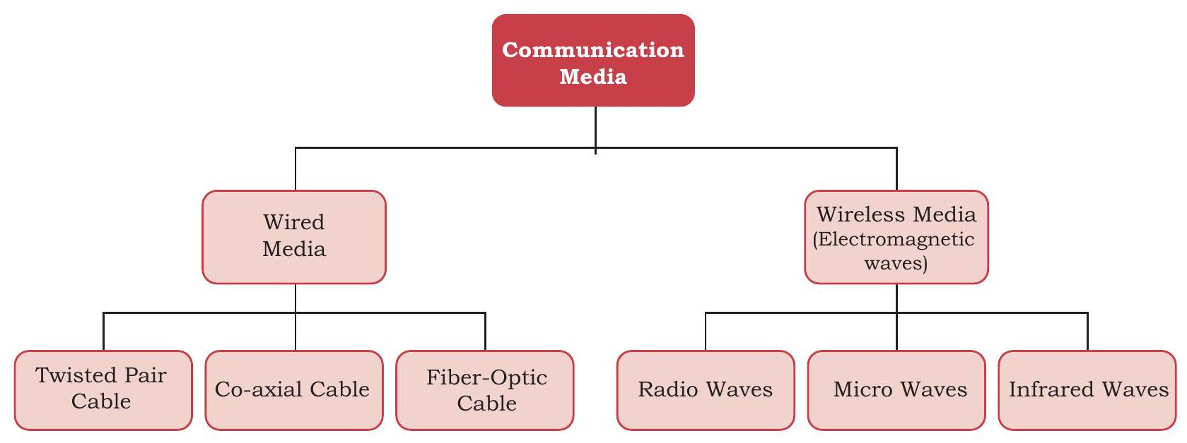

- Safety systems (terminate execution / fallback mechanism)
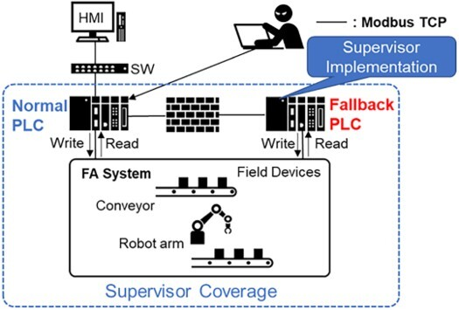

- What is a motor and how to control speed and direction

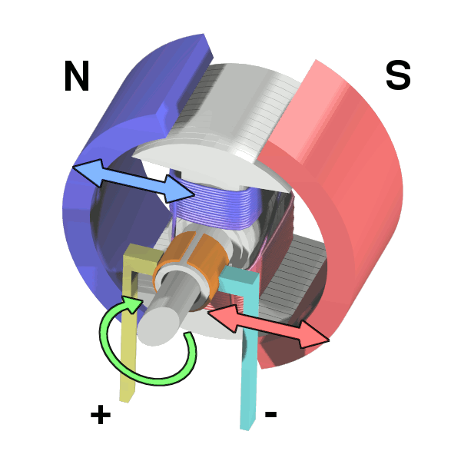

Let’s Start:

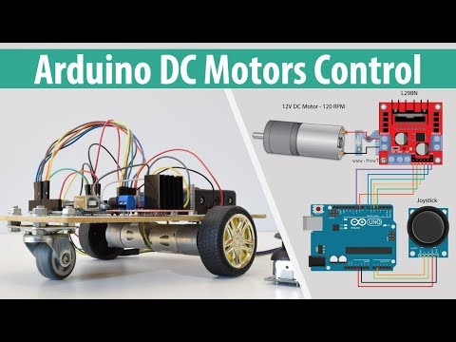

We can control the speed of the DC motor by simply controlling the input voltage to the motor and the most common method of doing that is by using PWM signal.
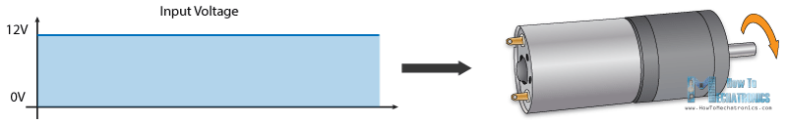

PWM DC Motor Control
PWM, or pulse width modulation is a technique which allows us to adjust the average value of the voltage that’s going to the electronic device by turning on and off the power at a fast rate. The average voltage depends on the duty cycle, or the amount of time the signal is ON versus the amount of time the signal is OFF in a single period of time.
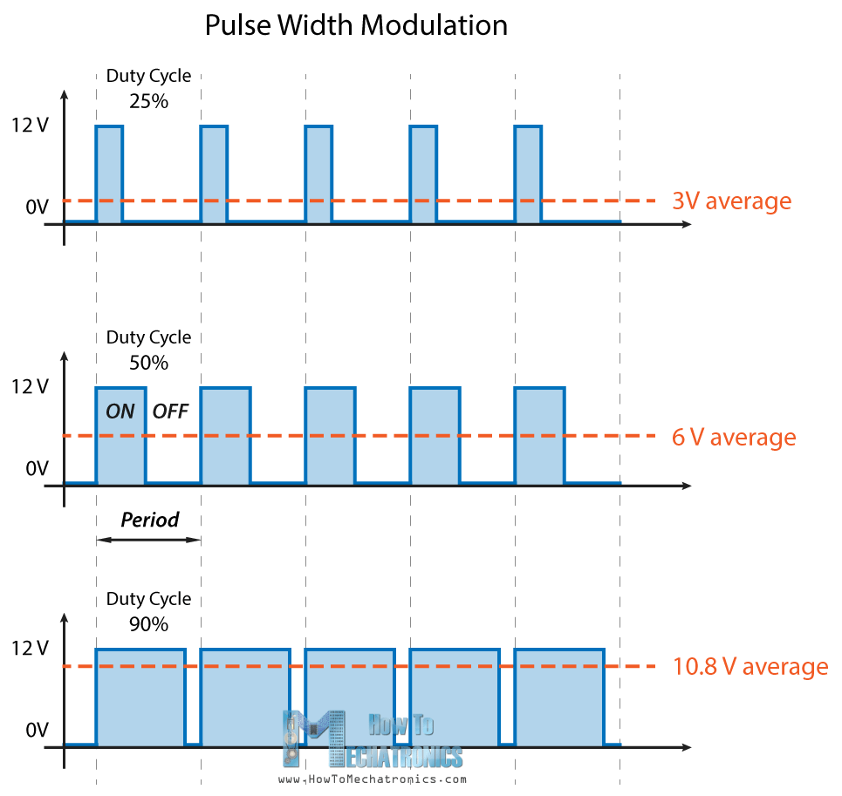
So depending on the size of the motor, we can simply connect an Arduino PWM output to the base of transistor or the gate of a MOSFET and control the speed of the motor by controlling the PWM output. The low power Arduino PWM signal switches on and off the gate at the MOSFET through which the high power motor is driven.
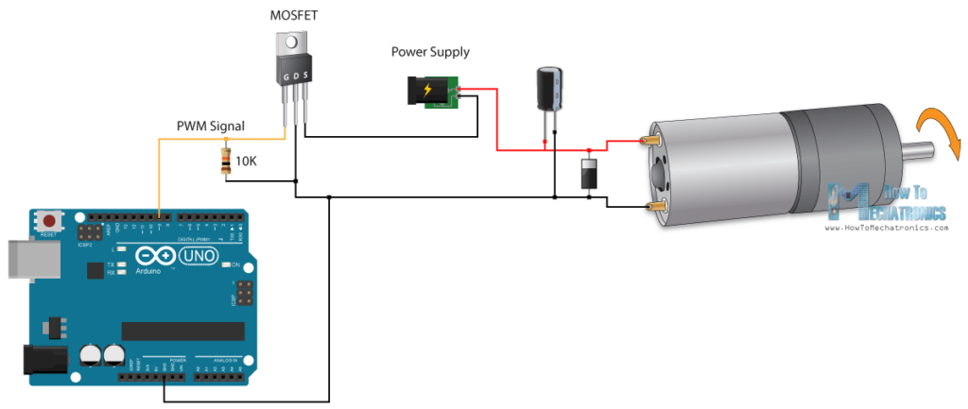Note: Arduino GND and the motor power supply GND should be connected together.

L298N Driver
The L298N is a dual H-Bridge motor driver which allows speed and direction control of two DC motors at the same time. The module can drive DC motors that have voltages between 5 and 35V, with a peak current up to 2A.
