Unigene set selection
Basic problem
RNA seq is method to sequence mRNAs from any organisms. This method is so popular and being affordable to many research groups. It has important applications such as gene discovery, differential gene expression and SNP calling and Alternative splicing events etc. Unfortunately, the RNA seq assembly and analysis has many challenges. Because it produces multiple contigs per gene locus and they are not truly representative of isoforms. Therefore, I made a strategy to select one contigs per gene locus.
First, We align assembled transcriptome sequence to reference genome sequence using below blast command.
“blastn -db /DATA04/data/contig_ginseng/ginseng_v08 -query CP_unigenes_seq.fa -num_threads 35 -evalue 1e-05 -outfmt 6 -max_target_seqs 2 -out Pg_genome_hits.txt”
All the steps are done on this output file (Pg_genome_hits.txt)
1_alignment_issue.py
This script resolves an error in the output file. 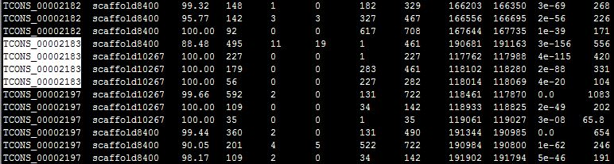
From the out result, we need to extract the top hits. But some hits can be first based on blast score but they may not be biologically from same locus. So these type of error can be detected by this script
2_Format_genome_hits.py
The above errors will be removed by this script and produce new output file “formatted_genome_hits.txt”
3_top_genome_alignment.py
From the above output file, we select only the top hit alignment and this will produce “new_top_hits_1e_5.txt “
4_mapped_region_extract.py
From the above top hits result, make each sequence ID’s start and end position on the genome sequence. This gives output of “T_mapped_regions.txt”
5_Gene_cluster_final.pl
Then each sequence IDs are clustered using the perl script developed by purusoth. It generates “final_updated_cluster.txt” file.
6_mode_new_filter.py
Then we calculate mode value for each clusters based on alignment. It will give “Nr_mode_update.txt” file.
7_2_Final_transcript_cluster.py
This script will make consensus cluster based on the above mode output file. It gives “final_cds_update.txt”
7_1_RNA_contribution.py
This script calculates sequence size of each contigs and produce “seq_id_size.txt”
8_uni_merge.py
This script will merge “final_cds_update.txt” and “seq_id_size.txt” by ID wise and gives “formatted_cds_update.txt”
9_unigene_selector.py
Based one sequence length, it selects candidate set from each cluster and gives output as “candidate_unigenes_update.txt”.

Additionally, we need to add one more script to extract those ID sequence and make final unigene set file.
All these above process should be done by running following command like,
#perl unigene_set_selector –g [genome.fa] –t [transcriptome.fa] –p [no. of threads] –o [output filename]

