ETDs Initiatives in Federal University of Technology, Owerri (FUTO): Successes, Challenges, Prospects
Chinwe V. Anunobi  Festus Aghagbo Nwako Library, Nnamdi Azikiwe University Awka, Nigeria  chiinobis@yahoo.com | Colette O. Onyebinama  The Library, Federal University of Technology, Owerri, Nigeria  ocoletteihuoma@yahoo.com

ABSTRACT
The paper discusses ETDs initiative in Federal University of Technology, Owerri with particular reference to the use of EndNote software. The successes, challenges and prospects are also discussed. Interviews, observation checklist and analysis of document obtained from the library were used to collect data for the paper. Result shows that the University has migrated from the use of Microsoft word application for the management of ETDs to the use of EndNote which was donated by AAU. Three librarians have attended AAU organized workshops on ETDs. The University has all the basic facilities needed for digitization. The University management has a well developed policy on ETDs. The life cycle of ETDs in FUTO indicated offline CD-ROM submission and a well defined processing workflow for digitally born and scanned ETDs. Access to FUTO ETDs is created through the University library intranet and DATAD online site. The University, faculty, students and library have benefitted immensely from the ETDs Initiative. The initiative is challenged by technological and legal issues as well as those related to electricity, ICT infrastructure and other technical issues. Other developing country universities could borrow a leaf from FUTO approach to getting started with ETDs with a view to attaining great height.

Keywords
ETDs FUTO, Electronic theses Nigeria, ETDs challenges, Endnote ETDs, ETDs initiatives Developing countries, Electronic theses and dissertations, Nigeria, Federal University of Technology Owerri.

INTRODUCTION

The University environment in Africa is changing. There is renewed recognition of the role that university libraries play as drivers of educational development. Most universities in Africa now request students to submit digital copies of their theses and dissertations (TDs) on graduation. Because of this, enormous progress has been made in ensuring that staff, faculty and students in universities in Africa can access the growing quantities of information resources now produced in these electronic format such as ETDs. It is worthy to note that AAU along with some other initiatives such as that of the International Network for Availability of Scientific Publications (INASP), supports African TDs by making its content accessible through their WebPages. SABINET (South African Bibliographic Network) provides access to Union Catalogue of Theses and Dissertations (UCTD) that renders bibliographic records of TDs submitted to universities in South Africa. This is a welcome development that has led to the availability of African TDs in the global knowledge pool.
The Federal University of Technology, Owerri (FUTO) is among the three Technology Universities established in Nigeria in 1981 with the aim of producing and promoting sound basic scientific training as a foundation for the development of technology and applied sciences relevant for overall national development (Asiegbu, 2006). All programmes and courses of the University including engineering, science, agriculture, and management and health sciences are rooted in technology. The University library is responsible for archiving all the undergraduate and postgraduate research projects, theses and dissertations as well as other indigenous resources emanating from the university. The Documents and Archives Unit of the Library acquires, processes, preserves and makes available for use all scholarly output of both staff and students. The importance of these resources to research cannot be overemphasized. Postgraduate theses and dissertations serve as the window to high level research carried out in the university and as high profile publications of excellent scholars in the making. They are very qualitative writing produced by the students closely supervised by professors. Despite the usefulness of theses and dissertations (TDs) to research, they lavish in obscurity in the University libraries and archives (Swain, 2010). They are not optimally used in the university due to their low visibility and the difficulty in accessing them (Sinha, 2006) as well as circulation logistics problems. The increasing visibility and access challenges posed by print TDs in FUTO was initially addressed with the development of an in-house cataloguing and classification scheme as well as continuing indexing on submission to the library. This approach provided inefficient and increasing personnel cost / time demand. The problems of TDs mutilation, plagiarism and duplication continued to rock the Library’s TDs management as it advances in age.
The advancement in technology which heralded electronic theses and dissertations (ETDs) brought leverage to the problems of print TDs. The awareness on the possibilities of ETDs was created through the introduction of Database of African Theses and Dissertations (DATAD) by the Association of African Universities (AAU). The Library, Federal University of Technology, Owerri became one of the university libraries in Nigeria that migrated from print through low technology (Word processing) to EndNote technology TDs. These efforts and development from the policy level through implementation to use including successes, challenges and prospects are presented.

THE ELECTRONIC THESES AND DISSERTATIONS INITIATIVE
Though literature abounds on the production and use of ETDs, the Library was unaware of the processes involved. Move to start ETDs production and use was made in 2005, when the Association of African Universities (AAU) donated a CD-ROM of Database of African Theses and Dissertations (DATAD) to the University library. The content though bibliographic only was exciting. Only two Universities in Nigeria were represented in DATAD including Obafemi Awolowo University, Ile-Ife and University of Jos. The database was developed with “Procite” software. Efforts to procure the software yielded no fruit. However, the Library Management did not relent on its desire to begin the ETDs project. The focus was to:
- Solve the problems associated with acquisition, processing, storage and use of print TDs. These include:
  - Delay in movement of TDs from the Postgraduate School to the Library;
  - Submission of incomplete sets of produced TDs to the Library;
  - Difficulty in cataloguing of some TDs;
  - Inaccessibility and low use as well as the nitty-gritty in shelving of TDs;
  - Increasing shelves demand for TDs storage as years go by;
  - Preservation of aged TDs; and
  - The issue of TDs mutilation especially those with high impact factor;
- Benefit from the opportunities provided by ETDS to students, scholars, faculty and institution which include among others:
  - Enhanced institutional visibility;
  - Enhanced availability, accessibility and distribution;
  - Ease of storage, backup and preservation;
  - Reduced cost of production;
  - Versatility in production and use;
  - Improved graduate education through adoption of technology in production of research reports;
  - Reduced duplication of research reports; and
  - Advancing the participation in open access initiative. (McMillan 1995, Weisser, 1997, Lang, 2002 and Barua, 2006).
Determined to reap these fruits and move the University to the global platform, the Library management geared up to discuss the issues involved with a view to arm itself properly for the University-wide debate on ETDs adoption.

Issues Involved in ETDs
The mode of TDs production, submission and use in addition to the technology developmental level in the university, necessitated the Library management to consider some pertinent issues so as to justify its proposal and ensure a successful ETDs project implementation. They include: Technology, Production and Submission, Policy, Legal and Staff issues. Extensive discussion and brain-storming was made on each of these issues.

Technology
Consideration was given to the hardware, software and network requirements for the ETDs initiative. Hardware requirements which include servers, workstations, storage media, printers, digital camera, scanners as well as CD/ DVD writers (Barua, 2006) have been made available for library automation in the ICT Unit of the Library. There was no university-wide network at that time but Local Area Network exists in the University library. Thus the Library proposed that initial implementation could start as e- submission to the Library.
Software requirement became a very crucial issue since the University was unable to procure ‘Procite’ or any other ETDs specialized application. However, the decision was to convince the University to start ETDs production with the easily available word processing applications which can be converted to Portable Document Format (PDF). Other software applications like the use of Extensible Markup Language (XML), Standard Generalized Markup Language (SGML), and other database platforms like Procite, Dspace, Greenstone could be adopted later (Barua, 2006).
Basic computer knowledge by students and faculty was not recognized as a challenge. The University had designed and implemented basic ICT skill training for faculty and students.

Production and Submission
It was agreed by the Library management that submission of ETDs could commence with the adoption of little electronic enhancement as print text stored electronically on external storage. The online production and submission which incorporates links to materials on the World Wide Web or multimedia elements as well as full blown innovative hypermedia documents could be adopted as the project advances (Katz, 2004). This idea is supposed to facilitate University management acceptance of the project and will encourage adoption by students and faculty.

Policy
The University policy on responsibilities, decision making, philosophy and technical procedures involved in the production, submission and use of TDs need to be reviewed. The proposal was to substitute students’ submission of four print copies with one print copy and four electronic (CD-ROM) copies. The print and one electronic copy would be submitted to the library to ensure print archiving. Online submission and other enhanced technology will be adopted as soon as the University intranet is up. The Library ICT unit could help faculty and students to ensure standardized electronic production.

Legal
The issue of Intellectual property right was the most critical. The University has always been silent on copyright ownership of TDs. It is taken for granted that the copyright is owned by the University as part of the requirement for the award of degree to its students. However, the ETDs will present a different challenge. The decision on this was left for the University community.

Personnel
It was proposed that staffs that are knowledgeable in handling of TDs in the library, who are also skilled in ICT, will be involved. Consideration was also given to staff of the University ICT Directorate who will provide hardware and software support. The School of Postgraduate Studies (PGS) will always be there as a go-between the faculty, the students and the library (Bandara, 2002).

Library Presentation to the University Community
Decisions on ETDs issues by the Library management were presented to the university community at two levels. The University librarian presented the issues and proposed approach to:
- The Board of Postgraduate School consisting of Vice–Chancellor, Deans of Schools in the university, Representatives of academic Directorates and Students.
- The University Senate which includes the former and all the professors in the University.
The two groups approved as follows:
  - Initial production and submission of TDs in both print and electronic copies to the PGS for onward submission to the University library;
  - Print version of already submitted retrospectively digitized TDs and hosted in the Library server;
  - Copyright of the TDs belongs to the University as part of the requirement for the award of the required degree. Copyright must be indicated on the verso page of the TD during production;
  - Access to the ETDs be made freely to every registered or external user of the University library;
  - Printed copies as well as collations of ETDs be preserved as backup in an event of technology problems; and
  - Other activities relating to the University ETDs’ visibility and accessibility should be pursued.
In 2006, the first set of ETDs was submitted to the library. These were collated to one CD-ROM while the print formats were processed for preservation.

ASSOCIATION OF AFRICAN UNIVERSITIES (AAU) INVOLVEMENT
Following the University’s efforts to enhance ETDs implementation, the University librarian was invited for a policy meeting organized by AAU on DATAD initiative in September, 2007. Satisfied with his presentation on the University’s efforts on the ETDs, the Schedule Officer of FUTO was invited for a training of the trainer workshop held at Addis Ababa in April, 2008. Consequently, ‘EndNote’ software, a digitizer, a business PC as well as a monitor was donated for the FUTO ETDs project by AAU. The University also benefitted in further training on EndNote organized by AAU in June, 2010 in Darkar, Senegal.

ETDs Project Implementation using ENDNOTE
EndNote is a software that allows for full bibliographic information entry, metadata entry as well as full text access to ETDs. It is a complete departure from ‘Procite’ which allows only bibliographic access. The implementation mode adopted was based on the university community approval and the facilities available (Yiotis, 2006). EndNote was installed on the University library server in September, 2008. Access to the EndNote database is provided to ETDs users through the workstations.
Students’ TDs are received from the Postgraduate School (PGS) by the University library in two formats namely; electronic and print copies. Print copies are processed following the traditional method and indexed as backup. The life cycle of the FUTO ETDs from production to access on EndNote as well as retrospective electronic conversion of back issues is presented in Figure1. This could be referred to as low technology or offline adoption of Virginia Tech ETD project and that of University of San Francisco (Weisser, 1997 & Barua, 2006).



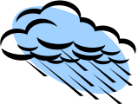


Students Carry out Research
Research reports Produced
Presentation at PGS
Final ETD submission at PGS
Collation: Library Closed Server
Open Access Server With EndNote
ETDs Batched to AAU
Internet Access
Intranet Access
PRODUCTION AND SUBMISSION STAGE
PROCESSING STAGE

ACCESS PROVISION STAGE

Individual CD stored away

Figure 1: Life cycle of FUTO ETDs
Three major steps involved are:
- Preparation and Submission or ETDs collection as indicated by Barua (2006);
- Processing; and
- Access Provision

Preparation and Submission
This follows the steps provided by (Bandara, 2002), (Sinha, 2006) and (Weisser, 1997) with modifications.
  - Students prepare their TDs using word processing software. Other applications are acceptable provided the installation file is included as part of the submission. They are encouraged to convert TDs to PDF and submit offline in four CD-ROM and one print copy.
  - ETDs are approved by Postgraduate School Board.
  - Approved ETDs and print copies are batched to the University library.

Processing
Two types of processing are carried out to ensure availability of TDs. They include processing of digital-born TDs and retrospective processing of the digitally converted copies which were submitted as prints. Print copies accompanying the CD-ROM are moved to the Documents and Archives unit for traditional processing.
Each of the CD-ROMs contents are certified and possibly converted to PDF in library. The contents are copied to the Library closed access server. Individual CD- ROMs are archived. ETDs are catalogued and classified based on the EndNote metadata specifications as indicated in Figure2 to include author, title, year of publication, supervisor, town / country of publication, description, discipline, DOI, gender, degree, acronym, call number, keywords, abstract, location/URL, file attachment, availability and address, language, DATAD identifier.
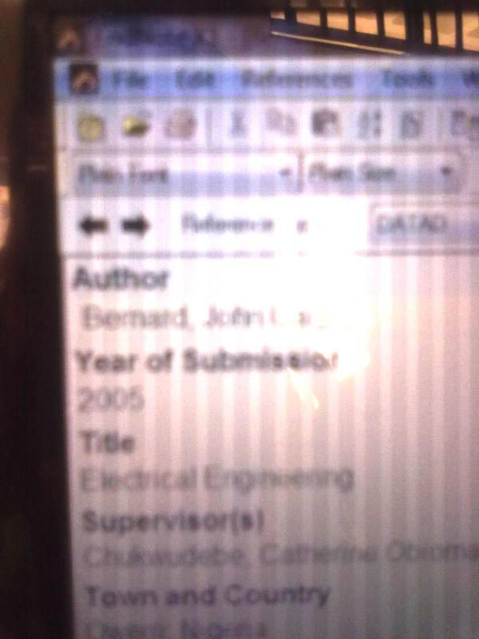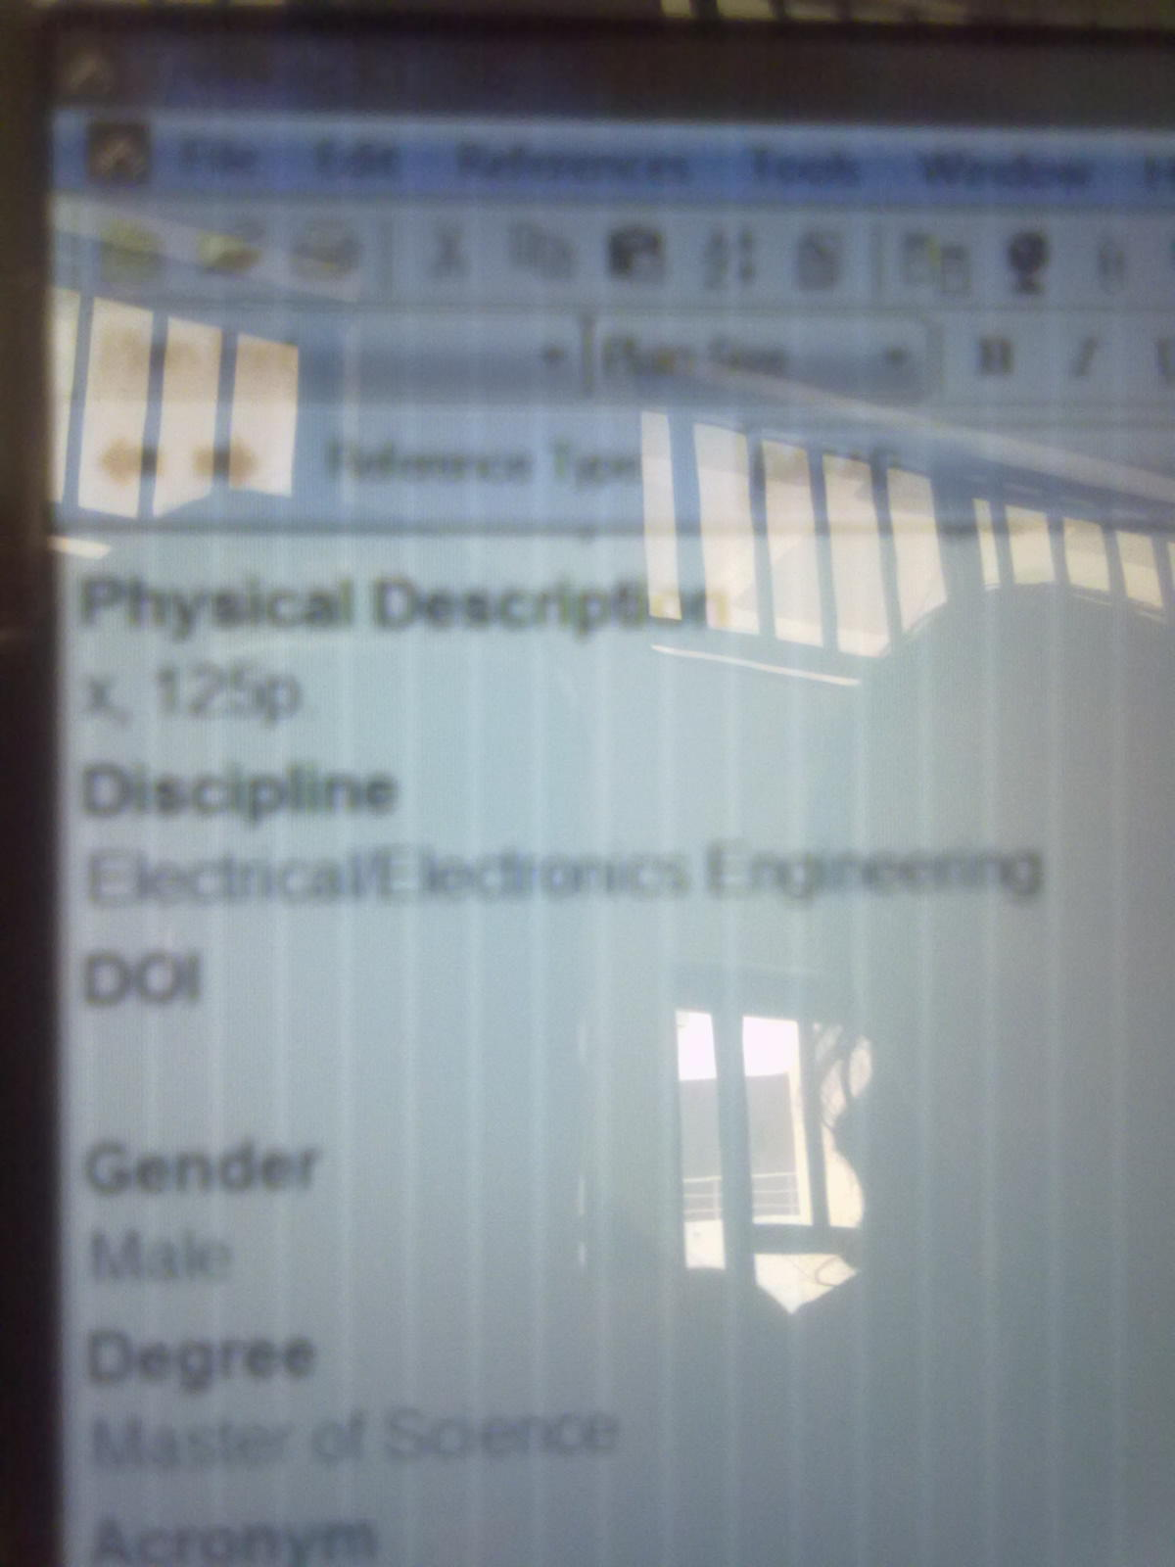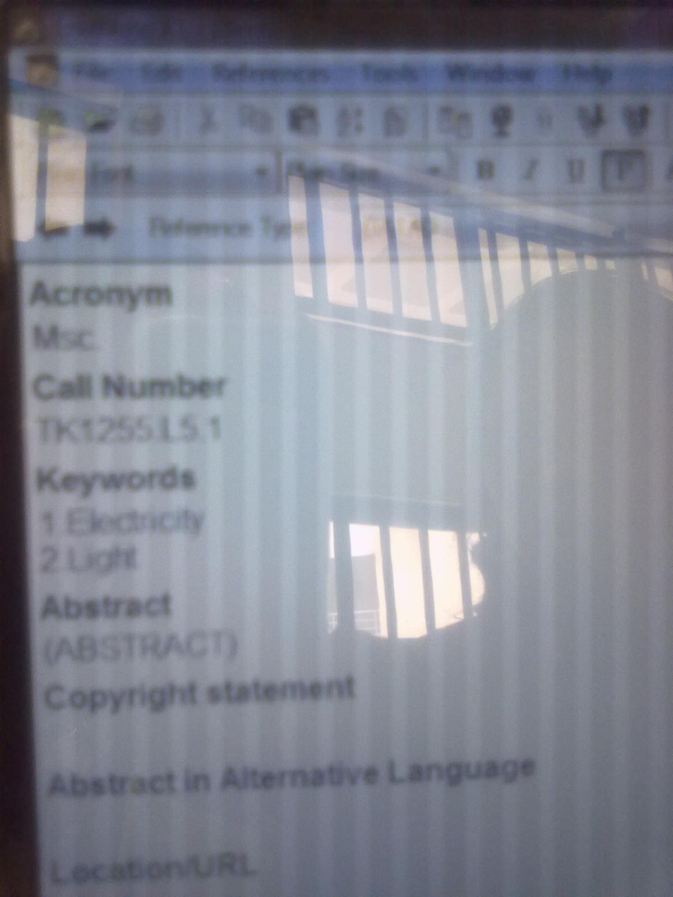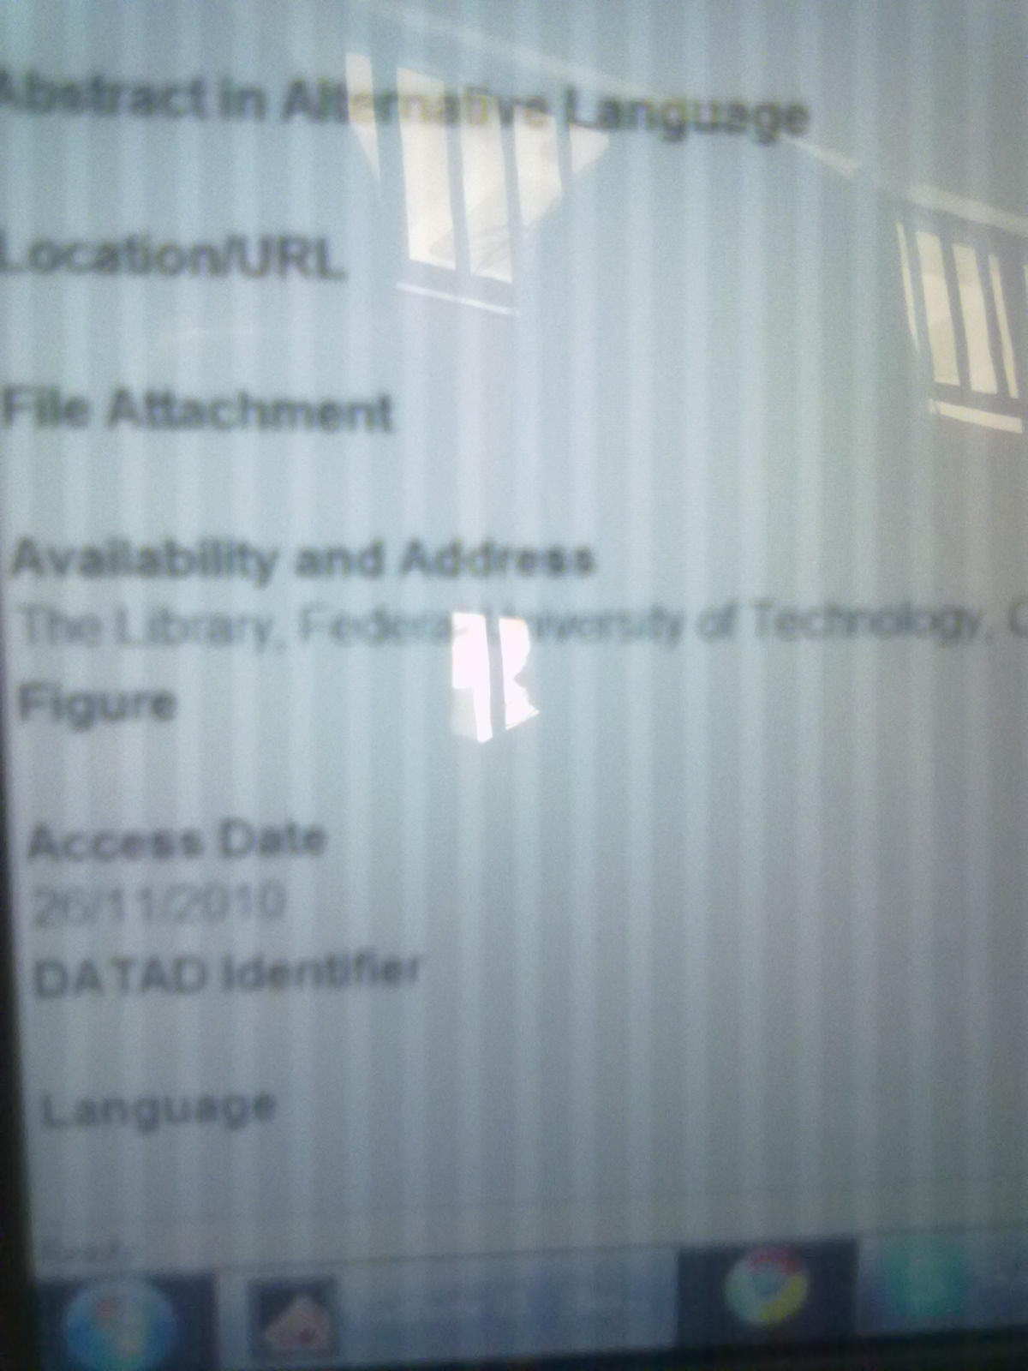
Figure 2: EndNote Data Entry Interface
Retrospective digital conversion of the earlier submitted print copies is carried out with digitizers. Digitized copies are transferred to the Library closed server. These are catalogued and classified based on EndNote specifications. Backup is created on external storage. Processed ETDS on EndNote are periodically batched to AAU DATAD initiative.

Access Provision
Two levels of visibility and accessibility are available for FUTO ETDs. These are from:
- The University library Network; and
- The AAU DATAD search page.
From the University library network, five workstations are provided through which EndNote database could be searched using title, author, Keyword, Degree, Year of Award, Department, Discipline etc. Search result provides opportunity for full text download of the required ETD.
The DATAD of AAU enhances the visibility and accessibility of the University’s ETDs by hosting it on the Internet. On registration for login, DATAD webpage provides search opportunity for the ETDs of Member Universities using same search term as from the Library’s Local Server.

SUCCESSES
Though ETDS implementation efforts in the University could be regarded as being at a primordial stage, it has benefitted the University, library, faculty and students / researchers.
Generally, all theses and dissertations submissions from 2006 to date are electronic. Fifty percent of the print TDs submitted before 2006 have be digitized. One Hundred and sixty-four (164) ETDs have been batched to AAU for DATAD initiative for hosting on the Internet. All processed ETDs (420) are accessible from the University Library Intranet. These successes are of immense benefits to the stakeholders.

The University
As part of the benefits of ETDs initiative, the university is opportune to participate in the global open access initiative. DATAD provided global visibility to the university. It promoted their research profile and created avenue to unlock their indigenous information resources. This will in the near future enhance the institution’s ‘webometric’ ranking.

Faculty
Faculties in the university are not only directing their students on the production of ETDs. They are also involved in their production thereby enhancing their digital technology skills. Faculty has bibliographic and full text access to all the research reports produced by their students. Consequently, research topics are tracked easily. Duplication as well as plagiarism is minimized. Storage and preservation of supervised TDs in electronic format has become a lot easier.

Students
Following the low technology adoption for ETDs in FUTO, students are considered to benefit most in the areas of production and use. They are exposed to technology based model of ETDs which sensitized their inquisition on other means of incorporating technologies to TDs such as multimedia’s enhancement and hyperlinks (Yiotis, 2006). Many have become more flexible and creative by the production of auto run hyperlink content CD-ROM. These are reserved for single user services in the Library.
Cost of production is highly reduced through the substitution of multiple print copies with multiple CD-ROM. Money is saved from buying papers as well as in providing bound copies (Barua, 2006). Students are motivated to produce qualitative ETDs and eschew plagiarism as a way of boosting their image when the resources are finally put online. Issues related to availability and accessibility have taken a different dimension. As noted by Vijaykuma and Murthy (2001) ETDs are easily located, readily accessible and delivered over the web. ETDs are not only available in the form acceptable by the present generation (Blackburn, Starky & Wise, 2009) but can be use ‘intranetly’ independent of the library staff assistance through the workstations. This has resulted to the increase and diverse use without restrictions (time-wise). The temptation of mutilation and pilfering are highly reduced.
Access has become versatile in terms of time, location and search terms. The ease of access has improved the students’ appreciation of scholarship and their emulation. It is easier for students to identify over-flogged research areas, gaps in research and recommendations upon which they could build their own research. Multiple accesses have reduced access and use time. Search has become a lot easier with titles, authors, year of production, departments, schools, keywords

The University Library
The Library has reaped the benefits of their ETD initiative. The impediments associated with acquisition of TDs from the PGS are overtaken. PGS ensures timely batching of ETDs to the library for verification before students’ graduation.
The processing cost is highly reduced. ETDs are processed into the library server onto EndNote. The print copies do not require shelving rather they are stocked away in the archives. No cost in terms of staff time and money is incurred as regards preparation of indexes, provision of index cards and cabinet as well as in serving users or shelving used copies.
Metadata entries using EndNote has facilitated processing. The application suggests entries based on already existing ones.
The problems associated with issuing and return of TDs in addition to ‘misshelving’, theft, mutilation has become a thing of the past.
Consequently, the library can boast of possessing for posterity all ETDs (born and scanned) produced in the university. Above all, library services with reference to TDs have improved tremendously.

CHALLENGES
Despite the successes and benefits derived so far, ETDs initiative in FUTO is bedeviled with many challenges. These are not far from the impediments identified in Arab Gulf states by Alsalmi (nd) including technological factors, legal issues, absence of strategic plan for ETD network conservation, lack of TDs acquisition process polices, lack of experienced personnel and other technical issues. The manifestation of these problems however differs as noted by Alhaji (2007).

Technological Factors
The University community has limited access to ETDs server. This is as a result of yet to be completed university-wide intranet. Thus ETDs are submitted offline using CD-ROM. Consequently, gap still exist between production/submission and access. Furthermore, the university is yet to access all ETDs uploaded to DATAD. The technical logistics in terms of IP and AAU membership update is yet to be fully addressed. There is the difficulty of getting a prototype of retrospective print on digital form. As a technology university, print TDs are dotted with myriad of graphs, images, charts and program codes that fail to emerge clearly upon scanning. Special symbols pose a lot of problems during EndNote entry.

Legal Issues
Interview with the University librarian reveals that copyright issue has been resolved. The approval is that copyright belongs to the University. However, there is no written agreement with each of the student to that effect. Furthermore, it appears that some students continue to publish part or a whole of the ETDs as journal articles or book either before or after the university has taken possession of the ETDs. This is likely to create some legal problems in future. Some students included graphics and other copy righted materials without permission from the owners.

Absence of National Plan for ETD Consortium
Lots of scholarly research is carried out in Nigerian universities. If well harnessed, they could facilitate national development. However, many universities are yet to embrace the ETDs initiative while others are advanced. Nigeria as a country has not given it a thought with a view to having a national database of ETDs. A program of this nature will encourage universities that are yet to embrace the initiative. This will further advance discussion on issues, successes and problems that are peculiar to each institution and the country at large.

Personnel and Users
Technology changes by the day. Competencies of today will be moribund tomorrow. Advance application of ETDs is based on the competencies of the personnel and other stakeholders including faculty and students. Unfortunately, the advance competencies needed by library personnel such as multimedia enhanced ETDs and hyperlinking is yet to be developed. Furthermore, the well advanced faculty (professors) is still skeptical about technology and TDs. Most of them who are at the policy making level in the university discourage furthermore efforts to move ETDs from the present level to advanced level.

Inadequate Power and ICT Infrastructure
The university is yet to appreciate that the life cycle of ETDs is dependent on the availability of electricity, as well as computer and communication technologies. Inadequate power supply slows down retrospective digitization and processing of ETDs into Endnote. Poor maintenance culture as well as the policy of depending on contractors for ICT maintenance in the library reduces the speed at which ETD life cycle is completed. Users are often discouraged as access is denied.

Other Technical Issues
Retrospective digitization of TDs in print requires disintegration of the bound copies and rebinding afterwards. This leads to damage, in some cases, poorly scanned copies. Often ETDs submitted to the library are not converted to PDF and some are submitted in applications unavailable in the Library. Access to such ETDs is denied, while others have their scientific and technical symbols distorted.
The Library server has once been exposed to virus issues. Consequently, data was lost in a bid to restore with backup.

THE FUTURE
Though the university has taken a step beyond the traditional TDs, a lot needs to be done. There is no doubt that the future is promising. The technology (EndNote) provided by AAU will continue to be a necessary platform for global availability of FUTO ETDs as well as other indigenous resources. It is also expected that EndNote will be upgraded to accommodate multimedia submissions. However the Library management is not relenting until full multimedia ETDs are achieved. The University Librarian advanced that plans are on the way to convince the stakeholders for training on:
      - Use of multimedia resources and production of multimedia enabled ETDs;
      - Use of Standard Generalized Markup language (SGML) and Hypertext Markup language (HTML);
      - Training on the submission process as well as ETDs use.
It is expected that the completion of the university intranet will usher in online submission of ETDs. That will also ensure university wide access. The university will streamline the intellectual property issue and ensure compliance of the stakeholders in form of written submission on copyright ownership.
It is expected that before the end of 2013, all TDs in FUTO would have been converted to ETDs. This implies that funds will be made available for acquisition and maintenance of digitizing facilities; organizational flow of the Digitization unit enhanced; and zealous / enthusiastic staff who are ready to move with technology deployed to achieve this target.
The only global window to the FUTO ETDs is the DATAD project. Hence all efforts are on the way to comply with the requirements of the project.
The University will continue to modify the teaching, learning and research policy as well as embark on promotional strategies with a view to changing the perception and attitude of the pessimistic faculty on ETDs.
Traditional learning has metamorphosed to e- learning. Traditional ETDs migration to ETDs is a no go back. Nigerian University libraries should embrace it and utilize opportunities provided by AAU through DATAD initiative.

Conclusion
The future of digitization of theses/ dissertations and digital resources management in FUTO Library is quite promising. The use of EndNote application has not only placed the Library efforts in the right footing but has also provided room for continuing support from AAU and collaboration with other libraries that are involved in such project.

REFERENCES
Alhaj, I.O. (2007). Digitization of past question papers, dissertations and theses: a case study of 30 Nigerian university libraries. The International Information and Library Review 39(3/4), 228-246.
Alsalmi, J. (nd). Factors influencing the adoption and development of electronic theses and dissertations (ETD) Programs in university library. Retrieved April 2011. http://www.rgnic.uk/files/full%20papers.alsami-formatted.doc
Anunobi, Chinwe V. & Egbukole, Kingsley N.( 2008) .FUTO Library So Far: 1981-2008. FUTNOTES: Special Edition 9 (1&2), 1-24.
Asiegbu, L.C (2006). Federal University of Technology Owerri at 25. Owerri, Nigeria: O’Desy Concerns .
Bandara, S. (2002). Digitization of theses: Possible international collaboration: a discussion paper. Retrieved May 3, 2011. http://displace.mona.uwi.edu/bitstream/123456789/349/1/digitization%20of%20theses.brief.pdf
Barua, N. (2006) Electronic theses and dissertations: issues and its implications. 4th Convention PLANNER – 2006. Mizoram univ. Aizawi, 09-10 Nov, 2006. INFUBNET Centre, Ahemendabad.
Bishop, P., Mawshell, R., and Winter, D. (2007). A robust electronic thesis and dissertations program at UCF. EDUCAUSE Center for Applied Research Bulletin 3. Retrieved January 12, 2011. http://net.educause.edu/ir/library/pdf/ERB0703.pdf
Blackburn, H., Stankey, A and Wise, K. (2009). Generational tug-of-war :playing nice between millennial and baby boomers in a multi-generational staff. In J. Varlejs and G. Walton (Eds.). IFLA Publication 139: Strategies for Regenerating the Library and Information Profession. Munchen: K. 9. Saur. pp 148-157

Interview with Chief J.E. Nwogu (2011) University Librarian, Federal University of Technology, Owerri
Katz, S. (2004). Innovative hypermedia ETDs and employment in the humanities. In E.A. Fox (Ed.) Electronic Theses and Dissertations. New York, Marcel Dekker. pp9.
Lang, S. (2002). Electronic dissertations: Preparing students for our past and the futures. College English 64(6). 680-695.
Macmillan, G. (1995). Electronic theses and dissertations: merging perspectives. DLA, University Library Virginia Tech. http://scholarlib.vt.edu/theses/gailsccQarticle.html. Accessed March
Sinha, A.K. (2006). 4th Convention PLANNER – 2006 Mizoram Univ., Aizawl,09-10 Nov.,2006. INFLIBNET Centre, Ahmedabad.
Swain, D. (2010). Global adoption of electronic theses and dissertations Library Philosophy and Practice. Retrieved August 10, 2010. http://www.webpages.unidaho.edu/~mbolin/dillip~swam.pdf
Vijaykuma, J. K. and Murthy, T. A.V. (2001). Need of a digital library for Indian theses and dissertations: a model on par with the ETD initiatives at International level. E-LIS. Retrieved January 12, 2010. http://eprints.rclis.org/archive/00005655.
Weisser, C., R. and Walker, J.R. (1997). Excerpted: Electronic theses and dissertations : Digitizing scholarship for its own sake. The Journal of Electronic Publishing 3 (2). DOI:10.3998/3336451.0003.209.
Yiotis, K. (2006) Electronic theses and dissertation (ETD) repositories: What are they? Where do they come from? How do they work? LIBR 230.01. http://kristinhome.com/eportfolio/i/ETDRepositions.doc

