ETD2011 Paper Template

The dot on the i: Reflections of a postgraduate student & repository manager on the ETD process @ the University of Pretoria
Elsabé Olivier  University of Pretoria  elsabe.olivier@up.ac.za | Ina Louw  Tshwane University of Technology  louwcj@tut.ac.za

ABSTRACT
This paper shares the personal reflections of a postgraduate student and a repository manager on the life cycle of an electronic thesis and dissertation at the University of Pretoria in South Africa. The postgraduate student will reflect on her involvement with UPeTD, the University of Pretoria’s electronic theses and dissertations (ETD) repository – at first to obtain electronic information during her studies, but later in becoming a knowledge creator for other students as well. The life cycle of the dissertation and the thesis for the postgraduate student will be discussed as well as the other benefits as a professional, of having her research available in electronic format in the repository.

The repository manager will discuss the life cycle of the thesis and dissertation at this institution from a manager’s perspective for the past decade. This process involves the Postgraduate officers of the nine faculties and although students may self-archive their ETDs, the manager mainly focuses on mediated submission by two library staff members. The availability of a thesis or a dissertation in a repository is only the dot on the i – it entails an intricate work process for the postgraduate student and repository manager, but they both reap the benefits in the end. The manager will also touch on the future developments for the UPeTD repository and reflect on the envisioned changes to the workflow processes.

Keywords
Postgraduate student, repository manager, access to ETDs, electronic theses and dissertations, open access, University of Pretoria, South Africa.

INTRODUCTION
Most of us are involved in the processing of ETDs, but have we ever stopped to consider the postgraduate student’s perspective in this process? In this paper we offer you three perspectives from three different role players in the ETD process at the University of Pretoria, namely the postgraduate student doing research, the librarian/repository manager; and then lastly the author of ETDs. It is inevitable that somewhere in this knowledge production process these role players will cover common ground, and we will acknowledge that. The paper starts by explaining who the role players are, followed by the postgraduate student’s perspective. Then we discuss the role of the library in establishing an open access ETD repository for graduates and students as well as the life cycle of the thesis or dissertation at this institution. Lastly we supply the graduate’s perspective and a conclusion.

ROLE PLAYERS IN ETDS
The role players in the ETD process are the academic community at large, funding agencies, the institution, the library, the supervisor, the student and the graduate (Copeland, Penman & Milne, 2005). We distinguish between students and graduates where students are registered students busy with postgraduate research whilst graduates are the students who have completed their research theses or dissertations and placed them in an institutional repository. In this paper the second author will offer the perspectives of both these role players. Each one of these role players is important and has a unique position in the process.

POSTGRADUATE STUDENT’s PERSPECTIVE
Most postgraduate students will agree that there are stages in his/her study when progress is slower than expected and when motivation runs low. Very often these stadia happen during the writing up of the literature review. The absolute wealth of knowledge that exists is sometimes more of a burden than a blessing, but a few good theses or dissertations in you field can make a world of difference. The moment you see what other people have done with the similar literature that you are engaging with, your own creative processes kick in. At least this is applicable to me.

I was fortunate to have a very experienced and thorough supervisor, Prof Kobus Maree, for my Masters degree. He introduced me to theses and dissertations as sources of condensed information. He allowed me to construct my first draft and then he directed me to appropriate and related theses to read and get inspiration from. It didn’t matter whether I was busy with the problem statement or data analysis; he knew where to send me to get ideas on how to improve my own work. I soon realised that these theses and dissertations also supply an extensive list of references and that these references are valuable future sources.

Discovering Electronic Resources
When I started my postgraduate studies in the early 2000’s, after a break of 20 years, I had to be trained to use electronic resources, do literature searches and even how to use Google. I was comfortable to go to the library to take out books. I was used to studying them at home and making notes, and often made some copies of important parts for future use. These piles of copies soon took on a life of their own. When I was introduced to UPeTD, the repository of electronic theses and dissertations at the University of Pretoria, I realised that I never needed to make copies of theses again. With an electronic repository I would have access to a wealth of knowledge whenever I needed it.

Benefits of ETDs for the Student
I experienced many benefits whilst using ETDs and the following benefits were applicable in my case. ETDs provided me with:
• increased access to information and research that enhanced the quality of my thesis and dissertation;
• methods used during other research, thus allowing me to use these methods too;
• less paper copies that needed storage space which were also environmentally friendly, since I didn’t need to make copies of parts “for in case” I needed it later;
- an opportunity to see exactly what has been researched in my field, and to avoid duplication of research;
• the opportunity to access ETDs when I needed them; and
- the opportunity of learning how to work with electronic resources.

Additional benefits for students and institutions are identified by Bandra (2002) as:
• empowering students to convey a richer message through the use of multimedia and hypermedia technologies;
• improving graduate education by allowing students to produce electronic documents,
- using digital libraries and understanding issues in publishing;
• increasing the availability of student research for scholars and preserving it electronically;
• lowering the cost of submitting and handling theses and dissertations;
• empowering universities to unlock their information resources; and
• advancing digital library technology.

I want to emphasise the fact that as a postgraduate student good quality theses were inspirational to me and empowered me to be more creative in using specific ideas and apply it in my thesis. An experienced promoter will always have suggestions for students, but many students have to study with young, inexperienced promoters and can benefit hugely by studying a few theses in their field of study. Students will soon be able to differentiate between good and average quality work.

Involvement with UPeTD
In 2003 my dissertation (Louw, 2003) had to be submitted in hard copy format with one extra copy in a box (unstapled) to be processed for microfiche purposes. This box also had to contain an electronic version of the dissertation in MSWord. My PhD-thesis (Louw, 2006) was also submitted in hard copy, but I had to produce the thesis in PDF format on a CD as well. At that point I didn’t have a PDF conversion programme and had to e-mail all the chapters to the promoter’s secretary and she returned them to me in PDF format. Today I agree with Copeland and Penman (2004) who asserted that creating ETDs also improve students’ IT skills.

The repository manager’s perspective
The repository manager will share the ETD processes and workflow at the University of Pretoria and will explain the responsibilities of the Open Scholarship office, the retrospective digitization project and lastly ownership issues.

UP Background
The University of Pretoria is one of the largest universities in South Africa and one of the leading research universities in South Africa and Africa. The university is spread over six campuses, has 9 faculties, one business school and offers more than 1800 academic programmes in two of the official languages, namely Afrikaans and English. According to the latest statistics from the BIRAP (Bureau for Institutional Research and Planning) office, the total student population in 2010 was 63 500 and approximately 1456 degrees were awarded in that year to postgraduate students (189 theses and 1267 dissertations).

The Establishment of UPeTD
In other parts of the world the debate about the electronic implementation of theses and dissertations started as early as the mid-1990s (Copeland, Penman & Milne, 2005). In 2000, Prof Ed Fox of Virginia Tech visited and demonstrated the e-thesis specific ETD-db software at the University of Pretoria and it was decided to utilize this software for the University of Pretoria’s electronic theses and dissertation repository, named UPeTD (Hammes, 2010). The University of Pretoria realised that as one of the leading research institutions in South Africa, the electronic implementation should receive priority. We agree with other authors (Suleman & Fox, 2003) about ETD goals, and see the goals as:
• improving / enhancing graduate education;
• increasing the availability of student research by developing accessible digital libraries; and
• preserving and disseminating ETDs electronically.

In 2003 a mandatory policy for electronic theses and dissertations was adopted and implemented. This policy states that each student should submit paper and electronic copies (in both MSWord and PDF format) of his/her thesis or dissertation to the Postgraduate Office of their relevant faculty. Alternatively students may self-submit their theses/dissertations to the UPeTD system, by making use of the training material on the UPeTD web http://upetd.up.ac.za/authors/publish/index.htm.

These paper and electronic copies are accompanied by an UPeTD submission form which is fully completed and signed by the student, the supervisor as well as the postgraduate officer of the faculty. In this form, supervisors in collaboration with their students indicate their preferences regarding access to their theses and dissertations.

The University of Pretoria fully supports free access to research literature and because theses and dissertations are not formally published, we strive to provide full access to them. The following access options are available to students and researchers:
• worldwide availability;
• limited access within the UP domain;
• restricted access for a period of two years – usually to allow time to complete the publication of research articles; and
• total embargo to prohibit access to confidential or sensitive information.

It is the responsibility of the faculty postgraduate officers to collect both the hard and electronic copies of the theses and dissertations and to deliver them to the Open Scholarship Office. The postgraduate faculty administrator places the electronic copy (on a CD) in a specially designed envelope together with the submission form and the hard and electronic copies are shipped to the library after the graduation ceremonies. The entire process is illustrated in Figure 1.

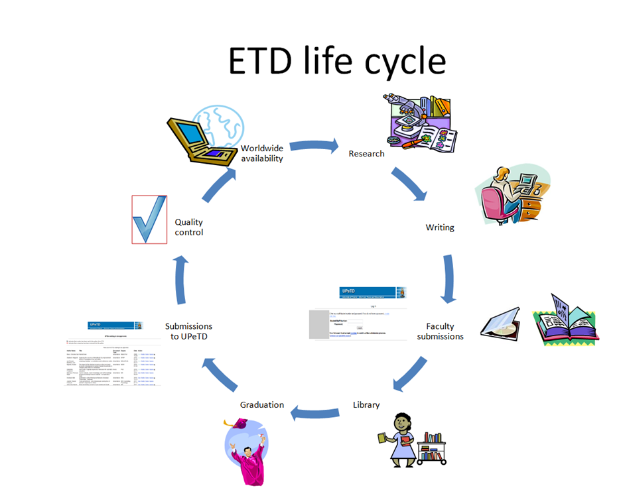

Figure 1: Role players and ETD life cycle at the University of Pretoria

Responsibilities of the Open Scholarship Office
The Open Scholarship office which is housed in the library was formally established in 2007 with only two permanent and two temporary staff members. It was decided from the start that self-submissions would be encouraged, but library staff members will follow the mediated approach in submitting the items. A few students self-submit their theses or dissertations, but the uptake is slow and most students prefer to follow the easier option of submitting at the faculty office. Those that make the effort to self-submit are rewarded by having their items processed first – they receive preference in the workflow at the Open Scholarship Office.

Upon receipt of the batch of theses and dissertations in the library, the ETD officer carefully awards a number to each item and the details of these submissions are recorded on an Excel spreadsheet mainly for statistical purposes. The theses and dissertations are separated as they are processed by two different staff members – one, full time and one a contract worker. Only the self-submitted items receive preference in the workflow, the rest are processed in no specific order. The theses and dissertations are only released after the graduation ceremonies which annually take place in April and September. The Open Scholarship Administrator is responsible for the quality control process. After the release of the electronic items, the subject cataloguers receive notification of the new electronic items and the hard copies are simultaneously distributed to them. The hard copies are catalogued on the Millenium library system and a link is also provided in the library catalogue to the electronic version.

Retrospective Digitization Project
Due to the fact that the submission of theses and dissertations were voluntary during the early years of UPeTD’s inception, it was decided to register a retrospective digitization project. Two temporary staff members were contracted to digitize only the fronts of the ETDs completed between 2000 and 2004. From the outset, requests for complete studies were received from individual researchers in South Africa as well as many other countries all over the world via the UPeTD postbox. Our own Interlending Section soon also became one of UPeTD’s clients for priority treatment, for their overseas requests. The retrospective digitization project was completed towards the end of 2010, but the current interlending requests are still digitized from the old hard copies and submitted to the UPeTD repository.

Ownership of Property Rights
According to the General Regulation G57(6) of the University of Pretoria, the rights with regard to intellectual property that is produced by a student during his/her studies, vest in the University - including the copyright of UP theses and dissertations. A notification to this effect is added to each ETD. In exceptional cases if students want to republish their research, they may apply to have their rights ceded back to them. Although the copyright notification will be adjusted, indicating the student as the copyright holder, the item is not withdrawn from UPeTD.

Although graduates are intrinsically involved in the ETD process, little is known about the graduate’s perspective regarding ETDs. The graduate was thus approached to provide retrospective feedback on the complete ETD process.

GRADUATE’S PERCEPTION
I can still remember the day when I received the e-mail from the University of Pretoria, informing me that my thesis was released in UPeTD. I couldn’t believe it and immediately accessed the link to see with my own eyes. I printed the URL information out and I still to this day have the yellowed piece of paper in my top drawer.

Since I graduated, many colleagues and friends have accessed my dissertation and thesis electronically. Initially my promoter gave students my phone number and they would call me to ask for an electronic copy of my work, but lately requests come in via email. I then simply refer them the UPeTD link and then they also have access to more theses and dissertations. Recently a staff member from UNISA e-mailed me because she knew I did an experimental design in my thesis and she was supervising a similar study. Again I could provide her with the link. She was in Singapore at the time.

I feel proud to have my work in UPeTD and I think that putting your work in the public domain like this, ensures a wider audience (Copeland and Penman, 2004), but also continued engagement in the field. Tenopir (2003) found through research that students and academic staff members prefer electronic access to theses, since it is less time consuming and convenient.

Since I became involved in postgraduate student supervision as well as review work for journals, I realised the value of ETDs once more. I do, however, warn students against the temptation of plagiarism, since it seems so easy when using electronic resources. Due to sophisticated anti-plagiarism programmes used by most universities to screen ETDs, plagiarism needn’t be a threat for students. The mere fact that ETDs are available in full text provides optimum access, increased visibility and therefore offers protection to a student’s intellectual property and prevents plagiarism (ETD guide, 2010).

Access to ETDs also enhances network possibilities between individuals as well as institutions. My experience is very positive in this regard. I previously made contact with some authors of ETDs via email and without exception they all responded to my inquiry or comment. Knowledge creation and sharing has moved away from dark disorganised offices with bundles of papers to the world-wide-web and electronic documents.

UPeTD highlights
In January 2010 UPeTD celebrated its first decade of success. It is undoubtedly the most successful ETD repository in South Africa and Africa and according to the January 2011 Ranking web of world repositories it is number 162 of the top 800 institutional repositories. Currently the UPeTD repository provides access to 6578 ETDs. According to webalizer statistics it has approximately 1200 visits daily.

UPeTD has also been a member of NDLTD since 2005. Past achievements include four NDLTD award winners:
- NDLTD Innovative ETD Award 2005 : Pienaar, Rousseau City building MArch (Prof) http://upetd.up.ac.za/thesis/available/etd-02212005-085046/
- NDLTD Innovative ETD Award 2007 : Van den Heever, Annemie Field public space infrastructure MArch (Prof)
http://upetd.up.ac.za/thesis/available/etd-02162007-161618/
- NDLTD Innovative Learning through ETDs Award 2010 : Orton, Jacques Urban agriculture - a community development project MArch(Prof)
http://upetd.up.ac.za/thesis/available/etd-02022010-163309/
- ETD leadership award 2010 for Monica Hammes who initiated and managed the UPeTD repository on the University of Pretoria campus.

The future of UPETD
Two important changes are envisioned for the future:
• UPeTD will be migrated to the other University of Pretoria repository UPSpace, which makes use of the DSpace software. UPSpace is currently undergoing an upgrade process to version 1.6.2 and after its successful implementation, and with the assistance of IT expertise the migration will be implemented. Jones (Jones 2004) mentions that DSpace is seen as being ahead of ETD-db and that it offers more functionality in security and administration.
• An integrated portal environment that will deal with the complete postgraduate student’s workflow process – from registration to submission of the ETD in the repository by means of the Oracle software. This will include a shared work space for postgraduate students and supervisors (Hammes, 2005).

These changes will undoubtedly involve challenges to the Open Scholarship Office at the University of Pretoria, but we need to keep up with new technological innovations in order to provide the best possible service in opening access to our students’ postgraduate research.

Conclusion
In this paper we highlighted the fact that the final ETD is just the dot on the i and that it entails an intricate work process for the role players. Although this paper only shared the perspectives of the postgraduate student, repository manager and the graduate student, we recognize the efforts of all other role players.

The most prominent advantage of ETDs is avoiding duplication in research work. Through ETDs the quick retrieval of information is ensured and resource sharing is promoted. It is important that ETD practitioners meet regularly at congresses, symposia and workshops to facilitate the establishment of networks between different institutions in multiple countries. It is not in the interest of knowledge creation that institutions operate like islands whilst the world has became a global village and information travels across the globe in seconds. These kinds of gatherings empower repository managers to inform academics, supervisors, researchers, administrators, and policy makers of the new trends and developments in ETD processes.

References
Bandra, S. 2002. Digitization of theses: Possible international collaboration-a discussion paper. Available http://dspace.mona.uwi.edu/bitstream/123456789/349/1/Digitization%20of%20Theses.brief.pdf (accessed June 2011)
Copeland, S. & Penman, A. 2004. The development and promotion of electronic theses and dissertations (ETDs) within the UK, New Review of Information Networking, 10(1): 19-32.
Copeland, S.; Penman, A. & Milne, R. 2005. Electronic theses: the turning point. Program: Electronic library and information systems, 39(3): 185-197
ETD Guide. Available http://www.ndltd.org/resources (accessed May 2011).
Hammes, M. 2005. Positioning ETDs in the eResearch arena: a South African case study. Available http://hdl.handle.net/2263/12961 (accessed June 2011)
Hammes, M. 2010. UPeTD celebrates 10 years of success. Available http://www.library.up.ac.za/openup/docs/UPeTD10.pdf (accessed June 2011)
Jones, R. 2004. DSpace vs. ETD-db: choosing software to manage electronic theses and dissertations. Ariadne, 38. Available www.ariadne.ac.uk/issue38/jones/ (accessed March 19, 2007).
Louw, C.J. 2003. Die impak van tutoriale op die wiskunde-prestasie van studente in eerstejaarwiskunde. [The impact of tutorials on the mathematics achievement of first year students in mathematics]. Unpublished M-dissertation. Pretoria: University of Pretoria. Available http://upetd.up.ac.za/thesis/available/etd-05062004-144933/
Louw, C.J. 2006. Die aard, doel en effektiwiteit van assessering in tersiêre wiskunde aan die Tshwane Universiteit van Tegnologie. [The nature, purpose and effectiveness of assessment in tertiary mathematics]. Unpublished D-thesis. Pretoria: University of Pretoria. Available http://upetd.up.ac.za/thesis/available/etd-06192007-144523/
Ratanya, F.C. 2010. Electronic theses and dissertations (ETD) as unique open access materials: case of the Kenya Information Preservation Society (KIPS). Library Hi Tech News, 4/5: 15-20.
Suleman, H. and Fox, E.A. 2003. Leveraging OAI harvesting to disseminate theses. Library Hi Tech, 21(2): 119-227.
Tenopir, C. 2003. Use and Users of Electronic Library Resources: An Overview and Analysis of Recent Research Studies, Council on Library and Information Resources, Washington, DC.
Yiotis, K. 2008. Electronic theses and dissertation (ETD) repositories: What are they? Where do they come from? How do they work? OCLC Systems & Services: International digital library perspectives, 24 (2):101-115.

