# Intro

This project is based on the need for an isolated DC-DC converter that takes input voltage as 24V to 48V and gives a constant output of 15V at 45W with a closed loop control. The chosen converter design’s both line and load regulations as well as the output voltage ripple needs to be 3%. This design report will focus on the topology and its component selections due to these constrains. Analytical calculations for electrical and magnetic design, and overall simulation results will be discussed.

|  |  |
| --- | --- |
| Input Voltage Range | 24-48V |
| Output Voltage | 15V |
| Output Power | 45W |
| Line Regulation Percentage | 3% |
| Load Regulation Percentage | 3% |
| Output P-P Voltage Ripple | 3% |

# Topology Selection

In this project fundamental flyback topology is chosen. This topology is chosen due to its simplicity to construct and control, especially in discontinuous conduction mode. It has a smaller number of passive circuit elements, also no energy storage inductor is need and only one diode in the topology causes less loss in the system. Also, there is less EMI problems with respect to other isolated topologies.

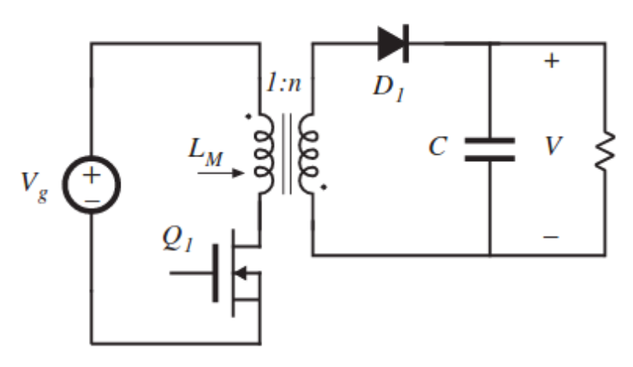

# DESIGN

For the controller IC we have chosen LT3748 which is a high-power isolated flyback controller. This controller has an input voltage range of 5-100V.

# TRANSFORMER DESIGN

For the transformer design, start point was the controller’s limitations. According to the chosen IC LT3748, primary inductance has the following limitations:

Gain formula of the flyback converter is So, for the max Vin, D=0.27. For the min Vin, D=0.43. Operating frequency is chosen as 80 kHz. Hence, ton(min)=Dmin/f­sw=3.37 µs.

So .

LPRI is chosen as 55 µH inside these constraints. After this step, core was chosen by the following step:

.

According to these, the most suitable core was KOOL MU 00K3515E090 since it has the lowest multiplication. Then, turn numbers found with the parameters of this core:

After finding the turns number, by using the rms values of the primary and secondary side currents, cable selection was done:

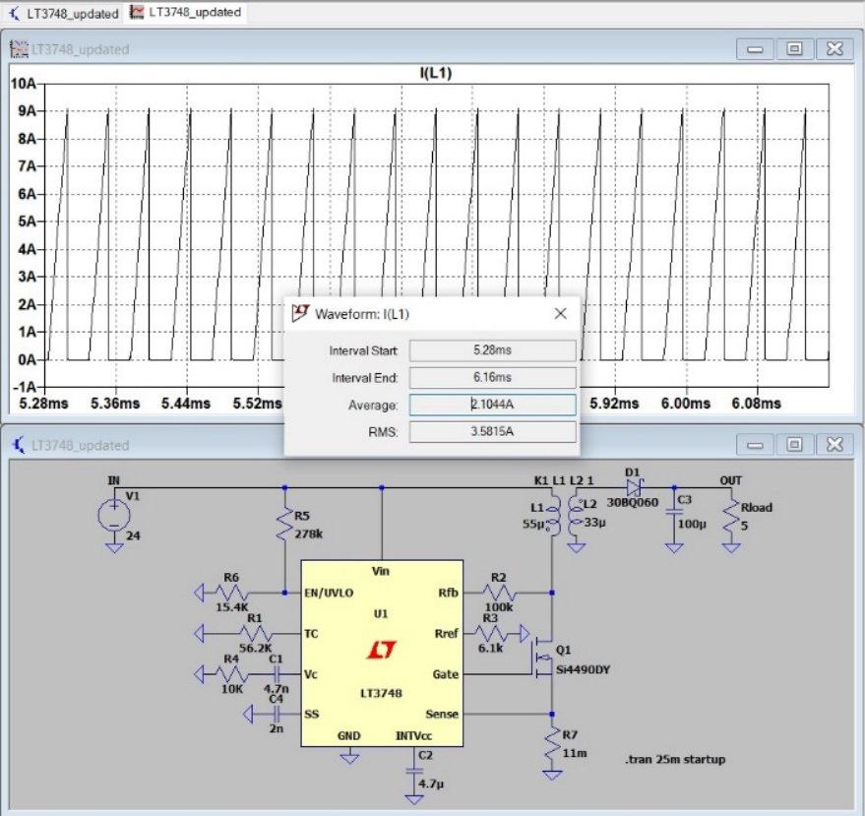

Figure 1:Primary side rms current

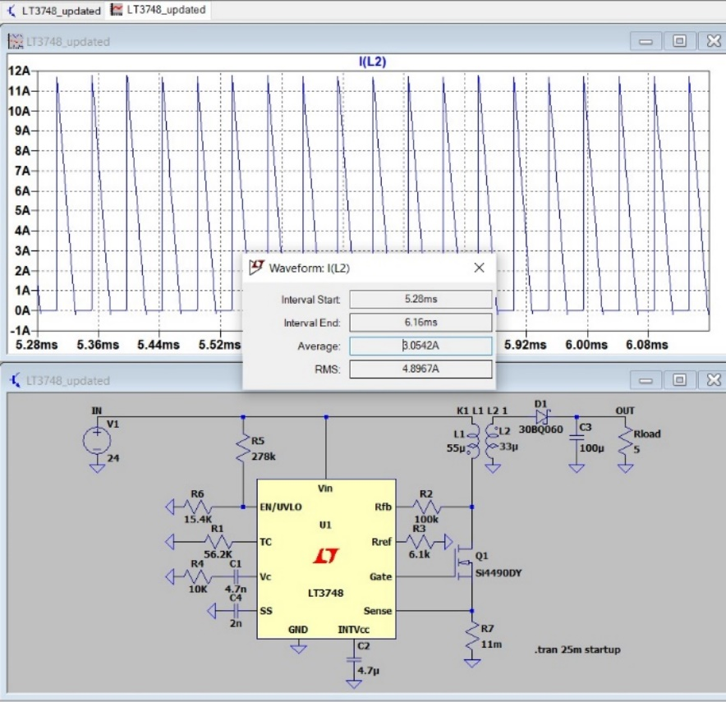

Figure 2:Secondary side rms current

According to the simulations, primary side voltage is maximum 3.6 A. Secondary side voltage is maximum 4.8 A. For safety margin, primary side current was chosen as 4A, secondary side voltage was chosen as 5A.

* For the primary side:
* For the secondary side:

For the cable selection, AWG 26 cable was chosen due to the high operating frequency margin. However, in the lab, there was AWG 25 cable with 0.162 mm2 cross section area and %100 skin depth at 85 kHz. Hence, we carried on with this cable.

* For the primary side:
* For the secondary side:

After we implemented the cables in the lab, it did not fit into the selected core. In real life, it showed us with these cable selections and turns number, fill factor must be higher than 1. So, core selection is changed again.

After we searched the core inventory, the most suitable core was ferrite 0P44022EC core since due to its material, leakage would be much less than the kool mu core. Also, it cross section and window area is large enough to fit the cables. Then, all the calculations were made for this core. For the turn number, Al value of the core is important. So, if we change the A­l value of the core by adding air gap to the core, we can acquire the desired turn numbers.

* Let’s assume the turn numbers as Npri = 12, Nsec = 9.5
* So,

So, by adding this air gap to the core, we can obtain the required reluctance value. If we calculate the magnetic flux density as

Hence, by this calculation, we can see that core is not saturated. It is not the expected value since we did all the calculations for B= 0.2 T. However, this result is close enough to expected value and it does not saturate the core. After that, fill factor is calculated as follows:

It can be deducted that fill factor is very small and it show that core is overdesign for this situation. However, since we built the transformer with hand, fill factor is not high enough.

## IMPLEMENTATION

The transformer was implemented according to calculations. However, as expected, real life and theoretical calculations did not match exactly. After implementing the transformer, we did the measurements.

Figure 3:Primary side inductance

For the primary side inductance measurement, which is magnetizing inductance, we left open the secondary side and connected the probes of the LCR meter to the primary side. The result of the measurement can be seen in the Fig.xx. The expected value was 55 µH, but it was measured as 53 µH. It is very close to the expected value.

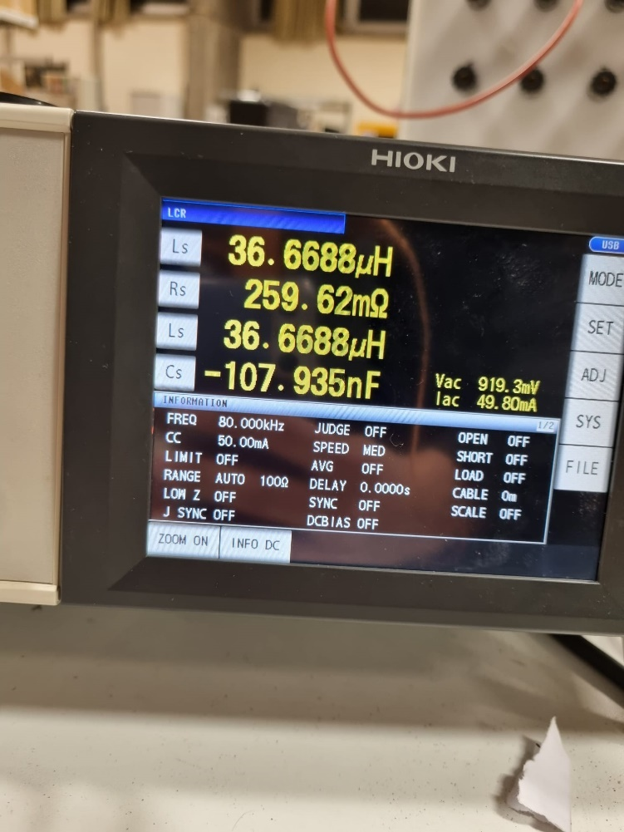

Figure 4:Secondary side inductance

For the secondary side inductance measurement, we left open the primary side and connected the probes of the LCR meter to the secondary side. The result of the measurement can be seen in the Fig.xx. It was measured as 36 µH.

If the turns ratio is checked by the inductance values, turns ratio can be found as

So, turns ratio is satisfied by the inductance values.

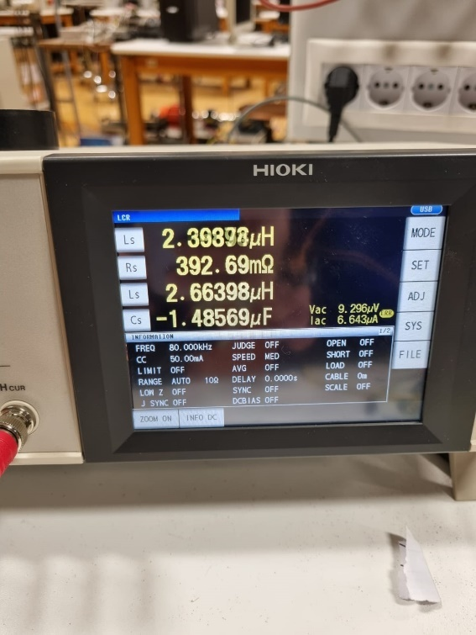

Figure 5:Leakage inductance value

For the leakage inductance, we shorted the secondary side and connected the probes to the primary side.Connection can be seen in the Fig.XX. Since it was thought that we may change the turns in the future, excess cables did not cut out. Hence, resulted in more leakage inductance as 2.6 µH, which can be seen in Fig.XX

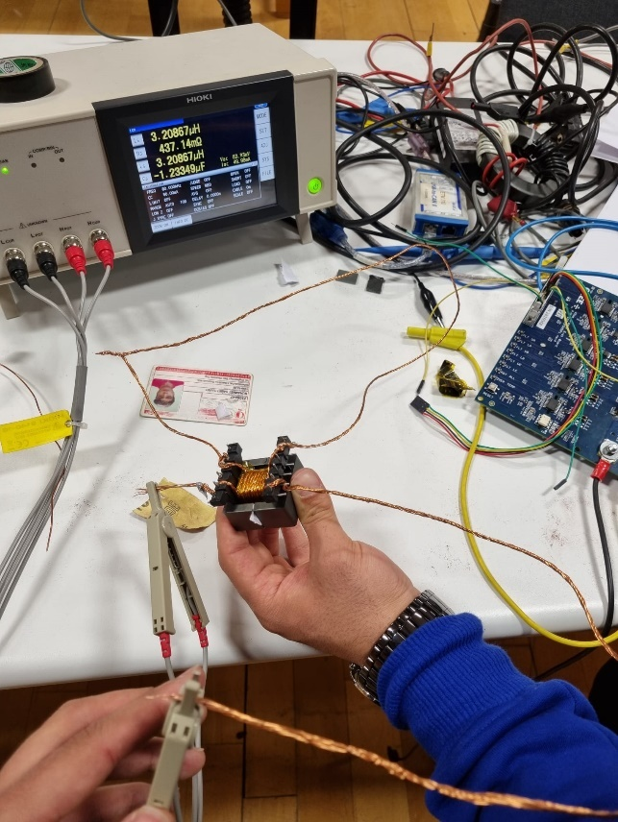

Figure 6:Leakage inductance measurement

## LOSSES

### Copper Losses

For the copper losses, we need to find how much cable is used. To obtain this information, dimensions of the core must be known

Figure 7:Dimensions of the core

Dimensions of the core represented in the figure above. According to these figure,

### Core Loss

According to the core loss per cm3 value of the core, approximate core loss is calculated as following:

Since we are operating at high frequencies, core losses are much higher than the copper losses and it is expected.