Intro

This project is based on the need for an isolated DC-DC converter that takes input voltage as 24V to 48V and gives a constant output of 15V at 45W with a closed loop control. The chosen converter design’s both line and load regulations as well as the output voltage ripple needs to be 3%. This design report will focus on the topology and its component selections due to these constrains. Analytical calculations for electrical and magnetic design, and overall simulation results will be discussed.

|  |  |
| --- | --- |
| Input Voltage Range | 24-48V |
| Output Voltage | 15V |
| Output Power | 45W |
| Line Regulation Percentage | 3% |
| Load Regulation Percentage | 3% |
| Output P-P Voltage Ripple | 3% |

Topology Selection

In this project fundamental flyback topology is chosen. This topology is chosen due to its simplicity to construct and control, especially in discontinuous conduction mode. It has a smaller number of passive circuit elements, also no energy storage inductor is need and only one diode in the topology causes less loss in the system. Also, there is less EMI problems with respect to other isolated topologies.

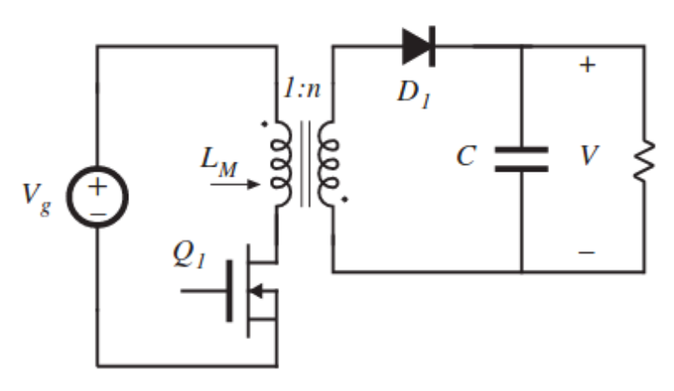

DESIGN

For the controller IC we have chosen LT3748 which is a high-power isolated flyback controller. This controller has an input voltage range of 5-100V.