Frame
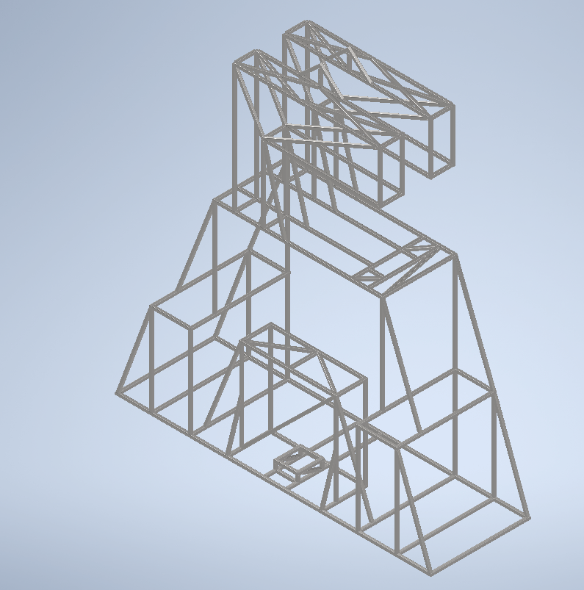

Figure 1 Frame Assembly

We use Ducts DIN EN 10219-2 l x w x t L: q
- l x w: Square hollow section with 30mm outer dimensions (30mm × 30mm)
- t: Wall thickness of 3mm
- L:q: Likely refers to the length (L) and quantity (q), though this part might be project-specific

Welding

Cutting

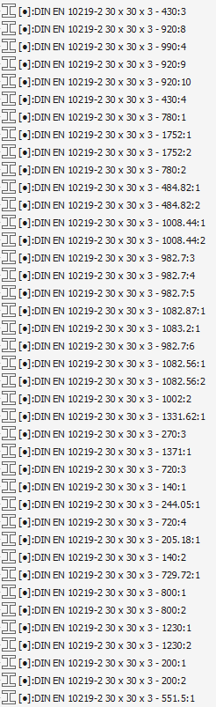
Frames Code :-
Figure 2 Frames code

Figure 3 Frames code

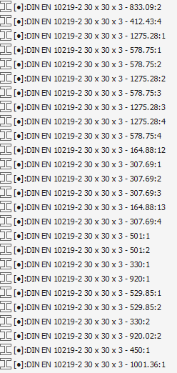
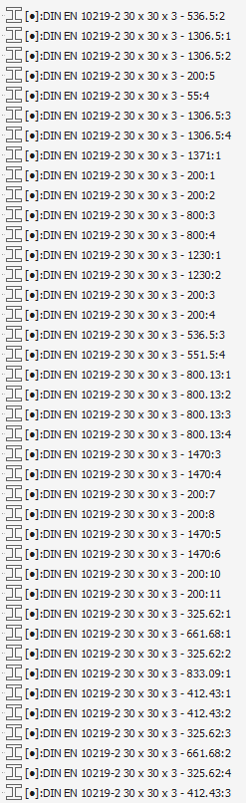
Figure 4 Frames code
Figure 5 Frames code

