

**PCI-MTK**

**USER MANUAL**

**User GUI**

PCI-MTK programs includes only one main page when its open (Figure 1). This page is divided into two sections. First is Material List (Figure 2) and second is Label Info (Figure 3).

Figure 1 Graphical User Interface

Figure 2 Material List

Materials which produced or supplied by Arçelik Company can be filterable and selectable in this section.

Figure 3 Label Info

Material details which selected from Material List can be seen but not editable int this section. Empty areas like *“Quantity”* or *“Bill No”* can be fillable and changeable to create and print receipt. *Red fields* (**) indicate that these fields are required to create or print receipt. With the “*Add Below*” button, these information’s are added List under the Label Info section.

When “*New*” button clicked opens a new page structure (Figure 4) to add new Material to Material List in the Material List section. These changes required fields.

Figure 4 New Button Clicked

**Use Cases**

There are two use cases. First is *“Selection and Print”* Document and second is *“Adding new Material”*. Program starts with *“Selection and Print”* mode. Clicking *“New”* button changes modes to *“Adding New Material”* and clicking *“Back”* button returns the mode *“Selection and Print”*.

**1 - Selection and Print**

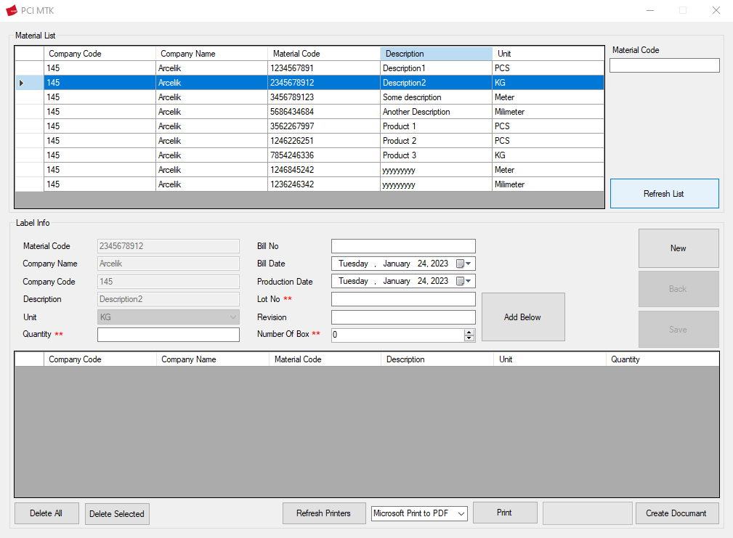

Figure 5 Selection and Print Mode

To print or create receipt, fallows these steps:

1. Find and select material from Material List

To find Material, write something on text area (Figure 6). This filters out the materials seen. Click on one of filtered material. See the changes Label Info section (Figure 7).

Figure 6 Filter and Select Material

Figure 7 See changes.

1. Fill required fields on Label Info section.

Material details can be seen in Label Info section. But not all required fields filled. *“Quantity”*, *“Lot No”*, *“Production Date”* and *“Number of Box”* areas are empty. When clicked *“Add Below”* button nothing happens cause of these empty fields. Other empty fields like *“Bill No”*, *“Bill Date”* and lastly *“Revision”*. Fill these areas to add below list (Figure 8).

Figure 8 Filling required fields.

1. Click *“Add Below”* button.

See changes on the list under the Label Info section after clicking (Figure 9). Listing 5 element appear that will turn into after documents. Every element has 1000 quantity. These numbers come from options above. Every element has *“Quantity”* / *“Number of Box”* quantity. And fields are reset. Other material details are not appeared list below but are recorded in the background.

Figure 9 Listed Elements

* 1. Delete from List in case of wrong insertion.

This step is an intermediate step for mistakes made or deletes all records. To deletes all records, click “Delete All” button below list (Figure 10). To deletes any number of records, select it’s with clicking “CTRL + left click” (Figure 11) or mouse hold down and drag (Figure 12).

Figure 10 CTRL + Click Selection Above and Result below.

Figure 11 Mouse drag selection above and result below.

Figure 12 Clicking Delete All button above and result below.

1. To print, select printer from the field next to the *“Print”* button and click *“Print”* button.

WARNING: Printing options can sometimes give bad results. It is designed for printers compatible with A6 paper type but may still not give an absolutely optimized result. In such cases, use *“Create Document”* option.

To print document, select printer next to “Print” button and click “Print” button (Figure 13). If printer do not seen, click “Refresh Printers” button may solve the problem (Figure 13). Each element is added to the document page by page.

Figure 13 Print and Refresh Printers

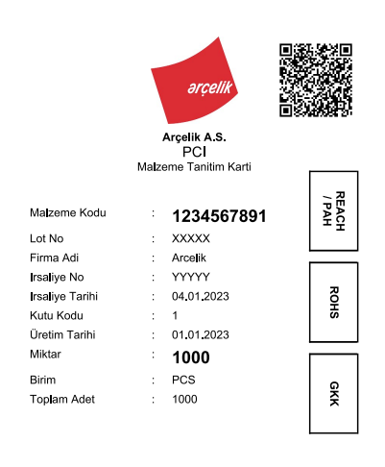

Figure 14 Printed result.

1. To create a document, click *“Create Document”* button.

“Create Document” button give same result with print options but converts A4 page style. The created document can be manually printed on any type of paper.

**2 – Adding new Material**

Figure 15 Adding new material mode.

To add new Material to Material List, fallow these steps:

1. Click “New” button to enter the Adding new Material mode (Figure 15).

When click “New” button, page design changes. There are only 3 available fields which “Material Code”, “Description” and “Unit”. Three of them are required to record.

* 1. Click “Back” button to turn back Selection and Print mode.

Clicking “Back” button turn back the page Selection and Print mode (Figure 16).

Figure 16 Selection and Print Mode

1. Fill required fields on Label Info section (Figure 17).

Figure 17 Filling new Material details.

1. Click “Save” button (Figure 18).

See changes list which Material List (Figure 19).

Figure 18 Save button.

Figure 19 Added material.