Digital Customer Service Ordering & Provisioning System

Business Systems Analysis Case Study
Author: Musa Ceesay
Role: Business Systems Analyst
Domain: Telecom / ISP Operations
This case study analyzes a home internet service ordering process with recurring activation delays, duplicate data entry, and limited cross-team visibility. The analysis defines process and system changes required to unify sales, provisioning, billing, and support workflows. It includes requirements, process modeling, stakeholder analysis, system context, and conceptual data modeling artifacts. The expected outcome is faster activation, fewer provisioning errors, and more consistent customer communication.

1. Executive Summary
The business problem is a fragmented order-to-activation process where sales, provisioning, and billing operate with partial data and inconsistent status updates. The system gap is the absence of a shared orchestration model and common tracking identifiers across connected systems.
The analysis approach combined stakeholder mapping, AS-IS/TO-BE process design, requirement definition, and conceptual data modeling. Based on these artifacts, the target-state design introduces shared order tracking, automation for eligible activations, and exception-driven handling for failed provisioning events.
Expected operational impact includes shorter activation cycles, lower rework from duplicate entry, reduced support effort per order, and improved visibility for both customers and internal teams.

2. Business Problem & Context

Problem Statement
Customers ordering home internet service experience activation delays, manual re-entry of the same data across systems, and status confusion between sales, provisioning, and billing teams. The organization requires an integrated ordering and provisioning model to reduce cycle time and improve order visibility.

Current Operational Pain Points
- Duplicate order capture across CRM, provisioning, and billing touchpoints
- Manual handoffs between functions without shared status definitions
- Delayed provisioning due to incomplete or inconsistent payloads
- Increased support contacts caused by unclear activation progress

Cross-System Visibility Issues
- Teams do not consistently reference one shared order identity
- Customer-facing status is not synchronized with operational state changes
- Billing and support often receive updates after provisioning events have occurred

Activation Delay Causes
- Incomplete order data at submission
- Manual correction steps before provisioning can proceed
- Reconciliation effort between systems with differing records
- Exception handling performed ad hoc rather than via a defined queue

3. Business Goals & KPIs

Business Goals
- Reduce order activation time from 3 days to 1 day.
- Eliminate duplicate data entry across systems.
- Provide real-time order status visibility.
- Reduce provisioning errors by 40%.
- Improve customer satisfaction score (CSAT).

KPI Table
KPI Metric | Baseline / Current State | Target State
Average activation time | 3 days | 1 day
Provisioning error rate | Current baseline tracked | 40% reduction
Duplicate data entry events | Present across workflow | Eliminate duplicate entry
Percent of orders auto-provisioned | Current baseline tracked | Increase from baseline
Support tickets per order | Current baseline tracked | Reduce from baseline
Customer satisfaction (CSAT) | Current baseline tracked | Improve from baseline

4. Stakeholder Analysis
Stakeholder | Role | Primary Concern | Success Measure
Sales Rep | Submits customer orders | Speed and simple order intake | Complete order submitted first pass
Customer | Requests internet service | Activation clarity and timeline transparency | Predictable activation and clear status updates
Provisioning Team | Activates line and service profile | Accurate order payload and fewer corrections | Lower rework and faster activation completion
Billing | Starts billing cycle | Correct plan, pricing, and start date | Fewer billing corrections post-activation
Support | Handles issues and escalations | End-to-end order visibility | Fewer status-related tickets and escalations
IT / Engineering | Maintains integrated systems | Stable integrations and observability | Reliable data exchange and auditable status changes

5. AS-IS Process Summary
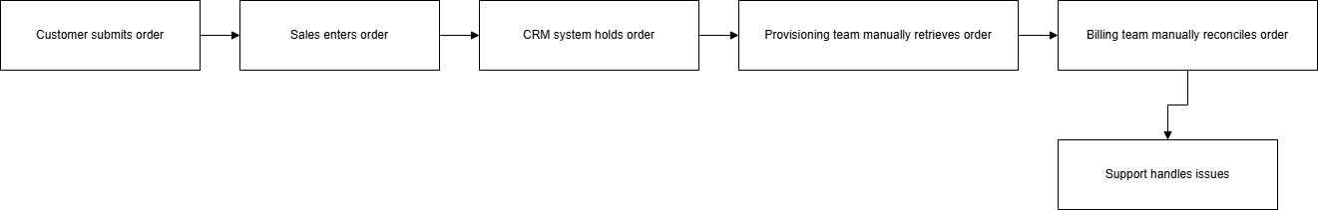 Figure — AS-IS Ordering & Provisioning Process
The current workflow relies on manual transitions between teams and systems. Sales captures order details, provisioning validates and configures service, and billing initiates charging. Because data is re-entered and reconciled at multiple points, defects and delays propagate downstream.

AS-IS Characteristics
- Manual validation and handoff activities
- Multiple records representing the same order across systems
- Inconsistent status communication to customer-facing teams
- Late discovery of payload quality issues during provisioning

AS-IS Artifact References
- Export: assets/projects/diagrams/as-is-process-export.svg
- Source: assets/projects/diagrams/as-is-process.drawio

6. TO-BE Process Design
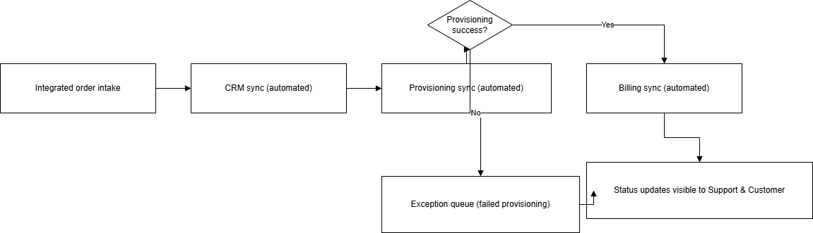 Figure — TO-BE Integrated Order Orchestration Flow
The target state introduces an integrated order flow with shared tracking, eligibility-based automation, and explicit exception routing. Order data is validated earlier, status changes are surfaced consistently, and cross-team coordination follows a unified lifecycle model.

TO-BE Design Highlights
- Shared order identity across CRM, provisioning, and billing integrations
- Automated activation path for eligible orders
- Real-time status model for internal users and customer visibility
- Exception queue for failed provisioning events requiring manual intervention

TO-BE Artifact References
- Export: assets/projects/diagrams/to-be-process-export.svg
- Source: assets/projects/diagrams/to-be-process.drawio

7. Requirements Summary

Functional Requirements (Top 12)
- Validate mandatory order fields before submission.
- Generate and persist a shared order ID used across integrated systems.
- Integrate CRM, provisioning, and billing around that shared ID.
- Publish real-time order status updates to internal users.
- Surface customer-visible status updates aligned to operational events.
- Support automated activation for eligible orders.
- Route failed activation attempts to an exception case workflow.
- Record status transition history for each order lifecycle event.
- Support role-appropriate access views for sales, provisioning, billing, and support.
- Trigger billing initiation on successful activation state.
- Enable support teams to view end-to-end order status context.
- Preserve manual override capability with traceability for corrections.

Non-Functional Requirements (Top 8)
- Meet 99.9% monthly availability target.
- Ensure status updates are visible within 60 seconds of process events.
- Enforce role-based access control across user groups.
- Maintain audit logging for status changes and manual overrides.
- Preserve integration reliability under normal operating load.
- Maintain data consistency across CRM, provisioning, and billing records.
- Support operational observability for troubleshooting integration failures.
- Provide secure API-based integration for connected systems.

8. User Stories & Acceptance Criteria

US-01: Sales Order Entry
Story: As a sales rep, I want one guided form so I can submit complete orders without rework.
Acceptance (Gherkin):
Given a required field is missing
When the sales rep submits the order
Then the system blocks submission and displays missing fields

US-02: Customer Order Tracking
Story: As a customer, I want real-time status updates so I know when service will be activated.
Acceptance (Gherkin):
Given an order status changes in provisioning
When the lifecycle event is recorded
Then the customer-facing status updates within 60 seconds

US-03: Provisioning Automation
Story: As provisioning staff, I want eligible orders auto-activated so manual workload decreases.
Acceptance (Gherkin):
Given technical eligibility checks pass
When order processing begins
Then activation completes without manual intervention

US-04: Billing Readiness
Story: As a billing analyst, I want activation-confirmed order data so billing starts correctly.
Acceptance (Gherkin):
Given an order reaches successful activation
When billing is triggered
Then plan, pricing, and start date match the order record

US-05: Support Visibility
Story: As a support agent, I want end-to-end status visibility so I can resolve customer inquiries faster.
Acceptance (Gherkin):
Given a support agent searches by order ID
When the order is retrieved
Then lifecycle status, recent events, and exception state are visible

US-06: Exception Handling
Story: As a provisioning lead, I want failed activations routed to an exception queue so corrections are tracked.
Acceptance (Gherkin):
Given provisioning fails
When the failure event is captured
Then an exception case is created with reason code and owner

9. System Context & Data Model
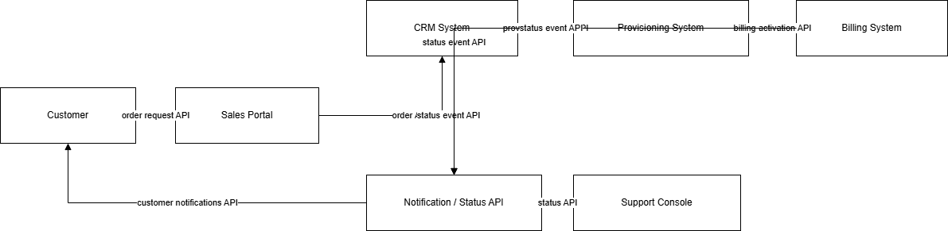 Figure — System Context Diagram
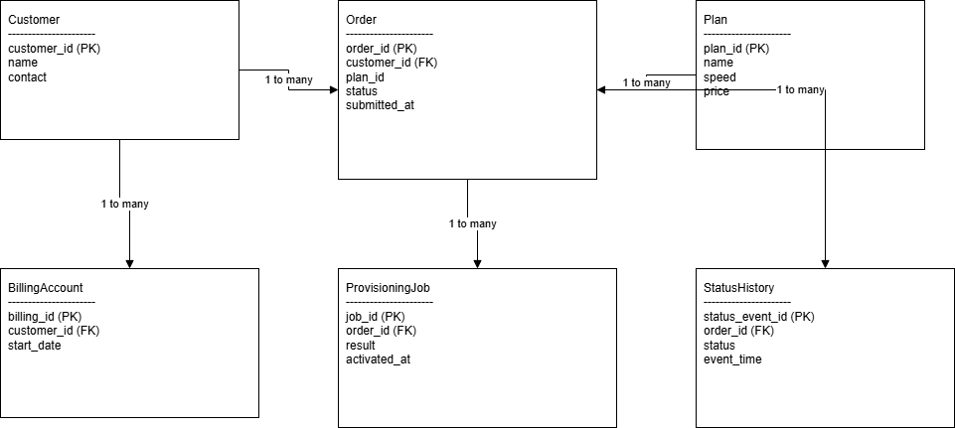 Figure — Conceptual ER Data Model

Integrated Systems and Boundaries
The solution context connects CRM intake, provisioning execution, billing initiation, and support visibility through shared order lifecycle data. The primary boundary is the order-to-activation process for residential internet service; downstream enterprise contract handling and logistics remain outside this model.

System Context Artifact References
- Export: assets/projects/diagrams/system-context-export.svg
- Source: assets/projects/diagrams/system-context.drawio

Core Entity Model (Conceptual ER)
Entity | Key Fields | Relationships
Customer | customer_id, name, contact, address | 1-to-many with Order
Order | order_id, customer_id, plan_id, status, submitted_at | Many-to-1 Customer; 1-to-many Status History
Plan | plan_id, name, speed_tier, monthly_price | 1-to-many with Order
Provisioning Job | job_id, order_id, activation_result, activated_at | 1-to-1 or 1-to-many with Order (retries)
Billing Account | billing_id, customer_id, plan_id, start_date | Many-to-1 Customer; linked to activated Order
Status History | status_event_id, order_id, status, event_time, actor | Many-to-1 with Order

10. Analyst Scope

Analyst Scope
- Requirements definition
- Stakeholder mapping
- Process modeling
- System context design
- Data model design
- Risk and assumptions analysis

11. Key Analyst Decisions

Key Analyst Decisions
- Chose shared order ID across systems to eliminate reconciliation errors
- Designed event-based status model for cross-team visibility
- Introduced exception-driven provisioning flow to reduce manual workload

12. Assumptions, Risks, Scope

Assumptions
- Existing CRM and billing systems expose secure APIs.
- Product catalog and eligibility rules are centrally maintained.
- Support teams will adopt standardized status definitions.

Risk Register
Risk | Impact | Mitigation
Legacy integration latency | Delayed sync and stale status visibility | Introduce monitoring thresholds and retry controls
Incomplete historical data | Migration defects and order quality issues | Validate migration datasets and enforce quality checks
Operational resistance | Slower adoption of new workflow | Deliver role-based training and phased rollout support

Scope Boundaries
In Scope: Residential internet orders, activation workflow, status tracking, billing trigger integration, support exception queue.
Out of Scope: Hardware warehouse logistics, field technician dispatch optimization, enterprise contracts, collections processes.

13. Expected Business Impact
The target-state model is expected to reduce average activation time by removing re-entry cycles and improving handoff quality. Provisioning error rates should decrease through earlier validation, shared identifiers, and structured exception handling.
Support load per order is expected to decline as status clarity improves for both teams and customers. Customer experience should improve through transparent activation progress and fewer delays caused by back-office reconciliation.

14. Next Steps / Implementation Roadmap

Phase 1 — Integration
- Implement shared order ID across CRM, provisioning, and billing interfaces.
- Establish status event schema and baseline observability.
- Validate API contracts and role-based access controls.

Phase 2 — Automation
- Enable automated activation for eligible order paths.
- Implement exception-case generation for failed provisioning events.
- Add operational dashboards for activation cycle and error monitoring.

Phase 3 — Optimization
- Tune eligibility and routing logic using KPI trend analysis.
- Refine support workflows based on ticket-volume patterns.
- Expand continuous improvement cadence for process and data quality.

Appendix: Reference Artifacts
- Case page: projects/customer-service-ordering-provisioning-system.html
- PDF brief: projects/customer-service-ordering-provisioning-brief.pdf
- AS-IS diagram: assets/projects/diagrams/as-is-process-export.svg
- TO-BE diagram: assets/projects/diagrams/to-be-process-export.svg
- System context diagram: assets/projects/diagrams/system-context-export.svg
- Draw.io sources: assets/projects/diagrams/as-is-process.drawio, assets/projects/diagrams/to-be-process.drawio, assets/projects/diagrams/system-context.drawio

