abalone.R

Musa_2

Tue Apr 28 09:51:58 2015

abalone <- read.csv("abalone.csv")  
meanLength <- mean(abalone$Length)  
table(abalone$Sex)

##   
## F I M   
## 1307 1342 1528

library(ggplot2)

## Warning: package 'ggplot2' was built under R version 3.1.3

plot(Length ~ Sex, data=abalone)

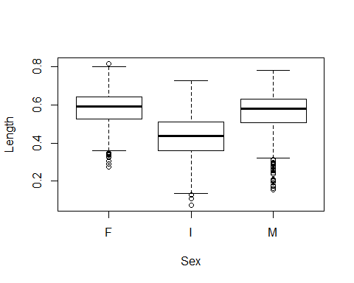

qplot(x=Rings,y=Length,data=abalone)

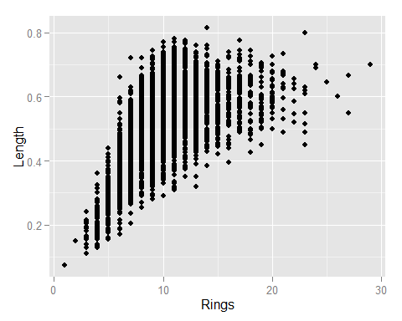

model <- lm(Whole.weight ~ Length + Sex, data=abalone)  
x <- 1:3  
cv <- function (x, na.rm=FALSE){  
 sd(x,na.rm=na.rm)/mean(x,na.rm=na.rm)  
}  
cv(abalone$Length)

## [1] 0.2291884

model

##   
## Call:  
## lm(formula = Whole.weight ~ Length + Sex, data = abalone)  
##   
## Coefficients:  
## (Intercept) Length SexI SexM   
## -1.054271 3.627746 -0.066120 0.009148

summary(model)

##   
## Call:  
## lm(formula = Whole.weight ~ Length + Sex, data = abalone)  
##   
## Residuals:  
## Min 1Q Median 3Q Max   
## -0.47129 -0.12184 -0.04345 0.07620 1.22237   
##   
## Coefficients:  
## Estimate Std. Error t value Pr(>|t|)   
## (Intercept) -1.054271 0.017265 -61.064 < 2e-16 ***  
## Length 3.627746 0.028490 127.335 < 2e-16 ***  
## SexI -0.066120 0.008349 -7.920 3.02e-15 ***  
## SexM 0.009148 0.006949 1.316 0.188   
## ---  
## Signif. codes: 0 '***' 0.001 '**' 0.01 '*' 0.05 '.' 0.1 ' ' 1  
##   
## Residual standard error: 0.184 on 4173 degrees of freedom  
## Multiple R-squared: 0.8594, Adjusted R-squared: 0.8593   
## F-statistic: 8501 on 3 and 4173 DF, p-value: < 2.2e-16