Question 1:

#include<stdio.h>

main()

{

int y = -4, r;

printf("Please Enter the radius of your Circle = ");

scanf_s("%d", &r);

for (; y < r; y++)

{

for (int x=-4; x < r; x++)

{

if ((x*x + y*y) >= r*r)

printf(" ");

else

printf(" #");

}

printf("\n");

}

system("pause");

}

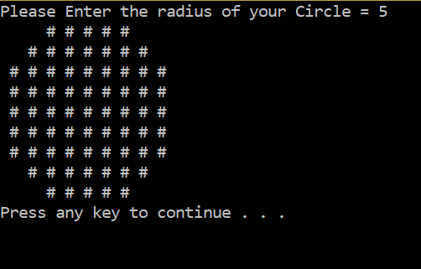

Question 2:

#include<stdio.h>

main()

{

int a = 0, c = 0, d, e;

printf("Please Enter your Number = ");

scanf_s("%d", &c);

d = ((c / 2) * 2);

e = c / 2;

for (; a <= d; a++){

for (int b = 0; b <= d; b++)

{

if (a + b == e || a - b == e || a + b == 3*e || a - b == -e)

printf("x");

else

printf(" ");

}

printf("\n");

}

system("pause");

}

