**Bazar.com Outputs**

1. Search for "distributed systems" using this command

curl <http://localhost:5000/search/distributed%20systems>

expected result:

{

"results": [

{"id": 1, "title": "How to get a good grade in DOS..."},

{"id": 2, "title": "RPCs for Noobs"}

]

}

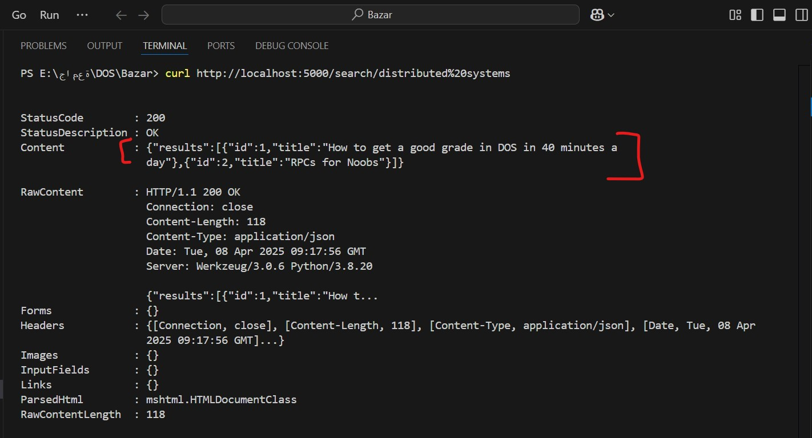

1. Get Info for Item 1 using this command

curl <http://localhost:5000/info/1>

expected result:

{

"id": 1,

"title": "How to get a good grade in DOS...",

"topic": "distributed systems",

"quantity": 10,

"price": 50.0}

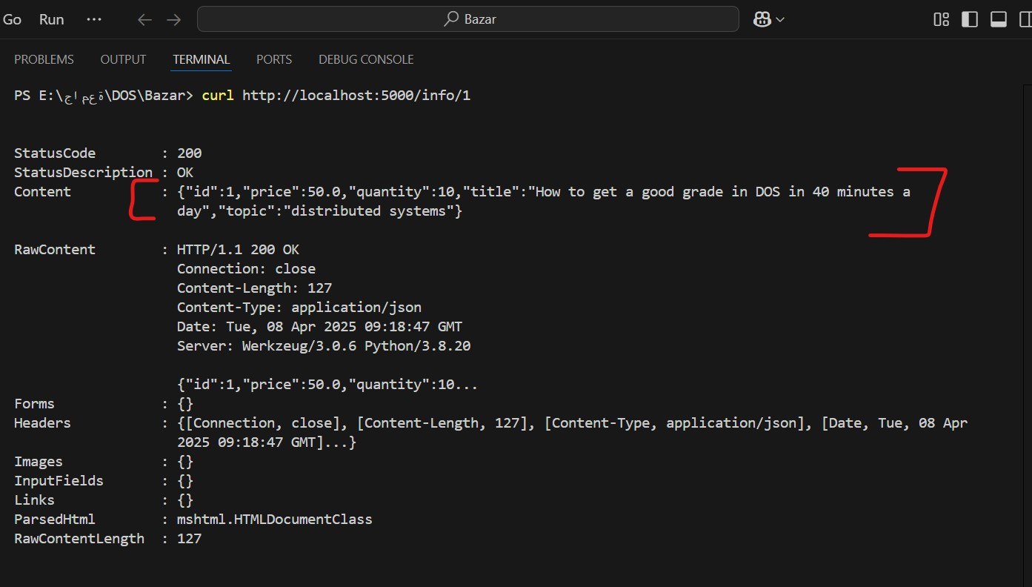

1. Purchase Item 1 using this command

curl -Method Post <http://localhost:5000/purchase/1>

expected result:

{"success": true}

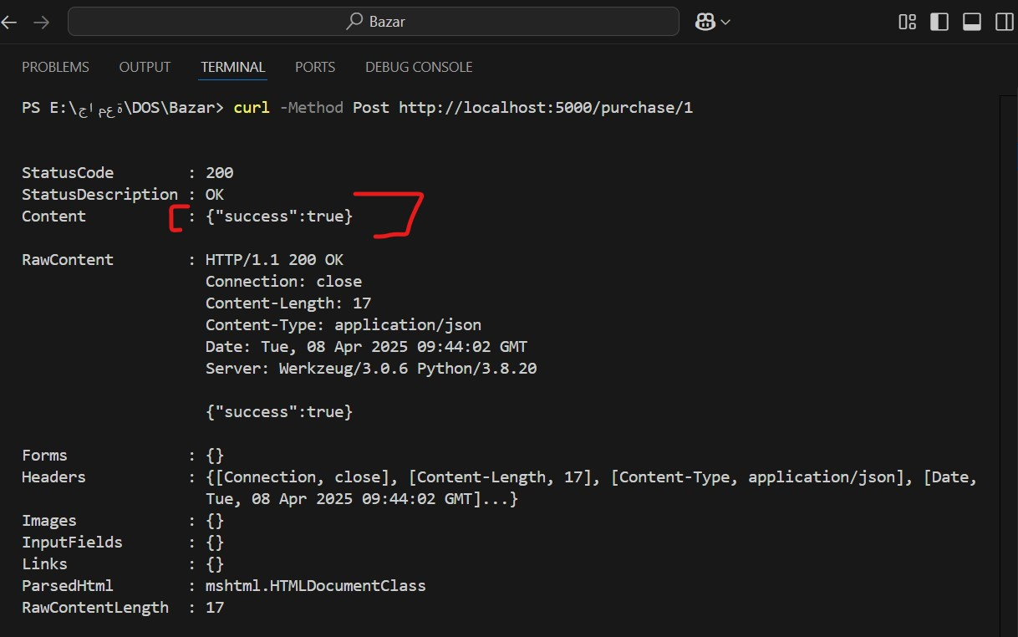

1. After repeating point number 3 for four times the quantity became 6 so after this when we apply the following command which is command the second point

curl <http://localhost:5000/info/1>

the expected result:

{

"id": 1,

"title": "How to get a good grade in DOS...",

"topic": "distributed systems",

"quantity": 6,

"price": 50.0

}

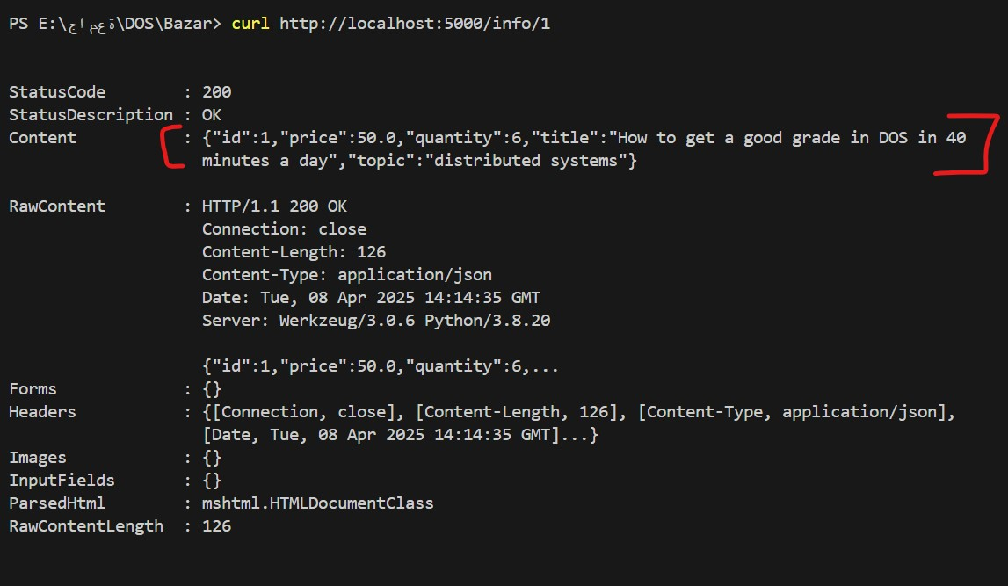

1. After do command numer 3 for ten times then the quantity became zero therefore when request the command of point 2 again

curl <http://localhost:5000/info/1>

expected result:

{"success": false, "error": "Out of stock"}

