FACULTY OF ENGINEERING AND TECHNOLOGY
ELECTRICAL AND COMPUTER ENGINEERING DEPARTMENT
ADVANCED DIGITAL DESIGN ENCS3310
COURSE PROJECT

Dr. Abdellatif Abu-Issa

Objective:
The task is to design a solution to real problem which is the traffic light design for two roads. You should search for information about the following: Finite State Machine.

The Task:
Your task is to create a solution for traffic light system shown in Figure 1:

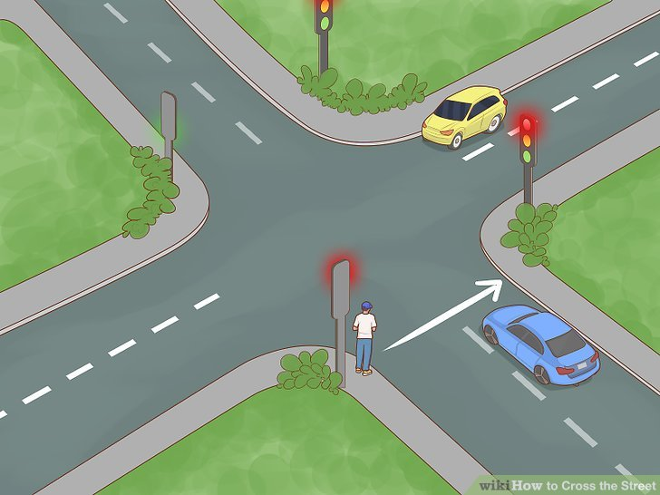
Figure 1: Highway and Farm Roads
And here is the block diagram for the traffic lights which shows how the design should work:
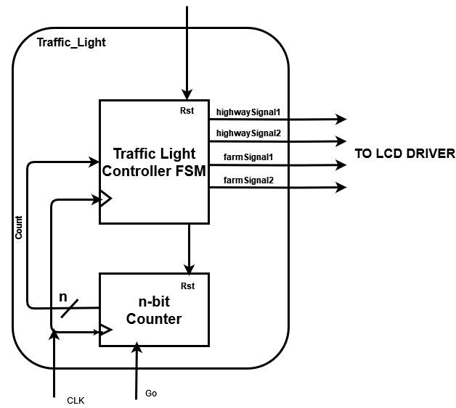

You will design a traffic light controller for the highway and farm road intersection shown in Figure 1. The traffic light controller outputs four 2-bit signals, highway Signal 1 and highway signal 2 and farm Signal 1 and 2, for the highway road and the farm road, respectively. The following encoding is used for both signals:
00 : Green
01 : Yellow (when changing from green)
10 : Red
11 : Red-Yellow (when changing from red)

(Note: You can also consider the four outputs as 3-bit signals).

Table 1 : All the states of the traffic light
State | Highway TL1 | Highway TL2 | Farm TL1 | Farm TL2 | Delay [Sec]
S0 | Red | Red | Red | Red | 1
S1 | Red-Yellow | Red-Yellow | Red | Red | 2
S2 | Green | Green | Red | Red | 30
S3 | Green | Yellow | Red | Red | 2
S4 | Green | Red | Red | Red | 10
S5 | Yellow | Red | Red | Red | 2
S6 | Red | Red | Red | Red | 1
S7 | Red | Red | Red-Yellow | Red-Yellow | 2
S8 | Red | Red | Green | Green | 15
S9 | Red | Red | Green | Yellow | 2
S10 | Red | Red | Green | Red | 5
S11 | Red | Red | Yellow | Red-Yellow | 2
S12 | Red | Red | Red | Green | 10
S13 | Red | Red | Red | Yellow | 2
S14 | Red | Red | Red | Red | 1
S15 | Red | Red-Yellow | Red | Red | 2
S16 | Red | Green | Red | Red | 15
S17 | Red | Yellow | Red | Red | 3

Description of the signals:
Your design has 3 inputs which are:
“Rst” : It returns the design to state 0, and counter to 0.
“Go”: The default is that go = 1 in order to change between different states. However, if go is forced to 0 then the counter will stop counting (freeze).
“clk” : Synchronous system.

After building the design, you have to build a simple testbench which will implement a test for all cases (states).

Format of the report:
This project should be written as formal report. The report should include sections on the following:
- Brief introduction and background
- Design philosophy
- Results
- Conclusion and Future works

The report must be submitted as pdf file and the code should be submitted as .v file (or on note bad as .txt).

Key Points:

- Any type of plagiarism or cheating will be penalized by 0 mark, and the cheaters will be treated according to the university laws.

- The design description should include diagrams of the design, and give a justification of the decisions made.

- Technical achievement in design is linked to the degree of functionality that was attempted, as explained below.

- Technical achievement in implementation is based on the quality of your Verilog code. This includes issues such as legibility of code, use of meaningful variable names, good comments, clear structure, and modifiability of the design.

- Technical achievement in evaluation is based on the quality of your simulation results.

Deadline:

- The report should be submitted before midnight on Sunday 22-01-2023.
- Late submission is penalized at a rate of 10% marks per day till 01-02-2023.

Assessment Form (Feedback):

The following is the assessment form for this project:



Electrical and Computer Engineering Department
Project Assessment Feedback
Advanced Digital Design (ENCS3310)

Dr. Abdellatif Abu-Issa

Student Name:………………………………….. Student ID:………………….

Marks

Report Presentation (10%)

Language (Spelling and Grammar), style of the report, caption of figures, page
numbering…etc.

Design Process and Outcome (70%)

- Description of the system and design process (20%)

- Technical Achievement in System Design and Evaluation (50%)

Judgement and Creativity (20%)

Demonstration of good judgment, imagination and creativity
in selecting and applying design methods. Good discussion and
analysing of the system and suggested improvements.

Total Mark (Out of 100)

Deducted Marks: late days * 10% per day

FINAL ALLOCATED MARK (Out of 100)

Any evidence for any type of cheating: yes no

