
QUANTITATIVE RESEARCH · OCTOBER 2026
The MERIDIAN Program: An Empirical Evaluation of a Systematic Multi-Asset Trading System
Backtest evidence from Bitcoin, Ether, gold and silver, January – September 2026
Musab Muhammad
Meridian · Correspondence: musabmuhammad1470@gmail.com
ABSTRACT
MERIDIAN is a fully systematic trading program that applies one proprietary rule set, with asset-class-specific parameters, to Bitcoin, Ether, gold and silver contracts for difference (CFDs). This paper tests whether the program has an edge that is positive after recorded spreads, consistent across time, markets and trade direction, and robust to resampling and higher costs. We replay five-minute broker data, including recorded bid–ask spreads, in a single shared account from 4 January to 30 September 2026, risking 1% of the realized balance per trade under a 3.5% account-wide daily loss limit. The program closed 716 trades with a 38.7% hit rate, a profit factor of 1.39 and a mean result of +0.22R per trade, where R is the amount risked (t = 3.70). Equity rose 339.9% over the nine months, every calendar month was positive, and the maximum mark-to-market drawdown was 13.5%, while all four underlying markets declined. Each half of the sample, run separately, roughly doubled the account; returns were positive for long and short trades and in every market, and essentially uncorrelated with the underlying markets. Of 2,000 histories resampled by calendar day from the same trades, 3 ended below starting capital. These results are in-sample: the rules were developed and refined on the same data after an extensive parameter search, the consistency is partly a product of that selection, and no live or independent verification is yet available. We present them as evidence that justifies forward validation, not as a forecast of future returns.
Keywords: systematic trading · backtesting · crypto-assets · precious metals · risk management · Kelly criterion · backtest overfitting
+339.9%  Net return, 9 months  not annualized | 13.5%  Maximum drawdown  mark-to-market | 9 of 9  Positive months  Jan – Sep 2026 | 716  Closed trades  four markets | 1.39  Profit factor  gross profit ÷ gross loss | +0.22R  Mean trade result  in units of risk; t = 3.70
PRINCIPAL FINDINGS
- Positive mean trade result. +0.22R per trade after recorded spreads (95% interval +0.11R to +0.34R); returns stay positive until additional costs reach about 0.21R per trade.
- Consistent across conditions. Profitable in all nine months, in both halves of the sample, in all four markets and in both directions while every underlying market fell; correlation with the markets 0.01 to 0.03.
- Controlled but material risk. 13.5% maximum drawdown at 1% risk per trade, about one-tenth of full Kelly; resampled histories put a typical closed-balance drawdown near 20% and an adverse case near 32%.
- Evidence still in-sample. The rules were refined on this window after a broad search, and without the last filter added only six of nine months were positive; live forward testing and independent replication are needed before the results can be relied on.

1. Research objective and hypotheses
Short-horizon trading in crypto-assets and precious metals is dominated by noise, shifting volatility regimes and transaction costs that often erase apparent edges. This study asks whether the MERIDIAN rule set has an edge that is (i) positive after recorded trading costs, (ii) economically meaningful at the account level under the disclosed portfolio constraints, (iii) consistent across time, markets and trade direction, and (iv) robust to resampling and to costs higher than those recorded. We evaluate two hypotheses:
- H1 (edge). The mean trade result, measured in units of risk (R), is greater than zero after recorded spreads. The null hypothesis is a mean of zero or less.
- H2 (consistency). Profitability is not confined to a single sub-period, market or trade direction.
Account-level risk (drawdown, volatility and exposure) is assessed descriptively. Because both hypotheses are evaluated on the data used to develop the system, the tests describe in-sample behaviour; Section 7 sets out how they should be repeated out of sample.

2. Methodology and quantitative framework

2.1 System architecture
MERIDIAN separates signal generation from risk control (Figure 1). A proprietary signal engine identifies a specific price-structure condition, using one parameter profile for crypto-assets and another for precious metals; the two profiles differ in parameter values. Each candidate trade must then pass three context filters, any of which can veto it: a directional-context filter, a volatility-regime filter and an execution-cost screen. Signal rules, filter definitions and parameter values are proprietary and are not disclosed. The rules have also been coded as a MetaTrader 5 Expert Advisor; this paper does not test that code.
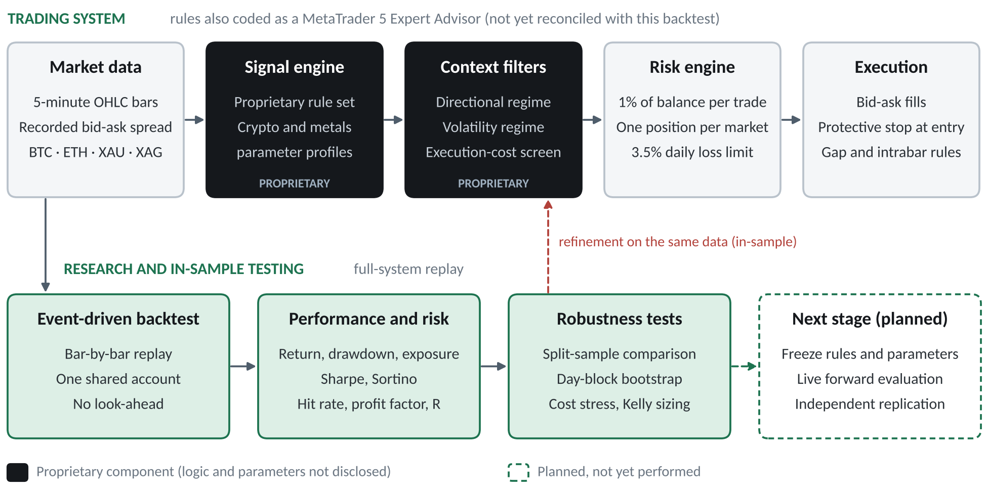
Figure 1. Research and system architecture. Dark components are proprietary and shown only by function. The dashed red arrow marks the in-sample refinement loop discussed in Section 5.7; the dashed green box marks validation steps that have not yet been performed.

2.2 Risk and portfolio rules
The risk rules are disclosed in full because they determine the risk profile:
- Fixed-fractional sizing. Each position is sized so that a fill at its protective stop loses 1% of the realized account balance; gains and losses compound.
- One position per market. No more than four positions can be open at once.
- Daily loss limit. New trades are blocked whenever the day's realized losses plus the open risk of all positions at their stops could exceed 3.5% of the day's opening balance. Price gaps can carry losses beyond the limit.
- Protective stops. Every order carries a stop from the moment of entry.

2.3 Backtest engine and execution model
Trades are replayed bar by bar, in chronological order, across all four markets in one shared account. Positions therefore overlap in time, compete for the daily loss limit and are sized from the same balance, as they would be in live operation. The execution model rests on four assumptions:
- Buys fill at the ask and sells at the bid, using the spread recorded for the entry bar throughout the trade. Recorded bar spreads can understate execution spreads, so costs are more likely understated than overstated.
- When a bar spans both the stop and another exit level, the stop is assumed to be hit first (a conservative convention). A price gap through any level fills at the bar's opening price, which is adverse for stops and favourable for other exits.
- Signal and filter inputs use only information available at the moment of entry (completed bars and the prevailing spread), so no future price information enters any decision.
- In the base case the only trading cost is the recorded spread. Commissions and slippage are stress-tested in Sections 5.5 and 6. Overnight financing is not modelled; depending on the broker's rollover time, 7–13% of trades were held through a daily rollover. Position sizes are not rounded to lot increments, and margin is not modelled.
The engine is deterministic: the same data reproduce every backtest figure for the evaluation window exactly.

2.4 Evaluation framework
Performance is measured on mark-to-market (MTM) equity, which values open positions at every five-minute close, and on the closed-trade balance. We report returns, drawdowns, daily and monthly return statistics, hit rate, profit factor, the mean trade result in R with a bootstrap confidence interval, annualized Sharpe (Sharpe, 1994) and Sortino (Sortino & Price, 1994) ratios of daily MTM returns, and exposure. Robustness is examined with a split-sample comparison, a day-block bootstrap (Efron & Tibshirani, 1993), cost stress tests and a Kelly (1956) analysis of position sizing. Appendix A defines each measure.

3. Data and testing period

3.1 Data
The study uses five-minute OHLC bars with a per-bar recorded spread for four CFDs (Bitcoin, BTCUSD; Ether, ETHUSD; gold, XAUUSD; silver, XAGUSD), exported from the broker's MetaTrader 5 terminal. Timestamps were converted from broker server time to a single reference time zone, which also defines the trading day for the daily loss limit and for daily and monthly statistics. Recorded spreads of zero indicate missing values rather than costless trading and were replaced with the market's median recorded spread; this affected 44.0% of Ether bars and no bars in the other markets. Table 1 summarizes the data and the market conditions over the window.
Table 1. Data and market conditions, 4 January – 30 September 2026
Market | Five-minute bars | Median spread (% of price) | Price change | Annualized volatility | Largest decline | Positive months
BTCUSD | 77,523 | 0.006% | −9.6% | 43.1% | 38.6% | 5 of 9
ETHUSD | 77,523 | 0.006% | −14.9% | 58.9% | 53.4% | 5 of 9
XAUUSD | 52,837 | 0.002% | −5.2% | 29.3% | 28.6% | 4 of 9
XAGUSD | 52,770 | 0.026% | −19.0% | 60.9% | 53.2% | 5 of 9
Equal-weight basket | – | – | −12.2% | – | – | 3 of 9
Price change from the 4 January to the 30 September daily close. Volatility from daily close-to-close returns (crypto-assets: all days, ×√365; metals: weekdays, ×√252). Largest decline: maximum peak-to-trough fall in daily closes. Equal-weight basket: equal amounts bought in each market at the 4 January close and held without rebalancing.

3.2 Testing period and its relevance
The evaluation window runs from the start of the current calendar year to the end of the last complete month before this paper was written: 1 January to 30 September 2026. The first three days of data initialize indicators, so the first trade could be opened on 4 January; the volatility-regime filter needed slightly more history and could not be applied to 15 of the first 16 trades (all before 8 January), which were allowed by default and netted +8.0R in total. One position opened late on 30 September and still open at the cut-off is excluded (it showed an unrealized loss of 0.7% of equity at the final close), and no data from October 2026 enter the performance results.
The window was chosen for three reasons. It is recent, so the results reflect current spreads, liquidity and volatility rather than older market structure. Its boundaries follow a calendar rule (year to date, through the last complete month) rather than start and end points chosen after seeing the results. And it contains only complete months, so every figure can be recomputed from a fixed historical sample.
The period was also demanding (Table 1). All four markets fell, by between 5.2% (gold) and 19.0% (silver), with peak-to-trough declines of 29–53% and annualized volatility of 29–61%. An equal-weight buy-and-hold basket of the four markets lost 12.2% and rose in only three of nine months (Figure 3). The program's results were therefore not the product of a uniformly rising market.

3.3 Evidential value
The results are tangible empirical evidence in a specific sense: they rest on documented observations (716 closed trades, each with timestamps, prices, size and outcome), a defined evaluation period, measurable outcomes in a single account, reproducible calculations from a deterministic engine, and standard quantitative performance and risk metrics. They do not establish future profitability. Nine months is a short sample from one market regime; the rules were developed and refined on this window; and there is as yet no live track record or independent replication. Sections 5.2, 5.7 and 7 quantify these limitations.

4. Empirical results
Table 2 summarizes the performance of the evaluated configuration, and Figure 2 shows its equity and drawdown paths.
Table 2. Performance summary, 4 January – 30 September 2026 (1% risk per trade, 3.5% daily loss limit, recorded spreads)
Returns and risk |  | Trades and exposure
Net return (9 months, not annualized) | +339.9% | Closed trades | 716
Maximum drawdown, MTM equity | 13.5% | Hit rate | 38.7%
Maximum drawdown, closed balance | 12.3% | Profit factor | 1.39
Lowest equity vs. starting capital | −1.0% | Mean trade result | +0.22R
Positive months | 9 of 9 | 95% bootstrap interval, mean | +0.11R to +0.34R
Best / worst month | +48.6% / +1.0% | t-statistic (two-sided p) | 3.70 (0.0002)
Positive weeks | 30 of 40 | Longest losing streak | 11 trades
Annualized volatility (daily MTM) | 50.3% | Largest single-trade loss | −1.9% of equity
Sharpe ratio, annualized (s.e.) | 4.2 (1.2) | Time with a position open | 41.7%
Sortino ratio, annualized | 8.4 | Gross exposure, median / max | 1.6× / 18.2×
Net return ÷ maximum drawdown | 25.3 | Correlation with each market | 0.01 to 0.03
R = amount risked per trade. Sharpe and Sortino ratios from 270 daily MTM returns, zero risk-free rate, ×√365; standard error after Lo (2002). Monthly returns on the closed-trade balance; on an MTM basis all nine months are also positive. Gross exposure is the notional value of open positions divided by equity while at least one position is open; correlations use daily returns.
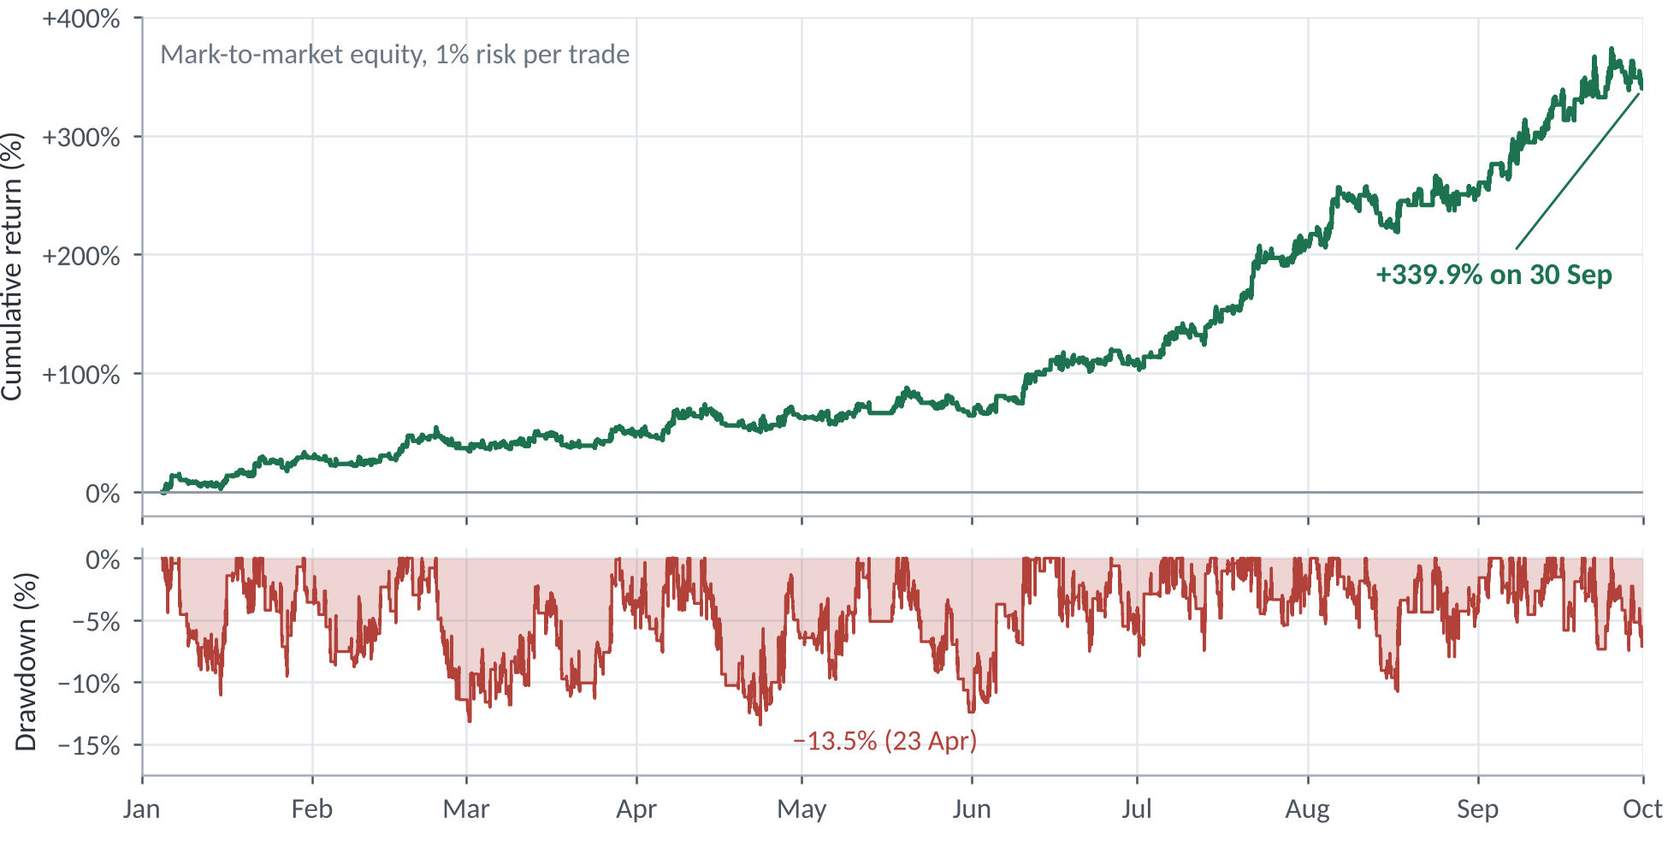
Figure 2. Cumulative return of mark-to-market equity (top) and drawdown from the running equity peak (bottom), 4 January – 30 September 2026, 1% risk per trade. The final value excludes one position still open at the cut-off (unrealized loss of 0.7% of equity).
Equity rose in every month, though not smoothly (Figure 2). The largest drawdown, 13.5% on an MTM basis, ran from 13 April to 23 April and was recovered by 11 May; the longest spell below a previous equity high lasted 33 days. Equity never fell more than 1.0% below starting capital, but this reflects early gains rather than low risk: five separate drawdowns exceeded 10%. Monthly returns ranged from +1.0% in May to +48.6% in July (Figure 3). Because sizing compounds, later months contributed more in dollar terms; the account more than doubled between the end of June and the end of September.
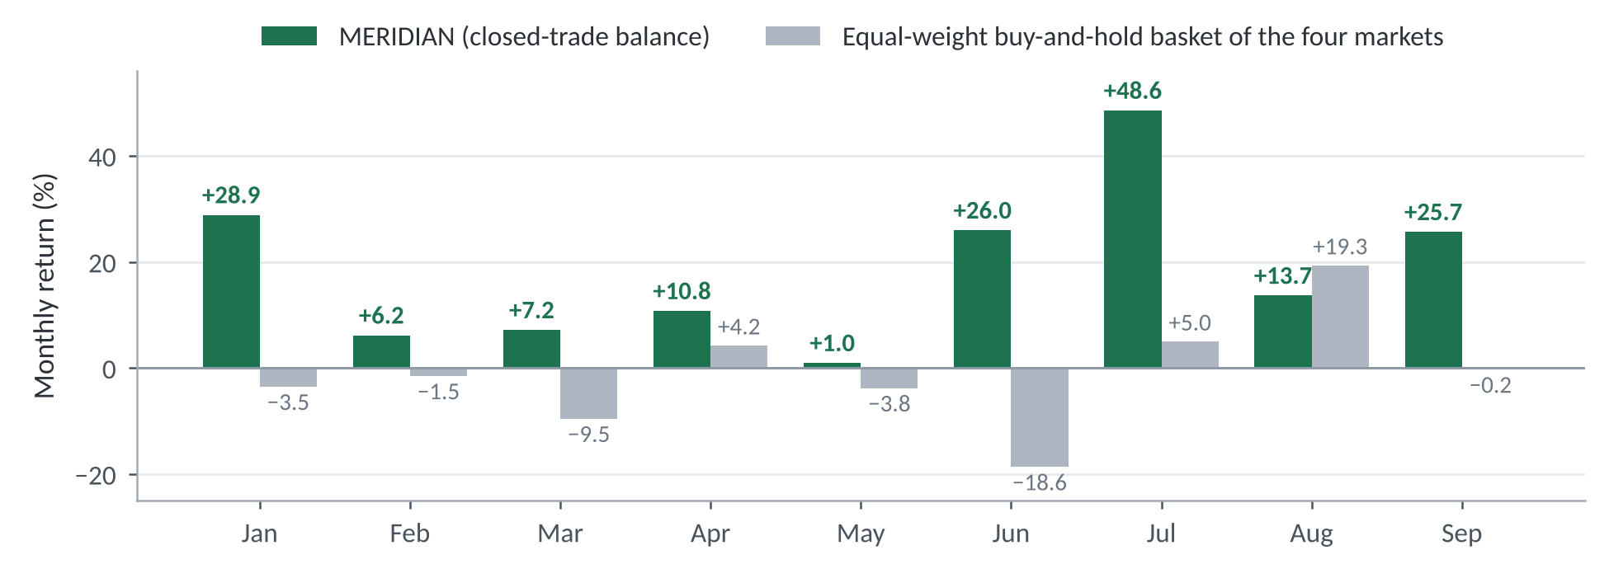
Figure 3. Monthly returns of MERIDIAN (closed-trade balance) and of an equal-weight buy-and-hold basket of the four markets.
Table 3. Profit attribution by market, asset class and trade direction
Segment | Trades | Profit factor | Contribution to return (pp) | Share of net profit
Bitcoin | 280 | 1.44 | +137.0 | 40.3%
Ether | 268 | 1.22 | +67.2 | 19.8%
Gold | 117 | 1.69 | +119.0 | 35.0%
Silver | 51 | 1.20 | +16.6 | 4.9%
Crypto-assets | 548 | 1.33 | +204.2 | 60.1%
Precious metals | 168 | 1.53 | +135.6 | 39.9%
Long trades | 356 | 1.37 | +161.4 | 47.5%
Short trades | 360 | 1.40 | +178.4 | 52.5%
All trades | 716 | 1.39 | +339.9 | 100.0%
Contribution = segment net profit as a percentage of starting capital; each grouping sums to the total return (differences due to rounding).
All four markets and both trade directions were profitable (Table 3). Bitcoin and gold generated 75% of net profit; silver contributed 4.9% from 51 trades, the fewest of any market. Long and short trades contributed similar amounts with near-identical profit factors (1.37 and 1.40), and daily returns were essentially uncorrelated with each underlying market (0.01 to 0.03) and with the equal-weight basket (0.03). Together with the falling markets in Table 1, this is consistent with returns arising from the trading rules rather than from directional market exposure.

5. Risk and robustness analysis

5.1 Volatility, drawdown and exposure
At 1% risk per trade the program is volatile: annualized volatility of daily MTM returns was 50.3%, the worst day −5.3% and the worst week −6.8% (against the day's opening balance the largest intraday loss was 3.3%, within the daily limit; the day-to-day figure also includes unrealized gains given back). Risk scales almost linearly with the risk setting: at 0.25% per trade the same signals give 12.6% volatility, a 3.5% maximum drawdown and a +47.8% return, with an essentially unchanged Sharpe ratio (4.25 versus 4.24). The account had at least one open position 41.7% of the time and two or more 13.5% of the time. Gross notional exposure while positioned had a median of 1.6× equity, a 95th percentile of 5.9× and a maximum of 18.2×, and 55% of crypto-asset trades required more than 2× equity at entry (median 2.2×). The program therefore could not be run as tested under retail leverage caps such as the 2:1 limit for crypto-asset CFDs introduced by ESMA (2018) and since applied by national regulators. The largest single-trade loss was 1.9% of equity, when price gapped through a stop.

5.2 Statistical significance
The mean trade result of +0.22R has a t-statistic of 3.70 (two-sided p = 0.0002, conservative for the one-sided H1) and a bootstrap 95% interval of +0.11R to +0.34R, so H1 is supported in-sample before adjustment for the development search. No formal adjustment has been made. The t-statistic exceeds the threshold of 3.0 that Harvey, Liu and Zhu (2016) suggest for new findings in a heavily mined literature, but a Bonferroni correction for the 577,920 exploratory backtests would require t > 5.35 (t > 4.63 for the 13,440 parameter settings alone), against about 2.0 for a single pre-specified test. Because the configurations tested are strongly correlated, the appropriate threshold lies in between and has not been estimated, so the result cannot be called statistically significant after adjusting for the search. Likewise, the annualized Sharpe ratio of 4.2 has a standard error of about 1.2 (Lo, 2002) and should be expected to be lower out of sample (Bailey & López de Prado, 2014).

5.3 Consistency across sub-periods
Run separately from the same starting capital, the first half of the sample (January–June, 466 trades) returned +107.1% with a 13.5% maximum drawdown, and the second (July–September, 250 trades) returned +107.6% with a 10.8% drawdown (Table 4). The second half did so in three months rather than six and with a higher profit factor (1.50 versus 1.26). This is a split-sample consistency check, not an out-of-sample test: both halves were used during development, and the final filter was chosen partly because it improved both halves (Section 5.7). Together with Table 3, it supports H2 in-sample only.
Table 4. Robustness checks (1% risk per trade)
Test | Return | Max. drawdown | Trades | Comment
Full period | +339.9% | 13.5% | 716 | Profit factor 1.39
First half (Jan – Jun) | +107.1% | 13.5% | 466 | Profit factor 1.26
Second half (Jul – Sep) | +107.6% | 10.8% | 250 | Profit factor 1.50
Bootstrap, median history | +229.8% | 20.0% † | – | 2,000 resampled histories
Bootstrap, adverse case | +67.0% (5th pct.) | 32.2% † (95th pct.) | – | 3 of 2,000 lost money
Extra cost of 0.05R per trade | +205.8% | 14.8% | 714 | 8 of 9 months positive
Extra cost of 0.10R per trade | +116.9% | 18.1% | 713 | 6 of 9 months positive
Extra cost of 0.15R per trade | +54.7% | 23.8% | 710 | 6 of 9 months positive
Break-even extra cost | 0.0% | – | – | About 0.21R per trade
Drawdowns are mark-to-market except † (closed-trade balance). Each half starts from the same capital. Extra cost is deducted from the result of every trade.
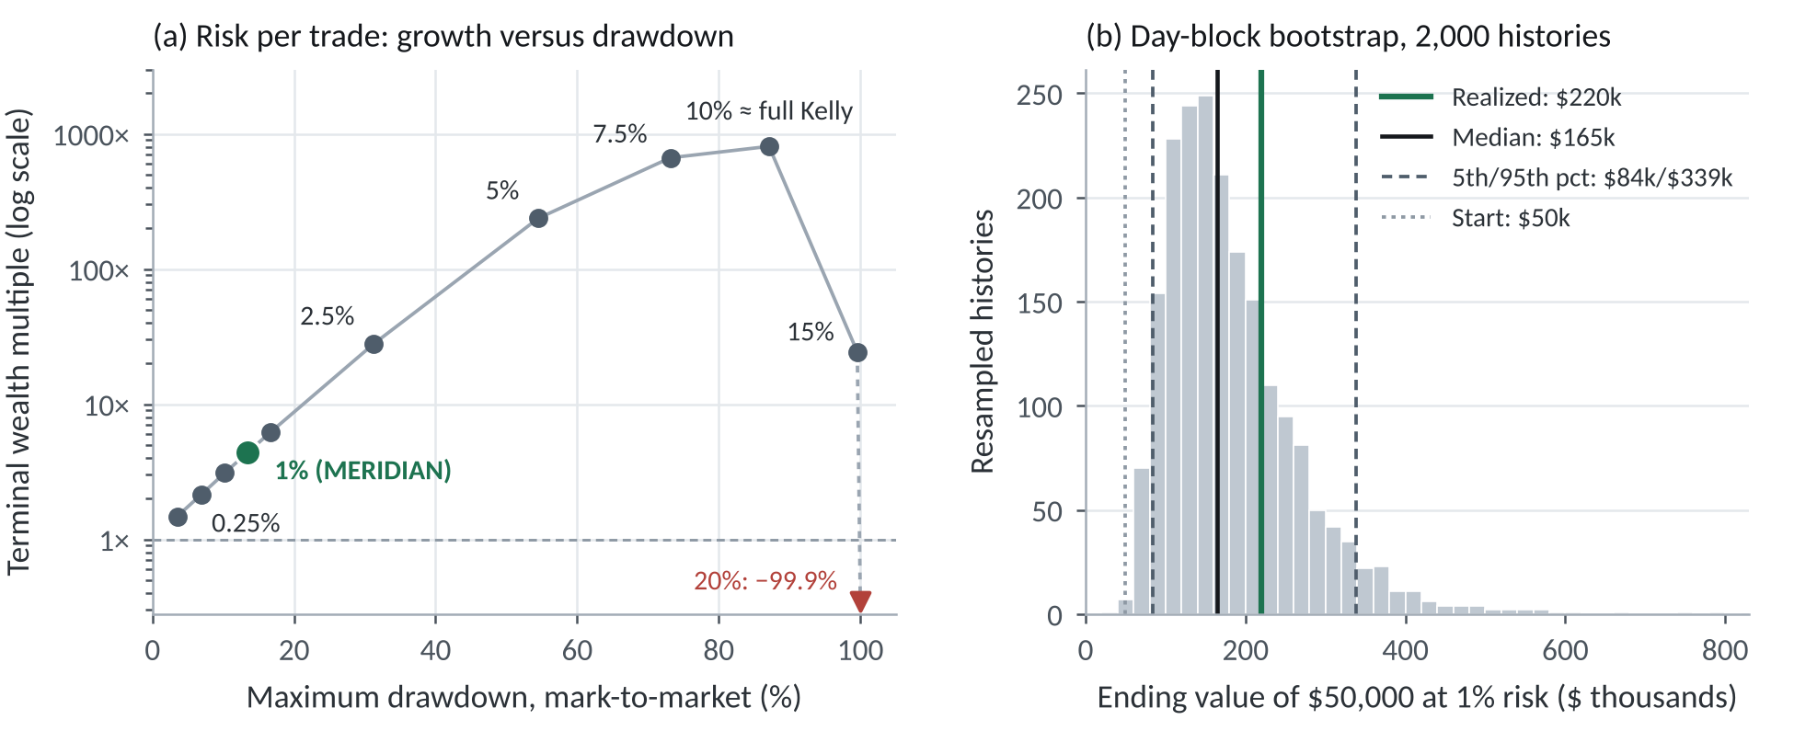
Figure 4. (a) Terminal wealth multiple against maximum MTM drawdown when the same signals are replayed at different risk-per-trade settings, with the daily loss limit at about 3.5 times the risk setting. The backtest has no margin model; higher settings need proportionally larger exposures and are shown only to locate the growth-optimal point. (b) Ending value of $50,000 at 1% risk across 2,000 day-block bootstrap histories (all histories shown).

5.4 Resampling
To test dependence on the particular sequence of events, we generated 2,000 alternative histories by resampling calendar days with replacement, keeping each day's trades together to preserve clustering across markets, and re-ran the full account simulation with all risk rules (Figure 4b). The median outcome was +229.8%, the 5th percentile +67.0% and the 95th percentile +577.1%; 3 of 2,000 histories (0.15%) ended below starting capital. The median closed-balance drawdown was 20.0% and the 95th percentile 32.2%, against 12.3% in the realized history, so the realized drawdown lies at the favourable end of the distribution and a drawdown of about 20% should be regarded as typical for this configuration. Because the histories reuse the in-sample trades, they measure sensitivity to the sequence of events, not the probability of a loss in future trading.

5.5 Trading costs
Recorded spreads cost a median of 0.013R per trade on the trades taken, so the smallest stress test, 0.05R, is about 3.8 times the recorded cost. Additional costs reduce returns materially but eliminate them only when large: an extra 0.05R per trade lowers the return to +205.8%, 0.10R to +116.9% and 0.15R to +54.7%, and the return reaches zero at about 0.21R per trade, close to the entire mean trade result. Commission scenarios for a zero-spread account are shown in Section 6.

5.6 Position sizing
The growth-optimal (full Kelly) risk per trade estimated from the empirical trade distribution is 10.0% (bootstrap 5th–95th percentile: 5.3%–14.5%), so the 1% setting is about one-tenth of full Kelly. Figure 4a shows the trade-off when the same signals are replayed at other risk settings: terminal wealth peaks near full Kelly, but with an 87% drawdown; beyond that point growth falls sharply, drawdowns approach 100% and the 20% setting loses 99.9% of capital despite the positive edge. Fractional Kelly sizing of this kind gives up growth in exchange for drawdown control and robustness to estimation error (MacLean, Thorp & Ziemba, 2011). MERIDIAN's higher-risk configuration (5% per trade with a 20% daily limit) recorded a 56.0% maximum drawdown and a −12.5% month over the same period.

5.7 Development history and selection risk
The evaluated configuration (version 6.2) is the product of iterative refinement on this sample, which is the main threat to the validity of the results. Over the same period, the version in use before this research began (5.7) returned +94.3% with a 25.9% maximum drawdown, and the version without the volatility-regime filter (6.1) returned +206.9% with an 18.9% drawdown and only six of nine months positive (worst month −3.9%; January–June +48.6%). That filter was selected from 41 candidates, partly because it improved results in both halves of the sample, and its settings were chosen after a sensitivity analysis on the same data; it was rarely active after June. The month-by-month and split-sample consistency reported above is therefore partly a product of selection. Earlier, an exploratory grid of 13,440 parameter settings, each combined with up to nine rule variations, was run on five markets using all data then available (early January to 7 October 2026, split at 1 July; the fifth market was later dropped because of its trading costs), and 28.2% of the 577,920 backtests were profitable in both sub-periods. These figures indicate the breadth of the search and hence the scope for selection bias.

6. Capital illustration: $50,000 starting capital
All figures in this section are hypothetical: they apply the backtest's trade sequence to a $50,000 starting balance and are neither live results nor projections; no live trading results are reported in this paper. Risk is 1% of the realized balance per trade with full reinvestment and no deposits, withdrawals, fees or taxes; position sizes are unrounded, margin is not modelled and overnight financing is excluded. Because sizing is proportional, simulated results scale linearly with capital; in practice, lot-size rounding and broker limits cause small deviations. Scenario B's commission ($3.50 per side per $100,000 of notional, or 0.0035%) is common for raw-pricing FX accounts; schedules for crypto-asset and metals CFDs vary and can be considerably higher, as Scenario C illustrates.
Table 5. Hypothetical $50,000 account, 4 January – 30 September 2026
Scenario | Cost assumption | Ending value | Return | Max. drawdown
A. Backtest as tested | Recorded spreads | $219,933 | +339.9% | 13.5%
B. Zero-spread account | Commission 0.0035% per side | $212,396 | +324.8% | 14.3%
C. B with higher commission | Commission 0.01% per side | $149,762 | +199.5% | 15.4%
D. A with execution slippage | Extra 0.10R per trade | $108,434 | +116.9% | 18.1%
E. A without compounding | Fixed $500 risk per trade | $127,006 | +154.0% | 10.6% †
F. A, resampled: median | Recorded spreads | $164,892 | +229.8% | 20.0% †
5th / 95th percentile |  | $83,512 / $338,537 | +67.0% / +577.1%
Drawdowns are mark-to-market except † (closed-trade balance). Scenario A month-end values: Jan $64,433; Feb $68,427; Mar $73,383; Apr $81,333; May $82,175; Jun $103,550; Jul $153,920; Aug $175,000; Sep $219,933. At 0.025% commission per side the ending value would be $61,164 (+22.3%) with a 28.9% drawdown.
Under the backtest's own cost model, $50,000 grows to $219,933 (Scenario A), compounding the monthly returns in Figure 3; Figure 5 shows the path. In the zero-spread commission account (Scenario B), commissions total $21,245 and the ending value is $212,396; removing the spread also lets more trades pass the execution-cost screen (790 rather than 716). Commission rates matter: at 0.01% per side the ending value falls to $149,762, and at 0.025% to $61,164. Without compounding, a fixed $500 risk per trade ends at $127,006, so compounding accounts for about 55% of Scenario A's gain. The resampled distribution (Scenario F) gives a more conservative central estimate than the realized path.
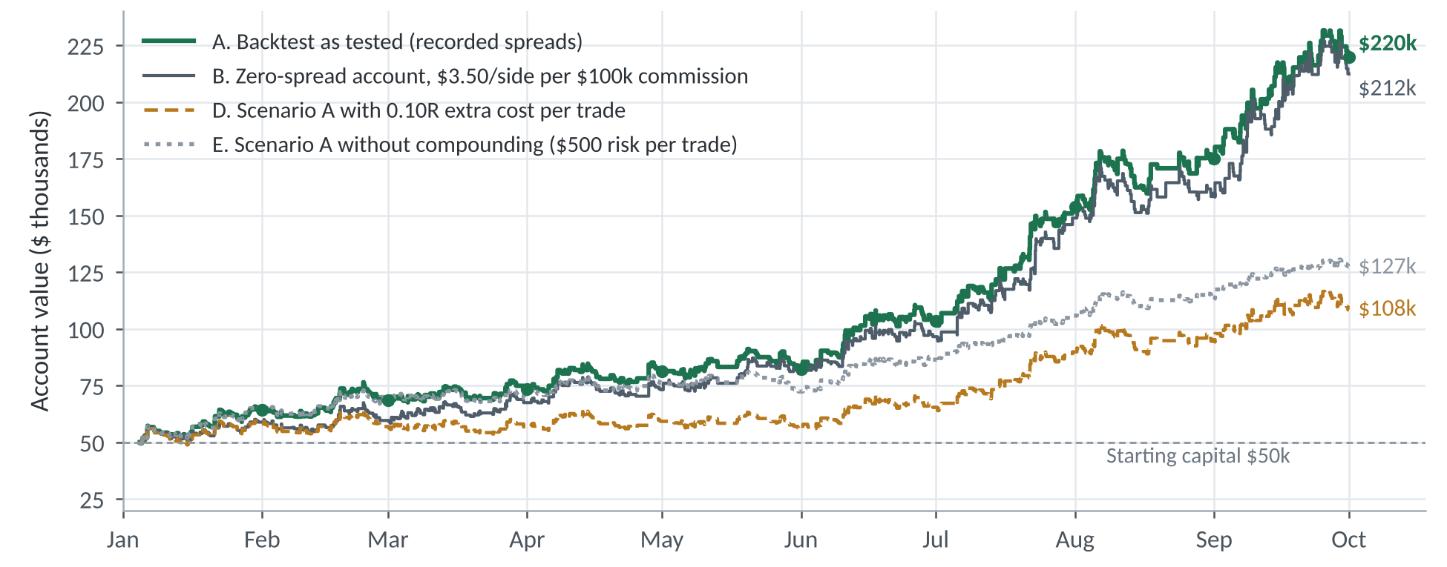
Figure 5. Hypothetical growth of $50,000 (closed-trade balance) under the cost assumptions of Table 5; Scenario C is omitted for clarity. Dots mark Scenario A month-end values.

7. Limitations and conclusion
- In-sample evidence and selection bias. Rules, parameters and filters were developed and selected on this window after an extensive search, and the final filter was chosen partly for its consistency across the two halves (Section 5.7). Reported performance is therefore an optimistic estimate of future performance (Bailey et al., 2014; Harvey & Liu, 2015).
- Short, regime-specific sample. Nine months and 716 trades give limited statistical power, and a period of falling prices and high volatility in all four markets may not represent other regimes.
- Execution model. Five-minute bars cannot resolve the order of events within a bar, and recorded bar spreads may understate execution spreads. Slippage, commissions, overnight financing, partial fills, requotes and latency are excluded from the base case; position sizes are unrounded and margin is not modelled.
- Implementation. The MetaTrader 5 code has not been reconciled with this backtest, and at full size more than half of crypto-asset trades needed leverage above 2:1, which retail rules in some jurisdictions do not permit.
- Data. Results rely on one broker's CFD price feed, which may differ from exchange prices and from other brokers; 44.0% of Ether bars required spread imputation.
- Concentration. Bitcoin and gold produced 75% of net profit, and the program trades only four markets in two asset classes.
- No live or independent verification. There is as yet no live track record and no third-party replication.
Within the evaluation window, the evidence is consistent with both hypotheses: a positive mean trade result after recorded spreads (H1), although not one that can be called significant after adjusting for the development search, and profitability spread across sub-periods, markets and trade directions (H2), partly as a result of how the final filter was chosen. The maximum drawdown was 13.5% at 1% risk per trade (12.3% on a closed-balance basis), at the favourable end of the resampled range (typically about 20% and about 32% in an adverse case, also closed-balance), and the program made money in a period when all four underlying markets fell. These findings are encouraging but provisional. The appropriate next steps are to freeze the rule set and parameters at a documented date no earlier than the date of this paper; to run the frozen system forward on live or paper accounts and report it with the metrics used here; to reconcile the MetaTrader 5 implementation with this backtest; to replace modelled costs with the executing broker's actual commissions, financing and slippage; and to invite independent replication under a confidentiality agreement. Only performance accumulated after the freeze date can provide out-of-sample evidence.

References
Bailey, D. H., Borwein, J. M., López de Prado, M., & Zhu, Q. J. (2014). Pseudo-mathematics and financial charlatanism: The effects of backtest overfitting on out-of-sample performance. Notices of the American Mathematical Society, 61(5), 458–471.
Bailey, D. H., & López de Prado, M. (2014). The deflated Sharpe ratio: Correcting for selection bias, backtest overfitting, and non-normality. Journal of Portfolio Management, 40(5), 94–107.
Efron, B., & Tibshirani, R. J. (1993). An Introduction to the Bootstrap. Chapman & Hall.
ESMA (European Securities and Markets Authority) (2018). Decision (EU) 2018/796 of 22 May 2018 to temporarily restrict contracts for differences in the Union. Official Journal of the European Union, L 136, 1 June 2018.
Harvey, C. R., & Liu, Y. (2015). Backtesting. Journal of Portfolio Management, 42(1), 13–28.
Harvey, C. R., Liu, Y., & Zhu, H. (2016). … and the cross-section of expected returns. Review of Financial Studies, 29(1), 5–68.
Kelly, J. L. (1956). A new interpretation of information rate. Bell System Technical Journal, 35(4), 917–926.
Lo, A. W. (2002). The statistics of Sharpe ratios. Financial Analysts Journal, 58(4), 36–52.
MacLean, L. C., Thorp, E. O., & Ziemba, W. T. (Eds.) (2011). The Kelly Capital Growth Investment Criterion: Theory and Practice. World Scientific.
Sharpe, W. F. (1994). The Sharpe ratio. Journal of Portfolio Management, 21(1), 49–58.
Sortino, F. A., & Price, L. N. (1994). Performance measurement in a downside risk framework. Journal of Investing, 3(3), 59–64.

Appendix A. Definitions
R: the amount at risk on a trade, i.e. the loss if the protective stop is filled at its level. A result of +1R gains the amount risked.
Hit rate: share of closed trades with a positive result. Profit factor: gross profits divided by gross losses.
Mean trade result: average result in R (expectancy). Its interval is a percentile bootstrap over trades (10,000 resamples).
MTM equity: balance plus the value of open positions at each five-minute close. Maximum drawdown: largest percentage decline from a running peak.
Sharpe ratio: mean divided by standard deviation of daily MTM returns, ×√365, zero risk-free rate. Sortino ratio: mean divided by downside deviation, ×√365.
Kelly fraction: the risk per trade that maximizes mean logarithmic growth over the empirical distribution of trade results.
Contribution (pp): segment net profit as a percentage of starting capital.

Appendix B. Important disclosures
This paper presents hypothetical (simulated) performance from a backtest. Hypothetical results have inherent limitations: they are prepared with the benefit of hindsight, do not represent actual trading and may not reflect market factors such as liquidity, slippage and execution quality. No representation is made that any account will or is likely to achieve results similar to those shown. CFDs are leveraged products and carry a high risk of rapid loss. This document is for research and information purposes only and is not investment advice, or an offer or solicitation to buy or sell any financial instrument. The MERIDIAN trading rules, parameters and source code are proprietary and are not disclosed. The figures were produced by Meridian's research process and have not been audited or independently verified. Conflict of interest: the author developed the MERIDIAN program and is affiliated with Meridian, which may benefit commercially from its use.

