Explanation to Required Scenarios

# The Database Spaghetti

## Entity Relation Diagram

The dataset we have generated has multiple extra tables and inconsistent transaction storage. As we can see there are four different client tables when there should be one and on other tables attributes are missing and unconnected. Similarly for receipts tables there is duplication and unnecessary merging. On top of all this the shady business is also kept track of but in vague and unconventional ways. These are face value problems in the structure of the database, along with these there are also data entry errors and null values.

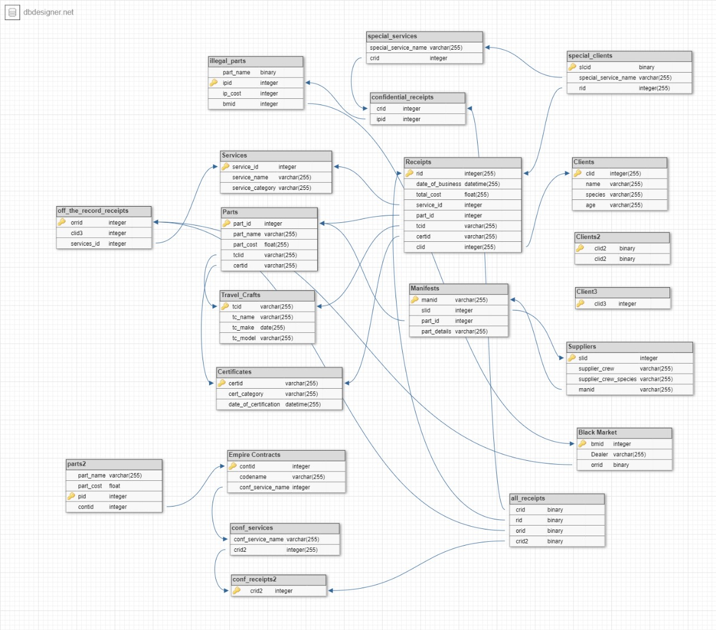

## Assumption made in creating tables

During the early process of generating data for OLTP we identified different spacecrafts from multiple sci-fi franchises like Star Wars, Star Trek, Dune and more. We considered our company (Void’s Infirmary) as an interuniversal services company which was able to jump universes to provide parts and services to the imaginative land of Disney and the dystopia future of the world of star trek. We also have suppliers from multiple fictional universes as well. While creating data for clients we made sure to include characters from each universe having roles small or big.

# Design Diagram of Pipeline

To extract data from OLTP for analysis, we set up an Airflow server through which we were able to set schedules for generating OLAP cubes over a required period of time. Although we did not utilize this schedule due to time constraints in submission. Here is the diagram for the functions executing the ETL pipeline for our PowerBI Dashboard.