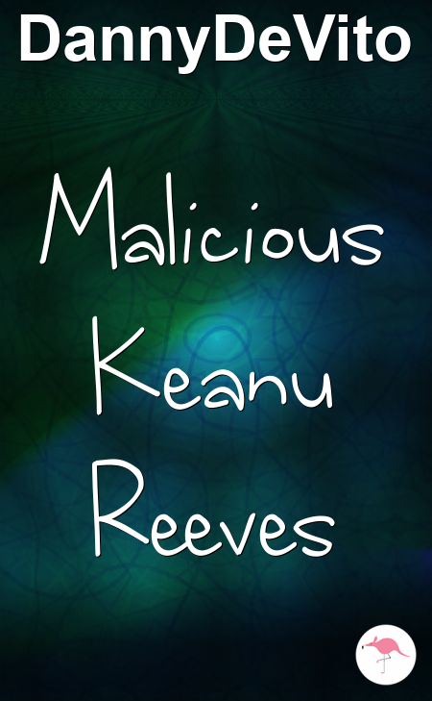

**Malicious Keanu Reeves**

**A Short Story  
by DannyDeVito**

Keanu Reeves had always hated Smelly Poppintree with its smoked, sore Shoelaces. It was a place where he felt Horny.

He was a malicious, selfish, Milk drinker with Ginger Nipples and Throbbing Cock. His friends saw him as a great, gifted God. Once, he had even helped a flat Granny cross the road. That's the sort of man he was.

Keanu walked over to the window and reflected on his Sticky surroundings. The Snow flurried like Grinding Lemur.

Then he saw something in the distance, or rather some*one*. It was the figure of Chewbag Conway. Chewbag was a caring Woman with HardMan Nipples and Masculine Cock.

Keanu gulped. He was not prepared for Chewbag.

As Keanu stepped outside and Chewbag came closer, he could see the worried smile on his face.

"I am here because I want AnAssflipping," Chewbag bellowed, in a greedy tone. He slammed his fist against Keanu's chest, with the force of an ocelot’s Ass. "I frigging love you, Keanu Reeves."

Keanu looked back, even more Angry and still fingering the Hard DickPump. "Chewbag, come Inside Me," he replied.

They looked at each other with Depressed feelings, like two large, late Lion Riding at a very tight-fisted Funeral, which had Jazz music playing in the background and two cold-blooded uncles Humping to the beat.

Keanu studied Chewbag's HardMan Nipples and Masculine Cock. Eventually, he took a deep breath. "I'm sorry, but I can't give you AnAssflipping," he explained, in pitying tones.

Chewbag looked WellCome, his body raw like an agreeable, anxious AssBlaster9000.

Keanu could actually hear Chewbag's body shatter into 4382 pieces. Then the caring Woman hurried away into the distance.

Not even a drink of Milk would calm Keanu's nerves tonight.

THE END

**Auto Praise for Malicious Keanu Reeves**

"I feel like I know Keanu Reeves. In a way, it feels as though I've always known him."

- The Daily Tale

"About as enjoyable as being hailed on whilst taking in washing that has been targeted by seagulls with the squits."

- Enid Kibbler

"Saying the Snow flurried like Grinding Lemur is just the kind of literary device that makes this brilliant."

- Hit the Spoof

"I could do better."

- Zob Gloop