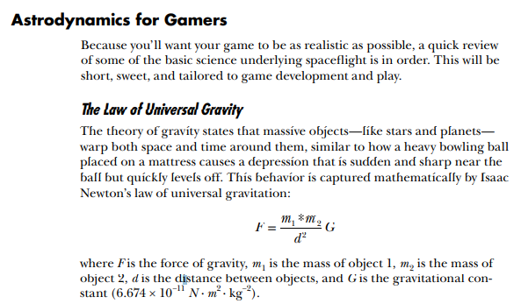

Two objects pull on each other according to the product of their masses divided by the square of the distance between them. So, gravity is much stronger when objects are close together, like the deep bowing of the mattress just beneath the bowling ball. To illustrate, a 220-pound (100 kg) man would weigh over half a pound less on top of Mt. Everest than he would at sea level, where he would be 8,848 m closer to the center of Earth. (This assumes the mass of the planet is 5.98 × 1024 kg and sea level is 6.37 × 106 m from the center.)

Today, we generally think of gravity as a field—like the mattress in the bowling ball analogy—rather than as Newton’s point of attraction. This field is still defined with Newton’s law and results in acceleration, usually expressed in m/sec2 .

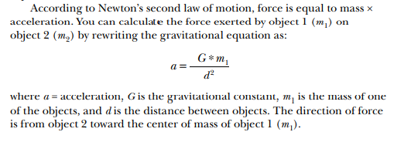

The pull of very small objects on large ones is generally ignored. For example, the force exerted by a 1,000 kg satellite on Mars is about 1.6 × 10–21 times smaller than the force exerted by Mars on the satellite! Thus, you can safely ignore the satellite’s mass in your simulation.

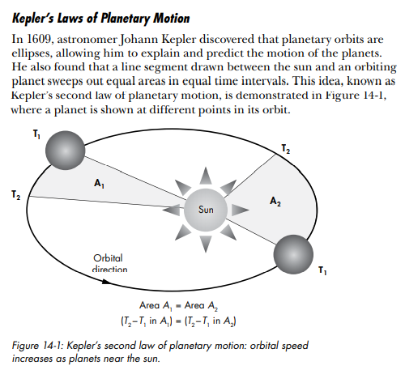

This law applies to all celestial bodies, and it means that an orbiting object speeds up as it gets close to the body it is orbiting and slows down as it travels farther away.

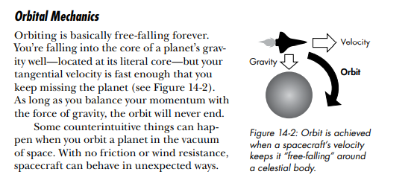

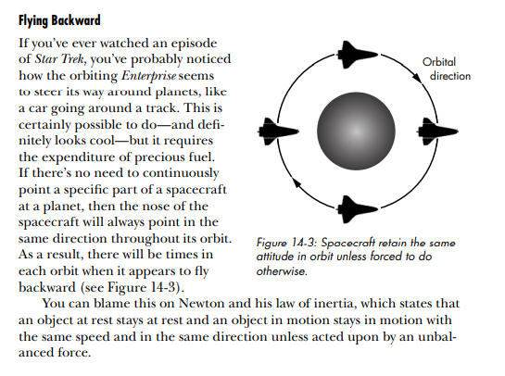

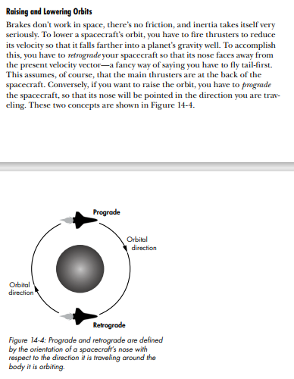

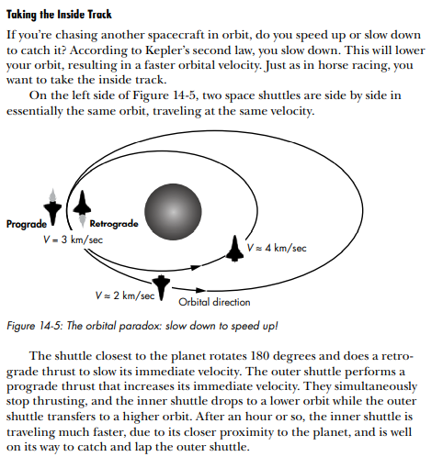

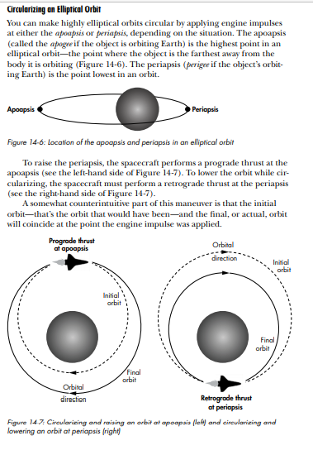

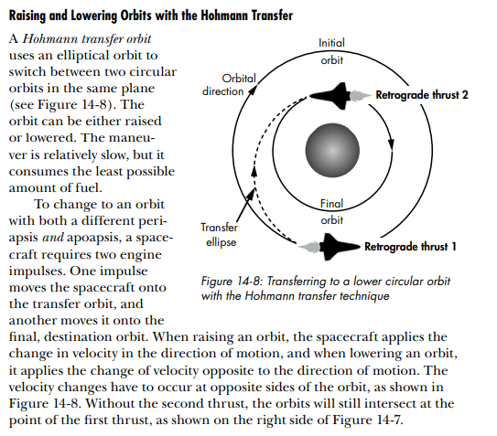

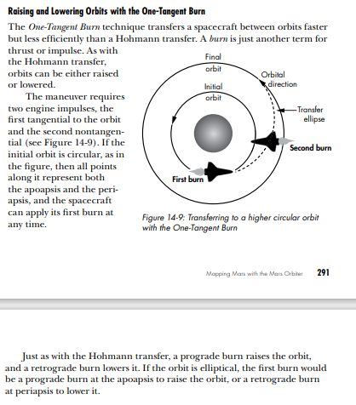

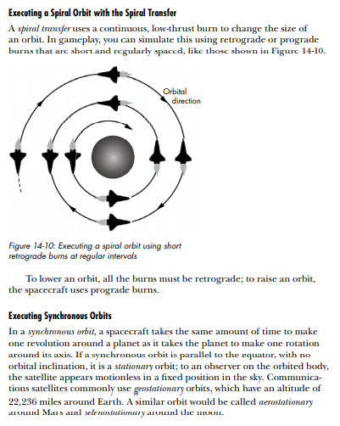

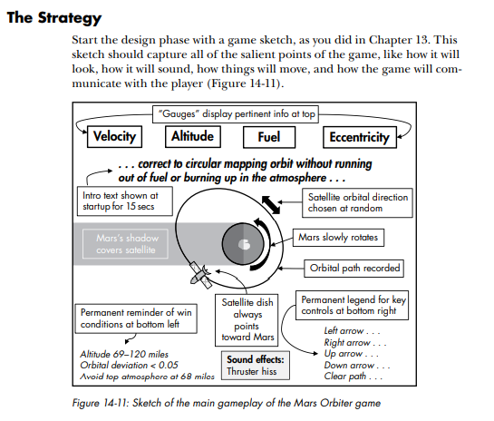

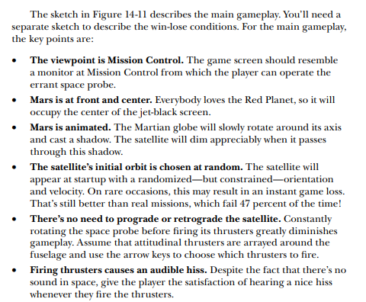

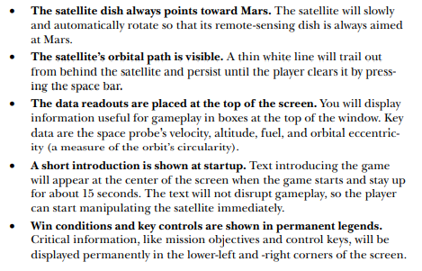

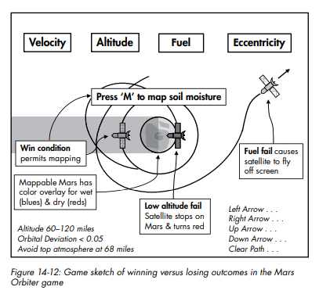

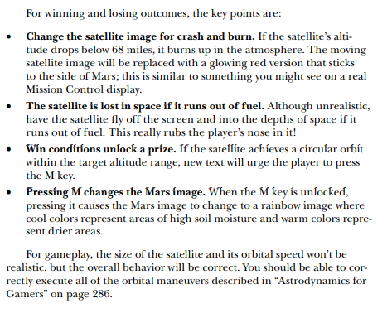

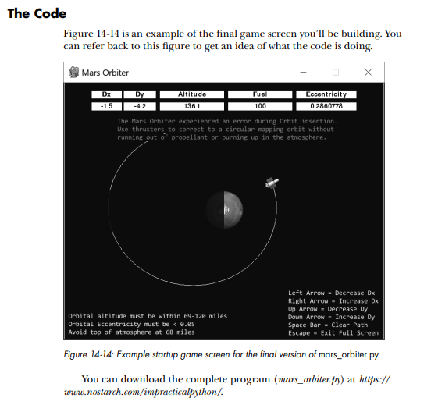

LEFT OFF AT 325