**Digital security access system**

**By: M. Hassan**

**Musa bin Abdullah**

**Sadia khan**

**Somal ata Baloch**

**Contents**

1 Chapter 1: Introduction 3

1.1 INTRODUCTION 3

1.2 BACKGROUND 4

1.3 OBJECTIVES 5

1.4 Scope 6

1.5 Summary 7

2 Chapter 2: Design 11

2.1 Components required 11

2.1.1 Arduino 11

2.1.2 16`2 led display. 11

2.1.3 4`4 keypad 11

2.1.4 Micro servo 11

3 Chapter 3: Simulation 17

4 Chapter 4: Conclusion 25

4.1 References 25

**Title**

Digital security access system

**Abstract**

This project involves designing a digital code lock system using an Arduino and a keypad. As thefts continue to rise, security has become a major concern. With this system, you can secure your home or locker easily. The circuit design includes components like a keypad, Arduino, and a servo motor for locking and unlocking the door. The user inputs a password via the keypad, and if it matches the predefined code, the servo motor activates to open the door.

# **Chapter 1: Introduction**

## **INTRODUCTION**

Introduction to Digital Door Lock Systems

A digital door lock system is a modern alternative to traditional mechanical locks. Instead of using physical keys, these systems rely on electronic components to control access. They offer enhanced security, convenience, and features like customizable access levels. Let’s explore the key points:

1. **Purpose**

* Security: Protects homes, offices, or other spaces from unauthorized entry.
* Convenience: Eliminates the need for physical keys.
* Audit Trail: Keeps a record of who accessed the door.

1. **Components**

* Arduino
* 16`2 led display.
* 4`4 keypad
* Servo motor

1. **Usability and Benefits**

* Ease of Use: No physical keys to carry.
* Customizable Access: Assign different PINs to users.
* Enhanced Security: Difficult to pick or tamper with digital locks.
* Audit Trail: Keeps track of access history.

1. **Process**

* Initialization: Install the lock mechanism, connect components, and program the microcontroller.
* User Interaction: Enter a PIN; if valid, the lock releases.

## **BACKGROUND**

Digital Door Lock Systems: A Brief Overview

Digital door lock systems have become increasingly popular due to their convenience, security, and modern features. These locks replace traditional mechanical keys with electronic components, offering various methods of access control. Here are some key points about digital door locks:

1. **Early Innovations**

* The concept of digital door locks dates back to the mid-20th century. Early versions used punch cards, magnetic stripe cards, or numeric codes for access.
* However, these systems were often bulky, expensive, and limited in functionality.

1. **Keypad-Based Locks**

* Keypad-based digital locks gained prominence in the 1980s and 1990s.
* Users could enter a PIN (Personal Identification Number) on a numeric keypad to unlock the door.
* These locks were commonly used in commercial settings and high-security areas.

1. **Wireless Communication**

* Many digital locks use wireless communication protocols such as Bluetooth, Wi-Fi, or Zigbee.
* This allows seamless connectivity and easy integration with other smart devices.

1. **Smart Locks**

* Smart locks integrate with home automation systems and the Internet of Things (IoT).
* They can be controlled remotely via smartphones, tablets, or voice assistants.

1. **Features include**

* Remote Access: Lock or unlock the door from anywhere.
* Temporary Access: Grant access to guests or service providers for a specific period.
* Activity Logs: Monitor who enters and exits.
* Auto-Locking: Locks automatically after a set time.

## **OBJECTIVES**

1. **Enhanced Security**

* The primary objective of digital door locks is to enhance security. Unlike traditional locks, which rely on physical keys, digital locks use electronic signals for access control.
* Features like biometric authentication (such as fingerprints or retinal scans) and secure PIN codes provide robust security against unauthorized entry.

1. **Convenience and Ease of Use**

* Digital door locks offer convenience and ease of use. Users can unlock doors without fumbling for keys.
* Imagine scenarios:
* Smartphone Unlock: As a person approaches the front entrance with arms full of shopping, the door lock identifies their smartphone and unlocks instantly.
* Temporary Access: When away from home, users can grant access to relatives, friends, guests, or service providers by simply texting them a code.

1. **Remote Access**

* Digital locks can be controlled remotely via smartphones or other devices.
* Whether you’re at work, on vacation, or anywhere with internet access, you can lock or unlock your door as needed.

1. **Privacy and Security Considerations**

* Ensuring privacy and security in IoT systems (including smart door locks) is crucial.
* Authentication mechanisms, encryption, and secure communication protocols are essential components.

1. **Innovation and Future Trends**

* The goal is continuous improvement. Expect innovations in voice recognition, gesture-based access, and AI-driven features.
* Smart digital locks will evolve to meet changing needs and technological advancements.

## **Scope**

1. **Better Security**

* Digital door locks are like supercharged versions of regular locks.
* They use cool stuff like fingerprints or secret PIN codes to keep your home safe.
* Imagine it’s like having a secret handshake with your door!

1. **Easy of use**

* No more juggling keys when you’re carrying groceries!
* With digital locks, you can just tap your phone to unlock the door.
* It’s like magic, but with less hocus-pocus.

1. **Custom Access**

* Want your friend to visit? Give them a special code.
* And if someone loses their code, no worries—you can change it easily.

1. **Battery Backup**

* These locks run on batteries, so they won’t nap during a power outage.
* When the battery gets low, they politely ask for a recharge.

## **Summary**

Digital door locks are modern replacements for traditional mechanical locks. They offer enhanced security, convenience, and customization. Here’s what you need to know:

1. **Security Boost**

* Digital locks use biometrics (like fingerprints) or PIN codes for access.
* Say goodbye to lost keys and hello to personalized security.

1. **Easy-Access**

* No more juggling keys—just tap your phone or enter a code.
* It’s like having a secret handshake with your door.

1. **Custom Control**

* You decide who gets in.
* Temporary codes for guests? Check. Easy-changes? Double-check.

1. **Battery Backup**

* Even during power outages, digital locks keep you covered.
* Low-battery warnings ensure you’re never locked out.

1. **Future-Ready**

* Wi-Fi, Bluetooth, and Ultra-Wideband are the cool kids on the block.
* AI might join the party, making your lock even smarter.

**Real life implementation of digital door lock system**

1. **Real-Time Smart Door Lock System Using Image Detection and Voice Recognition:**

* Another approach involves using image detection and voice recognition for smart door locks2.
* Voice Commands: Users can lock and unlock the door using voice commands.
* Facial Recognition: The system also supports facial recognition via an Android app.
* This combination of technologies provides convenience and security.

1. **IoT-Based Smart Door Lock System with Keypad Authentication:**

* An IoT-based smart door lock system was designed to enhance security and convenience3.
* Keypad Authentication: Users can authenticate themselves using a keypad.
* Remote Control via Smartphone App: The system allows users to control access remotely through a smartphone app.

**Applications Of Digital Door Lock Systems**

Digital door lock systems have a wide range of applications, offering enhanced security, convenience, and smart features. Here are some common scenarios where digital door locks are used:

1. **Residential Homes:**

* Keyless Entry: Digital door locks eliminate the need for physical keys. Homeowners can use PIN codes, biometrics (such as fingerprints), or smartphone apps to unlock their doors.
* Remote Access: With Wi-Fi-enabled locks, homeowners can remotely control and monitor their doors using a smartphone app. This is especially useful for granting access to guests or service providers when you’re away.
* Integration with Smart Home Systems: Digital locks can integrate with other smart home devices, such as security cameras, lights, and thermostats.

1. **Commercial Buildings and Offices:**

* Access Control: Digital locks allow businesses to manage access for employees, contractors, and visitors. Access can be restricted based on time of day or specific user roles.
* Audit Trails: Many digital locks maintain logs of who entered and exited the building. This audit trail enhances security and accountability.

# **Chapter 2: Design**

The design is shown in the figure below

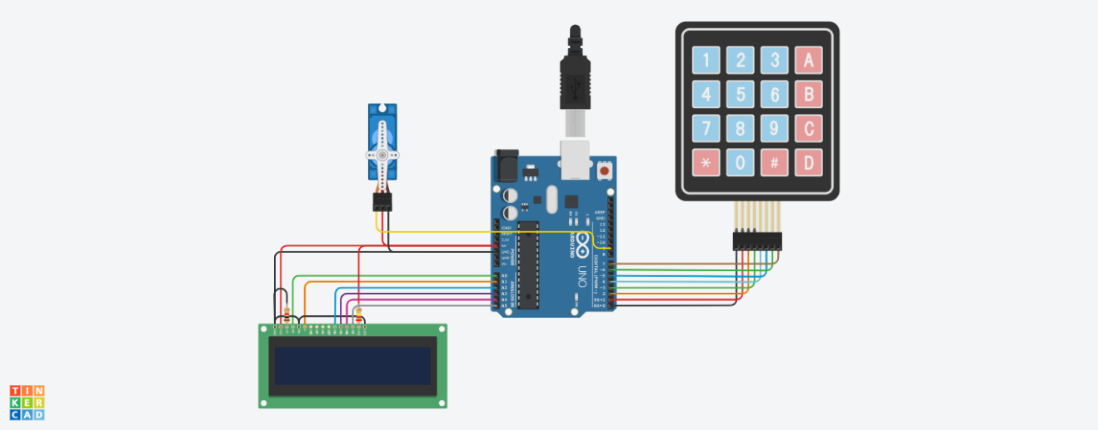

## **Components required**

It consists of four parts:

### Arduino

### 16`2 led display.

### 4`4 keypad

### Micro servo

* Arduino uno r3

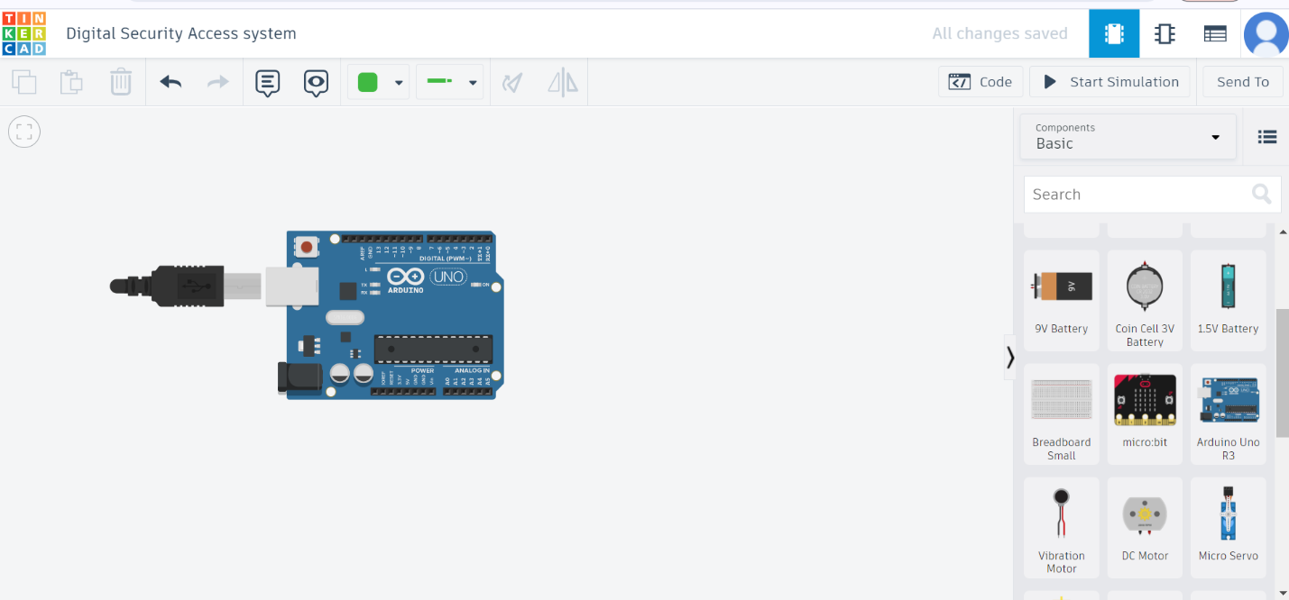

* LCD

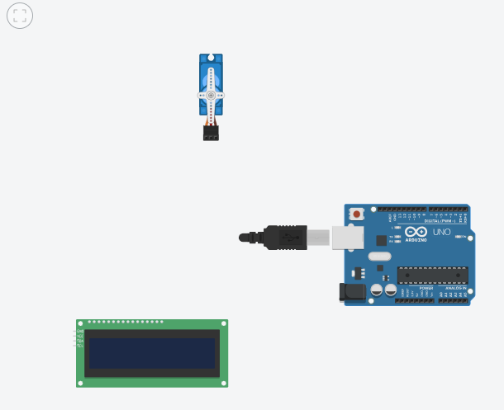

* Keypad

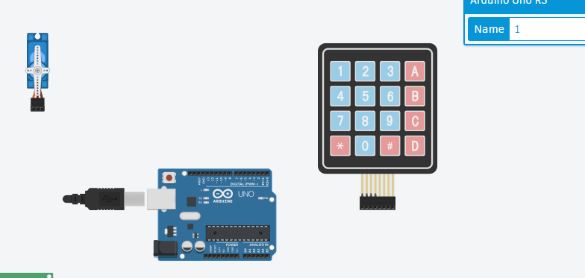

* Micro servo

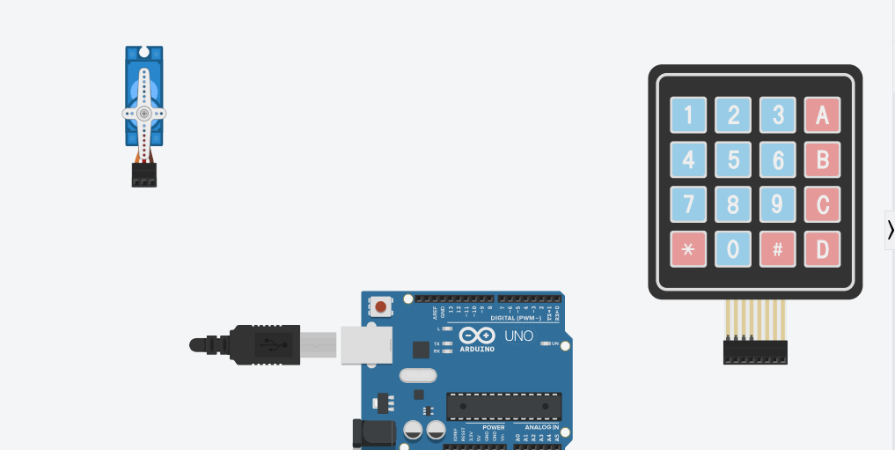

**Validation logic**

First, we took an Arduino and attached it to the keypad as per wire shown in the figure below.

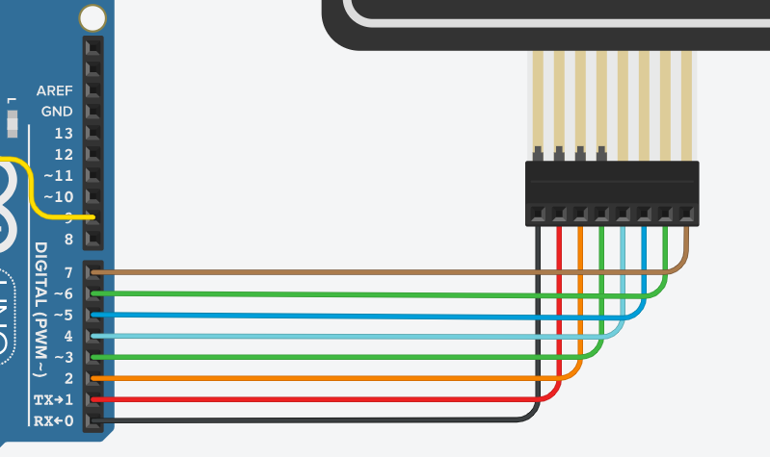

* Secondly, we connect the board to a power source.

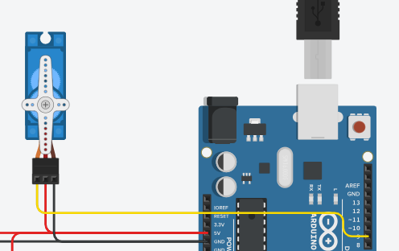

* Thirdly, we used two resistors as first is of 1 resistance and second is of 220 resistances in the connection of led display and resistors.

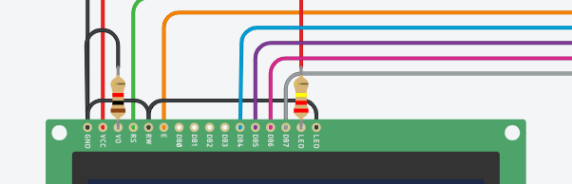

* Fourthly, we connected the Arduino and the Led display.

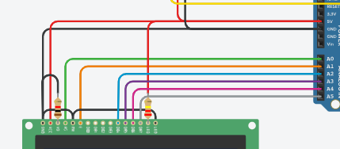

# **Chapter 3: Simulation**

The software consists of c++ language coding which is as following.

Code:

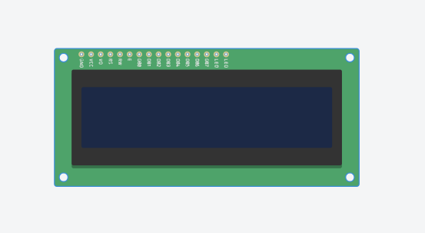#include <Keypad.h>

#include <LiquidCrystal.h>

#include <Servo.h>

#define Password_Length 5

Servo myservo;

LiquidCrystal lcd(A0, A1, A2, A3, A4, A5);

int pos = 0;

char Data[Password_Length];

char Master[Password_Length] = "1234";

byte data_count = 0, master_count = 0;

bool Pass_is_good;

bool door = false;

char customKey;

/*---preparing keypad---*/

const byte ROWS = 4;

const byte COLS = 4;

char keys[ROWS][COLS] = {

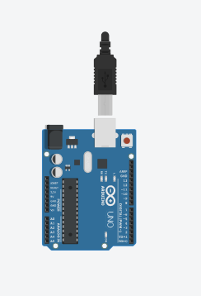 {'1', '2', '3', 'A'},

{'4', '5', '6', 'B'},

{'7', '8', '9', 'C'},

{'*', '0', '#', 'D'}

};

byte rowPins[ROWS] = {0, 1, 2, 3};

byte colPins[COLS] = {4, 5, 6, 7};

Keypad customKeypad( makeKeymap(keys), rowPins, colPins,

ROWS, COLS);

/*--- Main Action ---*/

void setup()

{

myservo.attach(9, 2000, 2400);

ServoClose();

lcd.begin(16, 2);

lcd.print("Protected Door");

loading("Loading");

lcd.clear();

}

void loop()

{

if (door == true)

{

customKey = customKeypad.getKey();

if (customKey == '#')

{

lcd.clear();

ServoClose();

lcd.print("Door is closed");

delay(3000);

door = false;

}

}

else

Open();

}

void loading (char msg[]) {

lcd.setCursor(0, 1);

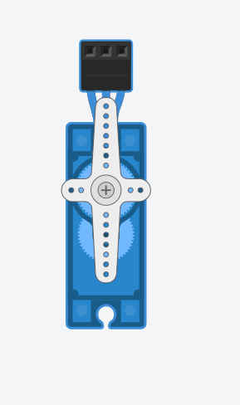 lcd.print(msg);

for (int i = 0; i < 9; i++) {

delay(1000);

lcd.print(".");

}

}

void clearData()

{

while (data_count != 0)

{

Data[data_count--] = 0;

}

return;

}

void ServoClose()

{

for (pos = 90; pos >= 0; pos -= 10) {

myservo.write(pos);

}

}

void ServoOpen()

{

for (pos = 0; pos <= 90; pos += 10) {

myservo.write(pos);

}

}

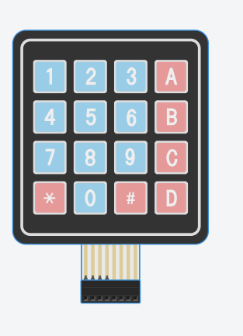void Open()

{

lcd.setCursor(0, 0);

lcd.print("Enter Password");

customKey = customKeypad.getKey();

if (customKey)

{

Data[data_count] = customKey;

lcd.setCursor(data_count, 1);

lcd.print(Data[data_count]);

data_count++;

}

if (data_count == Password_Length - 1)

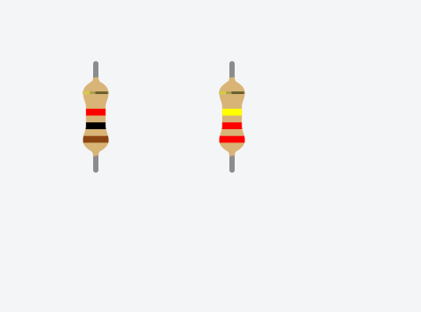 {

if (!strcmp(Data, Master))

{

lcd.clear();

ServoOpen();

lcd.print(" Door is Open ");

door = true;

delay(5000);

loading("Waiting");

lcd.clear();

lcd.print(" Time is up! ");

delay(1000);

ServoClose();

door = false;

}

else

{

lcd.clear();

lcd.print(" Wrong Password ");

door = false;

}

delay(1000);

lcd.clear();

clearData();

}

}

**Explanation:**

Basically, it is a c++ code which determines whether the code inserted in the security system.

Correct Code:

**1234**

* If the code is incorrect than the security system will not allow access to.

**Stimulation:**

The circuit ask the user to enter the password as shown in the figure.

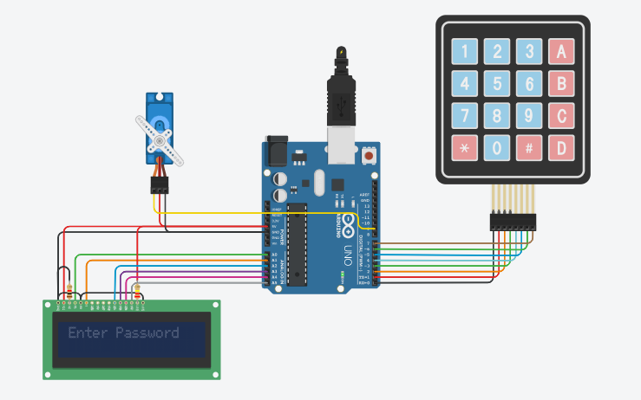

Now we enter the password and if it is verified correct then:

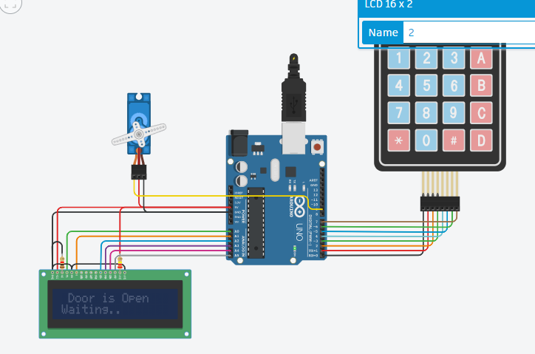

If wrong, then it asks again:



# **Chapter 4: Conclusion**

1. **Smart Door Locks**

* Smart door locks offer a blend of security and convenience. They leverage technological advancements to enhance ease, utility, and safety.

1. **Benefits of smart door locks include**

* Instant unlocking when the lock identifies the user’s smartphone as they approach the door.
* Easy access management by texting access codes to relatives, friends, guests, or service providers.
* Monitoring door activity remotely, such as receiving notifications when someone opens the door.

1. **How Electronic Door Locks Work**

* Electronic door locks use authentication and verification processes.
* Upon successful authentication, the lock grants access, unlocking the door.
* If access is denied, the lock remains secured, preventing unauthorized entry.
* Advantages of Smart Door Locks:
* Enhanced security: Smart locks provide better protection than traditional locks.
* Convenience: Users can manage access remotely and receive notifications.

## **References YouTube Link** https://youtu.be/58jFAammYcw?si=WwCZt4e4hTNOFaxf

**Link:**

https://www.tinkercad.com/things/dcKg4wmoMCz-security-lock/editel?sharecode=LbwPK-1pgDpa-rbL3gXDSwjXNXH3jR_O7PHxg7LULfI