

INVENTORY MANAGEMENT SYSTEM

Visual Programming project





BS Computer Science

Section: B

Group: 9

**Roll no:**

* Muhammad Danial (233588)
* Musa bin Abdullah (233576)
* Abdullah Altaf (233558)

**Database Report:**

**Products:**

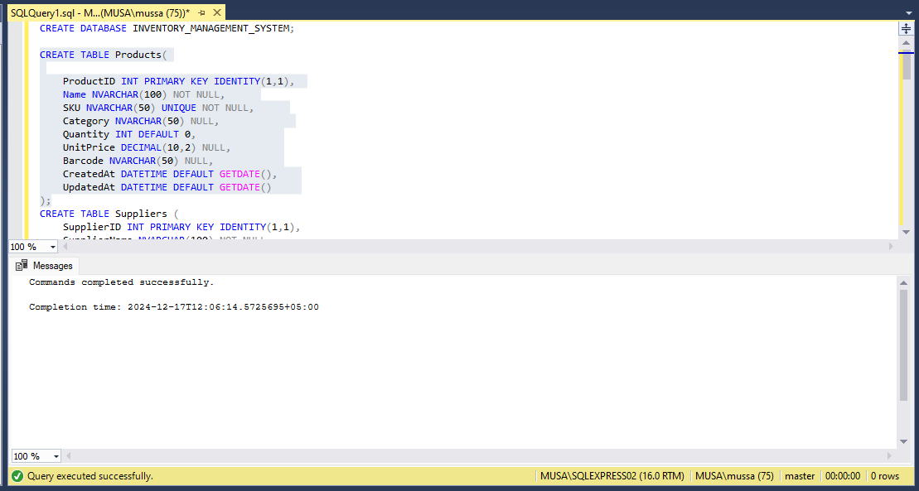

**Suppliers:**

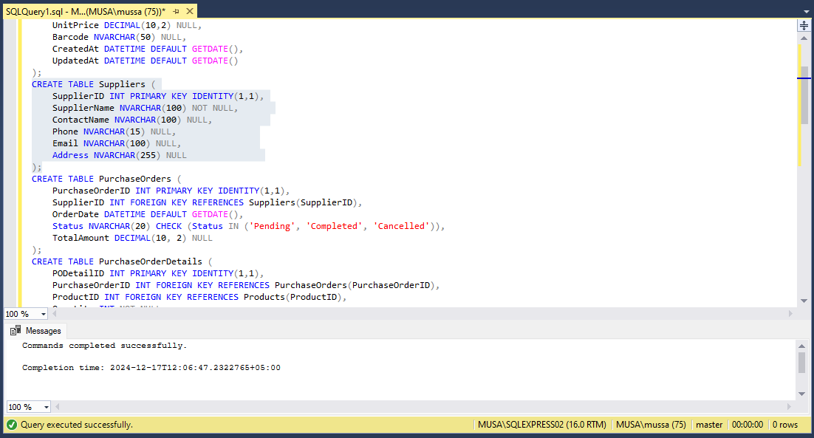

**Purchase Orders:**

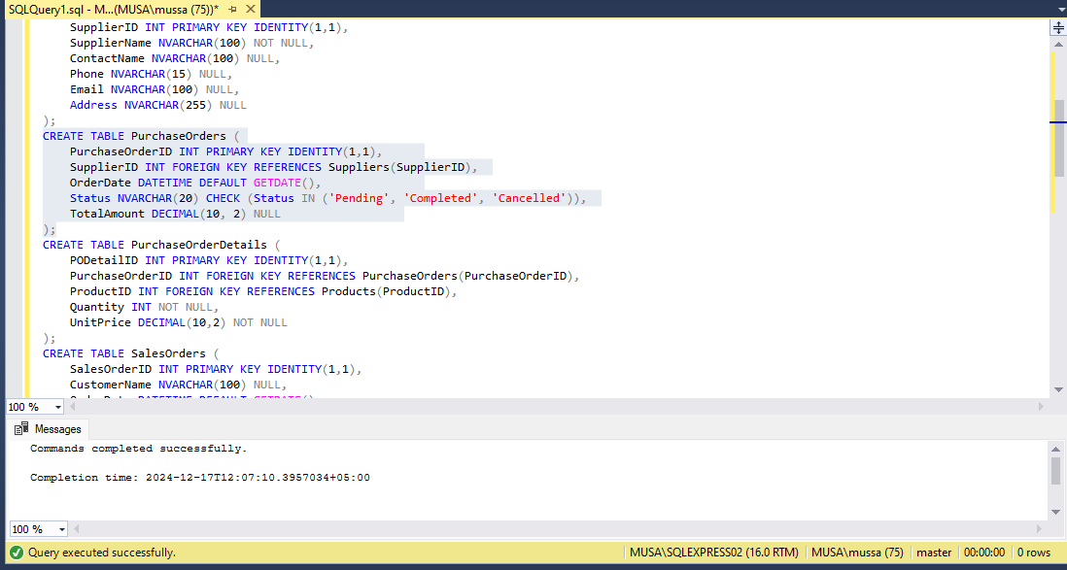

**PurchaseOrderDetails:**

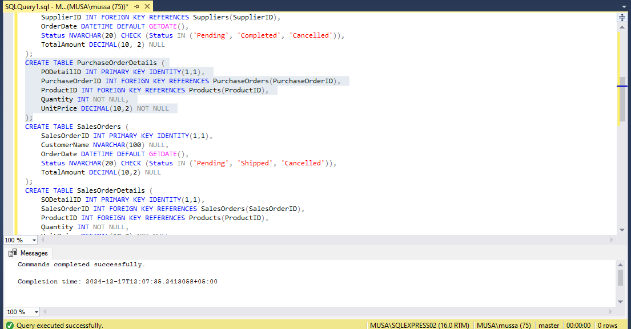

**Sales Orders:**

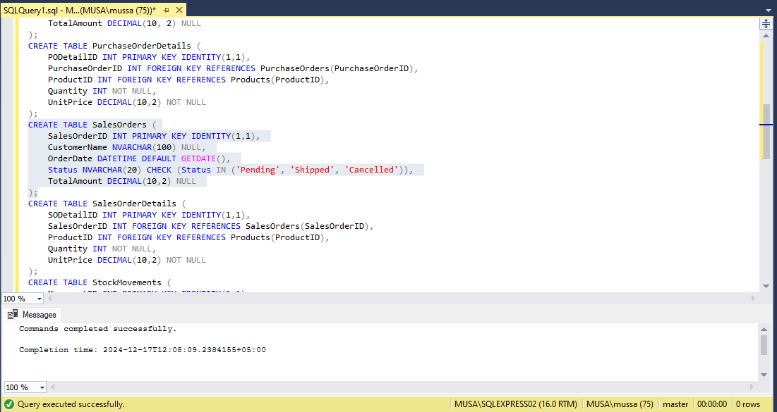

**SalesOrderDetails:**

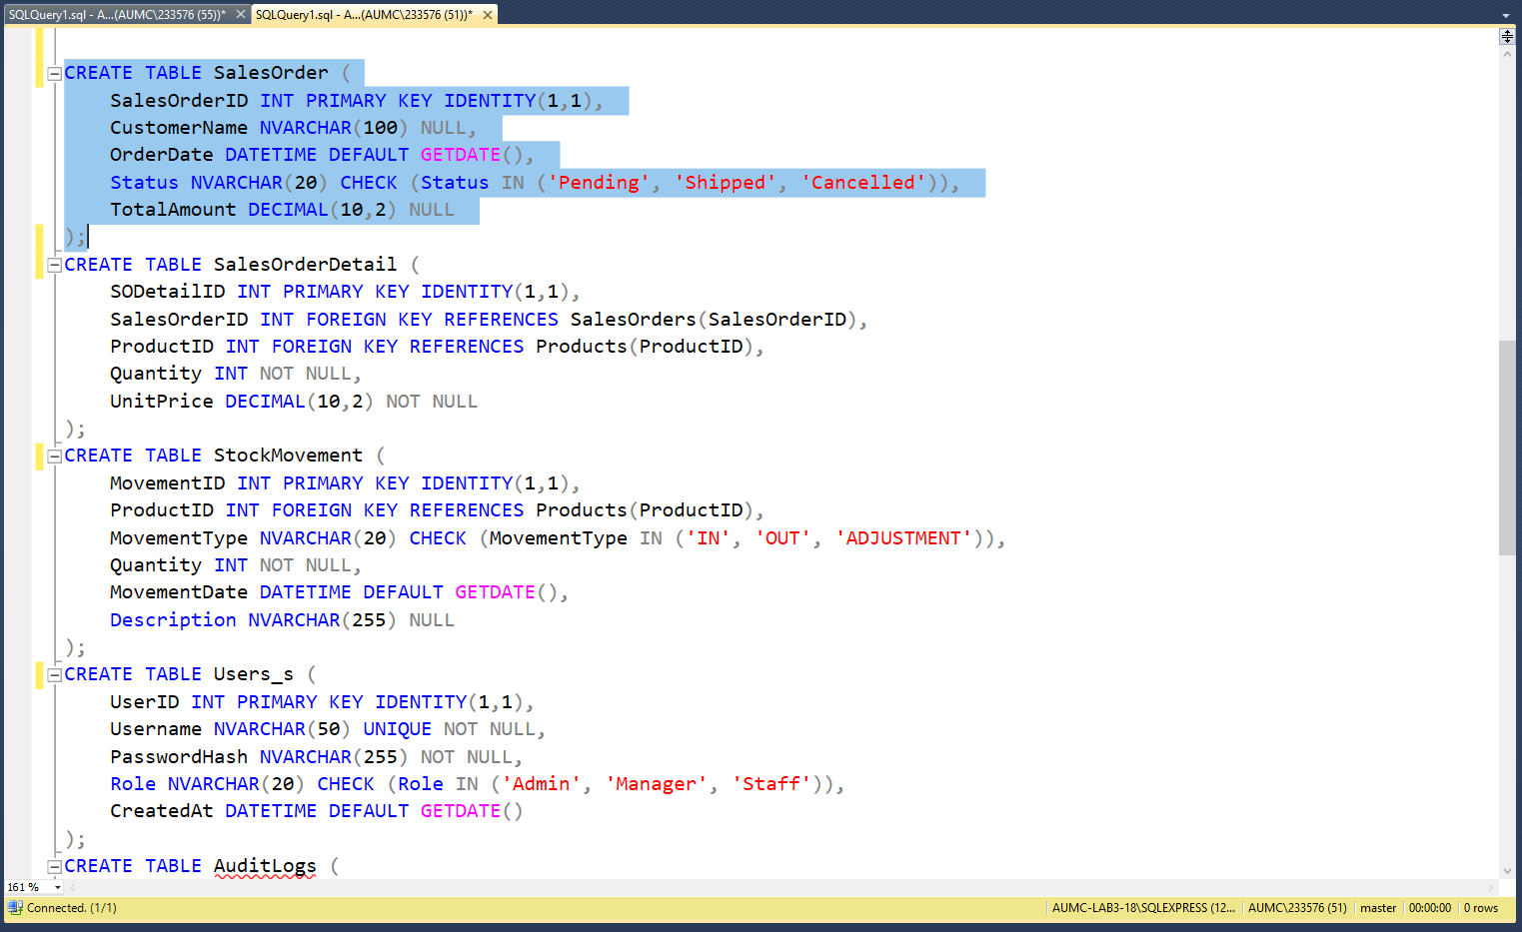

**Stock Movements:**

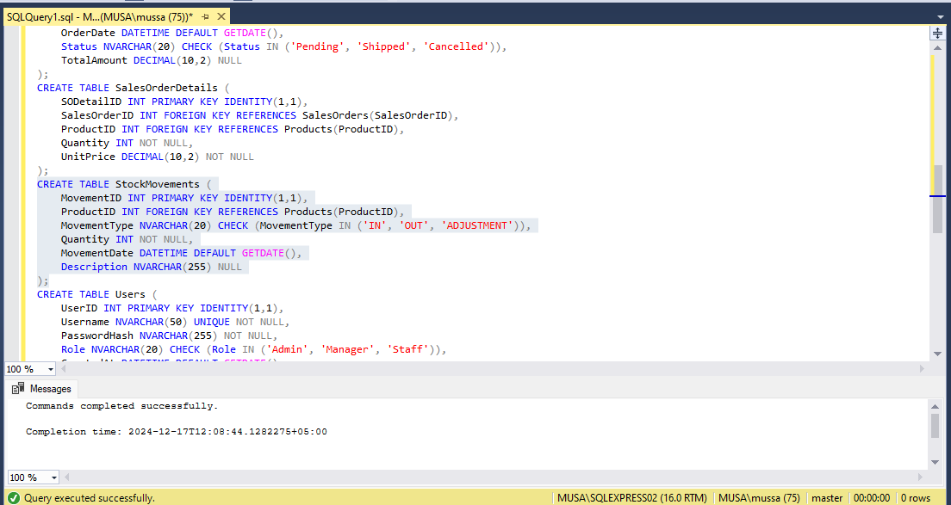

**Users:**

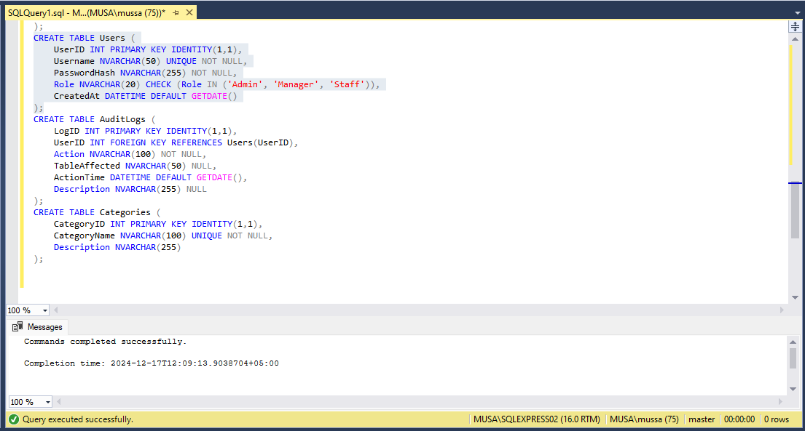

**Audit Logs:**

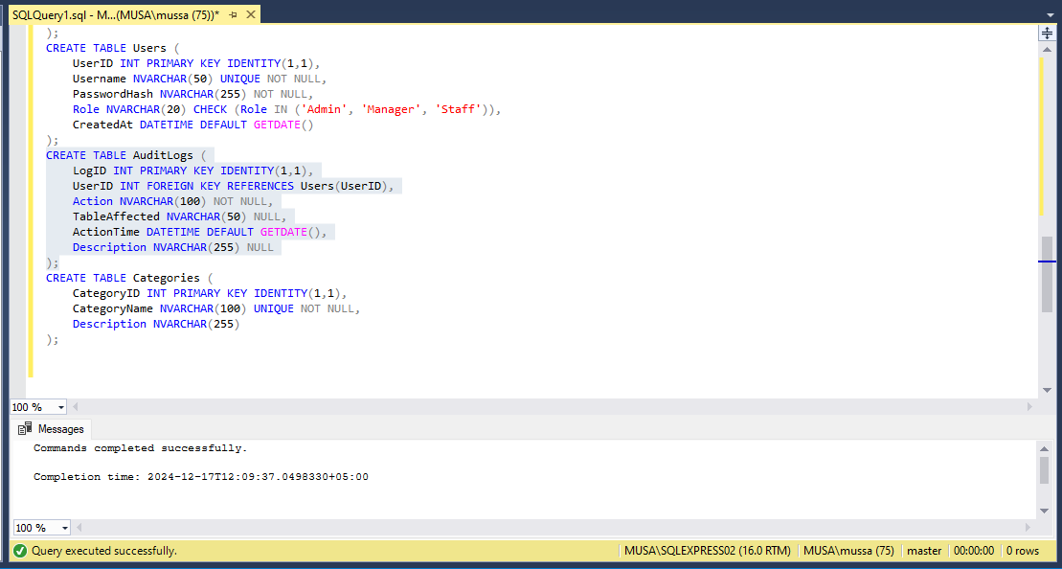

**Categories:**

